SST NEWS
PO Box 72301
Fairbanks, AK 99707

Phone: 970-689-1407
Email: coachjosh@outlook.com
Web: www.stingrayswim.org

April, 2015 Volume 2, Issue 6

SWIMMING IS A TEAM SPORT
By Lindsay Mintenko, USA Swimming National Team Managing Director

It’s championship season. You are racing to make the NCAA Championships. The Big Dance is your goal. You have been working hard all year, and finally, this is your chance.
In a few years you aren’t going to remember how hard the workout was or how excited or disappointed you were to make the NCAA Champs, to final, to score points for your team…You are going to remember the journey that got you there, and more importantly, the teammates who helped you along the way.
Many outsiders think swimming is an individual sport. I am always the one arguing with them. Swimming is a team sport. It is hard enough getting up every morning for morning workout, but knowing your teammates are with you makes all the difference.
They also live with you, eat with you and go to class with you. Your teammates will be your friends for life. You will be there for the good and bad times. And because you are swimmers, no one else will know your bond.
Good Teammates never see themselves as better and understand the importance of all members of the team, regardless of their ability level or motivation. NCAA swimming taught me that everyone needs a team behind them, pushing and encouraging. Individual goals are incredibly important, but being part of a team goal is extraordinary.
While most of us may not be athletes on an NCAA Championship team, you are still a part of a swim team and can help each other stay motivated during a killer set or to help your teammates stay focused on their goals.
Each person on a team has a role…find yours! And if you are ever blessed to be able to swim on a team in college, remember when NCAAs come around, you are swimming for your teammates.

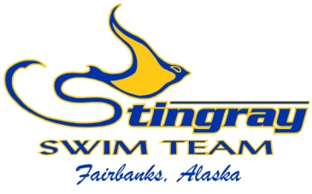
Inside This Issue:
Swimming is a TEAM
Sport 1

Northern Area Champs 2

NA Annual Awards 3
Swim-a-Thon 4
Board Director Election 5

Swimmers of the
Month 6

April at a Glance 7
SST 2014-2015
Meet Schedule 8
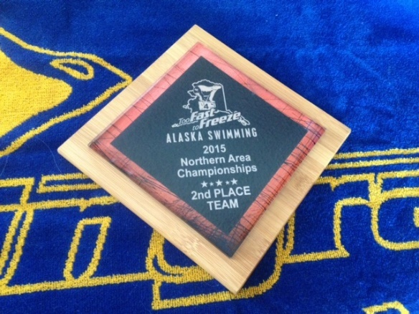

NORTHERN AREA CHAMPIONSHIPS
We could not be more proud of our swimmers and parents after an outstanding 2015 Northern Area Conference Championship! We had 65 swimmers in the meet, which was our highest participation in 6 years. Having 72% of our team in the meet made a huge difference as we had fun with our teammates, cheered hard, and kept our energy up all weekend. Each swimmer from age 6 to 18 raced hard, swam smart, and played an important role in the team success. We finished the meet with a combined Conference Runner Up title and a Women’s Conference Championship. We had many high point winners, a ton of best times, and high fives all weekend long. It was great to see our swimmers take up half the lanes in each heat; racing hard for a common goal. The Northern Area Conference Championship is the best, team-oriented meet of the year, and we are ecstatic with the outcome.

We also want to thank our parents for their time and support. It takes a great deal of volunteers to run a smooth, successful meet, and our parents did an outstanding job. We have said this many times, but our parents are truly our greatest asset and we thank you for your effort! The Stingrays are a family oriented team, and our amazing parents keep that atmosphere alive. From our lane times, to officials, to clerk-of-course, you all play an important role in our team’s success.

I would like to personally thank our amazing coaches for all their hard work in making SST the best team in the interior. We are very fortunate to have six coaches who care about each swimmer and do everything possible to see them succeed. Our coaches spent 33 hours on deck, taking splits, motivating, giving feedback, cheering, and teaching each swimmer. Those 33 hours fail in comparison to the countless time they put into the team all season. The Patty Pool has grown to nearly 40 swimmers, and things have not gone better at The Alaska Club in many years. Our swimmers feel the excitement and dedication our coaches exude each day, and they have built SST into a fun, competitive, goal oriented team. I feel blessed to work with such amazing people. Thank you coaches, keep up the great work!

To view the 2015 Northern Area Conference Championship recap, please visit our team website. *(results have not been released as of 4/1. Recap will follow asap once we get results file.)

2015 NORTHERN AREA ANNUAL AWARDS

Each season, Northern Area announces the annual award winners in multiple catigories. Each team submits their award winners, voted on by the coaches, and their nominations for the two higher awards, voted on by the Northern Area Board of Directors. We are proud to announce our 2015 Northern Area Annaul Award winners.

Future Stars | Breakout Performer
8&Under  - Lily Peterson  - Tyler Teslow | - Raven Drake  - Abigail Birkholz
9/10  - Meah McCallum  - Kyan Harnum | Big Dipper  - Shannon McCallum
11/12  - Madison Hrinko  - Logan Fox | Nova  - Lauren White
13/14  - Taylor Keyes  - Trevor Chiu | NA Male Swimmer of the Year  - Tommy O’Donoghue
15&Over  - Yuki Nagaoka  - Michael Lucero | SST Volunteers of the Year  - Laurie Keyes  - Ann Marie White  - Gina Hrinko

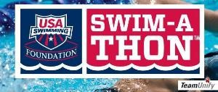
2015 SWIM-A-THON

It is that time again; time for our annual USA Swimming Foundation Swim-a-Thon! Our Swim-a-Thon is one of our largest fundraisers of the year and allows us to offer the greatest swimming experience possible. We did a great job last season by reaching our goal of $12,000 raised, and this year we’re shooting for more. Our goal this season is $15,000! In order to reach our goal, we need to average $175 raised per swimmer.

We have made things as simple as possible to contact donors, raise money, and earn cool prizes for your efforts. We handed out many prizes for last year’s Swim-a-Thon, including a swim parka to Gwendolyn Bunch. There are prizes for individual highest donations raised, highest donations by group, and highest donations by pool. Keep your group and pool in the running for these prizes by getting out there and talking to donors! To see this year’s prizes and what it takes to get there, please view the Swim-a-Thon tab on our website.

Current prize frontrunners:
Individual Top Dollar: Kyan Harnum ($345)
Swim Group Top Dollar: Bronze Group ($87 average)
Pool Top Dollar: Patty Pool ($200 average)

We are again using the on-line donation platform for this year’s Swim-a-Thon. Everything is done through our team website, from the first step of contacting donors to the final record of laps swum. By using the on-line platform, it can’t be easier to see your progress and watch the donations roll in.

This year’s Swim-a-Thon will be held on Saturday, May 2nd at Hamme Pool from 5:00 – 9:00. We will have a pancake feed and will also hold our Board of Directors election. Just over 5 weeks remain in our Swim-a-Thon campaign, so keep up the effort and help make 2015 our most successful Swim-a-Thon in team history!

BOARD OF DIRECTORS NOMINATIONS

The 2015 Stingray Board or Director elections will be held during the Swim-a-Thon on Saturday, May 2nd. Your vote is important to insure our leadership is a direct reflection of your wants and needs for your team. During the Swim-a-Thon, we will hand out the 2015 election packet for your review. This packet will include important information about our organization, a brief bio for each nominee, and your voting ballot. After reviewing your election packet, you will cast your annonomus vote in the ballot box.

Any Stingray parent who wishes to nomiate themselves or others for any open Board of Director position, please send your nomination to Coach Josh at sstboardelections@outlook.com. Nomination are due by Monday, April 20th.

The open positions this season include:
  - Board President
  - Board Vice President
  - Board Tresasurer
  - Board Secretary
  - Board Member at Large (3 positions)

Thank you and please submit your nominations by April 20th.

SWIMMERS OF THE MONTH IN MARCH

To be selected as the Swimmers of the Month, athletes must show their dedication to our team through their hard work, attendance, desire to improve, teamwork, and ability to listen to instruction. We are proud to look back at the March Stingray Swimmers of the Month.

Olivia Hrinko
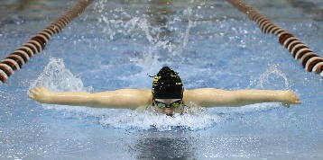
Olivia joined the Stingrays in March 2010 as a 12 year old, and is now taking advantage of her senior season. She had a great high school senior year from August to November, and has taken that momentum into her club season. She posted a best time in the 200 fly during the St. Patrick’s Day Meet, and added best times in the 200 back and 500 free in last weekend’s Northern Area Championship. She raced hard, swam smart, and scored 54 points for the team. She is a leader at the Patty Pool and listens well. She will compete in three individual events this month at the Alaska Junior Olympic State Championships. Congratulations Olivia on being the March Stingray Swimmer of the Month!

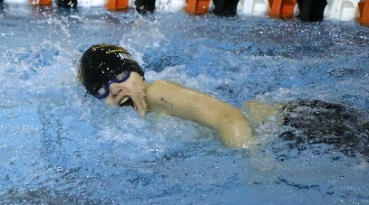
Ezra Billings
Ezra joined the Stingrays in October 2012. He has been working hard ever since, and is now training with the Platinum group. He has improved his technique, work ethic, and speed; all which led to a great month of March. He posted two best times (50 breast and 100 IM) during the St. Patrick’s Day Meet earlier in the month, and then dropped time in all of his events last weekend at the Northern Area Conference Championship. He also placed well last weekend, scoring 59 points and racing hard. He listens well, is a great teammate, and will continue to improve each day. Congratulations Ezra on being the March Stingray Swimmer of the Month!


APRIL AT A GLANCE
- April 3 – Tyler Teslow’s Birthday
- April 9 – Tommy O’Donoghue’s Birthday
- April 10-11 – House of Delegates Alaska Swimming State Meeting
- April 14 – SST Board of Directors Meeting
  - Open to all members
  - Time: 6:30-8:00pm
  - Location: Madden Real Estate

- April 14 – Baylee Elise Gutzman’s Birthday
- April 20 – Audrey Fox’s Birthday
- April 23-16 – Alaska Junior Olympic State Championship
  - Qualification standards required
  - Location: Anchorage, AK
  - Entry Deadline: April 14

- April 25 – Samantha Atchison’s Birthday
- April 26 – Timberlyn Wendt’s Birthday
- April 28 – Elizabeth Woller’s Birthday
- April 28 – Meah McCallum’s Birthday


SST 2014-2015 Remaining Meet Schedule

AK Junior Olympics - Bartlett Pool
April 23-26
Prelim/Final Meet
*Qualification standards required
Anchorage, AK

Friendly remembers:

Download the Meet Mobile App for live meet results

Activate your DeckPass on USA Swimming’s website
http://www.usaswimming.org/DesktopDefault.aspx?TabId=2151&Alias=Rainbow&Lang=en

Download the OnDeck App for the mobile view of our website
http://www.teamunify.com/__corp__/ondeck/

Verify your text message capabilities on your team account

Subscribe to our team YouTube account
https://www.youtube.com/c/StingrayswimOrg?gvnc=1

Join our team Facebook GROUP
https://www.facebook.com/groups/stingrayswimteam/

