SST NEWS
PO Box 72301
Fairbanks, AK 99707

Phone: 970-689-1407
Email: coachjosh@outlook.com
Web: www.stingrayswim.org

January, 2016 Volume 3, Issue 3

20 New Year’s Resolutions for Swim Parents
By Elizabeth Wickham, SwimSwam Featured Article

As a swim parent, I’ve made my share of mistakes. Through the years, I’ve evolved and hopefully improved. For example, I am not the same swim parent today that I was 10 years ago. I still get nervous at meets, but I no longer compare my kids to other swimmers. I enjoy each moment as a swim parent, knowing that I won’t be in this role forever.
The New Year provides a golden opportunity to reflect on our swim parenting skills. Are we adding to the swim experience—or detracting from it? Here’s my list of 20 New Year’s Resolutions for all swim parents:

- I will get my swimmer to practice consistently and on time
- I will talk positively about the coach and team to other parents
- I will sign up to volunteer at meets early and often
- I will not compare my child’s times with other swimmers
- I will not show my frustration when my swimmer has a bad swim
- I will cheer, not coach my child
- I will reach out to newer swim parents and be a positive role model
- I won’t rehash swim performances on the drive home from a meet
- I will let my kids mature and take charge of their lives
- I promise to not helicopter and hover at practices and meets
- I will praise my swimmer for good sportsmanship
- I will provide healthy food at meets and at home
- I will let my swimmers find their own heats and lanes
- I will cheer for other swimmers on the team
- I will not use bribery to motivate my child
- I will encourage my child’s effort and not focus on performance
- I will not engage in gossip on the pool deck or stands
- I will not automatically take my child’s side if there’s an issue with the coach or teammates
- I will not stand behind the blocks while my child races (unless I’m timing in their lane)
- I will not impose my goals on my swimmer

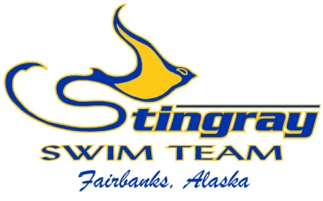
Inside This Issue:
Resolutions for
Swim Parents 1

Holiday Training
Pays Off 2-3

Championship Meet
Progression 3-7

Bright Future for SST 8-9

SST Masters Program 9-10

Jan. at a Glance 10

2016 Meet
Schedule 11-12

HOLIDAY TRAINING PAYS OFF

The alarm clock buzzes at 6:30am. It’s the first day of holiday break from school…why in the world is the alarm going off? Oh yes, it’s also the first day of holiday training. A two-week period in the year when there are no school obligations, homework, or extracurricular activities. Just swim, eat, sleep, and repeat.
This is the normal life of a competitive swimmer. Holiday training is one of the most crucial training portions of the year, and it marks the midway point in the short course season. We can hold twice as many practices per week, add thousands of yards per workout, and focus solely on the task at hand. Rest assured, surviving holiday training with a positive attitude and work ethic will pay dividends come championship time.

This is exactly what our SST Junior and Senior groups faced this holiday season. They completed 19 workouts over 15 days, swam 103,325 yards (62.6 miles), and woke up for 10 morning workouts. They burned around 4,000 calories per day and were challenged significantly more than during our normal schedule. Why do that to yourself when you’re supposed to be recovering from school’s first semester?
The answer will become obvious in the next few months. With championship season quickly approaching, it is now or never to put your training “in the bank”, ready to cash out when you need it most. Holiday training mandates you’re in the best shape of your life, and you will reap the benefits well into the summer months. Remember how good you feel during taper…imagine how strong and fast you will feel after putting in the work over the holidays. The more effort you put in during the season, the better your taper will work (and trust me you’ve put in more work than ever before). When you step behind the block, you will know you’ve worked harder than the person next to you and have the edge in any competition.
But what if I was on vacation during the holidays? What if I’m not yet training at the Patty Pool and my hours did not change due to lane availability at The Alaska Club? Well, it’s not too late! You have a month or more to put in the training necessary to have an outstanding championship season, and your effort over the next few weeks will play a large roll in reaching your goals. Remember, the more effort you put in now, the better your taper will work. Taper is the best time of year for a swimmer, when practices get easier and shorter, you feel strong and fast, and swimming a 200 feels more like a 100. But that will only be the case if you have quality training “in the bank” and your technique is as perfect as possible.
The effects of holiday training are more evident in our older swimmers, who’s muscle mass and endurance can withstand the high demands. Our younger swimmers will gain the same effect not with an increased workload, but with an increased focus on technique. The main idea is to perfect technique at The Alaska Club (which in turn improves speed), and then perfect the smaller details at the Patty Pool (such as strategy, race preparation, and specific endurance). Each group has its own developmental process, and our coaches are well trained in moving our swimmers through the steps. At some point in their Stingray career, each swimmer will have the opportunity to experience holiday training.
So now you’re back in school and the work is over…right? It’s true you’ve put in the bulk of the training, but we must remain focused in the months ahead. Our first championship meet is later this month, Age Group Champs is a short four weeks away, followed closely by Northern Area Champs and Junior Olympics. Now is the time to prefect those little details we may have overlooked up to this point. Are you breathing on your first stroke off the wall, breaking out before the flags, doing a one-handed turn, finishing backstroke on your stomach, treating backstroke as a “recovery lap” during the IM…we hope not. Focusing on the details will be the final step in making 2016 your best season yet. Your coaches will set you up for success, but the rest is up to you!

CHAMPIONSHIP MEET PROGRESSION

As we begin the final stretch toward our championship season, I have gotten questions about what these championship meets actually mean and how to get there. So, with the first championship meet later this month, I thought I’d take the time (and space in this edition) to cover the championship meet progression.
Regardless of which meet we focus on, the championship meets are the culmination of the season and is a swimmer’s best chance of achieving best times. It is also the most fun as you finally reap the benefits of all those hours in the pool. Unlike other sports, where you could have a 20-point game or score a hat trick anywhere along the season, swimmers have a limited number of meets to achieve a lifetime best. We cannot expect to swim a lifetime best at a mid-season meet, unrested and tired, when our best time came from a “shave and taper” meet just six months prior. And if you DO get a mid-season best time, more power to you! As our swimmers get older and faster, it becomes more difficult to get a best time. That’s where the championship meets come into play.
Most championship meets are considered “shave and taper” meets. That means we will go through the taper process, which is a gradual “taper” to easier, shorter workouts. This gives swimmers more rest and their muscles rebuild, putting them in the optimal condition to swim fast. Swimmers also shave their bodies for these meets, girls and boys, but is an optional process. The reason to shave everything the suit doesn’t cover is to get rid of the top layer of dead skin cells, uncovering the new skin which is covered in fresh nerve endings. When a swimmer dives into the pool after shaving, the cold water reacts with the fresh nerves and releases large amounts of endorphins from the brain. This increases heart rate, oxygen carrying capacity, muscle activation, etc. Basically, the body is at optimal performance physically, and the swimmer feels these effects mentally. Shaving off the hair also reduces drag, but it’s much more about releasing those endorphins. And rest assured, the old tale about hair growing back thicker and darker as completely false…we’re not doing anything to the hair follicles, just getting rid of the top layer of dead skin.
Amway, back to championship meets. The first championship meet for most swimmers is the Northern Area Championships. This is the only meet without qualifying times, meaning everyone can participate. It is our conference championship and our largest team championship meet of the year. Everyone from Bronze to Senior should compete in this meet, which makes it fun having your teammates to cheer you on. We placed 2nd last season and are gearing up to win our first conference title in many years, but we can only do so with everyone involved. The 2016 Northern Area Championship is held at Hamme Pool on April 1-3.
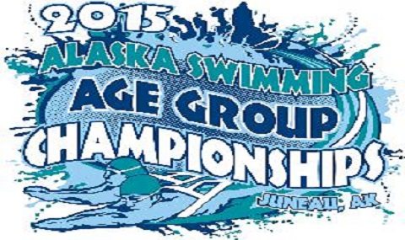
The next step in the championship process for most swimmers is the Alaska Age Group Championships, which has a maximum age limit of 14 years old. This meet marks the first qualifying meet, where swimmers much achieve a pre-set time in order to participate. These times are set by the Alaska Swimming Governing Body and are meant to control the size of the meet as well as provide experience in qualification standards. It’s amazing how swimmers will rise to the challenge once they start looking at these qualification times. USA Swimming made the qual times for the 2016 Olympic Trials more difficult in an attempt to make the meet smaller, but swimmers rose to the challenge and this year’s Trials is the largest ever, with nearly 2,000 athletes. Once a swimmer sees the goal, they are likely to achieve it. The same idea is true for our Age Group Championships, and I encourage you to view the time standards with your swimmer. This also marks the first travel meet and swimmers get to experience this exciting time. Learning how to handle a travel meet pays dividends later in their career. We have 26 Stingrays qualified for the meet this year (23 last year). The 2016 Age Group Championships will be held in Soldotna on February 5-7.
Next, most swimmers achieve qualification times for the Alaska Summer Championships. This meet was held for the first time in many years last season, when Fairbanks hosted the meet in short course. Traditionally, the summer season is geared toward long course swimming but Alaska has only one long course pool in Anchorage. This meet is the summer edition of a state championship and is open to all who qualify. We currently have 36 qualified swimmers with more to come in the next few months. The 2016 Alaska Summer Championships will be held in long course at Bartlett Pool in Anchorage on July 28-31.
A defining moment in a young swimmer’s career is to qualify for the Alaska Junior Olympics. This is the spring edition of a state championship and is open to all who qualify. Time standards for the Junior Olympics take a significant jump from the previous championship meets, and a great deal of pride goes into making the cut. This meet is always held at Bartlett Pool in Anchorage, the fastest pool in the state. We have recently taken a large team of 20+ swimmers, and currently have 26 qualified. In the next few years, we will grow this team to 40+ and compete well against the top teams in the state. The 2016 Alaska Junior Olympics will be held at Bartlett Pool in Anchorage on April 21-24.
The next two championship meets have similar qualification standards but differ in their structure. The Alaska Senior Championships has difficult time standards, but a swimmer only needs to make one cut in order to compete in the maximum six events. This makes it more realistic for a swimmer to participate if they only have one cut, because they can still swim the maximum events. In 2015, SST won the “Most Points per Swimmer” award with six athletes, and this season we qualified 12 swimmers. The 2016 Alaska Senior Championships will be held in long course at Bartlett Pool in Anchorage on January 29-31. The Region XII Championships have similar time standards, but swimmers can only compete in those events in which they made the cut. This is the first chance to travel outside Alaska and is a milestone in a swimmer’s career. We currently have 10 swimmers qualified, and the meet will be held in Gresham, Oregon on March 3-6.

Moving forward, championship meets begin to be on the national stage. The Speedo Sectional Championship Series brings the northwest portion of the United States together, from Montana down to Colorado and west to California. Age Group Sectionals is the next stepping stone, where qual times are separated by age group. Senior Sectionals has the same qual time per event regardless of age, and the time standards are much more difficult. This is perhaps the largest milestone in a young swimmer’s career, as it sets them up to compete at the national level. Following the Sectional Championships, swimmers begin to travel around the lower 48 and compete against the best swimmers USA has to offer. We currently have one swimmer qualified for both Age Group Sectionals and Senior Sectionals. In the coming years, we will build these teams to 10+ athletes. Both meets will be held in Federal Way, Washington with AG Sectionals March 10-13 and Senior Sectionals March 17-20.
Below is a diagram which shows the championship meet progression. Again, swimmers tend to reach these standards if they know what they’re shooting for, so please look over the time standards with your swimmer. All time standards and current SST qualifiers can be found on our website under the “times/awards” tab and “qualifiers” tab, respectively.
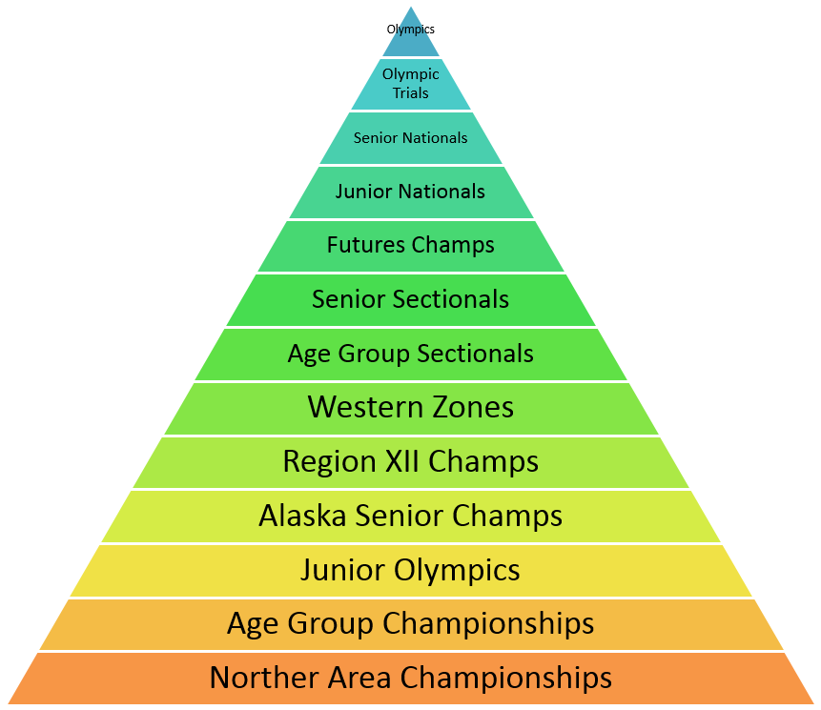
Championship Meet Progression

BRIGHT FUTURE FOR SST
With the beginning of a new year, we reflect on the past and evaluate where we’ve come. A few short years ago, the Stingrays had around 30 active swimmers and three coaches. In recession from coaching changes, declined financial stability, and receeding numbers, the future of SST was uncertain. A team that was formed nearly 30 years prior was in serious trouble and the budget forcast was grim. Less than four years later, we are proud to share that SST is again a thriving organization who continues to grow. With nearly 90 swimmers and seven coaches, the future has never been more bright for the Stingrays. And as an active participant in this success story, YOU played a critical roll in our resergence.
Sure, our coaches played a large part in the comeback. Coach Scott, our longest tenured and most experienced coach, ran a thriving team before our recession. During the hard times, he kept things afloat and made sure SST did not collaps. There was little he could do about the declining financial situation, but he kept our swimmer invloved and motivated. Now, he coaches the largest (and most tallented) Senior squad in many years. Coach Felina came on to resurect the groups at The Alaska Club, and she maintained a technique first approach. Our numbers began improving and swimmers were once again excited to come to practice. Coach Heidi and Coach Hilary have continued the success in our younger groups and we now have over 50 swimmers at that pool. We are also fortunate to have three substitute coaches, Coach Madison, Coach Claressa, and Coach Blair. Most teams cannot afford one substitute coach…and we have three!
Our structual changes also played a part in regaining success. Those of you who were on the team during the hard times will remember the lack of structure, primarily with our younger swimmers. There were no groups and swimmers were alowed to come to whichever practices they (or their parents) wished. The nightmare result was no consistancy between practices, coaches, or teammates. It also made season planning impossible as the coaches had no idea who would be where. We now have eight groups (with the addition of the Masters Group this month), maintain consistant practice times, and have a structure thal allows swimmers to progress mentally and physically. We can construct a seasonal plan for each group, track progress, and make any needed adjustments. The structual changes have made a substantial impact on our continued success.
But the largest and most important factor in SST’s resurection has been the swimmers and parents. Our swimmers and parents dedicate their time and effort for the sport, sacrificing other activites and social events. How many trips to the pool can a parent make in one week…? They are the swim-taxi, provide the large amounts of food swimmers tend to eat, and kept their athele on track during school. They volunteer their time during SST events, school funtions, board meetings, and fundraising. You’ve heard me say this before, but our parents are our most important resource. And the swimmers benefit greatly. They enjoy being part of a team, perfecting their sport, and spending time with their teammates. They go to school and tell their non-swimming friends how much fun it is to be on SST, and thus are our top recruiters. Our numbers have rebounded largely because the parents and swimmers were patient during hard times, seized the moment when we began to rebuild, and recruited their friends. We owe a great deal of gratitude to our parents and swimmers.
With all the recent success, where can we go in 2016 and beyond? Our financials are again stable and we are able to provie services that were not possible a few years ago. We will grow to 100+ athletes by September and are looking to add a third pool. We will begin morning workouts for our older swimmers and add lane space for the younger groups. We will host our first thee-day meet in February and are looking toward a team travel trip in the near future. We started a Masters program this week which will continue to grow, and our learn-to-swim program will reach new heights. What 2016 will bring is opportunity…to continue what we’ve done well, improve our shortcomings, and always reach toward our mission of “being the premier swimming organization in the Interior”. Cheers to 2016 and GO STINGRAYS!

STINGRAY MASTERS PROGRAM

We have begun the Stingray Masters Program, which is open to all post-graduate adults who wish to continue swimming. This program is designed for adults who already know how to swim but are interested in prefecting their technique, improving their physical fitness, and learning more about the sport. The fist phase of the program will include workouts at The Alaska Club on Tuesday and Thursday mornings from 7:00-8:00am. Coach Josh will run the workouts and dues will be $40 per month. A number of competitions will be available throughout the year and are optional. If you enjoy swimming, would like qualified feedback, and wish to exercise with others of the same mindset, our Masters Program is for you! Anyone interested in joining our Masters group please contact Coach Josh at coachjosh@outlook.com.

JANUARY AT A GLANCE
  - January 6 – Mika Grubis’ birthday
  - January 6 – Lucie Meyer’s birthday
  - January 8 – Atigun Pensley’s birthday
  - January 9 – Spring Will Come Meet
    - Warm up @ 8:00am, races start @ 9:00am
    - Hamme Pool
  - January 9 – Kade Harnum’s birthday
  - January 12 – SST Board Meeting
    - 6:30pm at Polar Fuel
  - January 15 – Tristan O’Donoghue’s birthday
  - January 18 – Thomas Conklin’s birthday
  - January 18 – Yuki Nagaoka’s birthday
  - January 21 – Kelly Gregor’s birthday
  - January 24 – Emma Henne’s birthday
  - January 27 – Alaska Age Group Champs Entry Deadline
    - Qualification standards enforced
  - January 27 – Lauren Bird’s birthday
  - January 29-31 - Alaska Senior Championships
    - Anchorage
    - Qualification standards enforced
  - January 29 – Josiah McCallum’s birthday
  - January 30 – Tayler Morris’ birthday
  - January 31 – Joseph Slusser’s birthday

SST 2016 Meet Schedule

Spring Will Come
January 9
Hamme Pool

Alaska Senior Championships (deadline 1/20/16)
January 29-31
Long Course Meters
*qualification standards
Bartlett Pool, Anchorage

Alaska Age Group Championships (deadline 1/27/16)
February 5-7
Prelim/Final Meet
*qualification standards
Soldotna

Sweetheart Superstar Invite (deadline 2/12/16)
February 19-21
Three Day Team Hosted Meet (volunteers needed)
SST Hosts at Hamme Pool

Region XII Championships (deadline 2/15/16)
March 3-6
Prelim/Final Meet
*qualification standards
Gresham, Oregon

Northwest Age Group Sectionals (deadline 2/25/16)
March 10-13
Prelim/Final Meet
*qualification standards
Federal Way, Washington

St. Patrick’s Day Meet (deadline 3/4/16)
March 12
Wescott Pool

Senior Sectionals (deadline 3/3/16)
March 17-20
Prelim/Final Meet
*qualification standards
Federal Way, Washington

Northern Area Championships (deadline 3/24/16)
April 1-3
Prelim/Final Meet open to ALL (volunteers needed)
Hamme Pool

Alaska Junior Olympic Championships (deadline 4/13/16)
April 21-24
Prelim/Final Meet
*qualification standards
Bartlett Pool, Anchorage

Alaska Summer Championships (deadline 7/19/16)
July 27-31
Prelim/Final Meet
*qualification standards
Bartlett Pool, Anchorage

