SST NEWS
PO Box 72301
Fairbanks, AK 99707

Phone: 970-689-1407
Email: coachjosh@outlook.com
Web: www.stingrayswim.org

September, 2015 Volume 3, Issue 1

Welcome to a New Season!

September brings new life to swim teams across the country, and the Stingrays are no different. After a summer filled with vacations and time away from the pool, it is finally time to get back to work. We have big plans for this season, both as a team and individually, and the road to success starts today!
We reached our team goal last season of finishing in the top 10 Alaska rankings, earning a 7th place rank and making big waves around the state. We grew to 90 swimmers, 7 training groups, and 7 coaches. Our swimmers attended more practices, competed in more meets, and dropped more time than ever before. We had our largest championship meet rosters in many years and were the Northern Area Conference Runner-ups. We had our first Junior National qualifier in a decade and saw multiple swimmers make a Speedo Sectional cut. So…where do we go from there?
The 2015-2016 season will be one for the record books, as we raise the bar and expectations. We will have 80+% attendance across all groups, continue to improve our technique and mental toughness, and grow as a team through bonding activities. We will have more meet participation than ever, take double digit swimmers out of state, and push for a conference title. We will train hard, race smart, and always show exceptional teamwork and sportsmanship. All of these accomplishments will gear us toward a top 5 Alaska State ranking, no small task looking at the teams ahead of us.
What does all this mean for each member of the Stingrays? The 2015-2016 season will be FUN! We pride ourselves in a family-first, exciting, and enjoyable atmosphere. That will always be the case as we begin to see the fruits of our labor. As long as our swimmers and having fun, learning each day, and improving mentally and physically, this season will be a huge success. So here’s to an outstanding season Stingrays!

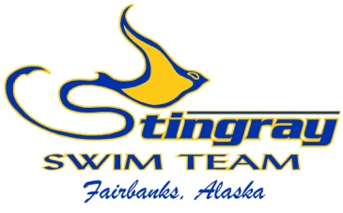
Inside This Issue:
Welcome to a New
Season 1

Team Registration 2-3

General Membership
Meeting 3

Crazy Big Swim 4
Sep. at a Glance 5

2015-2016 Meet
Schedule 6-8

TEAM REGISTRATION

It’s that time again; time to complete your 2015-2016 Stingray Registration. This registration is required to be a part of the team, and it also fulfills our requirement to USA Swimming. Each swimmer must complete the online registration process beginning on Sep. 1, 2015. All returning swimmers must have the process completed by Sep. 30, 2015…no exceptions. The process is quick and easy, so please take the time to register.
To register, follow these steps on our website (www.stingrayswim.org):

STEP 1 STEP 2
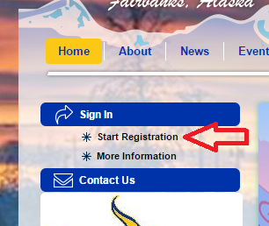
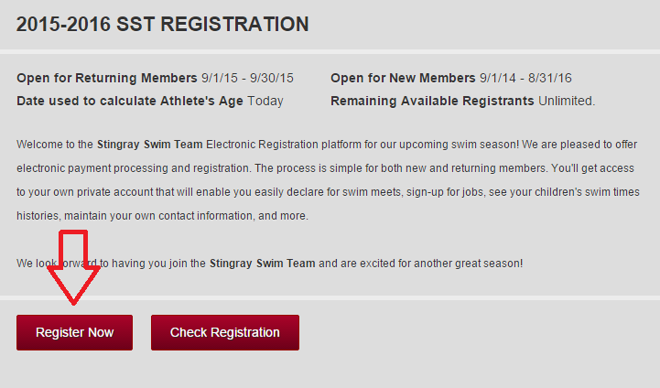

Click ‘start registration’ Click ‘register now’

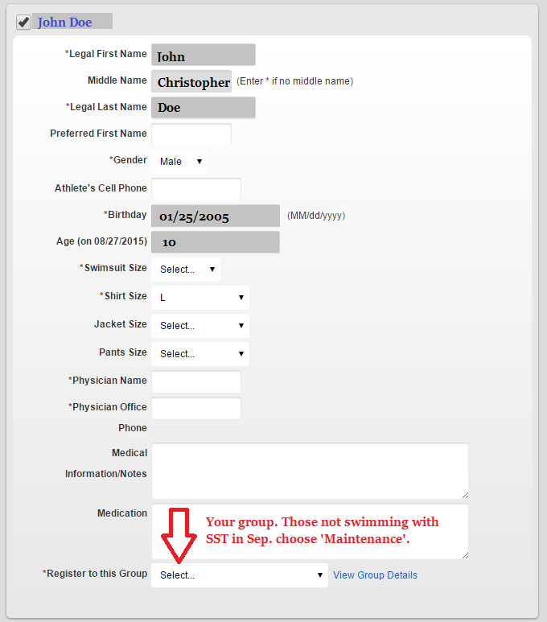
STEP 3 STEP 4
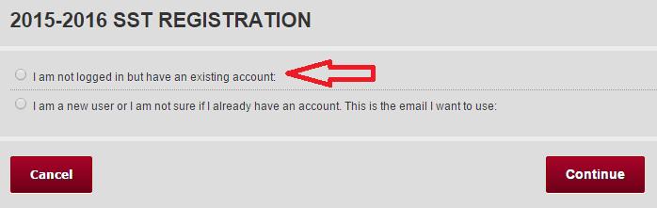

Select to log into your account

Select your swimmer(s) and fill out form.
High School swimmers and anyone on
maintenance choose ‘Maintenance’ group!
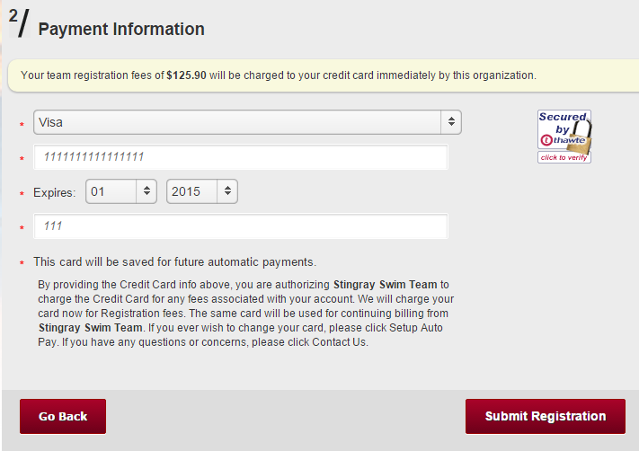
STEP 5 STEP 6
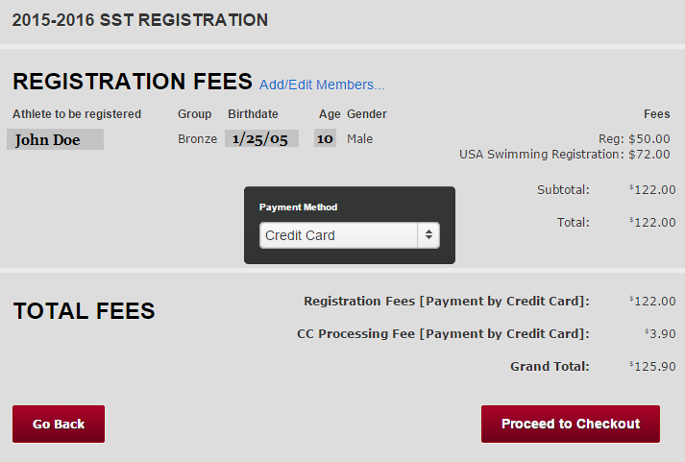
Choose your payment type. We
highly suggest credit card payment.
USA Registration fees will be paid
now and sent to Alaska Swimming.
Fill out payment information and
submit registration. You will get an
email confirming your registration was
successful.

GENERAL MEMBERSHIP MEETING
Each September we hold a Stingray General Membership Meeting. This is a chance for everyone to get together, talk about the upcoming season, and relay important information. We only meet as a team twice per year, so please plan to attend this meeting. We will cover the team registration process, our season’s outlook and goals, use of the team website, and important financial information. We will also be able to answer any questions you may have.
The General Membership Meeting will be on Wednesday, September 16 at 6:30pm at Monroe Catholic School. We will be in the multipurpose room; please park in back. There will be a baked potato feast and beverages provided. We hope to see everyone on Wednesday, September 16 at 6:30pm at Monroe.

CRAZY BIG SWIM – CRUSH CANCER & BREAK WORLD RECORD!
We are excited to participate in Swim Across America’s event, Crazy Big Swim. This event will be held on Sunday, September 27 at 3:00pm at the UAF Patty Pool.
The Crazy Big Swim event is hosted by Swim Across America, a non-profit organization raising money and awareness for childhood cancer. During this event, teams around the country will hold their own inter-squad meet, send in the results, and scores will be tallied. This will be the largest swim meet in world history, therefore breaking the Guinness World Record!
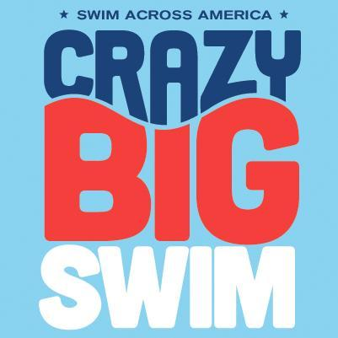
All proceeds will go to St. Jude Childhood Cancer Research to help the fight against childhood cancer. The minimum entry fee is $25/swimmer. Swimmers are required to swim the 50 free, and we will also offer the 100 IM, a mixed gender 100 free relay, and mixed gender 200 medley relay.
This event is for everyone! As this is not a real meet, your times will not count but it's a great opportunity to gain meet experience, see where you're at with your times, help crush childhood cancer, break a world record, and HAVE FUN! We hope to see everyone sign up to participate (sign-ups are on our website just like any other meet. Click ‘edit commitment’ next to ‘Crazy Big Swim’).
We will open the event to the community, so bring your friends and parents along! Anyone who is not a current SST swimmer will need to email Coach Josh (coachjosh@outlook.com) by Wednesday, September 23 to be entered. Let’s make this a huge event by bringing the community together for a great cause.

SEPTEMBER AT A GLANCE
- September 1 – Team Registration Opens!
- September 1 – Abigail Birkholz’s Birthday
- September 1 – Bradley Birkholz’s Birthday
- September 8 – Board or Director’s Meeting
  - Location: Polar Fuel
  - Time: 6:30pm
- September 16 – General Membership Meeting
  - Location: Monroe Catholic School Multipurpose Room
  - Time: 6:30pm
- September 18 – Sonia Ahmadova’s Birthday
- September 19 – Fall Equinox Meet
  - Location: Wescott Pool in North Pole
  - Time: 8:00am
- September 26 – Charity Leon’s Birthday
- September 26 – Hannah Hackett’s Birthday
- September 27 – Crazy Big Swim Event
  - Location: UAF Patty Pool
  - Time: 3:00pm
- September 30 – Team Registration CLOSES for all returning athletes

SST 2015-2016 Meet Schedule

Fall Equinox Meet
September 19
Wescott Pool

Crazy Big Swim Event
September 27
Inter-squad Event
Patty Pool

IM Challenge Pentathlon
October 10
*IMR events in morning, IMX events in afternoon
Team Hosted Meet (volunteers needed)
Patty Pool

Spooky Sprint Invite
October 24
*10&U in morning, 11&O in afternoon
Team Hosted Meet (volunteers needed)
Patty Pool

Wishbone Invite
November 13-15
Prelim/Final Meet
Hamme Pool

IMX Games
November 20-22
*qualification standards
Mesa, Arizona

Coach Robb Coady Novice Invite
December 5
*Non-Age Group Champ qualifiers only
Hamme Pool

Winter Junior Nationals
December 9-12
Prelim/Final Meet
*qualification standards
Austin, Texas

Candy Cane Meet
December 12
Wescott Pool

Spring Will Come
January 9
Hamme Pool

Alaska Senior Championships (formally Great Alaska Open)
January 29-31
Long Course Meters
*qualification standards
Bartlett Pool, Anchorage

Alaska Age Group Championships
February 5-7
Prelim/Final Meet
*qualification standards
Soldotna

Sweetheart Superstar Invite
February 19-21
Three Day Team Hosted Meet (volunteers needed)
Patty Pool

Northwest Age Group Sectionals
March 10-13
Prelim/Final Meet
*qualification standards
Federal Way, Washington

Senior Sectionals
March 17-20
Prelim/Final Meet
*qualification standards
Federal Way, Washington

St. Patrick’s Day Meet
March 12
Wescott Pool

Northern Area Championships
April 1-3
Prelim/Final Meet open to ALL (volunteers needed)
Hamme Pool

Alaska Junior Olympic Championships
April 21-24
Prelim/Final Meet
*qualification standards
Bartlett Pool, Anchorage

Alaska Summer Championships
July 22-24
Prelim/Final Meet
*qualification standards
Location TBD

