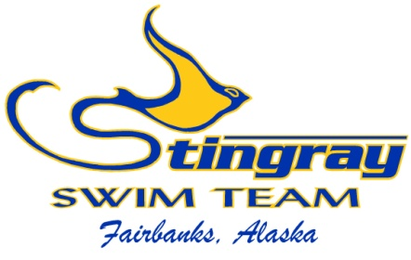
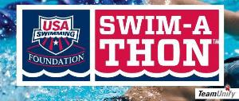

Dear NAME,

This February I will be participating in a Swim-a-Thon to raise funds for the Stingray Swim Team and the USA Swimming Foundation.

What’s a Swim-a-Thon? A Swim-a-Thon is a really fun way to combine something I love, swimming, with a wonderful cause. Together with my teammates, I will commit to swimming for either 2 hours or up to 200 lengths of the pool. I’m asking for the support of my friends and family to either make a flat donation to support my effort, or to pledge a certain amount of money per length. I’ve been training hard, and I’m going to do all 200 lengths!

You might be wondering why I’m committed to spending my time swimming laps at the pool. For me, this is a great opportunity to give back to a sport that I love. Swimming has given me a lot - it’s taught me skills like hard work, time management and perseverance. The money I raise will support crucial programs for my swim team and will allow us to continue working hard for the coming season.

In addition to raising funds for my team, 5% of the money I raise will go back to the USA Swimming Foundation. The Foundation works to strengthen the sport of swimming by saving lives and building champions - in the pool and in life. Whether they’re equipping children across the country with the lifesaving skill of learn-to-swim through their Make a Splash initiative or providing financial support to our heroes on the U.S. National Team, the USA Swimming Foundation aims to provide the wonderful experience of swimming to children at all levels across the country. It’s great to know that I’ll not only be building a stronger team here in Fairbanks, but I’ll be helping to give children across the country the same great experience that I’ve had!

I hope that I can count on you to help me achieve my fundraising goal for my upcoming Swim-a-Thon. Please consider checking out my fundraising page at www.stingrayswim.org.

On behalf of myself, my team, and children across the country who might not otherwise have the opportunity to swim, thank you! Your support will give me the energy I need to complete my 200 lengths this February - and it will truly make a difference for our team and our country!

Thanks again,

NAME

