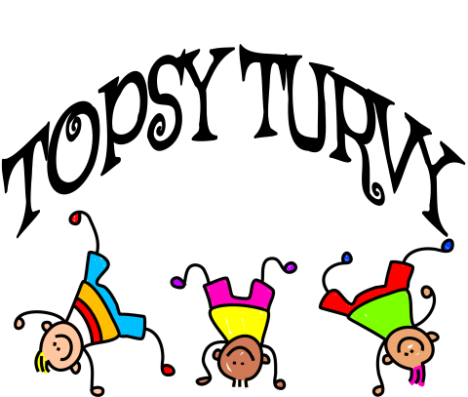

2021-2022 SESSION DATES
Boone’s Chapel MDO
September 13, 20, 27
October 4, 18, 25
November 1, 8, 15

Session 2:
November 29
December 6, 13
January 10, 24, 31
February 7, 14, 28

Session 3:
March 7, 14, 28
April 4, 11, 18, 25
May 2, 9

