Meet Sign-up Process

Below, I will put together the meet sign-up process. Since there was an update to Team Unify, we revisit this so that any issues with the process will be averted.

Steps to follow for Meet Registration.

Step 1 – Meet Posting

Allegheny Mountain Swimming (AMS) will post the swim meets for the season at this link:

https://www.gomotionapp.com/team/ezamslsc/page/events#/team-events/upcoming

There are other things that will also be posted on the site. Best advice is to look there for reference only.

Once a meet that we plan to attend is posted, I or another coach will go to the link above and download the necessary files that contain the meet invitation and the meet events. These are used to set up the meet in our Team Unify site for sign-ups.

The actual setup of the meet on our website will not be covered here.

Once the meet is posted you will receive an email notification that the meet is available for sign-up and you can proceed to the website and begin the signup process.

Step 2 – What to do when a meet is posted.

Once the meet is posted, there will be a new event in the Team Events tab on the CSC website. To navigate to that area use the following steps:

a. From the website on a computer
Scroll down to the Meet Sign-up button (Shown Below), hover over and left click

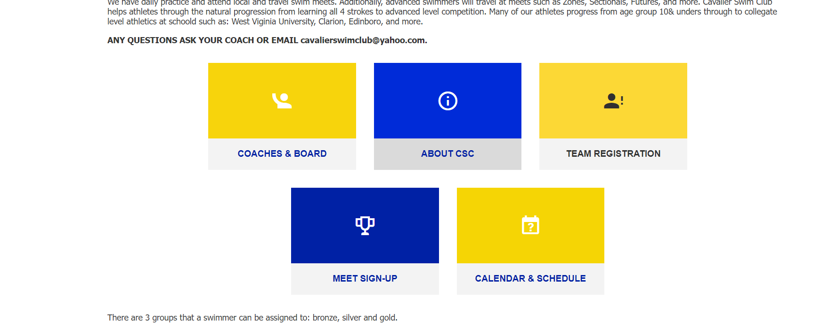
Next, the Team Events Tab will appear:

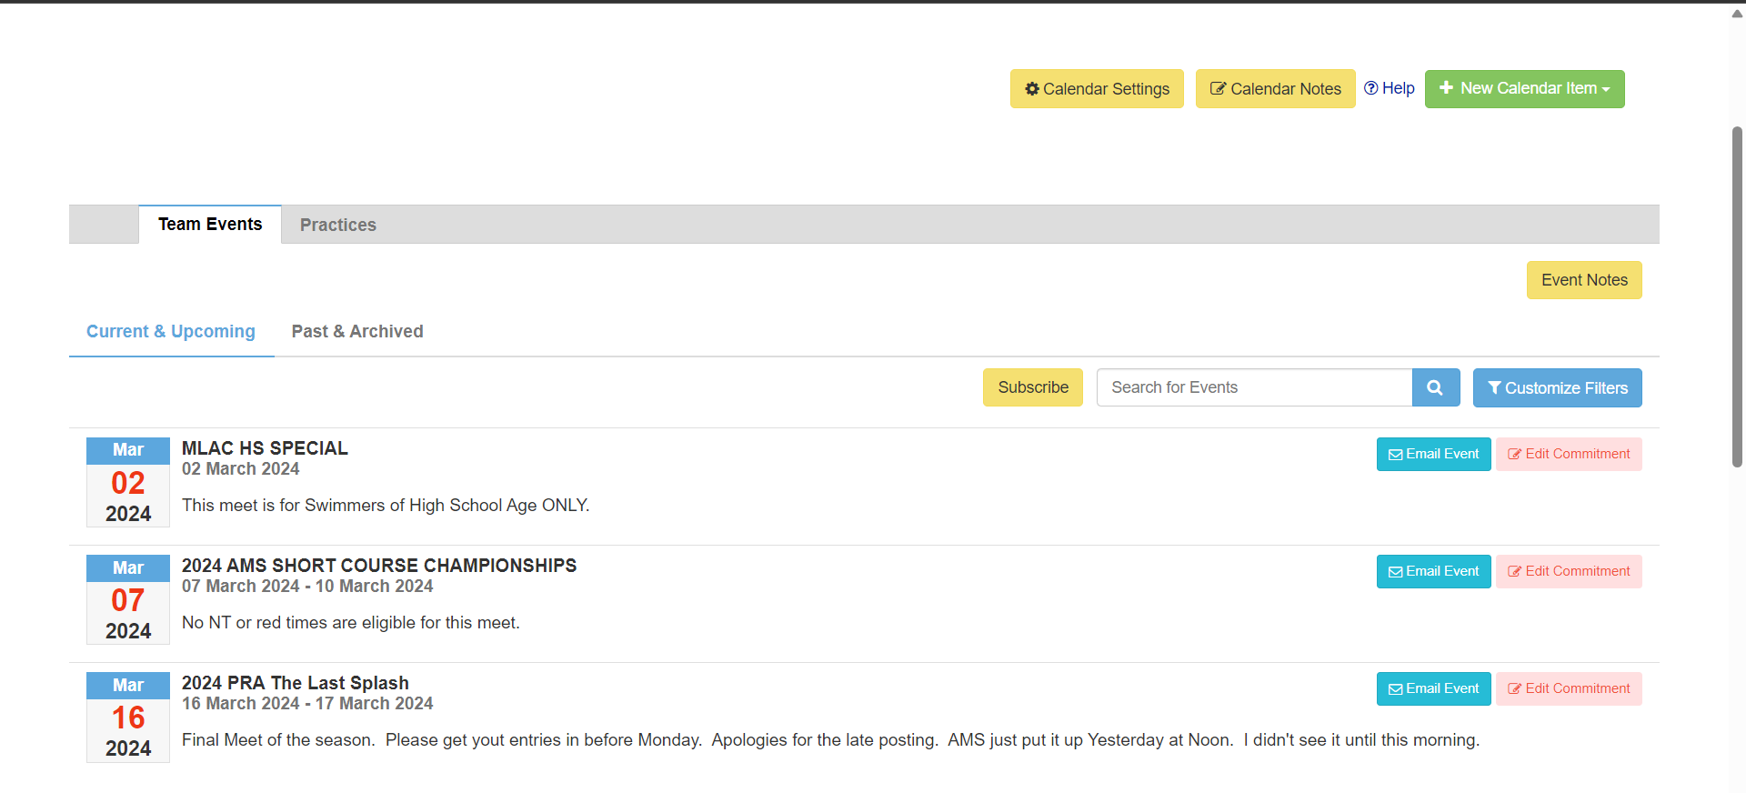
To enter your swimmer, mouse over and click on the pink “Edit Commitment” box.

The screen below will appear:
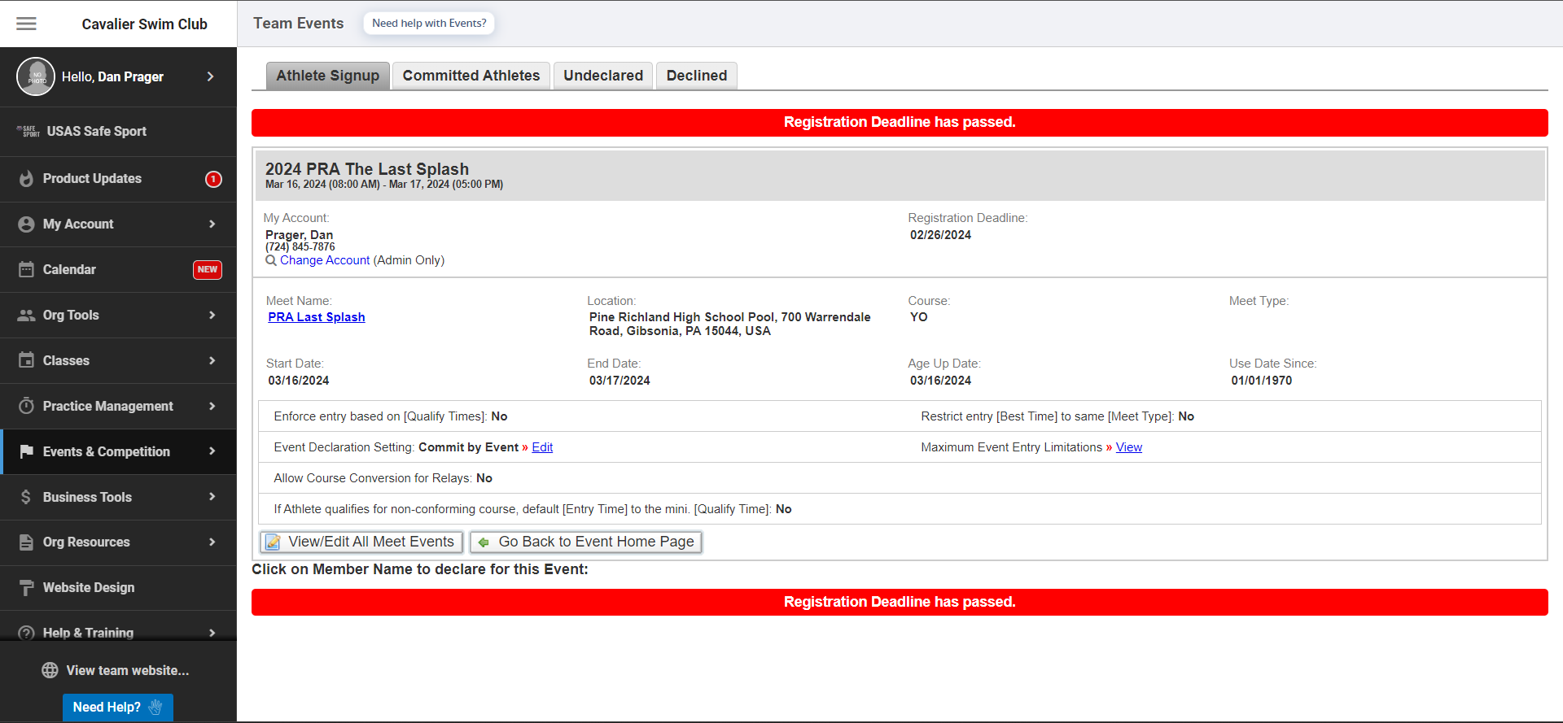

If this were a new meet, the red bars indicating that the registration Deadline has passed
would not be visible. Notice the Registration Deadline in the top center of the figure.
This indicates the date that entries you choose must be turned in. Deadline is 10:00PM.

To sign up for the meet, first click the Undeclared tab. This will
bring up the screen below:
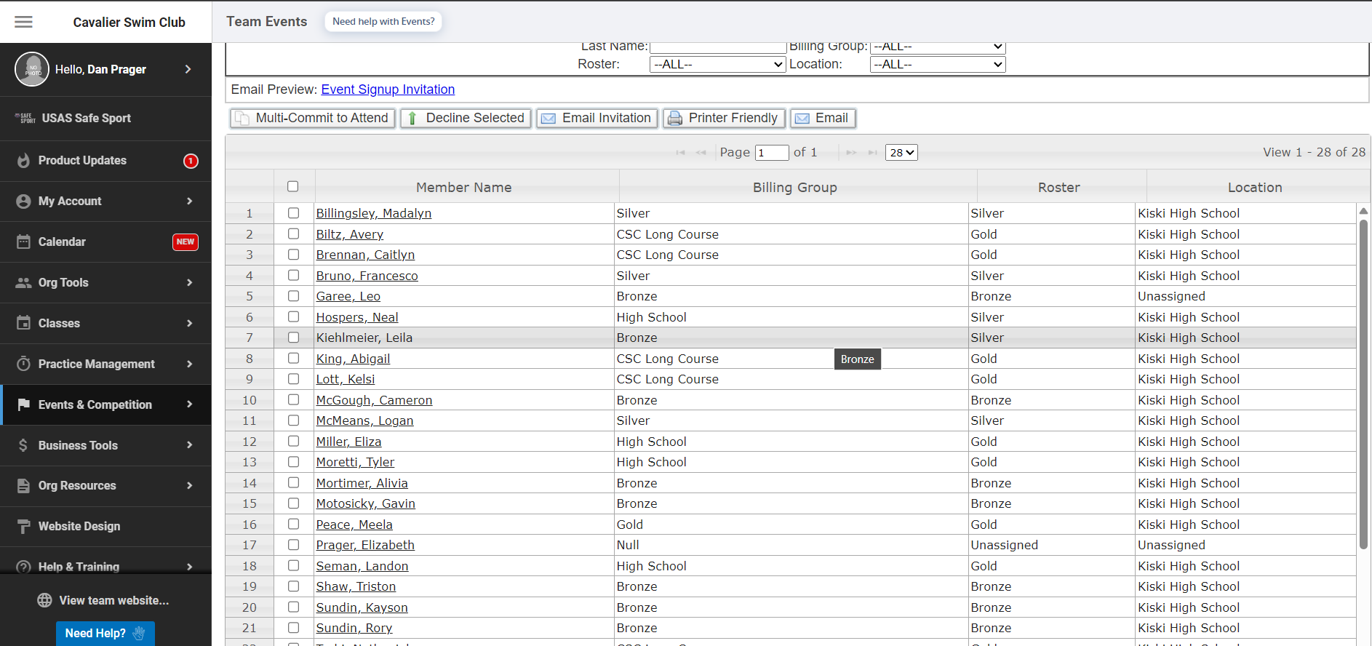

Select your swimmer by clicking on their name.
I will use a swimmer that is currently not on the team for illustration. Here is there
screen:

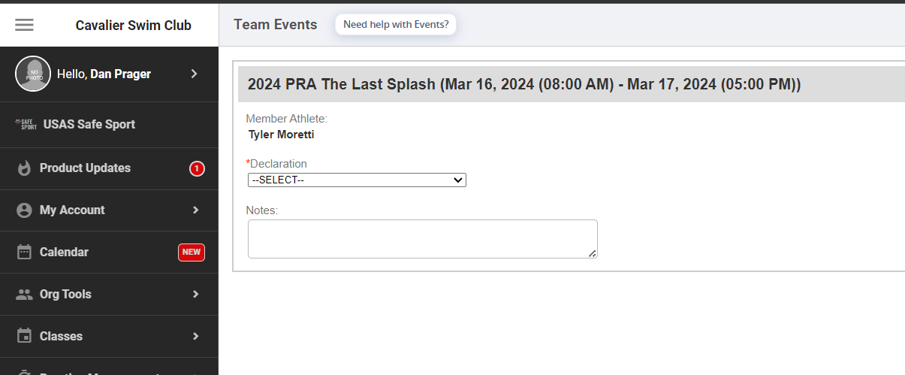

Pull down the SELECT menu and choose the “Yes, Please sign [] up for this event”
The name of the swimmer has been omitted from the bracket. Your swimmer will
appear in this bracket set.

The next screen will show your swimmers meet entry screen with all of the available
events for you to select. It appears immediately when you click on the selection above.
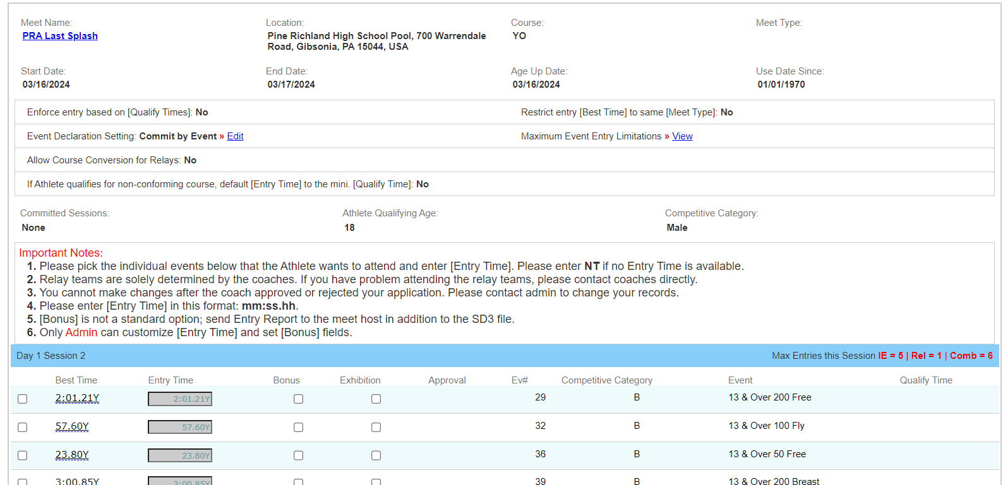

This is only a partial screen since there are many more events listed. You will have to
scroll through the events for the entire meet to make selections.

To sign up for an event, simply click the boxes for swims you would like to enter. Eligibility will be discussed later.

Once you have picked all of the events you want your swimmer to swim, proceed to the
bottom right of the full window, and click the save changes button.

That’s it! Your swimmer is signed up!

Step 3 – Verify your sign-up is complete.

To verify that the sign-up is complete, click on the “Committed Athletes” tab. Then scroll down
and find your swimmers name on the left side of the page. It will appear like this:
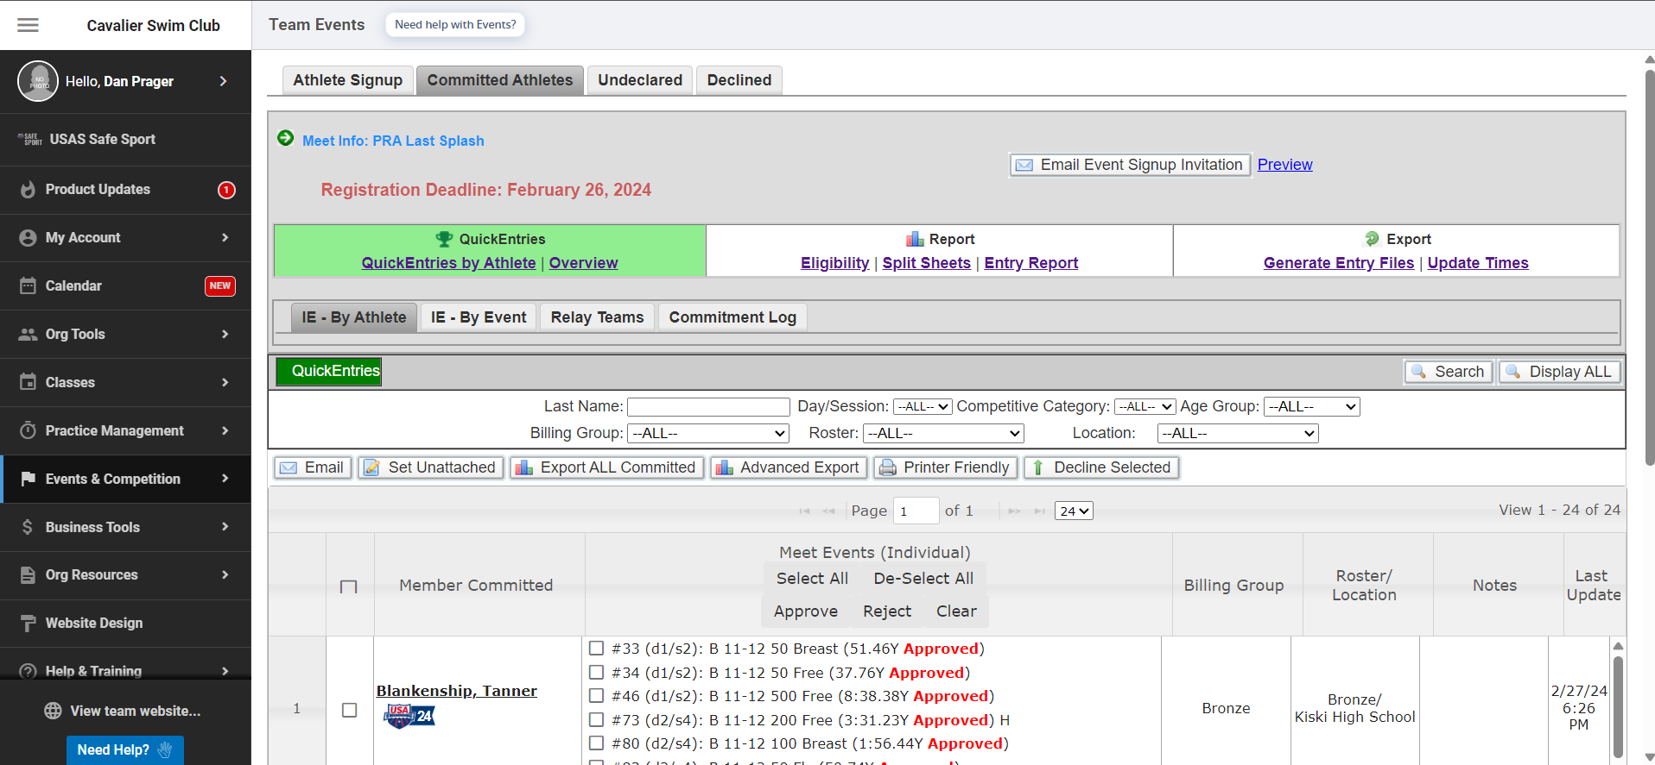
Your swimmer
Your swimmer

Important information regarding entries for meets.

When you enter a meet, if the events listed show up in black, whether there is a time listed for the event or an NT (no time), you are okay to select that event as one of your entries. Below is an example:
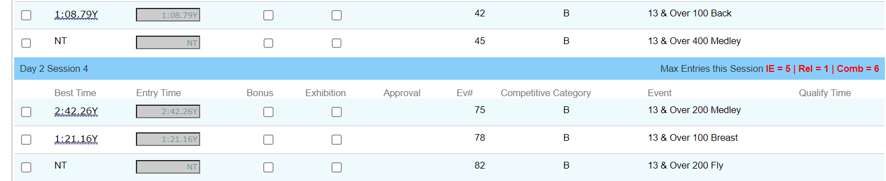
Notice that in the example above, at the far right of the screen, there will be no Qualify Time listed for the events. That means that entries will be accepted even if they are practice time entries. This is usually the case for open meets.

For meets that have Qualify Times, the display will be different. See below:
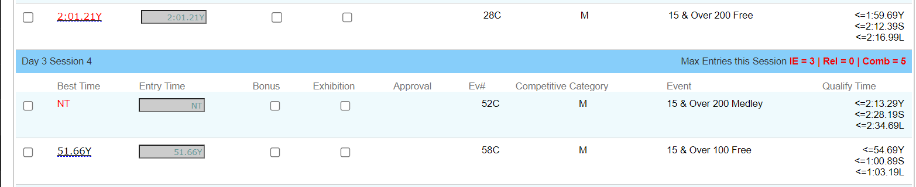
As you can see, there are Qualify Times listed for each event on the right. Looking back to the left, notice that there are two events that are listed with red Best Time descriptions. One is an NT and the other is a time value listed in red. These two events show times that are not within the Qualify Time designation for the event. NT would be obvious since there is no time, but the time for the 200 Free at the top is slower than the yard qualifying time listed on the right (<1:59.69Y).

Also notice that the time for the 100 Free at the bottom is shown in black. Looking on the far right, you can see that the Qualify Time is slower than the Best Time value on the left. So, the swimmer is eligible to enter that swim. checking the box for that event is appropriate.

