TeamUnify
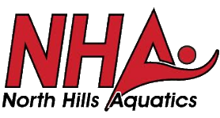 |  | North Hills Aquatics

Week of 09.16.24 NHA News and Notes

NHA Families,
Here’s what you need to know going into this week:
- If you did not attend the mandatory parent meeting, a recording of the meeting is available on our website under the weekly emails tab. Please go and listen so that you do not miss anything for this season.
- I apologize that caps did not get out last week. This week, they will be in your file folder in the bleachers. If you are a family with multiple swimmers, you will have a set of caps for each swimmer within your folder.
- This is the final reminder that the B&R team store closes for apparel and cap orders TODAY! If you wish to place an order, please do so ASAP!
- Please put our Dine to Donate night on your calendar! It will be on September 28th from 4-8pm at the Chipotle at 8870 Covenant Ave.

As always, if you have any questions, please don’t hesitate to ask!
Respectfully,
Your NHA Coaches
Visit Us Online at: https://www.gomotionapp.com/amnha
North Hills Aquatics
306 Cross Creek Court
Pittsburgh, PA 15237
4124987730

