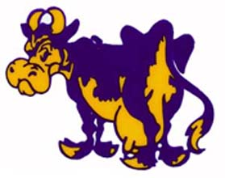
18th Annual



Come out and run, celebrate, and remember those we know who have battled cancer! All proceeds donated to the American Cancer Society in memory of Matt Stauffer.

