Glacier Swim Club



Aqualaps Fundraising Campaign Manual

Revised 1.2023

Table of Contents

Aqualaps Overview ..............................................................…. 3
Volunteer Positions & Timeline Overview …………………………………………..……………….... 4
Job Descriptions
Chairman …………………………………………………………….. 5
Corporate Sponsor Coordinator …………………………………………………………….. 15
Packet Compilation & Distribution …………………………………………………………….. 23
Pledge Collector Coordinators ……………………………………………………….……. 27
Pledge Collectors ……………………………………………………….……. 29
Pledge Entry ……………………………………………………….……. 33
Pledge Reconciliation & Deposit Preparation ………………………………………………... 34
Table Coordinators ……………………………………………………………. 36
Pool Publicist ……………………………………………………………. 39
Weekly Prize Coordinator ……………………………………………………………. 40
Pledge Level Prize Coordinator ………………………………………………………...... 43
Litter Pickup Coordinator ……………………………………………………..……. 47
Sponsorship Banner Coordinator …………………………………………………………… 49

GSC Tax Exempt #049

Aqualaps Overview

Aqualaps is a long standing Glacier Swim Club tradition. This annual fundraising event helps raise the necessary funds to support the club’s activities throughout the year. Donations received are used to rent pool time, pay coaching staff, purchase equipment, and assist with team travel.

The Aqualaps fundraising period runs from early January through mid-May of each year. The highly coordinated Corporate Sponsorship portion of the campaign begins its efforts in mid-January while the swimmer’s fundraising portion generally begins in early March (Aqualaps Kick-off Pool Party) and runs through mid-May.

Each swimmer (excluding the Pre-Comp and Masters’ programs) strives to raise a pre-defined amount (in recent years $350) to offset their annual membership fee. They do so by seeking not only corporate sponsorships from local businesses, but also pledges from family, friends and neighbors. Those swimmers who collect over $500 in donations are eligible for tiered-level incentive prizes at the conclusion of the campaign.

The Aqualaps fundraising campaign period comes to a close in early May when swimmers come together for a Lap Day celebration.

Volunteer Positions and Timeline Overview

The following matrix provides an overview of the various volunteer positions needed for a successful Aqualaps campaign, the volunteer hours earned with the respective positions, as well as the time frame commitment associated with those positions.

Volunteer Position / Volunteers Needed | Volunteer Hours Earned | Estimated Time Frame
Aqualaps Chairmen Team (3)  Volunteer Coordinator  Administrative Coordinator  Communications Coordinator | 20  20  20 | Year Round  Year Round  January – May
Corporate Sponsor Coordinator (1) | 20 | Late December – Mid May
Packet Compilation & Distribution (1) | 8 | Mid February – Early March
Pledge Collector Coordinators (1 Downtown/1 Valley) | 20 | Mid February – Mid May
Pledge Collectors (6 Downtown/6 Valley) | Actual Hours Worked | Mid March – Mid May
Pledge Entry (1 Downtown/1 Valley) | 20 | Mid March – Mid May
Pledge Reconciliation & Deposit Preparation (1) | 20 | January – June
Table Coordinators (4) | 16 | Mid January – Mid May
Pool Publicist (1) | 10 | Mid February – Mid May
Weekly Prize Coordinator (1) | 20 | Early February – Mid May
Pledge Level Prize Coordinator (1) | 20 | Early February - Late August
Litter Pickup Coordinator (1) | 8 | Mid April – Early May
Sponsorship Banner Coordinator (1) | 20 | August - September

Aqualaps Chairmen Team

General Responsibilities
Volunteer Coordinator  - Recruit volunteers for all positions  - Provide and review job descriptions with volunteers  - Oversee and communicate with all volunteers regularly to ensure tasks are being completed  - Assist with Kick-off Event & Swim Day Event Planning  - Monitor Pledge Level Prize Coordinator’s ordering and distribution progress | August – February  February  February – May  March & May  May - August
Administrative Coordinator  - Write/Revise volunteer job descriptions and update/maintain online Aqualaps manual, as necessary  - Field misc. administrative questions  - Order Pledge Slips, as necessary  - Finalize all packet print materials, prepare initial pledge collection boxes  - Create Aqualaps webpage and arrange for table sign ups on the web  - Set up the fundraiser on Teamunify  - Assist with Kick-off Event & Swim Day Event Planning  - Provide listing of $ earned per swimmer to Pledge Level Prize Coordinator for prize ordering validation  - Assist Sponsorship Banner Coordinator with preparing new banners for pools  - Provide listing of Corporate Sponsors, including addresses, to GSC Admin to prepare and send Thank You Cards  - Provide finalized Corporate Sponsor Recap listing to Corporate Sponsor Coordinator  - Post and Advertise Aqualaps Volunteer Opportunities via Teamunify for the upcoming season | Year-round  Year-round  Late January  Late January – Early February  Late February – Early March  Late February – Early March  March & May  June  August – September  August  December  August
Communications Coordinator  - Work as a communication liaison between club and Corporate Sponsor Coordinator  - Email weekly progress updates to GSC families  - Email reminders to coaches regarding prize drawings/prize winners  - Submit fundraising kick off & conclusion/thank you articles for Juneau Empire and other appropriate local media sources (KINY/KTOO)  - Assist with Kick-off Event & Swim Day Event Planning | January – May  March – May  March – May  March & May  March & May

Volunteer Hours
As a member of the Aqualaps Chairmen Team you will earn 20 volunteer hours!

Detailed Responsibilities
The Aqualaps Chairmen Team is comprised of 3 members: Volunteer Coordinator, Administrative Coordinator, and the Communications Coordinator. Collectively, this group ensures that ALL the various duties and responsibilities associated with a successful annual Aqualaps fundraising campaign are achieved. In order to accomplish this, the vast amount of responsibilities is divided as follows below:

Volunteer Coordinator

- All Aqualap Volunteer positions are posted on the Website and generally become available for sign-up at the start of the swim season in late August. Once the Aqualaps Administrative Coordinator posts those positions, reach out to any prior year volunteers and recruit them to fill those same positions for the upcoming season (assuming their job performance was acceptable).
- During the fall season, determine which Aqualap volunteer positions are still vacant and begin recruiting volunteers for all positions not already filled. A good time to do this is during the Time Trials, Season Banquet or practices;
- February-May, communicate with all volunteers prior to the start of their position and provide them with their detailed job descriptions and answer any questions they may have regarding their role;
- Confirm that the Packet Compilation & Distribution volunteer will be available for packet distribution at the Aqualaps Kick Off event in March.
- Throughout the Aqualaps Campaign, monitor and check in with all volunteers to ensure tasks are being completed in a timely manner;
- Continue to coordinate with the Prize-Level Coordinator throughout the spring and summer to ensure prizes are ordered within a month of the conclusion of Aqualaps to ensure they will be available for distribution at the beginning of the following season (August/September);
- Assist with the Kick-off Pizza Pool Party and Swim Day events.

Administrative Coordinator

- Though the majority of the tasks associated with this position fall within the January-May time period, there are several housekeeping items that must be addressed during other times of the year, therefore this position is responsible for fielding miscellaneous administrative questions surrounding the fundraising campaign at any time;
- In December, compile the list of businesses that donated over $100 during the corporate sponsorship drive the previous year and provide listing to the Corporate Sponsor Coordinator. See specific instructions on how to pull the list is outlined below;
- In January, contact GSC Head Coach or Board President to determine the goal for the year’s fundraising campaign as well as whether the $350 minimum requirement should be maintained or raised;
- In late January determine the pledge form supply and order via Printing Trading Company, as necessary. Notify the Packet Compilation & Distribution Coordinator when the printed forms are ready for pickup;
- In late January/early February work with the Pool Publicist to revise any Aqualaps Kick-off print packet materials (fundraising brochure, pledge sheets, prize order forms, etc.) Provide the Pool Publicist with an excel listing of all active swimmers, their current squad and assigned lap goal so that they can print off labels for packets. Lap goals are based on squad, as follows:
  - Coho 75
  - Sockeye 125
  - Sealion 150
  - Chinook 175
  - Shark 200
  - Orca 250
- Work with the Litter Pickup Coordinator to determine a viable date for Litter Pickup and post event to the GSC website.
- Once packet documents have been finalized provide them to the Packet Compilation & Distribution Coordinator so that they may begin the compilation process;
- In late February/early March, create an Aqualaps webpage, set up the fundraiser on Team Unify and arrange web sign-ups for the various fundraising tables/shifts;
- In spring, work with Head Coach and GSC Administrator to determine a time/location for a team photo. Team photo will be used for the corporate Thank You cards at the end of the Aqualaps Fundraising period.
- In May, printout the swimmer check-in list for Lap Day;
- In late May, close out the TeamUnify event on the website;
- In June, determine final Aqualaps Donation total;
- Assist with the Kick-off Pizza Pool Party and Swim Day events.
- In August, compile a listing of all corporate sponsors, the amount contributed, the business address and send along to the GSC Administrator and Sponsorship Banner Coordinator. The GSC Administrator will use this listing to send Thank You cards to all corporate sponsors donating $100+ as well as any large personal donors. The Sponsorship Banner Coordinator will use this information to design the new seasons corporate sponsorship banners for both pools

Setting up the Website
- Make sure you have Super User rights in Teamunify
- Go to Event Fundraising Admin in the TU Money menu
- Click on the prior year event
- Change the Event Title to reflect the current year
- Scroll to the bottom of the screen and click on Save to a New Fundraising Event (Clone)
- Open the current year event
- While you are editing, make sure Campaign is Off – in the upper right corner
- Make the necessary changes to dates, time, location
- Review and edit all information as necessary
- Delete event documents from prior year. Upload current year documents by clicking on Add New and selecting the files
- Click on Save Changes

Activating the Website
- Go to Website Design in the Team Admin menu
- Click on “AQUALAPS XXXX”
- Change the name to reflect the current year
- Click on Hide This Tab? Change to No
- Click on Access Control. Choose Everyone
- Go to Event Fundraising Admin in the TU Money menu
- Click on the current year event
- Change the Campaign to On - in the upper right corner
- Make sure you can see the Aqualaps tab on the top of the screen, the lane line and the side bar promotion on the home page

Deactivating the Website
- Do the above in reverse!

Corporate Sponsor Listing
- Click on TU Money
- Click on Fundraising Admin
- Make sure current year’s campaign is highlighted in red
- Click on the Results tab
- Select all donations by clicking on the square in the upper left corner above the first record
- Click on Export. Choose open with Excel
- Sort listing by donor last name
- Delete all columns except for donor name, address, phone, and swimmer name
- Combine the lines for the donors who have multiple lines, adding the amounts for all lines and including the swimmer names for each line
- Delete donations from direct family members
- Make sure any requests from businesses about how they are listed have been reflected Re-sort list by amount
- Delete all donations less than $100.
- Send report to meet director for meet programs
- Delete all individual (non-business donations) and save as a new report. Send to corporate sponsor coordinator.
- Go back to the report that includes everything $100 or more. Delete all donations less than $500. Send to person responsible for updating the banners at both pools.

Labels for Packets
- Click on Team Admin in TU
- Select Account/Member Admin
- Click on the Members tab
- Click on Customize Filters button
- Select Roster Group
- Select all active squads, not including Masters. Click on Done.
- Select all by clicking in the box in the upper left of the member listing
- Click on Export – Custom Excel
- Select member first and last name and roster group. Un-select all other fields. Export to Excel.
- Add a column for laps goal and fill in based on info from Scott
- Save for future use
- Do a Labels Merge in Word and print

Swimmer List for Check-In
- Use report created for labels
- Sort based on swim schedule (by squad if squads have assigned times, alphabetically if no assigned swim times, etc.)
- Print

Communications Coordinator

- In early March, prepare and send a letter to the Juneau Empire and any other local media sources for the Community Section announcing the Kick-off of the club’s annual Aqualaps Fundraising Campaign;
- From January to May write and send weekly status updates out to all GSC participants. During this time, coordinate timing of all emails with Corporate Sponsor Coordinator as to not overwhelm families with emails and to ensure any of the Corporate Sponsor Coordinator’s messages are included in email blast;
- Administrative Coordinator has samples of emails blasts and letters to the Juneau Empire for reference as needed;
- Weekly updates should include information such as progress to goal; kick-off party and lap day event info; weekly prize winners and a shout out to all our weekly prize sponsors; etc.;
- March to May, work with the coaches via email to help ensure they build excitement among swimmers during practice to increase fundraising participation. Fridays should be designated the day coaches are expected to ‘talk-up’ the importance of the fundraiser with the swimmers.
- Ask that coaches provide the list of weekly prize winners so that we can recognize them in the email blast;
- Weekly, update or email coaching staff to update the GSC Goal Tracker sheet located on GSC Board at both pools;
- In mid-May, prepare and send a letter to the Juneau Empire and any other local media sources for the Community Section announcing the conclusion of the club’s annual fundraising event and thanking the community for their support;
- In May, consult with the Aqualaps Administrative Coordinator and submit the required Fred Meyer Accounting Form, recapping the amount raised within the Fred Meyer Juneau location;
- Assist with the Kick-off Pizza Pool Party and Swim Day events.

Aqualaps Kick-off Pizza Pool Party

The Kick-off event is normally held in early March just prior to the start of the swimmer’s fundraising efforts. Together the Aqualaps Coordinators, working with coaching staff, will plan, organize and communicate this family friendly event.

Pre-Planning
- Coordinate the Kick-off Pool Party date with the head coach – this is normally determined in the fall;
- Ensure that the head coach secures rental of one of the pools/events rooms for the event;
- Post the ‘Event’ online with an RSVP option to help plan for turn-out volume, send email blasts announcing the event;
- Ask coaching staff to organize some fun family swim events;
- Consult with head coach or use historical data to determine how many pizzas should be ordered;
- Consult with head coach regarding existing supply of plates, napkins, forks/spoons and make purchases as necessary;
- Purchase juice boxes & chips at Costco;
- Purchase blue/gold table plastic table clothes and balloons;
- Order pizza from Dominos;
- Order sheet cake with Aqualaps Logo from Safeway. Don’t forget to bring a cake slicer!

Set-Up & Event
- Pick-up and deliver pizza and sheet cake;
- Organize the room set-up;
- While people are eating be prepared to speak about what is Aqualaps, why it is so important to the club, the process and ensure all swimmers picked up their packets;
- The Packet Compilation/Distribution Volunteer should be available and ready to pass out swimmers’ fundraising packets at the start of the Kick-Off party;
- Coaches will then take over for the family friendly events;
- Clean-up at the conclusion of the event;
- Provide the head coach with all remaining packets so that they can be distributed to swimmers during practice the following week.

Post-Event Follow-Up
- Follow-up with head coach to ensure all packets have been distributed and to determine if an email blast to swimmers needs to be sent out.

Aqualaps Swim Day

Swim Day concludes the Aqualaps Fundraising Campaign and all swimmers are expected to swim their defined number of laps. For those swimmers who can’t make the event, they will be responsible for making arrangements with their coach to swim their laps at another time.

Pre-Planning
- Coordinate the Aqualaps Swim date with the head coach – this is normally determined in the fall;
- Ensure that the head coach secures rental of one of the pools for the event;
- Ensure the ‘Event’ is posted online with time slots for staggered starts;
- Send email blasts announcing the event;
- Coordinate with head coach so that coaches are responsible for suppling healthy snacks for the event.
- Print supply of tally sheets, as necessary;
- Request supply of pencils and clip boards from head coach;
- Purchase Blue/Gold Balloon Boutique to display at check-in area on lap day;
- Coordinate with coaching staff to secure the underwater music system will be set up for the event.

Set-up & Event
- Set-up should include an area for swimmers to check-in, a pledge collection area, a prize level sign up area, and a weekly prize sponsor ‘thank you card’ signing area;
- Display signs for the various areas;
- A list of all swimmers for check-in will be provided by the Administrative Coordinator;
- Arrange for pledge collectors to work on Lap Day. Assist with pledge collection, as necessary;
- Randomly pass out any remaining ‘weekly prizes’ that were not distributed during the campaign period;
- Provide the signed ‘thank you cards’ to the Weekly Prize Coordinator to deliver to all the weekly prize sponsors.

Samples & Attachments
- Sample Kickoff Letter to Juneau Empire
- Sample Conclusion Letter to Juneau Empire
- Sample Swimmer Sign In Area
- Sample Pledge Collection & Pledge Level Prize Signup Area
- Sample Aqualaps Swim Day Tally Sheet
- Sample Aqualaps Swimmer Check In

GLACIER SWIM CLUB BEGINS ANNUAL FUNDRAISER

On March 7th Glacier Swim Club (GSC) kicked off its annual fundraising event, Aqualaps, a long standing club tradition. Over the next several weeks, GSC swimmers will be seeking pledge donations from family, friends, neighbors and community members. Swimmers will be collecting pledges at the Fred Meyer, Safeway, and Wharf Building locations. Please consider supporting the club by making a tax-deductible donation.

Glacier Swim Club is a non-profit organization which was founded by parents of swimmers in 1973. The club offers year-round swimming programs for boys and girls ages 5-18, as well as, a Masters program. Swimmers learn correct swimming techniques, gain physical endurance and develop team spirit and sportsmanship. The sport of swimming fosters the development of many valuable life skills including work ethic, determination, goal setting, time management, and self-improvement.

On May 2nd GSC swimmers will all come together in a Lap Day swimming event where each swimmer will swim anywhere from 100-300 laps, depending on age and ability, to meet their pledge responsibilities.

For every pledge dollar collected GSC donates five minutes of clean up time to Juneau! So when friends, family, neighbors and community members make an Aqualaps pledge they are not only supporting GSC and encouraging kids to do their personal best, but they are also making a donation to the beautification of our community.

For more information about this fundraiser or sponsorship opportunities, please visit the Glacier Swim Club website at www.gsc-swim.org.

GLACIER SWIM CLUB CONCLUDES 2016 ANNUAL AQUALAPS FUNDRAISER

Glacier Swim Club (GSC) would like to send a heartfelt thank you to the Juneau community for their incredible generosity and support during the club’s 2016 Aqualaps Fundraising Campaign. We are
extremely appreciative and thankful to all the businesses who have signed on as GSC sponsors as well as those that contributed weekly prizes during our campaign. Thank you to Fred Meyer, IGA, the Wharf and Safeway for allowing our swimmers to set up pledge collection tables at those locations.
And thank you to everyone who took time to engage with our swimmers and show their support through their pledge donations.

As a way to say thank you to Juneau, GSC coaches, swimmers and parents participated in a Litter Clean Up event on May 13th. Swimmers picked up litter in designated areas around the Augustus Brown and Dimond Park swimming pools as well as the two high schools.

Glacier Swim Club is a non-profit organization which was founded by parents of swimmers in 1973. The club offers year-round swimming programs for boys and girls ages 5-18, as well as, a Masters program. Swimmers learn correct swimming techniques, gain physical endurance and develop team spirit and sportsmanship.

Thank you so much, Juneau, for your support of Glacier Swim Club.







20XX Aqualaps Swimmer Check-In
Last Name | First Name | Squad | Check-In

Corporate Sponsor Coordinator

General Responsibilities
- Revise request for corporate sponsorship letter  - Prepare and maintain tracking spreadsheet  - Establish corporate sponsorship phase timeline  - Club member communication | Late Dec – Early Jan  Late Dec – May  Early Jan  Early Jan – Early May

Volunteer Hours
As the Corporate Sponsors volunteer you will earn 20 volunteer hours!

Estimated Time Commitment
- 5 hours prior to the start of the drive to prepare letters, set up spread sheet, and plan the time frames of the drive;
- 2-5 hours per week during the corporate sponsor drive to coordinate with families, answer questions, update the spreadsheet, market the drive to the membership and coordinate with the Aqualaps team;
- 2-5 hours after the drive to clean up records and debrief with the Aqualaps team.

Desired Skills
The Corporate Sponsor Volunteer should possess the following skills: ability to be organized and track information over a period of time, knowledge of excel or other spreadsheet program, ability to write clearly, ability to communicate effectively when resolving conflict, willingness to be available on an almost daily basis during the drive to respond to questions and update information.

General Responsibilities
The primary responsibility of the person in this position is to manage the corporate sponsor program for the swim club. Duties include:
- Assure the corporate sponsor letters are revised on a yearly basis and signed by the current swim club president.
- Establish timelines for the corporate sponsor drive.
- Communicate with the club membership about the purpose and timing of the drive. Provide updates on a regular basis that keep the membership informed and motivated to find sponsors.
- Work with swimmers and their families to coordinate which businesses will be approached.
- Maintain accurate records that track which businesses are being claimed by which swimmer to assure that the appropriate swimmer is credited with each donation.
- Provide ongoing and updated listing of businesses claimed to the Pledge Recon & Deposit Prep Coordinator so that as funds come in the correct swimmer is credited.
- Resolve any disputes that arise during the drive regarding who can approach a business or how the donations are distributed.
- Recommend any policy or procedure changes that you think will make the process run more smoothly or fairly to those participating.

Detailed Responsibilities

Late December/Early January
Obtain an updated list from the previous year’s corporate sponsor drive from the Aqualaps Administrative Coordinator. Donations continue to come in even after the Aqualaps period has closed so don’t assume the one you used the previous year is complete. You should receive an excel spreadsheet that has all donors who contributed $100 or more.

The spreadsheet will include the sponsor’s name, the swimmer who received the credit and the dollar amount of the sponsorship. Add a column to track who claims that sponsor for the upcoming drive. Typically the spreadsheet cross-references each business with an associated swim family. If in doubt, ask the person handling the recording of the financial contributions from the last year.

Review the corporate sponsor letters. They will need to have at least the dates updated and possibly the content. Send the revised version to the Swim Club President for review. Once the two of you have a letter that works, get a PDF copy with signatures. I have two versions, one for continuing sponsors and one for new sponsors. The letters also spell out the different level of sponsorships available and the advantages to the businesses for their donations.

Decide on the kickoff date for the sponsorship drive. I think of this in 3 phases and try to work the timing backwards from the date of the Aqualaps swim.

The first phase is to allow anyone who has a family/employment relationship with a company to declare their intent to approach a business. There will be a number of “established” relationships already, but new ones arise every year. Also, sometimes a long-standing sponsor moves from a swimmer with non-family/employment relationship to a family new to swimming who can make that claim. Allow at least three weeks. When that happens I try to give the family a heads up. You won’t necessarily hear from swimmers whose immediate family owns the business. If I know that relationship I just assume that any contribution will be credited toward their swimmer.

The second phase is to allow swimmers with previous sponsorship relationships to declare their intention to claim that business again. Allow at least three weeks for this phase as well. Not everyone will know the amount donated by the business the previous year. When the swimmer reaches out to claim their business again, I let them know the amount the business contributed the previous year. I also approach the senior swimmers’ families. Seniors do not have to fundraise but may choose to do so. They often have businesses that have been contributing high dollars. You’ll want to make sure those businesses are claimed by someone else if the senior is not going to approach them. Finally, if I have not heard from a family who has previously claimed a business who donates I check to see if the swimmer is still with the club. If they are, I reach out to the family and ask what their intent is. Although this is a little extra work, I find that it reduces friction later in the drive.

Third Phase: General solicitations. I try to time the opening of this phase with the opening of the general fundraising period for Aqualaps.

Once you announce the sponsorship drive, you will begin to get lists of businesses that people want to approach. I always wait until the first phase is done until I say yes or no to the businesses. After the first phase, if the business hasn’t been previously claimed, you can release it to the requesting swimmer at any point.

During the Drive
Kick off the drive with a club email announcing the phases and dates. You’ll want to get administrative rights to do so. It makes it easier if you are not relying on someone else to send out communication. I found what worked best for me was to set up a separate email account and funnel all requests to that location. There is a tremendous amount of back and forth and it is easy to loose details if you can’t easily track the emails that come in and cross-reference requests.

When you announce the beginning of Phase Three, include a list of reserved businesses so people know which ones have been claimed. You can also update this list from time to time and post a copy at each of the pools.

As people request businesses and you clear them to approach the business, send them a copy of the letter that they can use for that purpose. If it is a new family, they will likely have questions for you about how the process works.

Be careful when checking businesses, sometimes people claim a medical practice as an example, and the doctor may be listed by name. Or, someone may not have the business name correct, and the real name may already be claimed. There is no easy way to do this; you just have to pay attention.

At the beginning of each phase I send an email announcing we are starting the new phase, and then about a week prior to the end of that phase I remind people that I need to hear from them if they want to assert a claim to a business.

At some point in the drive, the swimmers will be able to see the names and donation amounts of their corporate sponsors on their GSC account. Remind them to check and send a thank you note.

As people claim businesses, update your spreadsheet with the swimmer’s name and contact information. I also try to keep track of whether or not it is a family relationship because that helps for the next year.

You’ll also have people who want to be given the names of unclaimed businesses who have previously donated. I keep a running list of names. At the end of phase two when we know whether or not businesses have been claimed, I make a list of the businesses and try to match people who want to approach them. How I do that has varied year to year depending on the number of people who want to be on that list and the number of businesses that are unclaimed. If there are more people than businesses, I’ve done a random selection of names by pulling people’s names out of a hat.

Once the Aqualaps drive starts, I try to send an update every other week to the individuals who are doing the email blasts. I think it helps to coordinate and not have too many emails going around. If you have an accounting of how much has been contributed via corporate sponsorship, it is nice to provide those numbers.

During the drive you will be asked if a business has donated or not. You can ask by coordinating with whoever is logging the submissions. Also, you can point the family to the website. This is the area that runs the least smoothly because there are many people involved and businesses often don’t donate on the spot. Families will want to follow up with businesses if they haven’t donated but don’t want to hassle them if they have already provided money.

Businesses can provide a check on the spot or send a check at a later time. If they give the donation directly to the swimmer, the easiest thing for the simmer to do is turn it in with their regular Aqualap pledges. It will get credited as a corporate sponsorship. Up to $1000 of corporate sponsorship is credited to the swimmer for Aqualap.

Occasionally there are issues with families about who gets to claim a business. I start by reminding them that the goal is to support the swim club so any money coming in achieves that. When that occurs, it is your job to resolve the issue. At times the business may want to make the decision – even if a business has been previously claimed by someone, if that business has a relationship with a swimmer and they want to support someone in particular, the business owner gets to make that decision. Sometimes a business will choose to split their contributions between more than one swimmer. If the business does not have a preference you should rely on the rules in place: a previously claimed business goes to the swimmer who received donations last year unless the new swimmer has a direct family relationship.

Sometimes families will claim a huge number of businesses out of the gate. I try to limit that so that the family is not overwhelmed by the number of businesses and so others have an opportunity to participate. It can be discouraging to swimmers who hear that every business they think of has already been claimed.

You might want to remind people in your emails that approaching a business where you already have a relationship of some sort is most likely to bear fruit: a doctor or dentist, a place where you already have a customer relationship, a firm with whom you do business. Those are great places to start. We also have a number of firms that support the club year after year and the sponsorship passes between swimmers.

Post Corporate Drive
Usually there is a little clean up, but mostly this amounts to making sure the person logging the money in has access to your final spreadsheet. There is value to debriefing with the Aqualaps team either in person or via email to see what worked well during the drive and what changes might be needed the next season.

Samples & Attachments
- Sample New Corporate Sponsor
- Sample Continuing Corporate Sponsor



P.O. Box 35382 E-mail: glacierswimclub@gci.net Juneau, AK 99803 Website: www.gsc-swim.org
907-523-0840
Providing a sports program for the youth of Juneau for over 30 years

Dear Friend,

We are writing to ask you to consider supporting the Glacier Swim Club. Over the past forty years our club has grown from a fledgling effort into a top-notch competitive swim program, thanks to the financial support of businesses like yours. Currently we serve over 170 youth in our community with our high quality, year round programming.

Corporate sponsorship provides a significant portion of the financial foundation that helps make this valuable program available to the youth of our community here in Juneau. Financial support for the Glacier Swim Club (GSC) relies on the financial support of the City & Borough of Juneau and the generosity of businesses like you. We simply cannot generate enough revenue in membership and dues to cover our operating expenses. In order to keep the program accessible to the majority of families in Juneau, we need to fundraise. This is where Aqualaps, Glacier Swim Club’s one and only fundraiser, comes to the rescue.

Corporate contributions made by businesses here in Juneau have helped to close this gap and provide opportunities to youth from all income levels in our community. Our dedicated volunteers work hard through out the year to help ensure that our program is the best it can be. From the smoothly run times trials and swim meets, our fun team-bonding events, to everything in between. When their hard work is combined with your financial support and our exceptional coaching staff, the result is a high quality local swim program that is available for the youth in our community.

We are proud of our longevity and particularly proud of the youth who swim with GSC. Swimming is well known as being considered a lifelong sport. Aside from learning how to swim, did you know that competitive swimming teaches kids several important life lessons that can serve them their entire lives? Kids in our program learn the importance of:

- Being on time (the race waits for no one);
- Being accountable and understanding the importance of hard work;
- Good sportsmanship and working as a team; and
- Handling disappointment (another swim meet is just around the corner).
They learn over and over again that each time they get on the blocks they have the chance to redefine their personal best. These lessons help build qualities that will make these kids successful long after they’ve left the GSC family.

The GSC offers four levels of Corporate Sponsorship: Diamond Level ($1,000+), Platinum Level ($500 - $999), Gold ($250 - $499), and Silver ($100 - $249). Of course, donations of any amount are greatly appreciated and because GSC is a non-profit organization, your donation is 100% tax-deductible!

As our way of saying “Thank you!” all four sponsorship levels are recognized in our swim meet programs. If you are interested in making a charitable contribution at either the Diamond or Platinum Level, your business name will also be added to the prominently displayed GSC sponsor boards located at the downtown Augustus
G. Brown swimming pool and the Dimond Park Aquatic Center in the valley.

Please contact us if you have questions or would like to hear from a swimmer about their experiences with Glacier Swim Club. To take advantage of this great opportunity to support youth swimming in Juneau, checks can be made out to Glacier Swim Club and mailed to P.O. Box 35382, Juneau AK 99803.

Thank you for your consideration. Through your sponsorship, you will have the satisfaction of knowing that you, too, are a member of our team and are touching the lives of youth in our community.

Sincerely yours,

P.O. Box 35382 E-mail: glacierswimclub@gci.net Juneau, AK 99803 Website: www.gsc-swim.org
907-523-0840
Providing a sports program for the youth of Juneau for over 30 years

Dear Friend,

We are writing to ask you for your continued support of the Glacier Swim Club. Over the past forty years our club has grown from a fledgling effort into a top-notch competitive swim program, thanks to the financial support of businesses like yours. Currently we serve over 170 youth in our community with our high quality, year round programming.

Corporate sponsorship provides a significant portion of the financial foundation that helps make this valuable program available to the youth of our community here in Juneau. Financial support for the Glacier Swim Club (GSC) relies on the financial support of the City & Borough of Juneau and the generosity of businesses like you. We simply cannot generate enough revenue in membership and dues to cover our operating expenses. In order to keep the program accessible to the majority of families in Juneau, we need to fundraise. This is where Aqualaps, Glacier Swim Club’s one and only fundraiser, comes to the rescue.

Your past contributions to GSC have helped to close this gap and provide opportunities to youth from all income levels in our community. Our dedicated volunteers work hard through out the year to help ensure that our program is the best it can be. From the smoothly run times trials and swim meets, our fun team-bonding events, to everything in between. When their hard work is combined with your financial support and our exceptional coaching staff, the result is a high quality local swim program that is available for the youth in our community.

We are proud of our longevity and particularly proud of the youth who swim with GSC. Swimming is well known as being considered a lifelong sport. Aside from learning how to swim, did you know that competitive swimming teaches kids several important life lessons that can serve them their entire lives? Kids in our program learn the importance of:

- Being on time (the race waits for no one);
- Being accountable and understanding the importance of hard work;
- Good sportsmanship and working as a team; and
- Handling disappointment (another swim meet is just around the corner).
They learn over and over again that each time they get on the blocks they have the chance to redefine their personal best. These lessons help build qualities that will make these kids successful long after they’ve left the GSC family.

The GSC offers four levels of Corporate Sponsorship: Diamond Level ($1,000+), Platinum Level ($500 - $999), Gold ($250 - $499), and Silver ($100 - $249). Of course, donations of any amount are greatly appreciated and because GSC is a non-profit organization, your donation is 100% tax-deductible!

As our way of saying “Thank you!” all four sponsorship levels are recognized in our swim meet programs. If, however, you are interested in increasing your charitable contribution to the Diamond or Platinum Level, we would like to add your business name to the prominently displayed GSC sponsor boards located at the downtown Augustus G. Brown swimming pool and the Dimond Park Aquatic Center in the valley.

Please contact us if you have questions or would like to hear from a swimmer about their experiences with Glacier Swim Club. To take advantage of this great opportunity to support youth swimming in Juneau, checks can be made out to Glacier Swim Club and mailed to P.O. Box 35382, Juneau AK 99803. We want you to be aware that our mailing address has changed from last year.

Thank you for your consideration. By continuing your sponsorship, you will have the satisfaction of knowing that you, too, are a member of our team and are touching the lives of youth in our community.

Sincerely yours,

Packet Compilation & Distribution

General Responsibilities
- Pick up pledge slips and packet labels  - Make copies of packet materials  - Compile swimmers’ Aqualaps Kick-Off packets  - Hand out packets at the Kick-Off event | Mid Feb - Mid March

Volunteer Hours
As the Packet Compilation/Distribution volunteer you will earn 8 volunteer hours!

Detailed Responsibilities
- In late January/early February the Aqualaps Coordinators will work directly with the Aqualaps Pool Publicist to make any necessary changes to Kick-Off packet materials. Materials may include but are not limited to information on the fundraising event/important dates, tips for swimmers when seeking pledges, pledge level prize information, pledge summary sheets, etc. Once those documents have been finalized you will be provide with them so that you may begin your compilation process.
- During the same timeframe, Aqualaps Coordinators will determine, based on existing supplies, if it is necessary to order additional Pledge Slips. If so, Pledge Slips will be ordered through Printing Trading Co. Coordinators will notify you once the Pledge Slips are available for you to pick up.
- Aqualaps Coordinators will provide you with print labels identifying each swimmer's name, squad and lap goal that will be affixed to the packets during the distribution process at Kick-Off.
- Once you have received all the necessary documentation you will need to make enough copies of the packet materials, if that hasn’t been done by the Coordinators, to ensure that all swimmers will receive a packet. Any receipts for copy costs should be submitted to GSC for reimbursement.
- Please prepare 15 additional packets for those swimmers that have recently moved up from PreComp and may not have a Printed Label. At Kick-Off you will provide those swimmers with a packet and blank label and indicate their Lap Goal based on their squad.
- Purchase enough Gallon-Size Ziploc Bags to compile packets as all materials will be sealed within a Ziploc. Again, purchase receipts should be submitted to GSC for reimbursement.
- The Aqualaps Kick-Off event is generally scheduled for some time within early March. Packets must be available to swimmers for pick up at that time.
- Your attendance at Kick-Off is expected in order to facilitate the distribution process.
- Please put 5 Pledge Slips in each Ziploc bag. Swimmers are only to use Pledge Slips for those donors who would like a receipt for their donation. Swimmers will be able to pick up additional Pledge Slips from the Pledge Collectors who will be located at both pools during fundraising.
- Please cut/slice the Pledge Summary Sheets and place 2 into each Ziploc bag. Pledge Collectors will have an extra supply if swimmers are in need of additional sheets.
- Please cut/slice the Pledge Level Incentive Prize Order Form and place 1 into each Ziploc bag.
- Please tri-fold and place 1 Aqualaps Brochure into each Ziploc bag.
- You should plan to set up a designated area at the Kick-Off event so that swimmers can pick up their packets from you.
- At Kick-Off as you are distributing packets to swimmers please place the Print Labels in the upper right corner of each Ziploc bag. Swimmers should not grab bags that haven’t received a label.
- At the end of the Kick-Off event all remaining bags should have print labels attached to them so that coaches know which swimmers have not received their packets.
- At the end of the Kick-Off event, please give all remaining packets directly to Coach Scott/Coach Robby so that they can facilitate the distribution of them at practice.
- Coordinators will gather all remaining/excess supplies from you at that time.

Samples & Attachments
- Sample Aqualaps Brochure
- Sample Pledge Summary
- Sample Aqualaps Donation Card
- Sample Aqualaps Incentive Prize Order Form

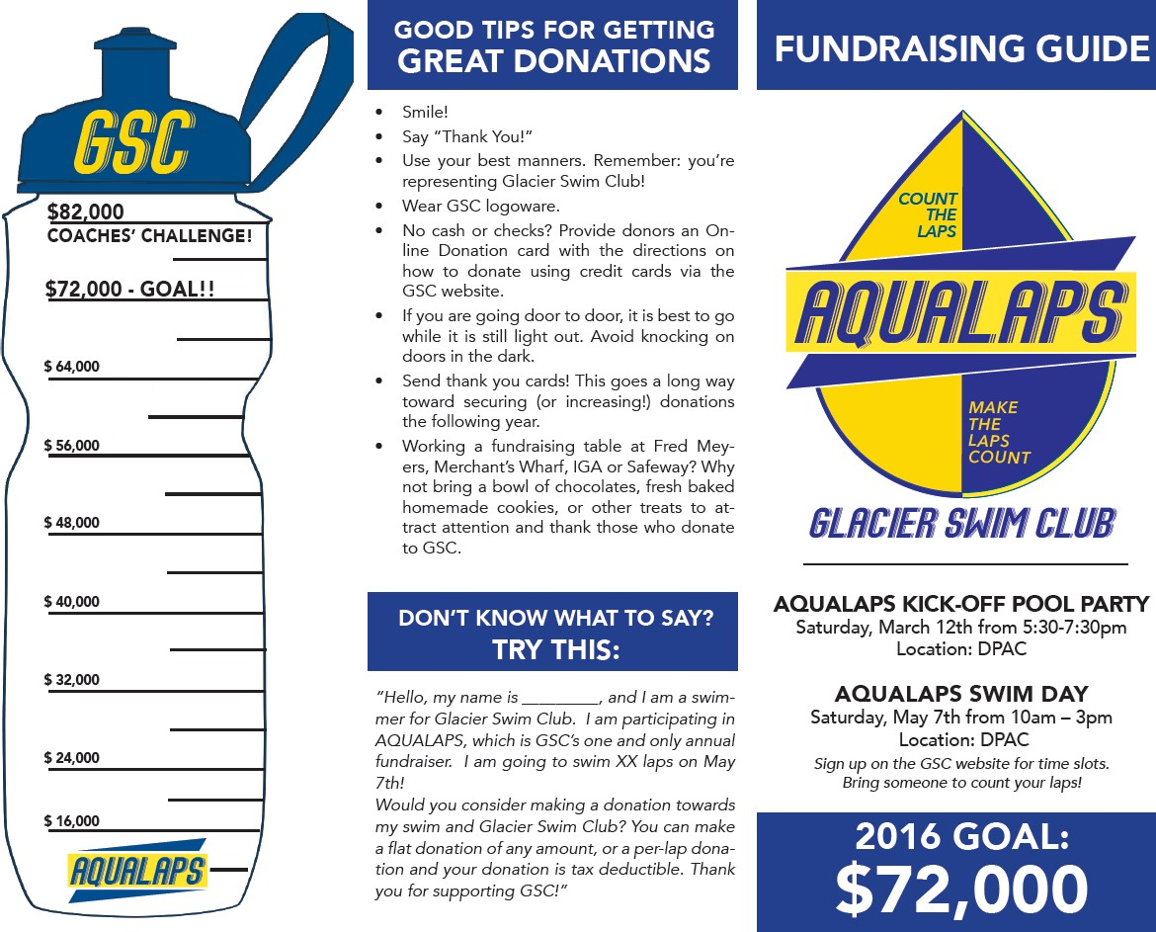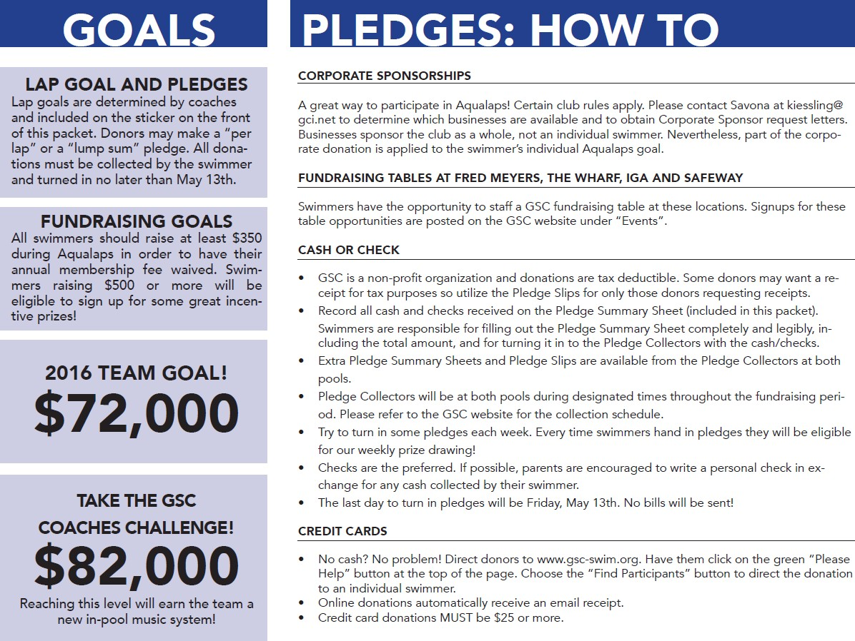

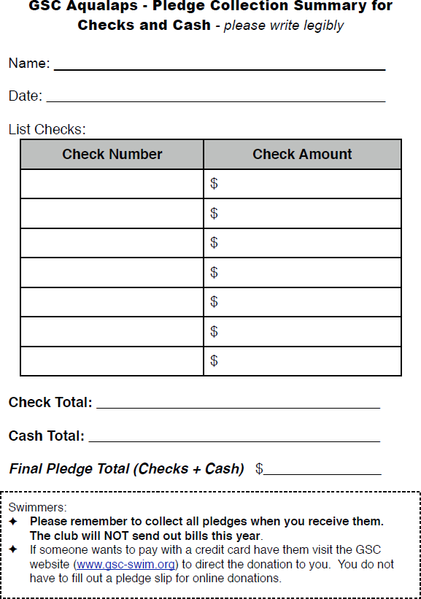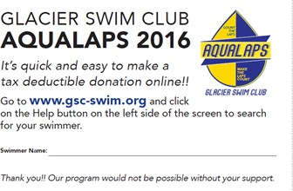

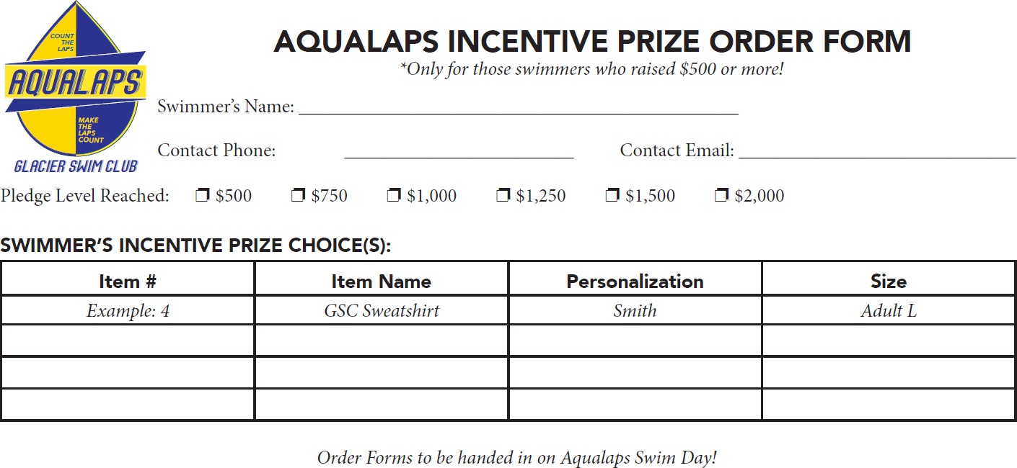

Pledge Collector Coordinator

(1 Downtown / 1 Valley)

General Responsibilities
- Recruits Pledge Collectors for defined pool location  - Establishes and posts pledge collector schedule  - Reminds volunteers of shifts and recruits or fills in as needed for absences  - Maintains Pledge Collector Box supplies  - Communicates with Pledge Entry Volunteer to establish process for handoff of collected funds | Mid-February  Early March  March – May

Volunteer Hours
As the Pledge Collector Coordinator you will earn 20 volunteer hours!

Detailed Responsibilities
- In mid-February, review the pledge collector volunteer sign ups on the website for your assigned pool location and work to recruit for any remaining slots, as necessary.
- In late February, reach out to your pledge collector volunteers in order to begin to determine a consistent collection schedule based on your volunteers' availability at your assigned pool location.
- Review the GSC website for posted pool closures, Spring Break, no practice schedules, etc. to assist you in the scheduling process.
- Several Pledge Collectors will also be need to be scheduled to work on Aqualaps Swim Day in May.
- Provide the Finalized Collection schedule to the Aqualaps Administrative Coordinator no later than the first week in March so that the information can be made available on the website and at the Aqualaps Kick Off event.
- The pledge collectors schedule should begin the week immediately following the Aqualaps Kickoff Event (early March) and run through the week following the Aqualaps Swim Day Event in early May in order to accommodate any lingering donations.
- Post a Pledge Collection Sign with days/hours on the GSC Board at your assigned pool location so that swimmers know when they can turn in pledges.
- Communicate with the volunteer responsible for Pledge Entry at your pool location so that they are aware of the days to expect funds coming in.
- Provide all Pledge Collector with the current Pledge Collector Job Description.
- Train all pledge collectors on the proper process for collecting, recording, and securing pledges, according to the Pledge Collector’s job description.
- Pledge Collectors earn volunteer hours based on their actual hours worked and therefore you will need to maintain a record of volunteer hours throughout the collection period.
- If a Pledge Collector is unavailable for their shift then you must either serve as collector or find a substitute collector. Swimmers expect that they can turn in pledges on the defined days so it is critical that those days/times covered. Communicate immediately with the Aqualaps Coordinators if you are unable to find coverage.
- An Aqualaps Box will be stored at each pool and will include an initial supply of such items as Pledge Slips (if a swimmer needs more), Pledge Collector Forms, Pledge Summary Sheets (if a swimmer needs more), zip lock bags, pens, calculator, manila envelopes, etc.
- It is the Coordinators responsibility to monitor supplies and keep the boxes sufficiently stocked.
- The Pledge Collectors should get the box out at the beginning of their shift and return it at the end of their shift. Boxes will be in the closet at the downtown pool and in the Coaches Office at DPAC.
- At the end of the day, all zip lock bags with pledges will go into a large manila envelope and should be sealed and marked with the date on the front. Those manila envelopes need to be securely locked in the vault in the Coaches Room at DPAC and in the Lockbox in the GSC closet at AGB.
- Aqualap Pledge Entry volunteers are responsible for picking up those pledges from the secure location and performing their verification and pledge entry. It will be the Pledge Entry volunteer’s responsibility to determine how they will handle the hand off of funds to the volunteer responsible for Pledge Reconciliation and Deposit Preparation who is responsible for reconciling and approving all pledges and make the bank deposits.
- At the end of the Collection period, please provide the Aqualaps Coordinator with the total number of volunteer hours worked by each pledge collector so that the hours can be appropriately credited to them for billing purposes.

Samples & Attachments
- Sample Posting of Collection Hours for GSC Boards

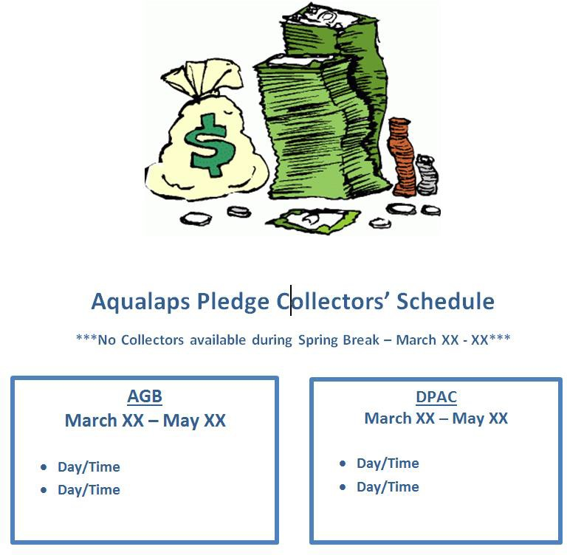

Pledge Collectors
(6 Downtown / 6 Valley)

General Responsibilities
- Coordinate your collection availability schedule with the Pledge Collector Coordinator  - Collect pledges during defined times and match swimmers’ pledge totals to Pledge Collection Summary sheets  - Complete a Daily Pledge Summary Recap sheet for each collection day  - Maintain the Weekly Prize Drawing Eligibility Listing  - Store funds & pledge collection box securely at pool at the end of your shift  - Notify the Pledge Collector Coordinator in advance of any absences  - Notify the Pledge Collector Coordinator if pledge collection supplies are running low | Early March  Mid-March– mid May

Volunteer Hours
As a Pledge Collector you will earn volunteer hours based on the actual number of hours you have worked. Please keep track of your hours so that you can get credit at the end of the campaign period.

Detailed Responsibilities
- Communicate with the Pledge Collector Coordinator assigned to your pool location to determine a consistent schedule for your collection shifts.
- Collection hours will be communicated to all swimmers at the start of the fundraising campaign; therefore it is critical that you are available to work your defined shift.
- If you are unable to work a shift, please communicate in advance with the Pledge Collector Coordinator. Doing so will allow him/her ample opportunity to make other arrangements to ensure collection is still available to our swimmers on the posted days/times.
- At the start of your shift, take the Pledge Collector’s Box out of the GSC Closet at AGB or the GSC Office at DPAC.
- When accepting pledges from swimmers it is important to work with only one swimmer’s pledges at a time.
- Verify that the swimmer included a Pledge Collection Summary sheet, and that the numbers on the summary sheet match to the total amount of cash and checks included in the packet. If the amounts do not match, make a correction on the Pledge Collection Summary sheet and ask the swimmer (for older swimmers) or parent to initial the change.
- It is not necessary for the swimmer to have filled out a Pledge Collection Summary sheet for each donation – swimmers will often include a single Pledge Collection Summary sheet for multiple donations.
- There should be no Pledge Collection Summary sheets without associated donations.
- On-line donations do not require Pledge Collection Summary sheets.
- All pledges must be paid in full – we do not send bills.
- After verification, place the swimmer’s Pledge Collection Summary sheet, cash & checks in a Ziploc bag.
- On the Daily Pledge Summary Recap sheet, list each swimmer’s pledges separately. If two swimmers combine their pledges into a single packet (this sometimes happens), they should be allocated and listed separately on the table, but make a note that both swimmers’ pledges are in a single bag.
- At the end of the collection shift, add the totals at the bottom of the Pledge Collection Summary sheet and place it into a large manila envelope along with all the zip lock bags, seal the envelope, and write your name and date on it.
- Be sure to add the name of every swimmer who passed in a pledge that week onto the Weekly Prize Drawing Eligibility Listing sheet. The same sheet should remain in the Pledge Collectors Box until the last collection day of the week and should include the names of all swimmers who turned in pledges during the current week.
- On the last day of pledge collecting, each week, please put the Weekly Prize Drawing Eligibility Listing in the Coaches Office at DPAC/Coaches Closet at AGB. Coaches at both pools will use this list to randomly draw, announce and distribute weekly prizes to the Weekly Prize Winners. Drawings will be held on the last weekday practice throughout the 8 week period. The prizes distributed each week will be for swimmers who turned in pledges that week.
- At the end of your shift, secure the Pledge Collectors Box in the GSC Office at DPAC or the GSC Closet at AGB.
- Communicate with the Pledge Collector Coordinator if any of the supplies in the Pledge Collector’s Box are running low.

Samples & Attachments
- Daily Pledge Summary Recap Sheet
- Sample Weekly Prize Drawing Eligibility Listing

Daily Pledge Summary Recap

- Work with only one swimmer’s pledges at a time.
- Verify that the swimmer has included a GSC Aqualaps Pledge Collection Summary sheet with their cash/checks. Verify that the totals on the summary sheet match the total amount of cash and checks included. If the amounts do not match, make a correction on the Pledge Collection Summary sheet and ask the swimmer (for older swimmers) or parent to initial the change.
- It is not necessary for swimmers to fill out a Pledge Collection Summary sheet for each donation – swimmers will often include a single Pledge Collection Summary sheet for multiple donations.
- There should be no Pledge Collection Summary sheets without associated donations. On-line donations do not require Pledge Collection Summary sheets. All pledges must be paid in full – we do not send bills.
- On the Daily Pledge Summary Recap sheet, list each swimmer’s pledges separately. If two swimmers combine their pledges into a single packet (this sometimes happens), they should be allocated and listed separately on the table below, but make a note that both swimmers’ pledges are in a single bag.
- Put the swimmer’s Pledge Collection Summary sheet, cash & checks in Ziploc bag.
- At the end of the collection shift, add the totals at the bottom of the Daily Pledge Summary Recap sheet and place it into a large manila envelope along with all the zip lock bags, seal the envelope, and write your name and date on it.

Date: Collector:

Swimmer Name | Amount of Cash Pledges | Amount of  Pledges by Check | Total Pledge Amount
Total all Swimmers:

Weekly Prize Drawing Eligibility List

Week of

Instructions:
- Please maintain one list, at each pool, with the first and last name of all swimmers who turned in pledges during the current week.
- On the last day of pledge collecting each week please put this list in the Coaches Office at DPAC/Coaches Closet at AGB.
- Coaches at both pools will use this list to randomly draw, announce and distribute weekly prizes to the Weekly Prize Winners.
- Coaches will announce winners on the last weekday practice (generally Friday) throughout the 8 week period.
- In general, the same prizes/number of prizes will be available at both pools each week.

1.

2.

3.

4.

5.

6.

7.

8.

9.

10.

11.

12.

13.

14.

15.

16.

17.

18.

Pledge Entry
(1 Downtown / 1 Valley)

General Responsibilities
- Picks up weekly pledges from secured location at assigned pool  - Verifies and enters pledge information onto TeamUnify system  - Transfers pledges to Pledge Reconciliation & Deposit Preparation Coordinator | March – May

Volunteer Hours
As a Pledge Entry volunteer you will earn 20 volunteer hours!

Detailed Responsibilities

Samples & Attachments

Pledge Reconciliation & Deposit Preparation

General Responsibilities
- Approves offline pledges  - Makes adjustments to entries and enters ad hoc pledges  - Reconciles daily pledges  - Prepares and makes bank deposit | January – June

Volunteer Hours
As the Pledge Reconciliation & Deposit Pre volunteer you will earn 20 volunteer hours!

Detailed Responsibilities
Some pledges, especially corporate sponsorships will come to you directly. These will need to be entered into Teamunify.

Entering Offline Donations
- Click on Aqualaps tab on menu bar of home page
- Click on Find Participants
- Enter swimmers name to search
- Click on View Profile
- Click on + Offline Donor
- Enter amount, your email address, payment method and name and address if you have them
- Be sure that checks of $100 or more are entered separately with a name and address for sponsor tracking
- Cash and checks less than $100 can be entered in total, but not commingled with each other – a separate entries for cash and checks
- Click on Donate Now and confirm

Offline donations must be approved before they are visible to the swimmers and are included in the totals. This is an important control in the process and, if not done carefully and accurately, will make reconciling the bank deposit a nightmare!!

Approving Offline Donations
- Coordinate with pledge enterers at each pool to get the pledge envelopes
- Work with one envelope at a time
- Go to Event Fundraising Admin in the TU Money menu
- Click on the Results tab near the top of the screen
- Click on Donor Type at the top and choose Offline (not approved) and click on Search
- For each swimmer’s pledges, count the cash and checks. Make sure the amounts match what is on the summary sheet and entered in the system
- Check the box next to each pledge as you match them up
- After all pledges in an envelope have been checked off click on Approve Offline
- Make sure the total shown on the Summary screen matches the total on the summary sheet from the envelope
- If something has been entered incorrectly, select it and click on Delete Not Approved. Then re-enter it using the instructions above
- Be sure that all checks of $100 or more have been entered separately with a name and address for sponsor tracking
- Separate the cash and checks from the pledge information and pass them to the Treasurer for deposit

Because of the way Teamunify interfaces with QuickBooks, I recommend that the deposits for Aqualaps be prepared by the Treasurer. Deposits should be done once per month, along with any checks and cash collected for dues, swim shop, Masters, etc.

Teamunify posts one lump sum total to QuickBooks for the all of the payments collected for the month, regardless of source. This makes reconciling the Aqualaps receipts pretty difficult and makes it even more important that the interim checks and balances are done properly.

Preparing Deposits
- Click on Billing Admin button in TU
- Click on Invoices & Payments
- Click on Payment Sum tab. Set date parameters for the 1st and last day of the prior month.
- Click on Generate Payment Summary report. I usually export to Excel so I can delete all columns with no activity.
- Include cash and checks collected for all activity posted through TU for reconciliation, but keep the amounts collected for Aqualaps separate from that collected for dues, etc.
- In a perfect world, the total in the cash column will match the cash you have to deposit. Same for the checks.
- If the separate amounts don’t tie out, see if it works in total. If check payments were posted as cash or vice versa, it will cause the individual tie outs to be off.
- If there is still a difference, run an Inc. & Pay Sum report for the same time period.
- Eliminate all credit card payments.
- Make sure the non-Aqualaps payments tie to cash and checks.
- Match up remaining check numbers to those on the report.
- No real good procedure from here. Tie out what you can. If you’re still left with a difference, post to Aqualaps Income and hope that it resolves itself in the next month (very last resort).

Samples & Attachments

Fundraising Table Coordinators

General Responsibilities
- Secure table locations & determine options for storage of table  - Establish collection schedule (days/hours)  - Provide collection schedule to Aqualaps Administrative Coordinator for website sign ups  - Find or supply table, chair and GSC banner  - Place reminder calls/text weekly to swimmers signed up for shifts  - Set up and take down table, as necessary | January  January - February  Mid-February  Early March  March – Early May  March – Early May

Volunteer Hours
As a Fundraising Table Coordinator volunteer you will earn 16 volunteer hours!

Detailed Responsibilities

Securing the Location
- Each year Glacier Swim Club works to secure several store locations including Fred Meyer, Foodland IGA and Super Bear in order to assist swimmers with their fundraising efforts.
- Table Coordinators are responsible for reaching out to the Managers at those locations in early January in order to secure the location for the March/April/May fundraising period.
- In person communication with on-site managers is the preferred method and goes further toward ensuring GSC is able to secure the location.
- All Table Coordinators must determine, through communication with local Store Managers, any rules that apply to table set up/take down and storage during the campaign period.

Historically:
- Fred Meyers has allowed us to store the table during weekends only throughout the campaign period.
- IGA and Super Bear have provided a table and therefore storage is not an issue.

Collection Schedules
- Table Coordinators must work independently with Store Managers at their assigned location in order to determine the dates and times slots available for GSC to conduct fundraising efforts.

Historical Collection Schedules:
- Super Bear collection days vary based on the store’s commitment to other organizations. It is best to try to establish a schedule that includes Friday through Sunday.
- IGA collection days vary based on the store’s commitment to other organizations. It is best to try to establish a schedule that includes Friday through Sunday.
- Historically, Fred Meyer collection days are Saturday-Sunday 10:00am – 4:00pm. Occasionally Friday evenings from 4:30 – 8:30 become available.
- Once Table Coordinators have finalized the collection schedule for their assigned location they must communicate the schedule to the Aqualaps Administrative Coordinator.
- Finalized collection schedules should be provided to the Aqualaps Coordinators no later than mid-February.
- The Aqualaps Administrative Coordinator will ensure table sign-up slots are posted on the GSC website.
- Table sign-ups (days/shifts) will be posted on the GSC website at the beginning of the fundraising campaign (aka ‘Kick-Off’) in early March.
- Time slots are generally available throughout the campaign period which equates to the months of March, April and early May.
- A maximum of 2 swimmers are allowed to work each shift.
- All shifts are broken into 2 hour time slots.
- Swimmers are initially limited to signing up for 2 non-consecutive time slots per location. Setting this limit allows all swimmers the opportunity to utilize these tables for fundraising purposes.
- It is the Table Coordinators responsibility to monitor and address overscheduling by the same swimmer at any one location.

Set-Up/Take Down/Banners & Supplies
- Table Coordinators may either provide their own table or communicate with the Head Coach in order to obtain a GSC table from the DPAC location. If you are utilizing a GSC table then please ensure that the table is labeled as ‘GSC’ prior to taking it.
- Table Coordinators are responsible for ensuring that a table, a banner and needed supplies (bag of spare pledge slips, online donation cards, and pens) are available at their assigned location each week.
- All of these supplies will be made available by the Aqualaps Coordinators during the Kick-Off event.
- Fred Meyer Table Coordinator: Take table, banner and supplies to Fred Meyer in time for either the Friday or Saturday set up (whichever is the first day of the collection period that weekend).Retrieve the table at the end of the day on Sunday and keep at home until the following week.

Placing Reminder Calls/Texts for Scheduled Shifts
Table Coordinators should review the table reservation sign-up sheet on the GSC website and place calls/texts to remind parents/swimmers of their shift the day before and confirm attendance. If a swimmer did not include their phone number on the Sign-Up page of the GSC website you can search for member contact info by logging in and clicking on the ‘Members’ link at the top of the screen and search by last.

When contacting parents/swimmers:
- Encourage them to consider bringing chocolates, cookies, swim medals, googles, swim caps, etc. to decorate the collection table and make it more inviting.
- Remind them to bring a collection jar.
- Advise swimmers to decide ahead of time if they are going to take turns with pledges during their shift or if they are going to split the pot at the end of the shift.
- Explain that parents are expected to accompany their swimmer. Swimmers should never be left unattended.
- Emphasize that swimmers are expected to be well behaved and respectful at all times.
- Explain any requirements their shift has for set up/take down and storage of the table.

Conclusion of Fundraising
- Fred Meyer Table Coordinator must provide the Aqualaps Coordinators with the total amount of donations obtained in that location.
- Thank you cards signed by swimmers will be provided to Table Coordinators by the Aqualaps Coordinators at the conclusion of the campaign period.
- Table Coordinators are asked to deliver the “Thank you” cards to their assigned location at the conclusion of the fundraising period.
- Return any borrowed GSC tables, GSC Banners and remaining supplies to the GSC Coaches Office at DPAC.

Samples & Attachments
- Aqualaps Donation Card
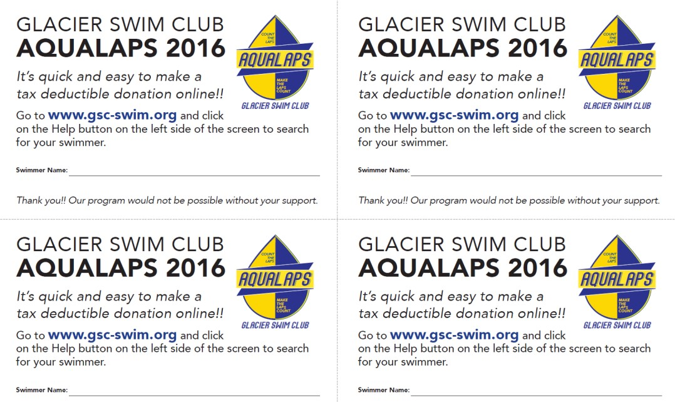

Pool Publicist

General Responsibilities
•

Volunteer Hours
As the Pool Publicist volunteer you will earn 10 volunteer hours!

Detailed Responsibilities

Sample & Attachments

Weekly Prize Coordinator

General Responsibilities
- Weekly prize solicitation, donation request letters, collection of prizes  - Bag and label prizes/ Delivery to both pools  - Thank you card delivery | February – early March  Mid March  May

Volunteer Hours
As the Weekly Prize Coordinator you will earn 20 volunteer hours!

Detailed Responsibilities

- In order to avoid overlap it is important that prior to soliciting any business for donations that you reach out to the Corporate Sponsorship Coordinator to obtain a list of businesses that are currently being approached by swimmers through the corporate sponsorship portion of the fundraiser.
- After reviewing the list provided by the Corporate Sponsorship Coordinator you should compile a list of the businesses you plan to approach for smaller weekly prize giveaways.
- Provide the list of those businesses you plan to approach to the Corporate Sponsorship Coordinator so that he/she can appropriately manage a swimmers request to approach the same business at a later date.
- Begin to solicit small prizes from local businesses by providing them with a customized Donation Request letter. Sample letter is attached.
- Throughout the swimmer’s collection portion of the campaign we will be encouraging them to turn in pledges each week as they receive them. In order to encourage this practice we use ‘Weekly Prize Drawings’ as an incentive.
- All swimmers who pass in pledges each week are eligible to have their name entered to win a prize at Friday’s practice.
- Weekly Prize Drawings are held by the Coaches. Swimmers must be present at practice to win.
- For consistency, we strive to have similar prizes/number of prizes being distributed at both pools each week over an 8 week period.
- Average number of prizes given out each week is dependent on the total number of donations received during the solicitation period.
- In general, you should strive to obtain between 3-5 prizes per pool, per week.
- Based on the total number of prizes obtained you will need to divide them equally (as best you can) among the 2 pools.
- Prepare a prize listing that indicates which prizes are to be given out during each of the 8 weeks.
- All prizes for each given week should go in a separate manila envelope (or similar) and labeled “Week 1 Prizes/Week 2 Prizes/Week 3 Prizes, etc.”
- Once you have prepared/organized all the prizes for each pool then you will deliver the 8 weeks’ worth of prizes to each pool location.
- Drop off locations are the GSC office at DPAC and the GSC Coaches Closet at AGB.
- Weekly prizes should be gathered and delivered to pools by Aqualaps Kick-Off.
- Provide the Aqualaps Coordinators with the final listing of businesses who showed their support through the donation of weekly prizes along with the prizes they donated.
- Coaches will work directly with the Aqualaps Coordinators to provide a weekly listing of winners/prizes so that we can give a shout out to those local businesses in our weekly email announcements.
- At the conclusion of Aqualaps all swimmers are asked to sign thank you cards. You will be provided with the appropriate number of thank you cards to deliver to the businesses that helped make our campaign a success.

Samples & Attachments
- Sample Donation Request Letter
- Sample Weekly Prize Box Distribution Listing

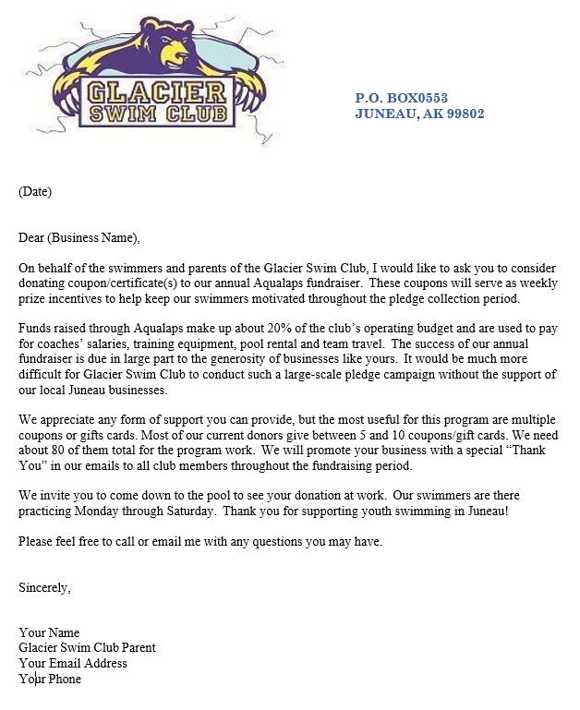

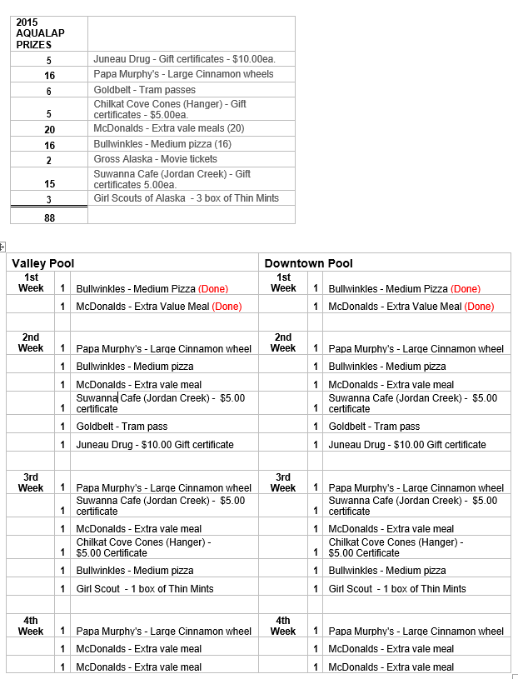

Pledge Level Prize Coordinator

General Responsibilities
- Select incentive prizes for each tier level  - Prepare document of prize offerings to be hung at each pool and posted on the GSC website  - Order prizes with vendor  - Distribute prizes to swimmers | February  March  May - June  August - Sept

Volunteer Hours
As a Pledge Level Prize Coordinator volunteer you will earn 20 volunteer hours!

Detailed Responsibilities
- In January and February, work with the vendor to review and select prize options for the various tier levels.
  - Prize options should be available at the beginning of Aqualaps or as soon as possible to help motivate kids to raise funds.
  - Prize values are 5% of amount raised:
- $500 $25-prizes
- $750 $35-prizes
- $1000 $50-prizes
- $1250 $62-prizes
- $1500 $75-prizes
- $2000 $100-prizes
  - For embroidery, water bottles, or other gear with the team logos, we work with Alaska Outdoor Warehouse and Embroidery. They have all of our logos and we have an account with them. Talk to the owner about the companies he works with; review product catalogs, discuss costs – may have discount due to order size. In general, embroidery/silk screen is extra. Schedule a time to meet with owner to review options. d. See previous year’s prize list for ideas.
- In early March, create document of prize options and send to the Aqualaps Administrative Coordinator for review/edits/comment. Upon approval:
  - Post at both pools locations on the GSC board.
  - Provide an electronic version to the Aqualaps Administrative Coordinator to link to the Aqualaps fundraising page.
- At the conclusion of Aqualaps, collect prize sign-up sheets from swimmers.
  - Be sure to request parent email and cell numbers on the sign-up. Sometimes swimmers put their own contact info on the form.
- Choose a deadline for prize sign-up. Usually 2-3 weeks after Aqualaps because swimmers will have donations coming in for a bit after the event.
- Obtain pledge verification information from Aqualaps Administrative Coordinator and cross check those amounts with the amount of prizes being ordered.
- Create a prize spread sheet; confirm swimmers raised required funds to be eligible for their selected prize. Communicate, as necessary, with swimmers who ordered a prize and were not eligible as well as those who were eligible but may not have ordered a prize.
- Place prize orders.
    - For all AK Warehouse orders, we have an account. The invoice needs to be mailed to GSC for billing or coordinate with Amy Davis to pay directly with GSC’s credit card.
    - For all other prize orders, you’ll need to talk with Coach Scott or the treasurer about using a team credit card. Alternatively, you can pay out-of-pocket, submit receipts and request reimbursement.
    - Keep copies of all receipts from orders.
- Distribute prizes.
    - Prizes take a bit of time to order and obtain but the target date should be distribution at the start of following season (August).
    - Have Aqualaps Coordinators send out an email with the date, time and locations of the prize distribution.
    - Bring any remaining prizes to the GSC Kick-off Banquet in the fall. Be sure to have GSC send out an email advising everyone that remaining prizes will be available for pick up.
    - Always have the original listing of orders along with a listing of what all swimmers earned. Sometimes swimmers think they are eligible for a prize but really weren’t. Having the ending pledge level listing, provided by the Aqualaps Administrative Coordinator, will assist in determining a swimmers final pledge level balance.
- Give undeliverable prizes (labeled with swimmer’s name) back to coaches to distribute.

Sample & Attachments
- Sample Aqualaps Incentive Prize Order Form
- Sample Order Tracking Spreadsheet
- Sample Pledge Level Prize Packet

Verified  Order Info | Final Amount  Earned | Swimmer's  Name | $500  Item | $750  Item | $1000  Item | $1250  Item | $1500  Item | $2000  Item



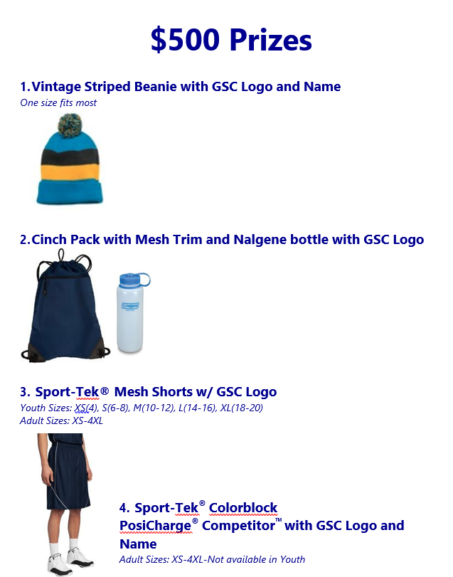

Litter Pickup Coordinator

General Responsibilities
• Coordinates litter pick up around both pools in conjunction with Litter Free Juneau  - Recruits parent helpers at each pool  - Publicizes event on GSC Bulletin Boards  - Keep coaches informed of dates | April - May

Volunteer Hours
As the Litter Pick-Up Coordinator you will earn 8 volunteer hours!

General Information
For every pledge dollar collected during the Aqualaps Fundraising Campaign GSC donates five minutes of clean up time to Juneau! So when friends, neighbors and family members make an Aqualaps pledge they are not only supporting GSC and encouraging kids to do their personal best, but they are also making a donation to the beautification of our community in cooperation with Litter Free Juneau.

Using previous year’s figures this generally equates to about 1 – 1 ½ hours of clean up time per swimmer. This is GSCs opportunity to give back to the community for all their support in funds raised each year - so it is critical to get team involvement.

Coaches are asked to cancel practices on the define Litter Pick-Up Day at both pool locations and have all their swimmers clean up trash within the pool vicinity during practice time. With that many kids picking up trash it is important to try to recruit parents to join in along with coaches.

Detailed Responsibilities
- You are responsible for coordinating Litter Pick-Up Day at both pool locations on a defined Friday in late April or early May.
- In general, we strive to coordinate our efforts with Litter Free Juneau and conduct our Pick-Up event the Friday before their Saturday Clean Up. Doing so allows us to leave the bags on the roadside for pickup on Saturday. However, timing our Litter Pick-Up the day prior to Litter Free Juneau is not always possible.
- You will need to coordinate the date directly with Coach Scott ahead of time so that the coaches can plan accordingly. Coaches are expected to encourage swimmer participation through actively promoting the event date.
- Upon determining the Litter Pick-Up date, please immediately communicate the date to the Aqualaps Coordinators who will facilitate getting the event posted on the GSC website.
- You should recruits parent helpers for each location and publicize the event to swimmers, coaches, and parents.
- If the Litter Pick-Up date is scheduled for after Aqualaps Swim Day then use Aqualaps Swim Day as a venue to promote and advertise GSC’s Litter Pick-Up Event with posters, handouts, etc.
- Obtain enough bags and vest for both pool locations from Litter Free Juneau www.litterfree.org and determine if they will provide for pick-up of bags at both locations.
- GSC should not receive income from Litter Free Juneau for their efforts as this is the club’s way of thanking the community for the support showed during the campaign period.
- If Litter Free Juneau is unable to provide for bag pick-up then you will be responsible for picking up bags at both locations.
- Gloves and hand sanitizer should be made available at both pool locations for Pick-Up Day.
- Submit receipts for the purchase of gloves and sanitizer to Amy Davis for reimbursement.

Sample & Attachments

Sponsorship Banner Coordinator

General Responsibilities
• Design & Order new Corporate Sponsorship Banners | August - September

Volunteer Hours
As the Sponsorship Banner Coordinator volunteer you will earn 20 volunteer hours!

Detailed Responsibilities

August - September
Obtain an updated listing of all corporate sponsors from the Aqualaps Administrative Coordinator in order to design and order new corporate sponsor banners for both pools. New season banners should be ordered and up in September.

Sample & Attachments

The success of GSC’s annual Aqualaps
Fundraiser depends on you, our dedicated volunteers.

We thank you!

