
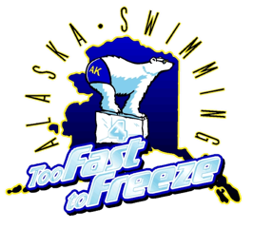

Alaska Sr Championship Time Standards*
Short Course Yards (25 Yard Pool)
Through 2028

Girls | Event | Boys
27.89 | 50 Free | 25.59
1:00.89 | 100 Free | 55.69
2:11.69 | 200 Free | 2:02.19
5:53.39 | 500 Free | 5:30.59
12:09.49 | 1000 Free | 11:23.99
20:19.59 | 1650 Free | 19:11.09
31.09 | 50 Back | 28.89
1:05.89 | 100 Back | 1:01.09
2:22.59 | 200 Back | 2:12.59
36.09 | 50 Breast | 33.09
1:15.99 | 100 Breast | 1:08.99
2:43.79 | 200 Breast | 2:29.89
30.69 | 50 Fly | 28.39
1:05.89 | 100 Fly | 1:00.39
2:26.69 | 200 Fly | 2:14.39
1:07.59 | 100 IM | 1:01.89
2:27.19 | 200 IM | 2:15.39
5:13.49 | 400 IM | 4:49.49

* USA Swimming 2024-2028 National Motivational Times (13/14 “A”)

