 | Northern Lights Swim Club Boosters  Procedure on How to Check Volunteer Hours in Team Unify

Background
The Northern Lights Swim Club (NLSC) Boosters relies heavily on the support and dedication of its swimmers and their families. We host many swim meets and functions that require family participation and, in fact, could not be run without assistance. As a condition of your family’s membership with NLSC, it is necessary that each swim family dedicate a specific number of hours assisting the team with running swim meets and activities for our swimmers. Volunteering time, energy, ideas and resources will enhance NLSC as well as afford your swimmers an improved sporting experience. The specifics of the volunteering program can be found on the NLSC website or by clicking here: https://www.teamunify.com/team/aznlsc/page/about-us/nlsc-boosters-volunteer-program- vip. The guidelines below outline how to check your volunteer hours in Team Unify – the tracking system used.

Steps To Follow
- Go to the Northern Lights Swim Club (NLSC) website: https://www.teamunify.com/team/aznlsc/page/home
- Hit the Sign In button in the right-hand corner.
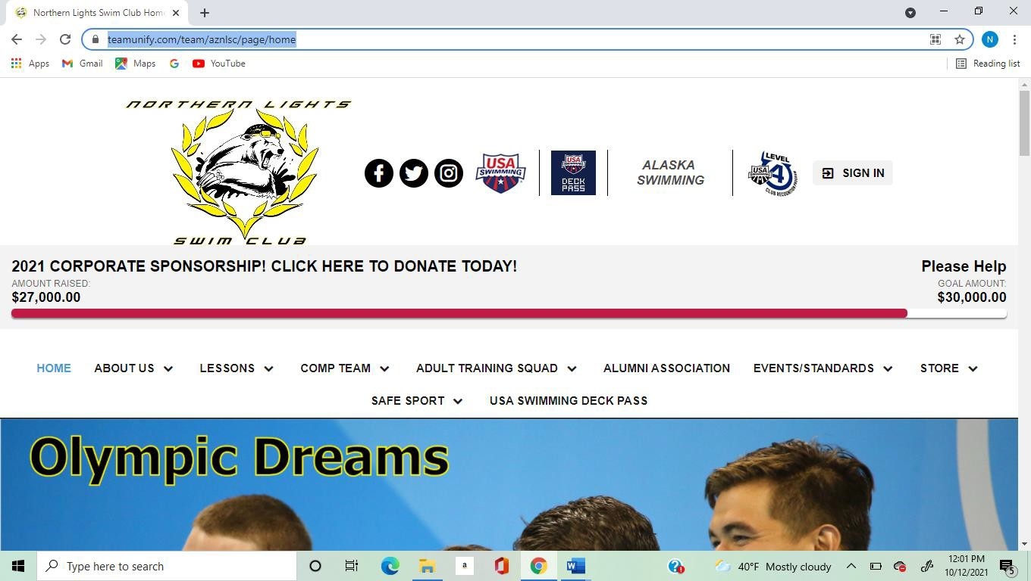

- Enter your login information.

- Once logged in you should be in the “back office” view.
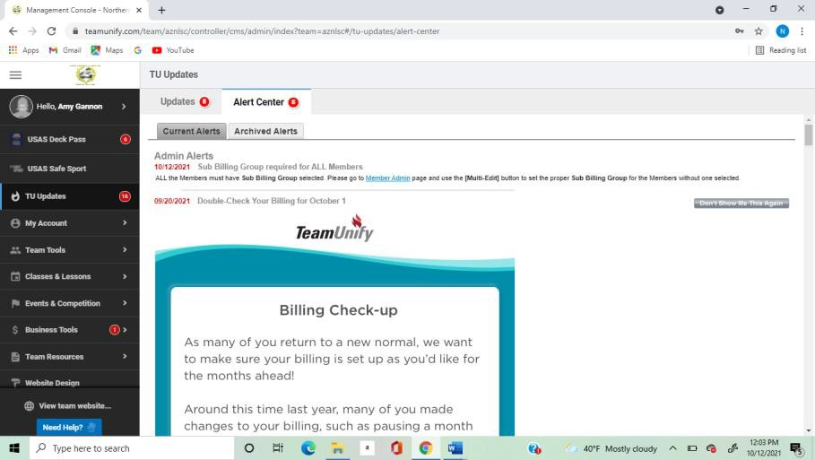
- If this is not the screen you are in, click on the picture circle in the right-hand corner and select “Back Office” or “My Account”. Both will get you into the right view.
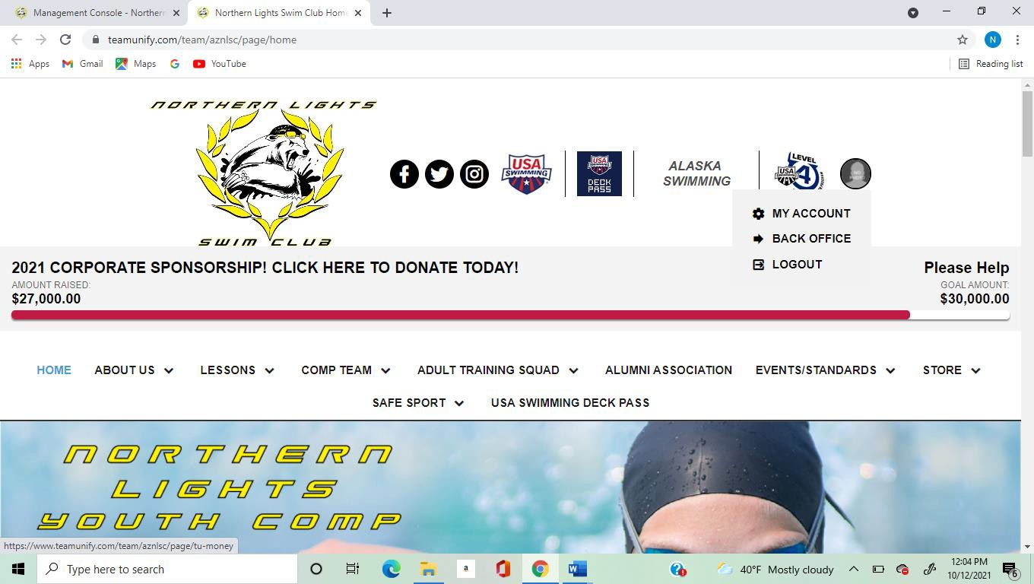

- In the black menu on the left-hand side, put your cursor over “My Account” and click on “Account Info”

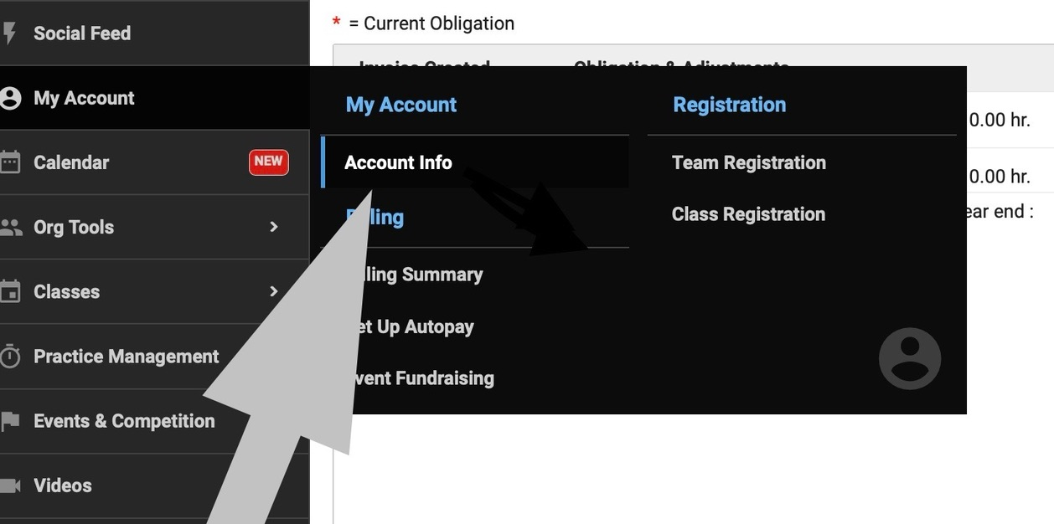

- There are tabs at the top of this screen: Click the tab titled “Service Hours”.
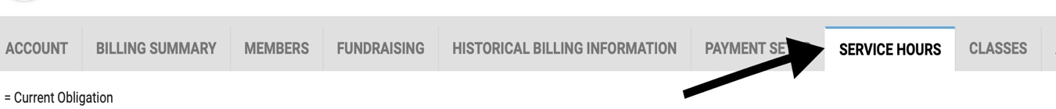

- For each cycle there will be a section (dated with the first month/year of that cycle) with any events that you volunteered at. It will have the hours earned listed next to each event. Under balance it will show how many hours you have remaining. Once you have fulfilled all of your hours, the balance will show 0.00 hr.

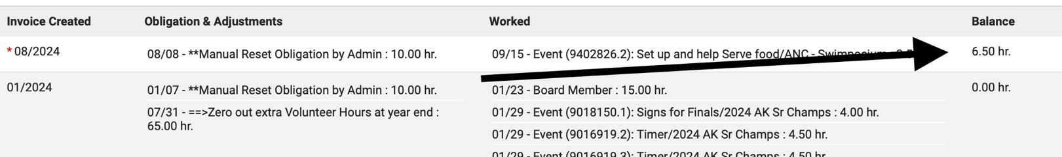
- If there are any errors, or hours you volunteered not listed, please email the volunteer coordinator with the required updates/additions. Include the event name, date of event, type of volunteer role you helped with, and how many hours you volunteered. The volunteer coordinator can manually add these hours for you.

