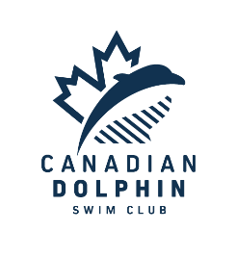
VPSC Meet results: Best times achieved

WOMEN
Luna Cheung:
200 breast
200 IM

Audrey Chow:
50 free
100 free
200 free
400 free
1500 free – Canadian Open QT
50 breast
100 breast
200 breast

Lauren Day:
50 free
50 back – Canadian Open QT
100 back
200 back

Lucy Liu:
50 free
100 free
200 free
50 back
100 back
200 back
50 fly
100 fly
200 fly

Abigail Skinder:
200 free
400 free

Milly Tung:
100 free
400 free
800 free
200 breast
400 IM

Olivia Zhou:
50 free – BC RECORD! – Gold medal – Canadian Open QT
100 free
50 back – Club record – Canadian Open QT
100 back – club record – Canadian Open QT
50 fly – Club record – Canadian Open QT
200 free
100 fly

Olivia Harb:
50 free
100 back
200 fly

Relays
New Club Records:
800 F.R.
Lucy, Olivia, Audrey, Lauren – Bronze Medal

400 F.R.
Abby, Lauren, Olivia, Lucy -Bronze Medal

400 M.R.
Olivia, Luna, Lucy, Lauren

43 Best times for women
1 Gold medal & 2 Bronze medals
1 Provincial Record
4 individual club records
3 relay club records

