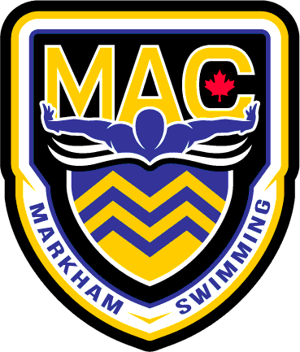
Bantam & JAG Group Tentative Meet Schedule for First Cycle 2025-2026
Date Meet Qualifications/Standards
OCTOBER:
18th- 19th MAC Fall Fest Invitational All Swimmers

NOVEMBER:
6th- 9th Gus Ryder Invitational JAG & Bantam
8-9th MAC Rising Star Only JAG
21st Alex Baumann Invitational All Swimmers

DECEMBER:
4-7th Windsor (Travel meet) All Swimmers
12-14th MAC Jingle Bell meet All Swimmers

