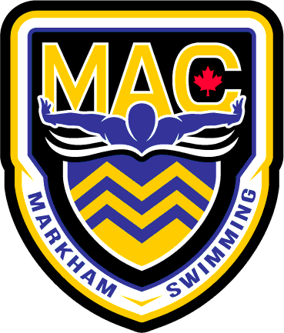 December 2025
Senior
Sunday | Monday | Tuesday | Wednesday | Thursday | Friday | Saturday
30  OFF | 1  4:00-6:00pm  MPAC | 2  5:30-7:30AM  MPAC  4:00-6:00pm  MPAC | 3  4:00-5:30pm  MPAC | 4  5:30-7:30AM  MPAC  4:00-6:00pm  MPAC | 5  RACE  MURRAY DRUDGE | 6  SWIM OYO
7  SWIM OYO | 8  4:00-6:00pm  6:00-6:45 Dry  MPAC | 9  6:00-7:30AM  MPAC  4:00-6:00pm  6:00-6:45 Wts  MPAC | 10  4:00-5:30pm  MPAC | 11  OJI | 12  OJI | 13  OJI
14  OJI | 15  OFF | 16  4:00-6:00pm  6:00-6:45 Wts  MPAC | 17  4:00-5:30pm  MPAC | 18  BLUE AND GOLD MEET  4:00-7:00PM | 19  4:00-6:00pm  MPAC | 20  OFF for  Christmas  Break
21  Christmas  Break | 22  Christmas Break | 23  Christmas Break | 24  Christmas Break | 25  Christmas! | 26  Boxing Day | 27  TBC  9:00am-12:00pm  MPAC
28  TBC  9:00am-12:00pm  MPAC | 29  TBC  9:00am-12:00pm  MPAC | 30  TBC  9:00am-12:00pm  MPAC | 31  TBC  9:00am-12:00pm  MPAC | 1  Happy  New Year! | 2  TBC  9:00am-12:00pm  MPAC | 3  TBC  9:00am-12:00pm  MPAC

Notes:
- Please have proper attire and dress appropriately for dryland/Wt room.
- Equipment required for the first two weeks: Running shoes/Skipping rope/water bottle/paddles/pull buoy/Band/Speedo Fins/Snorkel **WT BELTS BY OCT 1st please**
- All Practices at MPAC unless noted. On time = 15 min early
- TBC= To Be Confirmed
- December 27-Jan 3rd is 9-11 swim 11-12 dryland

