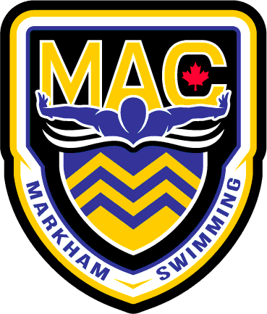 February 2026
Senior
Sunday | Monday | Tuesday | Wednesday | Thursday | Friday | Saturday
1  OFF | 2  4:00-6:00pm  6:00-6:45 Dry  MPAC | 3  5:30-7:30am  MPAC  4:00-6:00pm  6:00-6:45 Wts  MPAC | 4  4:00-5:30pm  MPAC | 5  5:30-7:30am  MPAC  4:00-6:00pm  6:00-6:45 Wts  MPAC | 6  5:30-7:00am  MPAC | 7  On Your Own  Coaches Workout
8  OFF | 9  4:00-6:00pm  6:00-6:45 Dry  MPAC | 10  5:30-7:30am  MPAC  4:00-6:00pm  6:00-6:45 Wts  MPAC | 11  4:00-6:00pm CORNELL | 12  5:30-7:30am  MPAC  4:00-6:00pm  6:00-6:45 Wts  MPAC | 13  5:30-7:00am MPAC | 14  5:30-7:00am MPAC
15  OFF | 16  OFF FOR FAMILY DAY | 17  5:30-7:30am  MPAC  4:00-6:00pm  6:00-6:45 Wts  MPAC | 18  4:00-5:30pm  MPAC | 19  5:30-7:30am  MPAC  4:00-6:00pm  OYO Wts  MPAC | 20  4:00-7:00PM  MPAC | 21  6:00-9:00am  MPAC
22  OFF | 23  4:00-6:00pm  6:00-6:45 Dry  MPAC | 24  5:30-7:30am  MPAC  4:00-6:00pm  6:00-6:45 Wts  MPAC | 25  4:00-5:30pm  5:45-:6:30 Dry  MPAC | 26  5:30-7:30am  MPAC  4:00-6:00pm  6:00-6:45 Wts  MPAC | 27  4:00-6:00pm  MPAC | 28  5:30-7:00am  MPAC

Notes:
- Please have proper attire and dress appropriately for dryland/Wt room.
- Equipment required for the first two weeks: Running shoes/Skipping rope/water bottle/paddles/pull buoy/Band/Speedo Fins/Snorkel **WT BELTS BY OCT 1st please**
- All Practices at MPAC unless noted. On time = 15 min early
- TBC= To Be Confirmed
- Family day long weekend 14-16th.

