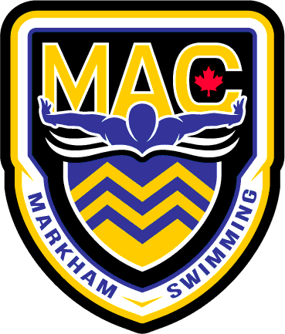 January 2026
Senior
Sunday | Monday | Tuesday | Wednesday | Thursday | Friday | Saturday
28  9:00am-12:00pm  MPAC | 29  9:00am-12:00pm  MPAC | 30  9:00am-12:00pm  MPAC | 31  9:00am-12:00pm  MPAC | 1  Happy  New Year! | 2 | 3  MPAC CLOSED FOR BACKWASH
4  MPAC CLOSED FOR BACKWASH | 5  4:00-6:00pm  6:00-6:45 Dry  MPAC | 6  5:30-7:30AM  MPAC  4:00-6:00pm  6:00-6:45 Wts  MPAC | 7  4:00-5:30pm  MPAC | 8  5:30-7:30AM  MPAC  4:00-6:00pm  6:00-6:45 Wts  MPAC | 9  4:00-7:00PM  MPAC | 10  6:00-9:00am
11  OFF | 12  4:00-6:00pm  6:00-6:45 Dry  MPAC | 13  5:30-7:30AM  MPAC  4:00-6:00pm  6:00-6:45 Wts  MPAC | 14  4:00-5:30pm  MPAC | 15  5:30-7:30AM  MPAC  4:00-6:00pm  6:00-6:45 Wts  MPAC | 16  4:00-6:00PM  MPAC | 17  5:30-7:00am
18  OFF | 19  4:00-6:00pm  6:00-6:45 Dry  MPAC | 20  5:30-7:30AM  MPAC  4:00-6:00pm  6:00-6:45 Wts  MPAC | 21  4:00-5:30pm  MPAC | 22  MAC WINTER INVITATIONAL | 23  MAC WINTER INVITATIONAL | 24  MAC WINTER INVITATIONAL
25  MAC WINTER INVITATIONAL | 26  OFF | 27  OFF  4:00-6:00pm  6:00-6:45 Wts  MPAC | 28  4:00-5:30pm  MPAC | 29  5:30-7:30AM  MPAC  4:00-6:00pm  6:00-6:45 Wts  MPAC | 30  4:00-6:00pm  MPAC | 31  5:30-7:00am

Notes:
- Please have proper attire and dress appropriately for dryland/Wt room.
- Equipment required for the first two weeks: Running shoes/Skipping rope/water bottle/paddles/pull buoy/Band/Speedo Fins/Snorkel **WT BELTS BY OCT 1st please**
- All Practices at MPAC unless noted. On time = 15 min early
- TBC= To Be Confirmed
- December 27-Jan 3rd is 9-11 swim 11-12 dryland

