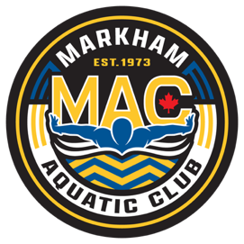
January Schedule 2026
JAG
Sunday | Monday | Tuesday | Wednesday | Thursday | Friday | Saturday
Jan 4th  OFF | Jan 5th  OFF | Jan 6  4:00-6:00pm  Cornell Pool  6:15-7:00pm  Dryland | 7  4:00-6:00pm  Cornell Pool | 8  4:00-6:00pm  Cornell Pool  6:15-7:00pm  Dryland | 9  4:00-6:00pm  Centennial | 10  6:00-7:30AM  Centennial
11  OFF | 12  OFF | 13  4:00-6:00pm  Cornell Pool  6:15-7:00pm  Dryland | 14  4:00-6:00pm  Cornell Pool | 15  4:00-6:00pm  Cornell Pool  6:15-7:00pm  Dryland | 16  4:00-6:00pm  Centennial | 17  6:00-7:30AM  Centennial
18  OFF | 19  OFF | 20  5:30-7:30AM  MPAC  4:00-6:00pm  Cornell Pool  6:15-7:00pm  Dryland | 21  4:00-6:00pm  Cornell Pool | 22  MAC Winter Invitational  MPAC | 23  MAC Winter Invitational  MPAC | 24  MAC Winter Invitational  MPAC
25  MAC Winter Invitational  MPAC | 26  OFF | 27  4:00-6:00pm  Cornell Pool  6:15-7:00pm  Dryland | 28  4:00-6:00pm  Cornell Pool | 29  4:00-6:00pm  Cornell Pool  6:15-7:00pm  Dryland | 30  4:00-6:00pm  Centennial | 31  6:00-7:30AM  Centennial
Feb 1st

OFF

Notes:
- Equipment required for the Dryland: Mat /Running shoes /skipping rope/water bottle.
- On-time = 15 min early
- Black training suits are mandatory
- MAC white caps for the training

