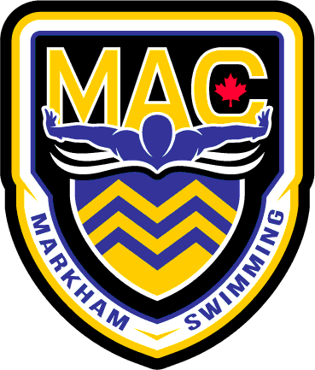 November 2025
Senior
Sunday | Monday | Tuesday | Wednesday | Thursday | Friday | Saturday
2  OFF | 3  4:00-6:00pm  6:00-6:45 Dry  MPAC | 4  5:30-7:30AM  MPAC  4:00-6:00pm  6:00-7:00 Wts  MPAC | 5  4:00-5:30pm  MPAC | 6  Lakeshore  Gus Ryder Swim Meet | 7  Lakeshore  Gus Ryder Swim Meet | 8  Lakeshore  Gus Ryder  Swim Meet
9  Lakeshore  Gus Ryder  Swim Meet | 10  OFF | 11  5:30-7:30AM  MPAC  4:00-6:00pm  6:00-6:45 Wts  MPAC | 12  4:00-5:30pm  MPAC | 13  5:30-7:30AM  MPAC  4:00-6:00pm  6:00-6:45 Wts  MPAC | 14  *Mallard Meet  Friday Night Racing | 15  5:30-7:00am  MPAC
16  OFF | 17  4:00-6:00pm  6:00-6:20 Dry  MPAC | 18  5:30-7:30AM  MPAC  4:00-6:00pm  6:00-6:45 Wts  MPAC | 19  4:00-5:30pm  MPAC | 20  5:30-7:30AM  MPAC  4:00-6:00pm  6:00-6:45 Wts  MPAC | 21  5:30-7:30AM  MPAC  PA DAY  4:00-6:00pm  6:00-6:20 Dry  MPAC | 22  5:30-7:00am  MPAC
23  OFF | 24  4:00-6:00pm  6:00-6:45 Dry  MPAC | 25  5:30-7:30AM  MPAC  4:00-6:00pm  6:00-7:00 Wts  MPAC | 26  4:00-5:30pm  MPAC | 27  5:30-7:30AM  MPAC  4:00-6:00pm  6:00-6:45 Wts  MPAC | 28  5:30-7:00am  MPAC | 29  5:30-7:00am  MPAC
30  OFF | 1  4:00-6:00pm | 2  5:30-7:30AM  MPAC  4:00-6:00pm | 3  4:00-5:30pm  MPAC | 4  5:30-7:30AM  MPAC  4:00-6:00pm  6:00-6:45 Wts  MPAC | 5  RACE  MURRAY DRUDGE | 6  TBD

Notes:
- Please have proper attire and dress appropriately for dryland/Wt room.
- Equipment required for the first two weeks: Running shoes/Skipping rope/water bottle/paddles/pull buoy/Band/Speedo Fins/Snorkel **WT BELTS BY OCT 1st please**
- All Practices at MPAC unless noted. On time = 15 min early

