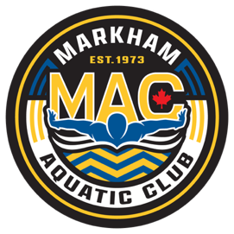
November Schedule 2025
Bantam
Sunday | Monday | Tuesday | Wednesday | Thursday | Friday | Saturday
OFF | OFF |  |  |  | Oct 31st  4:00-6:00pm  Centennial | Nov1st  6:00-7:30AM  Centennial
2  OFF | 3  OFF | 4  5:30-7:30AM  MPAC  4:00-6:00pm  Cornell Pool  6:15-7:00pm  Dryland | 5  4:00-6:00pm  Cornell Pool | 6  5:30-7:00AM  MPAC  4:00-6:00pm  Cornell Pool | 7  Gus Ryder Cup | 8  Gus Ryder Cup  &  Rising Star
9  Gus Ryder Cup  &  Rising Star | 10  OFF | 11  4:00-6:00pm  Cornell Pool  6:15-7:00pm  Dryland | 12  4:00-6:00pm  Cornell Pool | 13  5:30-7:30AM  MPAC  4:00-6:00pm  Cornell Pool  6:15-7:00pm  Dryland | 14  4:00-6:00pm  Centennial | 15  6:00-7:30AM  Centennial
16  OFF | 17  OFF | 18  5:30-7:30AM  MPAC  4:00-6:00pm  Cornell Pool  6:15-7:00pm  Dryland | 19  4:00-6:00pm  Cornell Pool | 20  5:30-7:30AM  MPAC  4:00-6:00pm  Cornell Pool  6:15-7:00pm  Dryland | 21  Alex Baumann  Invitational  MPAC | 22  Alex Baumann  Invitational  MPAC
23  OFF | 24  OFF | 25  5:30-7:30AM  MPAC  4:00-6:00pm  Cornell Pool  6:15-7:00pm  Dryland | 26  4:00-6:00pm  Cornell Pool | 27  5:30-7:30AM  MPAC  4:00-6:00pm  Cornell Pool  6:15-7:00pm  Dryland | 28  4:00-6:00pm  Centennial | 29  6:00-7:30AM  Centennial

Notes:
- Equipment required for the Dryland: Mat /Running shoes /Skipping rope/water bottle.
- On-time = 15 min early
- Black training suits are mandatory
- MAC white caps for the training

