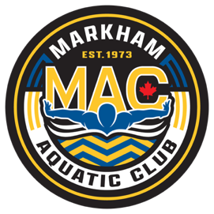
October Schedule 2025
JAG
Sunday | Monday | Tuesday | Wednesday | Thursday | Friday | Saturday
OFF | Sep 29  OFF | Sep 30  4:00-6:00pm  Cornell Pool  6:15-7:00pm  Dryland | Oct 1st  4:00-6:00pm  Cornell Pool | 2  4:00-6:00pm  Cornell Pool  6:15-7:00pm  Dryland | 3  4:00-6:00pm  Centennial | 4  6:00-7:30AM  Centennial
5  OFF | 6  OFF | 7  4:00-6:00pm  Cornell Pool  6:15-7:00pm  Dryland | 8  4:00-6:00pm  Cornell Pool | 9  4:00-6:00pm  Cornell Pool  6:15-7:00pm  Dryland | 10  4:00-6:00pm  Centennial | 11  Thanksgiving  No Practice
12  Thanksgiving  No Practice | 13  Thanksgiving  No Practice | 14  4:00-6:00pm  Cornell Pool  6:15-7:00pm  Dryland | 15  4:00-6:00pm  Cornell Pool | 16  4:00-6:00pm  Cornell Pool  6:15-7:00pm  Dryland | 17  4:00-6:00pm  Centennial | 18  MAC FALL Invitational
19  MAC FALL Invitational | 20  OFF | 21  4:00-6:00pm  Cornell Pool  6:15-7:00pm  Dryland | 22  4:00-6:00pm  Cornell Pool | 23  4:00-6:00pm  Cornell Pool  6:15-7:00pm  Dryland | 24  4:00-6:00pm  Centennial | 25  6:00-7:30AM  Centennial
26  OFF | 27  OFF | 28  4:00-6:00pm  Cornell Pool  6:15-7:00pm  Dryland | 29  4:00-6:00pm  Cornell Pool | 30  4:00-6:00pm  Cornell Pool  6:15-7:00pm  Dryland | Oct 31st  4:00-6:00pm  Centennial | Nov 1st  6:00-7:30AM  Centennial

Notes:
- Equipment required for the Dryland: Mat /Running shoes /Skipping rope/water bottle.
- On-time = 15 min early
- Black training suits are mandatory
- MAC white caps for the training

