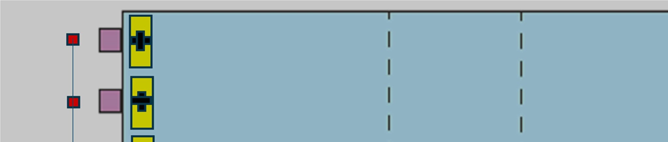
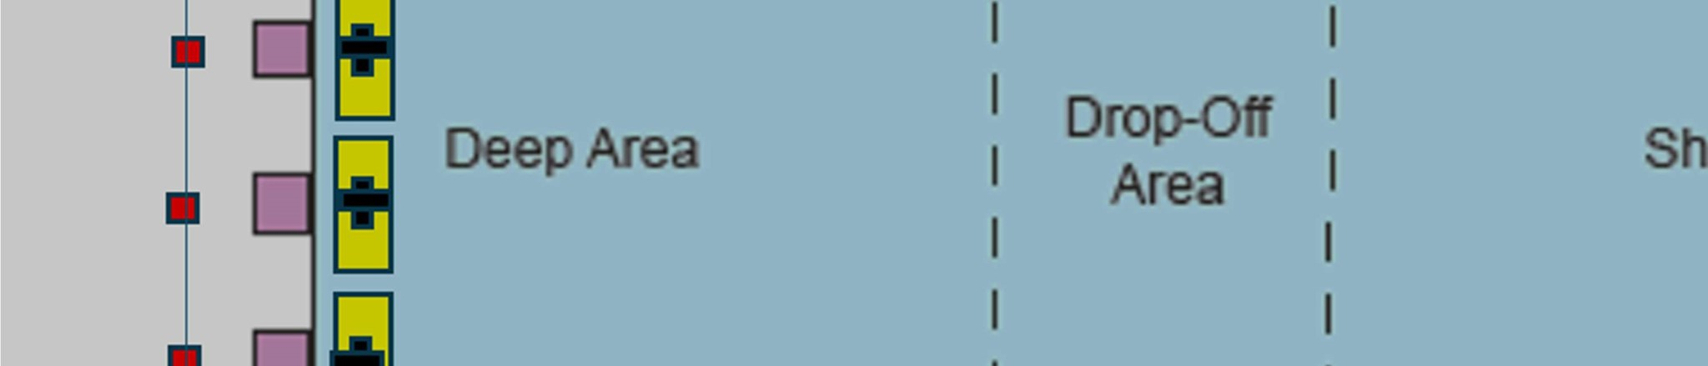
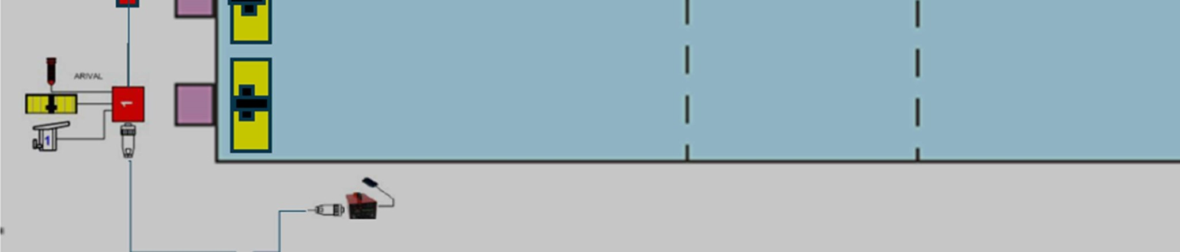
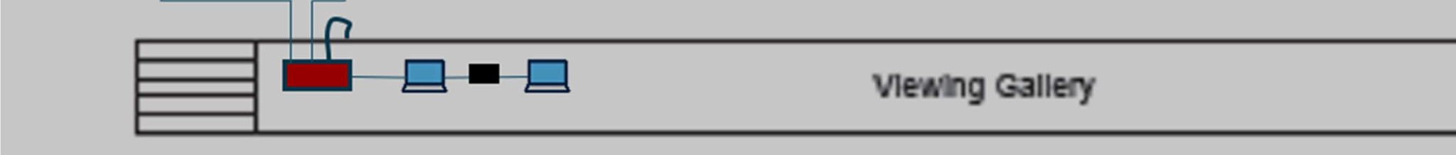

Prior setting up the Timing system:
- Prepare platform in Viewing Gallery by setup 4 frames and 2 plywood boards
- Place a foldable table on platform
- Connect two power extension cable
  - One cable powered from the outlet inside the storage room connect to a large power bar. This will provide power all the equipment to be setup on the table
  - One cable powered from power bar. This will provide power to the starting unit
- Move the following to the pool deck from storage at each lane:
  - 6 x touchpad
  - 12 x plungers
  - 12 x stainless steel touchpad mounting bracket to install touchpads at pool edge iv. 12 x stainless steel screws to tighten the mounting bracket onto the floor
- Setup touchpad at each lane using the mounting bracket and screws

Setup timing system:

Deck harness
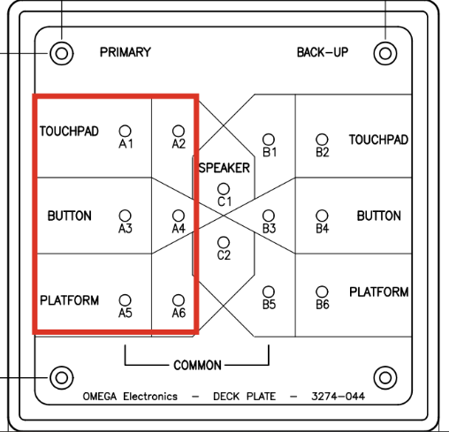

The inputs in the red box are connected.

Connect touch pad to TOUCHPAD (A1, A2)
- Connect one plunger to BUTTON (A3, A4) and one to PLATFORM (A5, A6)

Portable harness (if Deck harness broken)
- Build the portable harness by connecting the six junction boxes together
- Connect an extension cable to the cable of junction box 1. The other end of this cable will be connected to ARES
- Connect touch pad, plungers to the junction box at each lane according to the labels on the box
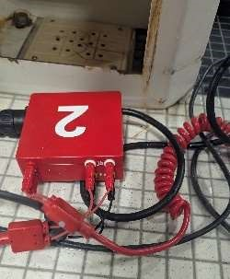

ARES 21 Console
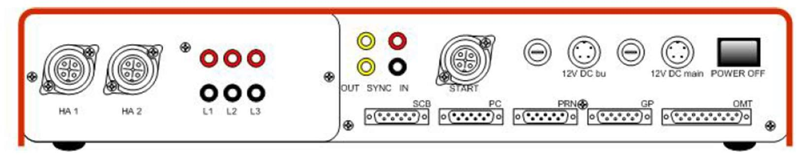
- Connect the bundled grey cable to the deck plate on the wall. Make sure to match the number 1 to 3 of the connectors on the wall. Connect the 9-pins connector at the other end of the grey cable to ARES console labeled as “SCB”( Scoreborad)
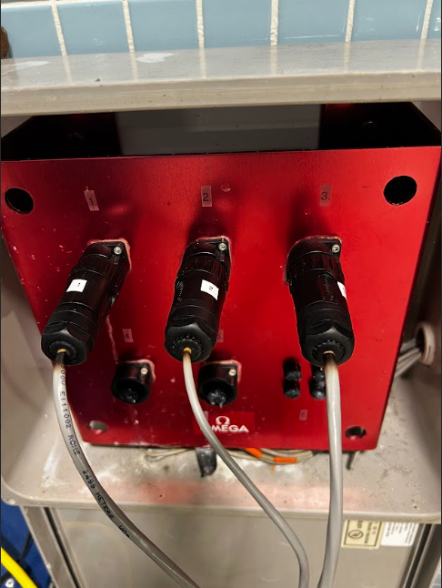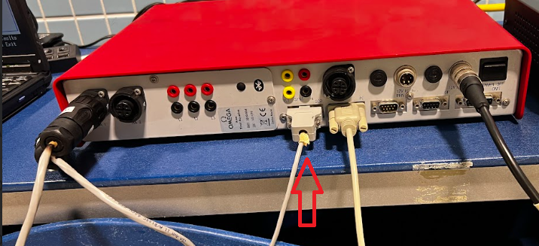
- Connect cable HA1 (or the extension cable from the portable harness) to console labeled as “HA1”
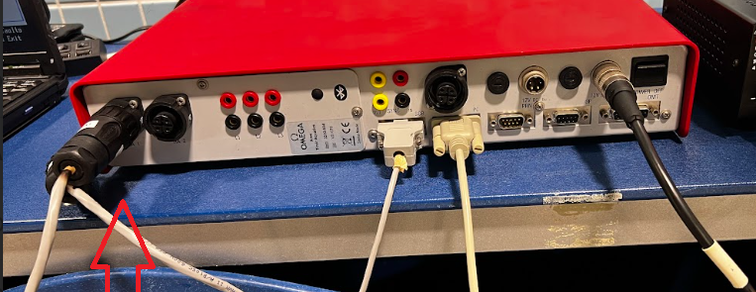

Starting Unit
- Install the starting unit on the tripod
- Connect gun to the unit
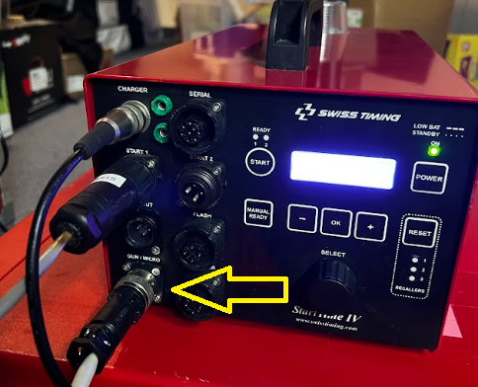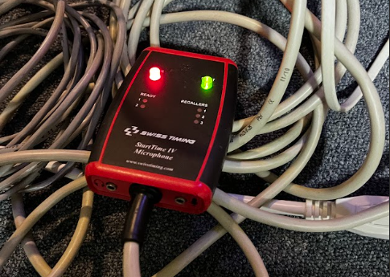
- Connect the unit to ARES Console
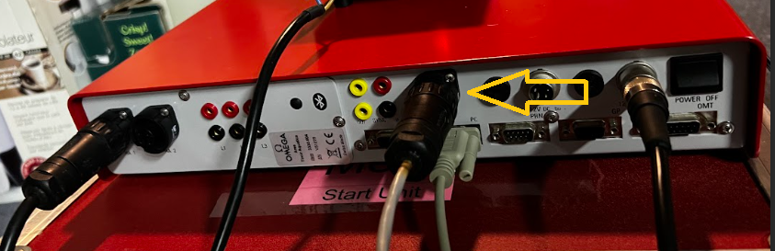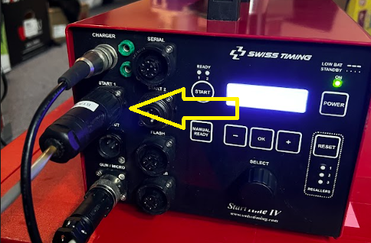

Laptops
There are two laptops in the setup: ARES laptop and Hy-tek Meet Manager laptop
- Connect ARES laptop to ARES controller via serial cable
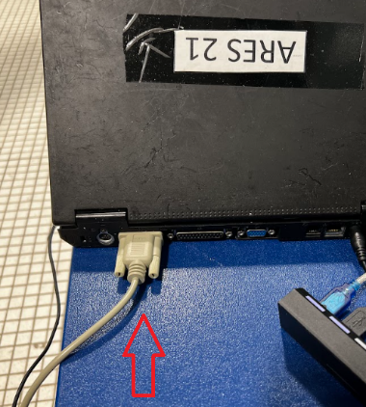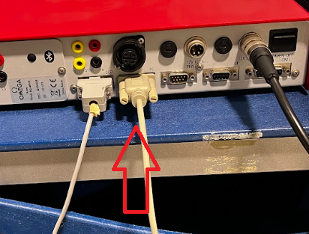

- Connect ARES laptop to Hy-tek Meet Manager laptop via USB-Serial Adapter cable.
  - ARES laptop only has left side USB port working, use USB hub for mouse USB-Serial Adapter;
  - The black USB-Serial adapter works with MM laptop;
  - The blue-silver USB-Serial adapter works with ARES laptop only.
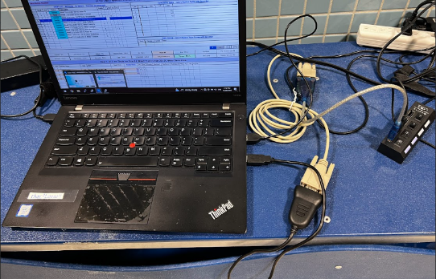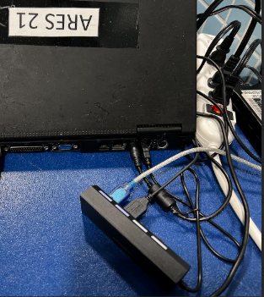
- Power up ARES laptop. The battery die, must configure system time every time power up. F10 save and exit
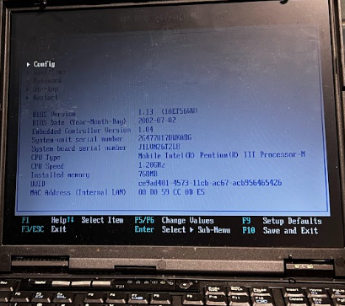
- Go to device manager in ARES laptop, ensure USB-to-Serial COMM Port is assigned COM4 is. If not, go to port property, advance, change to COM4
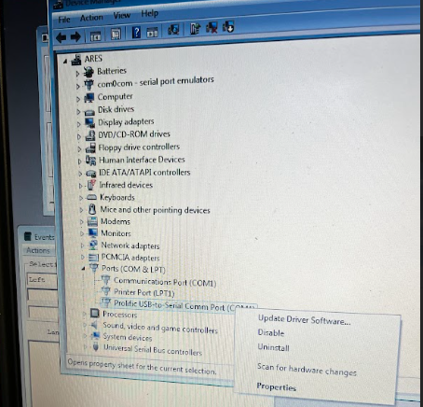

- Go to Device Manager in MM laptop, ensure USB-to-Serial is assigned a port number. If not and found PL2303HXA phased out error under port, need to reset. Right click this port, choose update driver, select Browse my computer for divers, select Let me pick from……, select 2010 version.
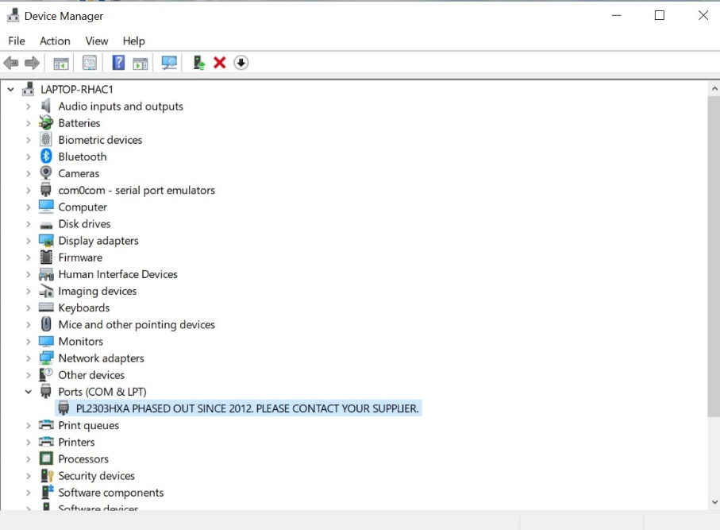
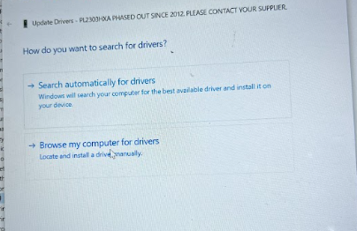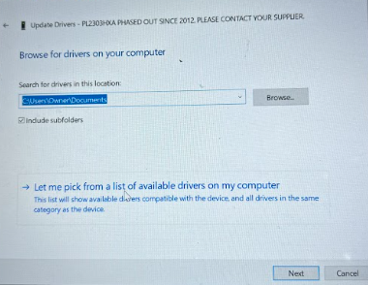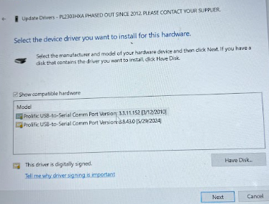
- Open ARES21 application in ARES laptop, choose a new data folder. Open Swim MM8.0 in MM laptop.
  - Run event, go to interfaces, select setup – Timing console interfaces, choose Omega ARES21 Bi-Directional, save.
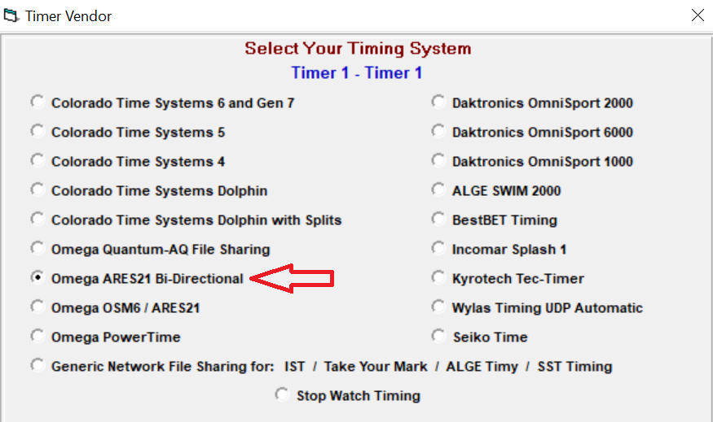

  - Go to interfaces – Timer 1 – Open/Close Serial Port for ARES, input the port number found in step 5. Click OK, if the connect works, it will show communication pass
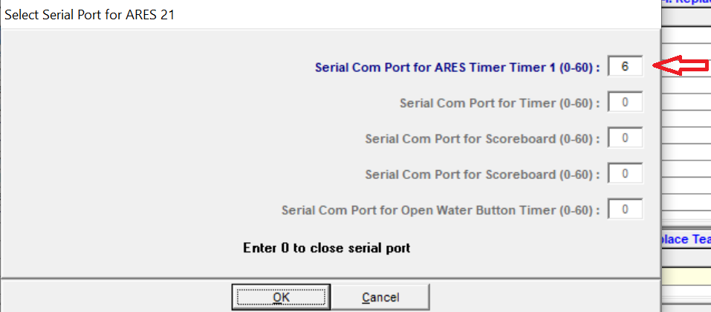

  - Go to interfaces – Timer 1 – Download Event to ARES, accept download in ARES laptop.

This should finish all physical setup of the timing system. Follow the other document to fully test the function of the starting unit, score board, touchpads and plungers at each lane before the session starts.

