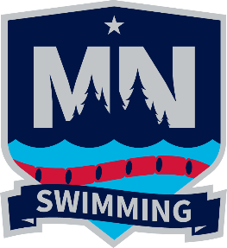
Minnesota Swimming Outreach Athlete
Suit & Goggles Request Form
MN Swimming has allocated funds to support Outreach Athletes or athletes that satisfy the financial requirements as noted on the MN Swimming website -
https://www.gomotionapp.com/czmnlsc/UserFiles/File/Documents/2026%20Documents/2026-outreach-athlete-fee-waiver-application-8-15-2025_094205.pdf

MN Swimming will provide a new practice suit and pair of goggles to those athletes that meet the financial criteria. We ask that families complete the form and return it to Tracy Meece, MNSI Registrar. Once the form is received, we will confirm athlete eligibility and then get the items ready to ship to the athlete. Please be aware that the items cannot be returned for credit or cash value.

If athletes, coaches or club leaders have questions about this support, please contact Anne Knapp, Administrative Vice Chair at afknapp@icloud.com.
Send completed form to Tracy Meece, MNSI Registrar at tmeece@mnswim.org.

Athlete Name
Club
Shipping Address | Street Address  City, State Zip code
Phone #
Email
Specify suit type (check one) | Girls Cross Back Girls Open Back  Boys Jammer Boys Brief
Specify suit size (See size chart on next page) | SIZE OF SUIT REQUESTED
Select up to 3 color choices.  (Every effort will be made to accommodate one of these choices.) | Blue Green  Red Yellow  Orange White
Goggles (check one) | Youth Adult
