Registering for Parent Safe Sport Training on LEARN
To ensure that your training is recorded under your club, please follow the directions below to register as a non-member parent.
- Go to: https://learn.usaswimming.org/
- Click the Register button
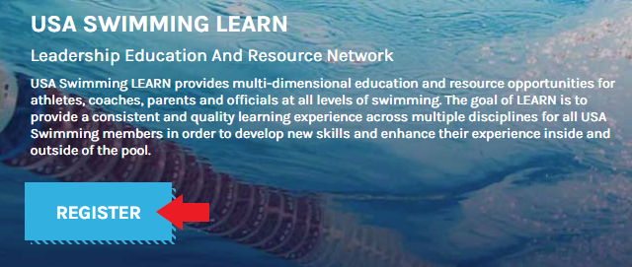
- Click on the Create Account button under Non-member access
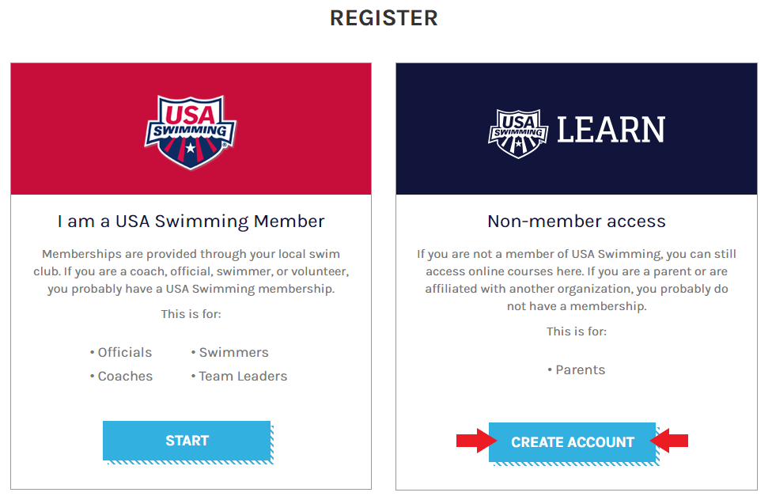

- Complete the registration form and click the Register button.
  - Select Minnesota Swimming under LSC
  - Select your club name under Club Name
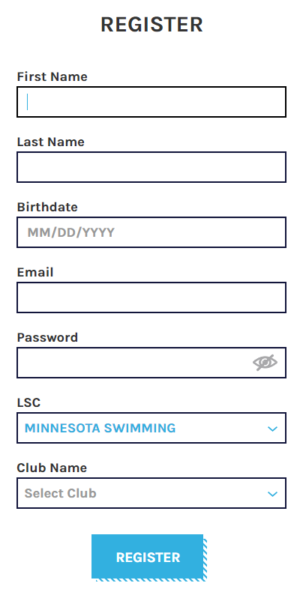
- Once registered and logged in, complete the Safe Sport for Swim Parents course.
- In addition to the Safe Sport for Swim Parents course, you may wish to also complete the Preventing Bullying course.

