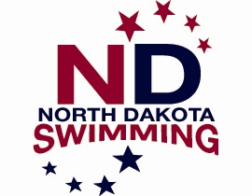
Policy 8.3 National Level Meets
Request for Swimmer/Coach Reimbursement

Reimbursement will be granted ONLY for the following meets;
Speedo Sectionals, Futures Championships, Speedo Junior National Championships, Arena Pro Swim Series (previously Grand Prix Series), Phillips 66 National Championships, and AT & T Winter National Championships.

In accordance with the North Dakota LSC Policy Manual, part 8.3, individually qualified swimmers and coaches participating in the above meets may request reimbursement for swimmer entry fees, transportation, and lodging expenses incurred. Check the policy manual on the NDSwimming.org website and also the Forms/Reimbursement Forms tab for details and current reimbursement amounts.

This form must be sent electronically to the Treasurer (see below) for approval within 30 days from the last day of the meet that reimbursement is being requested for.

Who incurred the expenses? Swimmer Coach Club

Name: _________________________________________________
Club Affiliation: ______________________________ Date of last meet swum with Club:_________________
Meet requesting Reimbursement for: ______________________________________________________________
Location of Meet:________________________________________ Dates: _________________________________
Expenses: Meet Fees: ___________________
Mileage: ___________________ (25% of current IRS Rate)

Lodging: ___________________
Total: ___________________

All applicable receipts must be attached to receive reimbursement. (Need only include receipts that bring reimbursement to the maximum allowed amount.)

Mail payment to (name/address): (Checks will be mailed within 30 days)

_________________________________
_________________________________
_________________________________
_________________________________

Email to: NDLSC Treasurer
Angie Heckaman
treasurer.ndswimming@gmail.com

