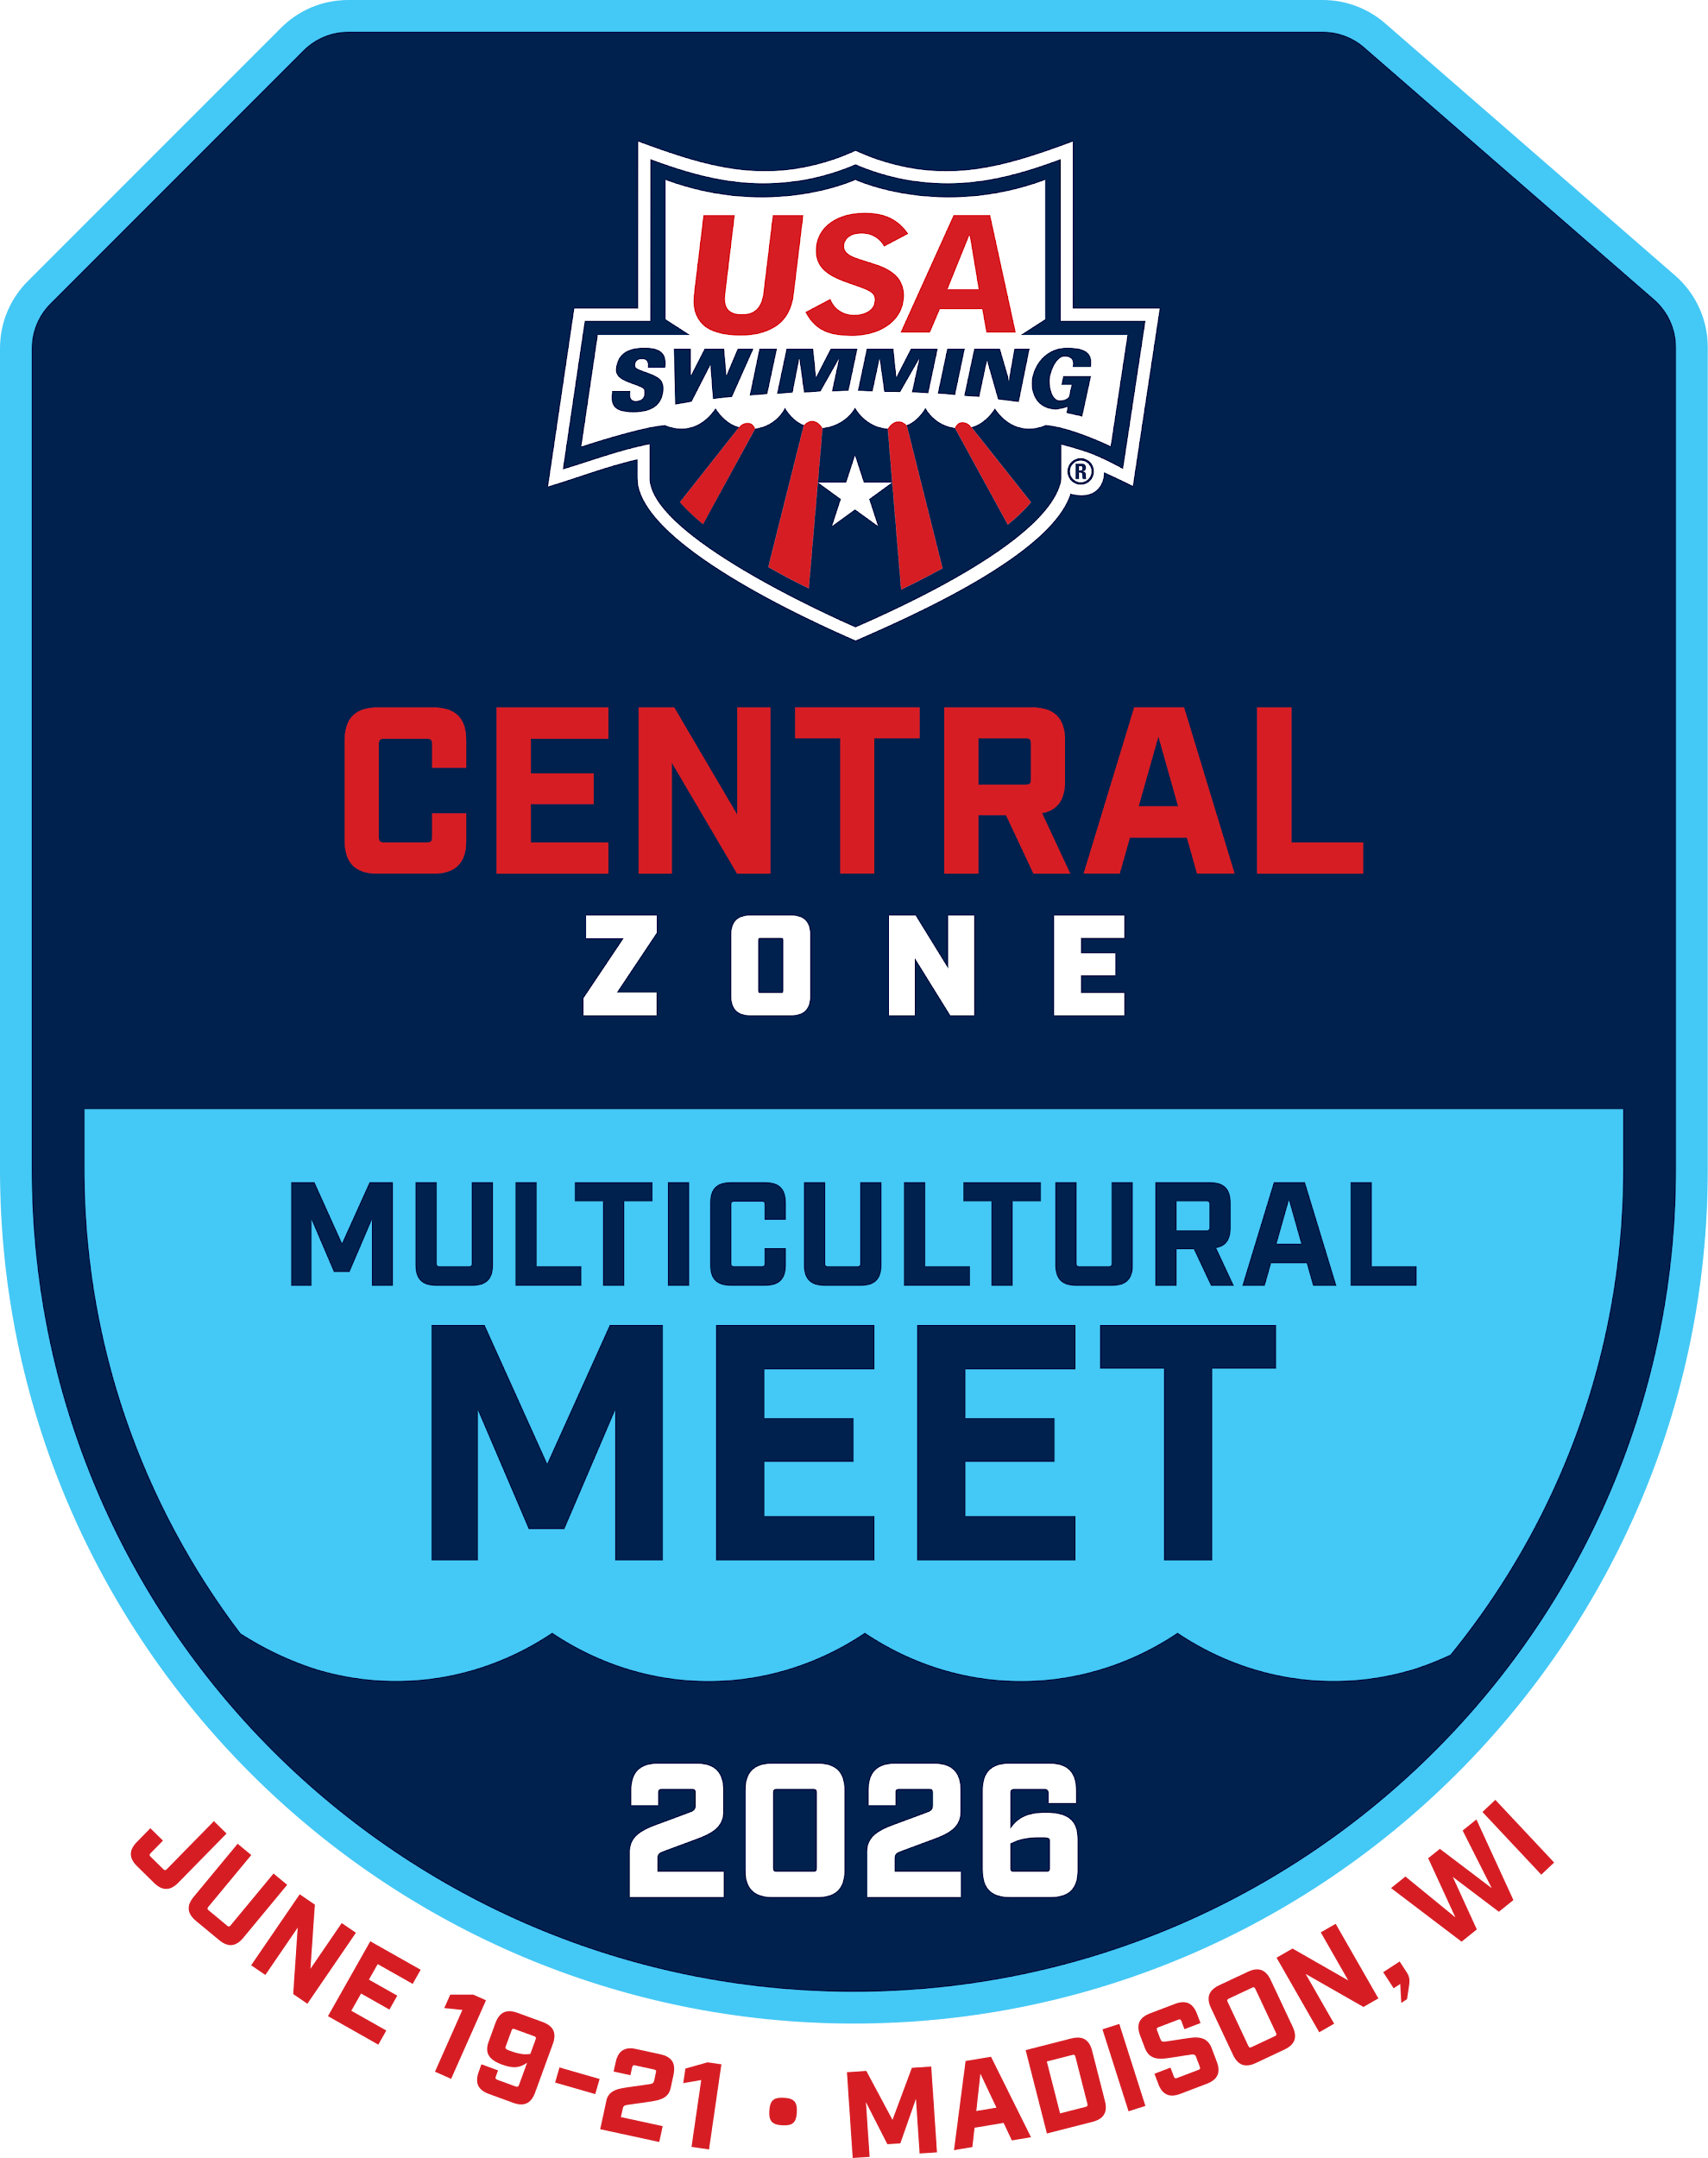

PARTNER HOTELS

THANK YOU TO THE FOLLOWING HOTELS FOR SUPPORTING THE 2026 MULTICULTURAL ZONE MEET!

Each hotel has different rates, deadlines, and number and type of reserved rooms. Please use the booking links provided for each hotel or feel free to reach out to them directly!

———-
Best Western Premier Park Hotel: BOOKING LINK
22 S Carroll Street, Madison, Wisconsin 53703-3309

———-
Hilton Garden Inn: BOOKING LINK
770 Regent St, Madison, WI 53715

————-
DoubleTree: BOOKING LINK
525 West Johnson St, Madison, WI, 53703
————
Embassy Suites by Hilton Madison Downtown: BOOKING LINK
231 S. Pinckney Street, Madison, Wisconsin, 53703, USA

—————
Hampton Inn and Suites -Downtown: BOOKING LINK
440 West Johnson Street, Madison, WI 53703

———-
Best Western Plus InnTowner Madison: BOOKING LINK

2424 University Avenue, Madison, Wisconsin 53726

——————
Holiday Inn Express & Suites Madison Central: BOOKING LINK
610 John Nolen Dr. Madison, WI 53713

