DIRECTIONS for ATHLETES NEEDING TO TAKE THE ATHLETE PROTECTION TRAINING
The APT is required for all athletes that are 18 years or older. An adult athlete without the APT in place is not a valid member of USA Swimming and may not participate or compete.
I highly recommend not waiting until the last minute to take your APT course.
- First step for athletes is to create your own login. Follow the Help guide to create an account. How to Create a New Login in SWIMS.docx
- Once you create your own login, your dashboard should have your name and membership card in the top left. It may take a minute or a few refreshes to see it. It is kind of important to see this then you know you linked your account properly.
- Once you see that the account was created properly, on the top toolbar, click “Education.”
- Choose “Course Catalog” from the drop-down menu.
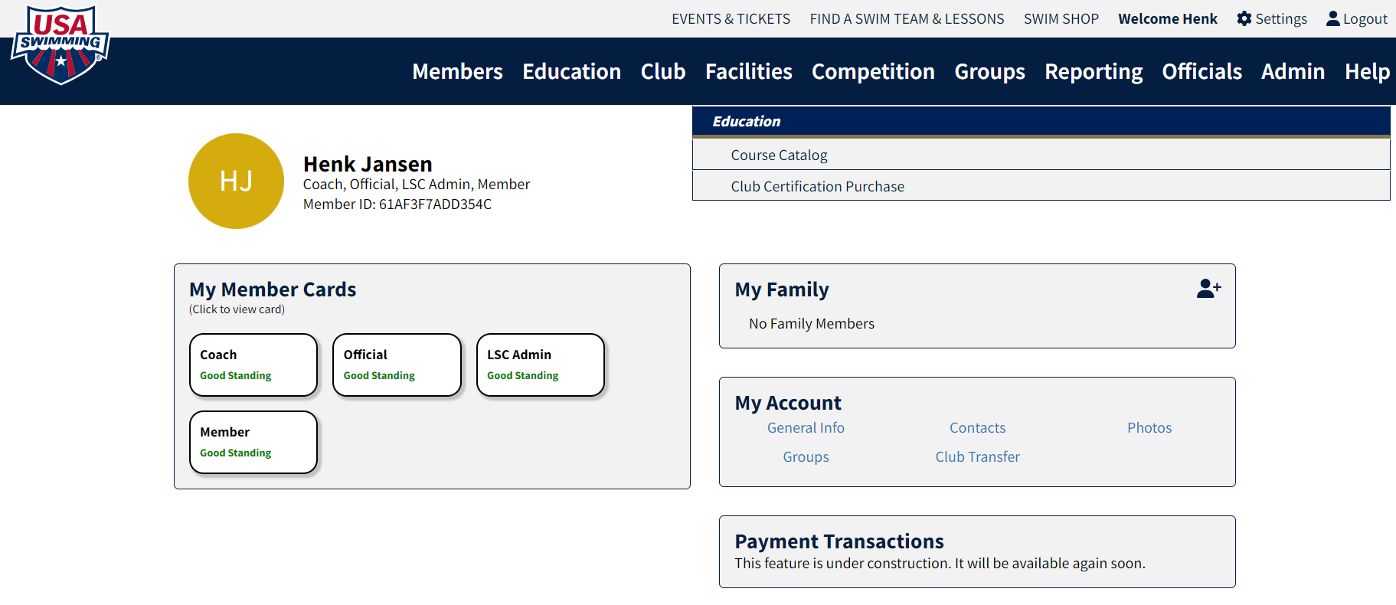

- On the next screen, select the Safe Sport circle. Choose “Athlete Protection Training.” If the name of the course does not match, it is not the correct course
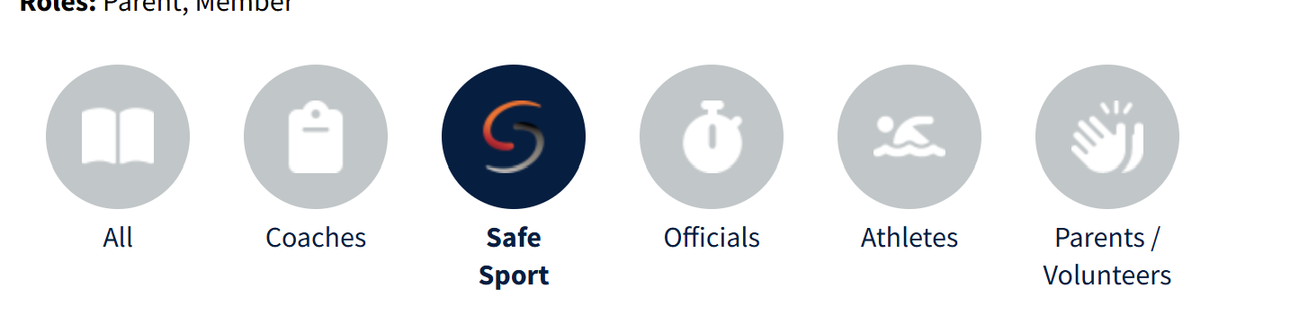
- Select Athlete Protection Training and follow the prompts. Note: this is the Core Course.
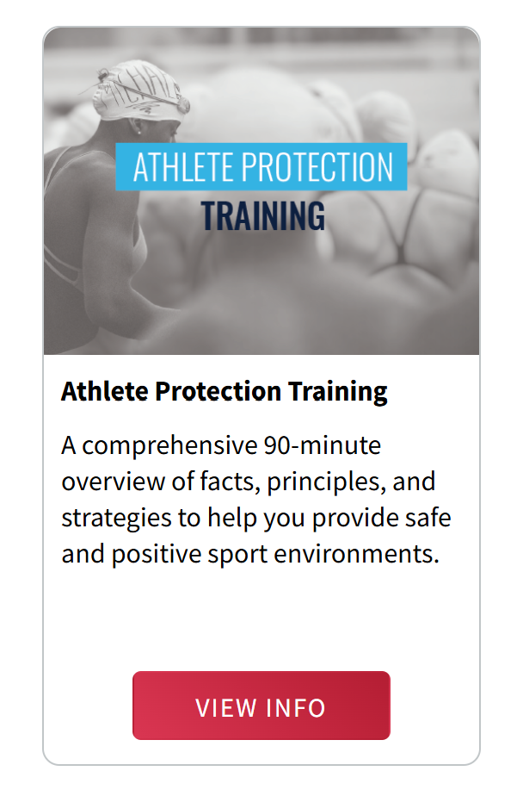

- Once you complete the course, it should take about an hour for your SWIMS 3.0 account to update.
- If the date does not populate to your membership card within 24 hours, you should submit a Help Ticket through your member account to request assistance.

