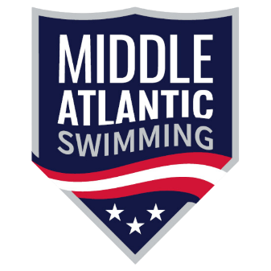
Dear Middle Atlantic Meet Host Clubs,
At the March 10, 2025 Board Meeting, Middle Atlantic Swimming (MASI) approved an important update to our Meet Sanction Policy. Starting soon, all MASI clubs that host sanctioned meets must be certified through the USA Swimming Safe Sport Recognition Program (SSRP).
What’s changing?
This new policy will not affect the 2025–2026 meet bids submitted for approval at the April 2025 House of Delegates. Instead, the requirement will be phased in over the next nine months.
Deadline:
All MASI clubs hosting sanctioned meets must complete SSRP certification before there hosted meet in 2026 and beyond.
Support is available!
The MASI Safe Sport Committee—and USA Swimming’s Safe Sport staff—are ready to help guide you through the process.
What is SSRP?
The Safe Sport Recognition Program is a USA Swimming initiative that highlights your club’s collaboration in creating a safe, supportive, and abuse-free environment for athletes, coaches, parents, and volunteers.
Why is this important?
MASI puts safety first. When all host clubs are SSRP certified, we provide an added layer of protection for swimmers traveling across our LSC to different meets and facilities.
How to get certified:
- Visit the Safe Sport tab on your club’s SWIMS account.
- Scroll to “Checklists to Achieve in 3 or 6 Months.”
- Use the step-by-step guides, model policies, and templates provided—no need to start from scratch!
You may be closer than you think—many requirements are already part of being a USA Swimming club.
Don’t wait!
Now is the perfect time to complete your certification before preparing for the September 1 start of the 2025–2026 season. Even if your club doesn’t host meets, all MASI clubs are encouraged to get certified.
Need help getting started?
- Join one of our “Get You Started” Zoom Q&As (see the MASI Safe Sport tab HERE for dates).
- Or email MASI Safe Sport Committee Chair Lisa Serafin at safesportcommittee@maswim.org to be connected with a committee member.
Let us know how we can help. Together, we can create a safer environment for every athlete in Middle Atlantic Swimming.
