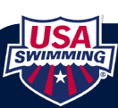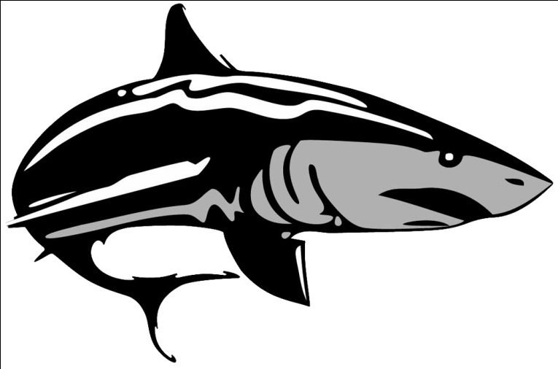
14 & Under Age Group Sectionals Highlights
The Coaching Staff is excited to share some of the accomplishments of our 11 DAQ Swimmers that swam at the 2013 14 & Under ESSZ Age Group Sectional Championships this past weekend in Greensboro NC . This was an exciting meet to compete against some of the top swimmers in the Southeastern Region the Country.
The participants were:
Lindsay Schroeder, Jaila Gladmon, Camille Johnson, Kendall Seefried, Melissa Brown, Justin Cucchi, Shani Edmond, Leona Harper, Anna Newman, and Christopher Thames
DAQ placed 33rd Overall out of 79 Scoring Teams
Our Top 20 Performers were as follows:
- Camille Johnson was named the Sectional Champion in the 11-12 Yr Old 50 Backstroke receiving 1st Place. This swim earned Dekalb Aquatic’s first Female to win a Sectional Victory with a time of 27.99. She also placed 14th in 50 Fly, 18th in 100 Back.
- Chris Thames Received 12th Place in the 100 Back and 2th Place in the 200 Back.
- Lindsay Schroeder Placed 17th in the 200 Free and 8th in the 500 Free,
- Jaila Gladmon Placed 8th in the 100 Breast, and 6th in the 50 Yard Breast
- Kendall Seefried Placed 9th in the 1650 Free, 19th in 400 IM and 13th Place in the 1000 Free
For Complete Results Please Visit: https://www.teamunify.com/ncssa/UserFiles/File/ag%20sectional%20results.pdf
Pictures Below:
