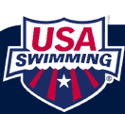
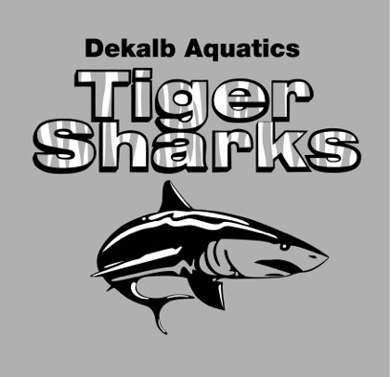
2013 Northern Divisional Highlights
We would like to formally thank all of the swimmers that participated in the 2013 Northern Divisional Championships recently at Mountain View Aquatic Center April 22nd - 24th. This year was significantly unique because the Northern Divisional was restructured with other mid-sized teams. This year was a great year with all around fast swims from the entire team. There were an overwhelming number of top 16 performances that helped DAQ achieve 3rd place.

DAQ placed 3rd Overall out of 7 Scoring Teams.
Please be sure to check out the team photos located on our team shutterfly page for all of the exciting new updates to the team: http://www.daqswim.com/TabGeneric.jsp?_tabid_=36810&team=gada
Password: Tigersharks10
For Complete Results Please Visit: http://www.daqswim.com/gada/UserFiles/File/2013%20divisionals%20results.pdf

