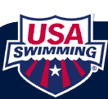
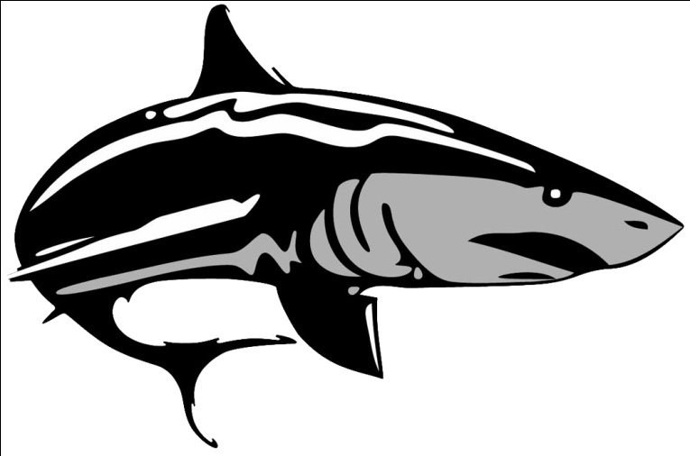
2013 SZ ES Speedo Sectional Series DAQ Highlights
This past weekend Coach Melissa and Mike traveled to Nashville Tennessee for the Speedo Senior Sectional Meet. This Senior Sectional Meet featured some of the top athletes across Southeastern Region the Country. DeKalb Aquatics was well represented with the Highlights noted below.
The participants were:
Devyn Hughes,Cash DeLoache, Dean Farris, Jake Smith, Jordan Williams
DAQ placed 9th Overall out of 36 Scoring Teams (Men Scoring Only)
DAQ placed 11th Overall out of 49 Scoring Teams (Combined Men’s/Women’s)
During this 4 Day Swim Meet, the top 32 Swimmers earned an opportunity to come back to Finals and score points for their respective teams.
DAQ’s Top 32 Performers were as follows:
- Devyn Hughes was named the Senior Sectional Champion in the 100 Breaststoke receiving 1st Place. This swim earned DeKalb Aquatic’s first Male title at a Senior Sectional Meet with a time of 55.71. This swim also earned Devyn his 1st Short Course National Cut in that event. He also placed 17th in the 100 Yard Fly, 8th in the 50 Free, 8th Place in the 100 Free, 7th Place in the 200 IM, and 6th Place in the 200 Yard Breast.
- Cash DeLoache placed 9th in the 100 Fly. This swim earned Cash his 1st Short Course National Cut in that event with a time of 49.78. He also placed 18th in the 200 Fly, 13th in the 50 Free, 29th in the 100 Free, 32nd in the 200 IM, and 19th in the 100 Back

DeKalb Aquatic’s Relay Teams:
- DAQ Men 400 Yard Medley Relay Place 13th – Dean Farris, Devyn Hughes, Cash DeLoache, and Jordan Williams. This relay also earned a NSCA Spring Junior National qualifying time
For Complete Results Please Visit: http://www.daqswim.com/gada/UserFiles/File/2013%20sectionals%20final%20results(2).pdf

