KATY Aquatics
2025 Swim-A-Thon
Fundraiser Packet

Saturday, March 22, 2025
Goal: $85,000
Swim-A-Thon FAQ's
What is Swim-A-Thon?
- Swim-A-Thon is our single largest fundraiser each year. The funds raised will help keep our swimming programs affordable and accessible to the youth of Katy.
As stated in our Registration Policies, this is a mandatory fundraiser where all families are required to raise a minimum amount of $125. (Please note the minimum amount is per family, not per swimmer.)
If the family minimum is not met, the balance will be applied to your Account after the fundraiser
has ended. (Future Stars and Masters Swimming are encouraged to participate in Swim-A-Thon Fundraising, but not required.)
- Swimmers will earn money for the club by swimming lengths of the pool. They will have two (2) hours to swim a maximum of 200 laps. (That's 2.84 miles in case you were wondering!)
- Swimmers can raise donations through sponsorships, corporate matching, family, friends, and neighbors prior to swimming on Swim-A-Thon Day.
When and where is Swim-A-Thon?
- Swim-A-Thon will be held Saturday, March 22, 2025. We will announce the specific times and pool locations of where each practice group will be swimming once we are closer to the event.
How do we raise money for Swim-A-Thon?
- Sponsorships – In an effort to achieve our goal of $85,000, we are offering Corporate Sponsorship opportunities. A copy of the Corporate Sponsorship Packet, along with a formal club letter, can be found on pages 8-11 of this packet. The Corporate Sponsorship Packet is also available on our website under the ‘Fundraising’ tab. Please print the letter/packet and take it to your family doctor, favorite restaurant, or employer. Many businesses generally get excited for the opportunity to support local athletes.
- Corporate Matching – Matching Gift Programs are charitable giving programs set up by corporations in which the company matches donations made by employees to eligible nonprofit organizations. For example, if a donor works for Bank of America and donates $250 to a nonprofit organization, Bank of America will then match the donation and write a check for $250 to the same organization.
Note: This process can take several weeks depending upon the corporation. Any checks received after March 31th will not be calculated into the Swim-A-Thon Prize Packages. However, the amount will go towards your family fundraising requirement.

- Team Unify Donation Website – This year we will be using TU Money to set up personal fundraising web pages. You can send your page link to family and friends via email, Facebook, and Twitter. Then watch the donations roll in! See directions on how to set up your Team Unify fundraising profile on page 5
of this packet.
- Pledge Letters – This may be old-fashioned, but Mail pledge letters to everyone you know! Get personal and grab your address book and go for it! Relatives and friends are great for sending pledge letters.
A sample of the pledge letter can be found on pages 6-7 of this packet.
- Donations – We are going “Contactless” and will not be distributing Collection Envelopes for Checks or Cash. All donations can be submitted online and securely through our website, www.katyaquatics.org

How can I earn Service Hours for Swim-A-Thon?
- Watch for Service Hour jobs online and sign up as they are posted.
- 1 service hour will be awarded to the Family Account for every $100 raised OVER the mandatory $125 family minimum. Be sure to turn in those pledges and see if you can get some Corporate Sponsorships for Swim-A-Thon. This is the easiest way to earn hours!
Note: Service hours will only be credited AFTER final Swim-A-Thon accounting is complete.

How can my Swimmer earn Prizes?
- Each swimmer will have the opportunity to seek donations individually to earn prizes. Individual prizes will be awarded at different levels, starting at $300.
- See Swim-A-Thon prizes on page 4 of this packet for more information on our fabulous prizes.

What is the Deadline for Donations?
- The deadline for ALL Online Donations is midnight on Saturday, March 30th, 2025.

When will the Swim-A-Thon Winners be Announced?
- Swim-A-Thon Top Achiever Awards will be announced in May 2025 via email.

What if I have Questions?
- Please email all questions to swimathon@katyaquatics.org.
This email will be monitored daily throughout the fundraiser to ensure all questions are answered.
Swim-A-Thon Prizes

Individual Awards - Individual Awards will be given by Katy Aquatics and USA Swimming based on the following fundraising levels.
Prizes Supplied by Katy Aquatics
Fundraising Level | Prizes
$125 - $299.99 AND swim laps | Katy Aquatics Swimmer Participant Gift
$300 - $499.99 | All of the above AND KATY Polar Bottle
$500 - $699.99 | All of the above AND Katy Aquatics  Swim-A-Thon T-Shirt
$700 - $899.99 | All of the above AND Katy Aquatics Towel
$900 - $1,099.99 | All of the above AND Speedo Backpack
$1,100 - $1,399.99 | All of the above AND Speedo Warm-up Suit
$1,400+ | For ages 13 and Over: All of the above AND Speedo Technical Suit  OR  For ages 12 and Under: All of the above AND new team suit

Prizes Supplied by USA Swimming
(The prizes listed below are subject to change)
Fundraising Level | Prizes
$400 - $599.99 | Swim-A-Thon Rally Towel
$600 - $799.99 | Swim-A-Thon Stainless Steel Water Bottle
$800 - $1,199.99 | Swim-A-Thon Silicone Cap
$1,200 + | Swim-A-Thon Full Size Towel

Top Achiever Awards - Athletes must collect at least $1,400 in donations to be eligible for the
Katy Aquatics top achiever awards.
- 1st Place – $175 Gift Card to D&J Sports
- 2nd Place – Parka
- 3rd Place – Speedo Snorkel & Fins

How to Set Up Your Personal Team Unify Fundraising Webpage

- Each athlete will need to create/update their Team Unify fundraising webpage for our
2025 Swim-A-Thon campaign.
- To set up an online fundraising page for each athlete, all you need to do is log into your family account at www.katyaquatics.org and click on the Fundraiser Banner on our homepage to access your setup.
- From here, choose your swimmer from the ‘Participant’ box; click ‘View Profile’ and then click on the ‘Set Up’ tab to begin editing your swimmer’s profile.
- Next, you will personalize/update your swimmer’s profile page by filling in their fundraising goal, lap goal, and message template. You can even choose to upload a personal photo! Swimmers also have the option to place additional flare to their page from the Stock Photo Library provided by Team Unify.
- If you would like to edit your swimmer’s message template, simply click inside the text box to personalize your thoughts about swimming with Katy Aquatics.
- At the bottom of the ‘Set-Up’ page, there is a designated area to type in your Facebook URL and Twitter URL. Once you have added your Social Media links, click the ‘SAVE’ button located at the bottom.
- After you have set-up your personal page, simply click on the ‘Promote’ tab to post your fundraising page on Facebook and Twitter. There is also a designated email section under the ‘Promote’ tab where you can enter email addresses of close family and friends.
- For extra assistance, there is a ‘Help Video’ tab with tutorials to guide you through the set-up process and how you can make the most of promoting your fundraiser page through Social Media.
- Click here to access the complete Team Unify Participant Set-Up Guide. It offers step-by-step diagrams to creating your swimmer’s personal webpage via our team website.
- 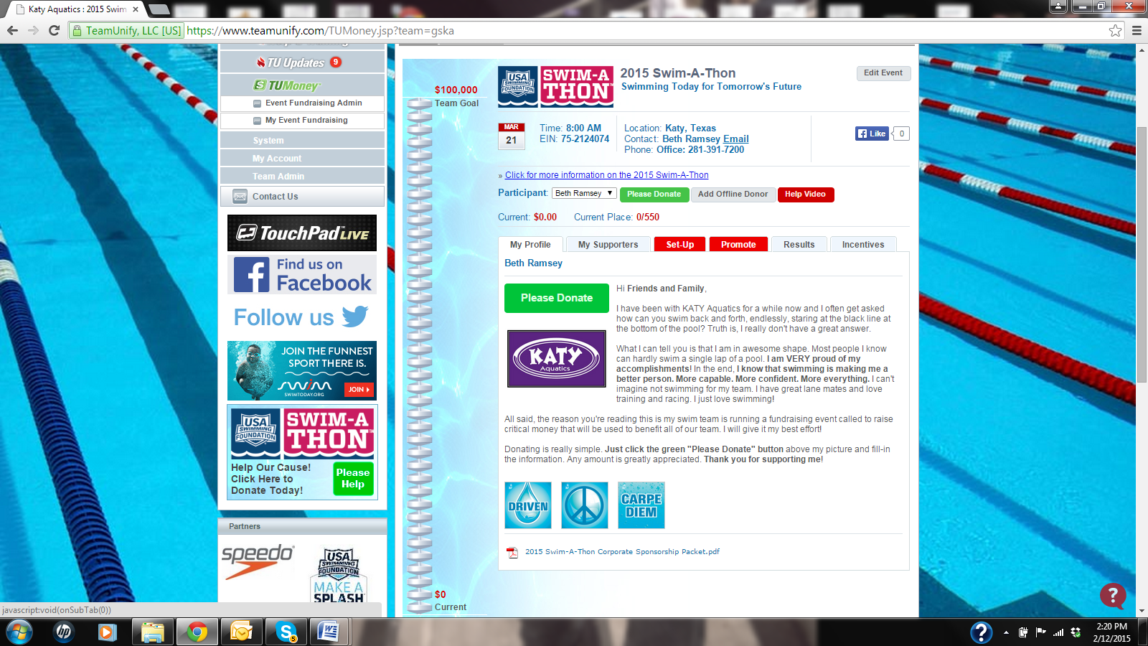
Katy Aquatics would like to thank all families for their support during Swim-A-Thon!
Please feel free to email swimathon@katyaquatics.org if you have any
questions or concerns regarding the fundraiser requirements.

How to Send Pledge Form Letters

- Make copies of the pledge letter on page 7 of this packet or go to katyaquauatics.org and click on ‘Fundraising’ in the top gray bar. Then click on ‘2025 Swim-A-Thon’ to find the file and print all the copies you need.
- Enter the donor’s name at the top of the letter, sign your name at the bottom and add a
personal note.
- Put the address of the donor along with YOUR personal return address on an envelope.
- Place postage on the envelopes and drop the letters in the mail to your friends and family!
Note:
All Swim-A-Thon contributions should be made online at
www.katyaquatics.org
All donations must be submitted by Saturday, March 22nd, 2025.


1806 Avenue D, Suite 103, Katy, Texas 77493 TEL 281-391-7200

Dear _______________________________________________,

I am helping my USA swim club, Katy Aquatics, build a stronger team and I am asking for your support.

Katy Aquatics has made a huge difference in my life. Through swimming, I have learned the power of discipline, teamwork and setting goals. I especially enjoy the fun that comes with this sport when all three of these traits are encouraged by great coaches. Our coaches at Katy Aquatics make swimming more than just exercise. They make swimming an activity that builds character for life.

Katy Aquatics is a premier swim club with over 30 years of history in Katy. Our club is nationally ranked
as one of the top 25 swim teams in the USA and supports the personal development of each individual swimmer.

That is why I am participating in our team Swim-A-Thon on March 22rd, 2025. In 2 hours, I will strive to swim 200 laps (2.84 miles)! That is a lot of swimming, but it’s all for a great cause. A donation made through our Swim-A-Thon fundraiser will help to support my team and keep our swimming programs affordable and accessible to the youth of Katy.
Your pledge will help me meet my goal of $__________ and help Katy Aquatics raise $85,000 towards a stronger future.

The best way for you to make a pledge contribution is online through my Team Unify Donation Webpage at www.katyaquatics.org. It is a secure website where you can use a credit card and donate any amount you desire to our club. All you have to do is search for my name under the ‘Fundraising Participant’ tab.

No matter what amount you choose to donate, please know you are giving to an organization that has made a huge difference in my life.
All contributions are 100% tax deductible – Tax ID# 75-2124074.

Thank you for helping me to reach my goal!

