2025 Safe Sport Impact Award Form
Do you know someone or a group of people who deserve recognition? Nominations for the USA Swimming Safe Sport Impact Award are now open through July 31.
The purpose of this award is to recognize significant achievements by an individual or group who has contributed to the fulfillment of the Safe Sport mission to safeguard all members of USA Swimming from sexual, psychological, emotional, and physical abuse.

NOMINATE HERE

Ohio Swimming Spotlight
Caroline Holmes, former USA Swimming Safe Sport Fellow and current Safe Sport Chair for Ohio Swimming, is preparing for the LSC's annual Safe Sport Pentathlon.
"Every year, Ohio Swimming hosts a meet called the Safe Sport Pentathlon," Holmes said. "It's actually a continuation of my Safe Sport Fellowship capstone project from 2018, and the athletes and coaches get really excited for it! It's an age group meet centered around the five core pillars of Safe Sport, complete with Safe Sport swag, a Safe Sport trivia game, and super fun championship medals."
Earlier this month, Holmes contacted the Safe Sport team for guidance.
"One of Ohio Swimming's goals for this year is to increase the number of SSRPs within our LSC. Because the parent training requirement seems to be the biggest hurdle for many teams, we are hoping to facilitate a training opportunity during the warmup sessions of the Pentathlon this year."
This year, the Pentathlon will be held on November 16 at Ohio University. See pictures for inspiration from last year's meet.
Great job, Ohio Swimming!

  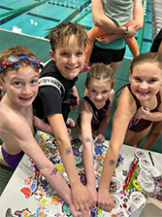
  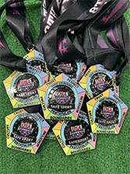
  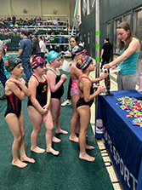

USA Swimming Safe Sport Question of the Month
Participate in USA Swimming Safe Sport's trivia question of the month by clicking the button! It is only one question, and we will share the results next month.
June question: How many clubs are SSRP approved as of June 1? (Hint: There are approximately 2,575 clubs)

ANSWER HERE

May 2025 Trivia Results
Question: What are the permissible hours for electronic communication between an adult participant and a minor athlete?
Answer: Less than 39% of respondents picked the correct answer, which is 5 a.m. - 10 p.m.

SSRP Spotlight
Thank you to all our clubs approved for Safe Sport Club Recognition (SSRP) in April and May
Throughout the two months, 50 clubs were either approved for the first time or renewed their approval status.

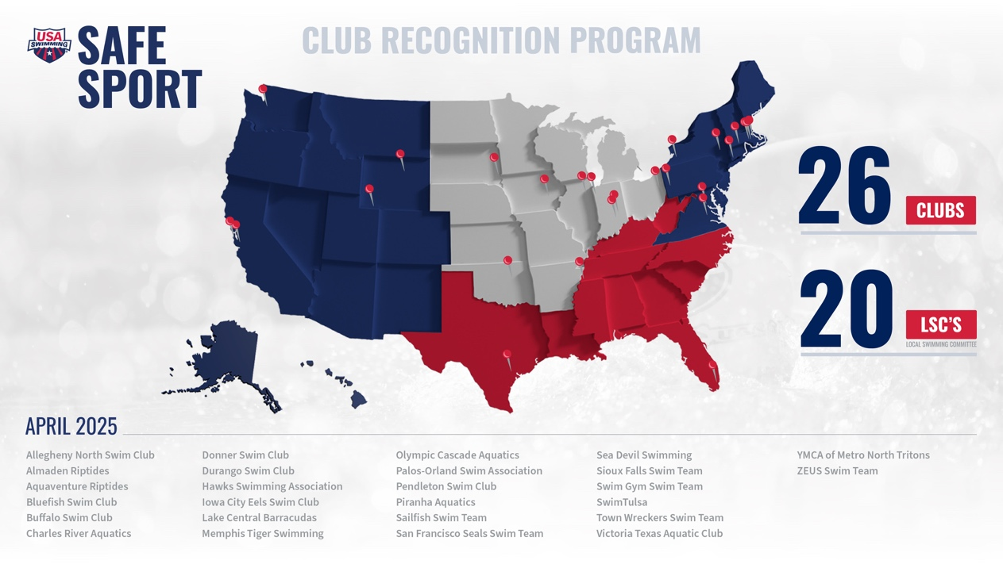

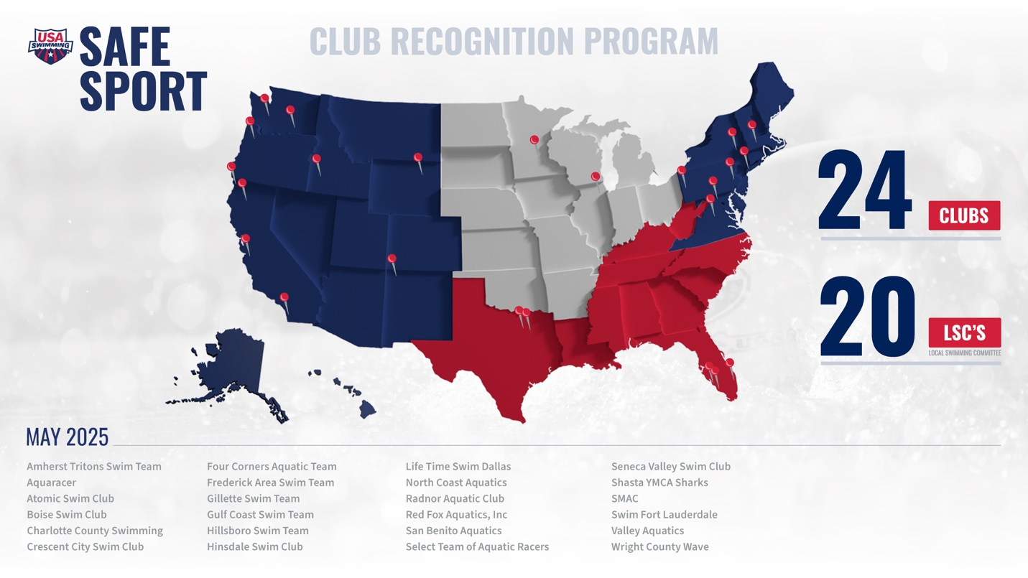

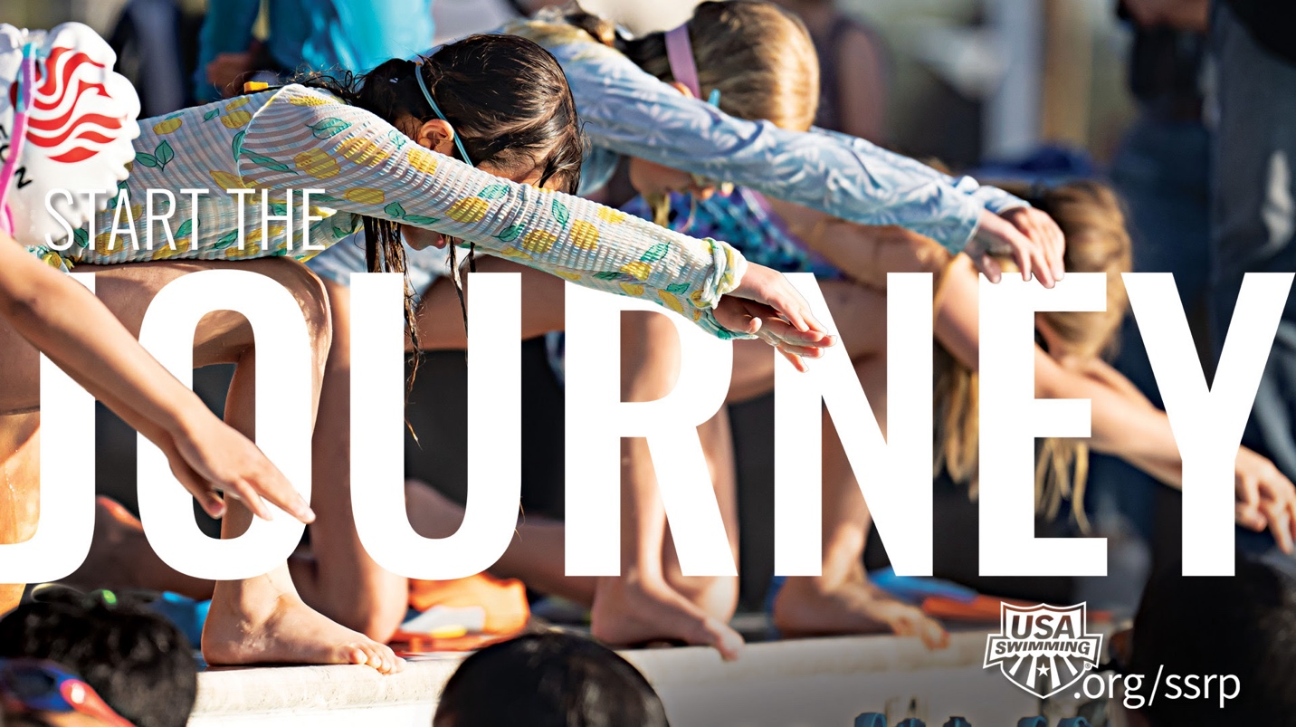

2024 Safe Sport Club Recognition Training
For Parents:
- July 23, 8 p.m. ET | REGISTER
- August 6, 8 p.m. ET | REGISTER
- September 3, 8 p.m. ET | REGISTER
For Athletes:
- July 24, 8 p.m. ET | REGISTER
- August 7, 8 p.m. ET | REGISTER
- September 4, 8 p.m. ET | REGISTER
Members can also participate in trainings online at their own pace through the Education tab on their USA Swimming account. To learn more, including easy-to-follow steps, visit USA Swimming's Safe Sport training page here.

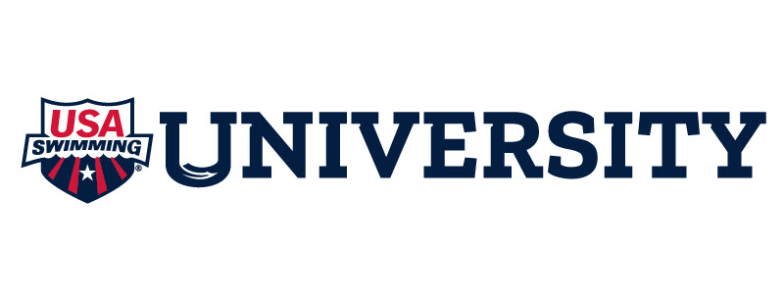

Unable to Attend Live Educational Opportunities?
If the timing doesn't work, that's okay! Log in to USA Swimming University to start and complete courses at your own pace.
Tip: These courses count towards SSRP approval points. If you click these links, remember to log in to earn credit for SSRP approval points.
- For parents: Parents Guide to Misconduct in Sport
- For athletes: SafeSport for Youth Athletes (5-12), SafeSport for Youth Athletes (13-17)

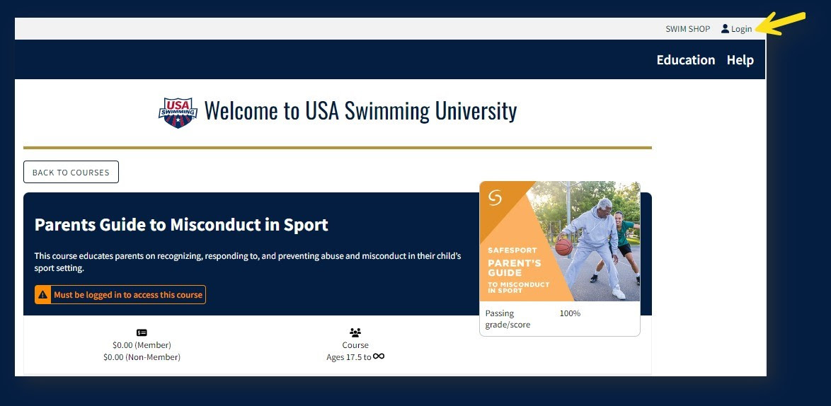

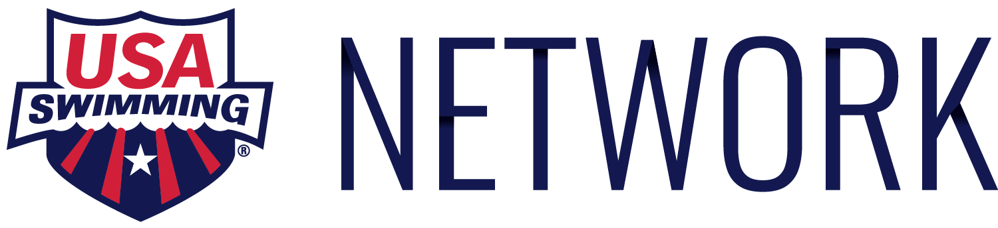

Specialized Safe Sport Content on the USA Swimming Network
Have you downloaded the USA Swimming Network? The free application is available for anyone to download, and has two new Safe Sport videos. To view, click the USA Swimming University content block and scroll to the Safe Sport playlist.
Download the USA Swimming Network on your mobile device, tablet, desktop, or connected TV now.

  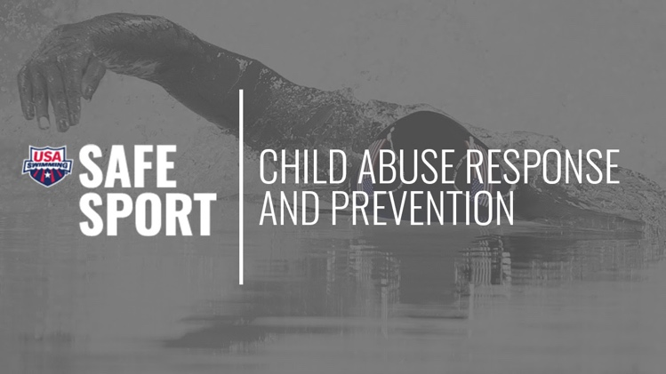
  A Day in the Life
  Watch Liz Hahn and Nikki Patton, USA Swimming's National Safe Sport Committee Outside Expert, as they take viewers on an educational journey at a local child advocacy center.
  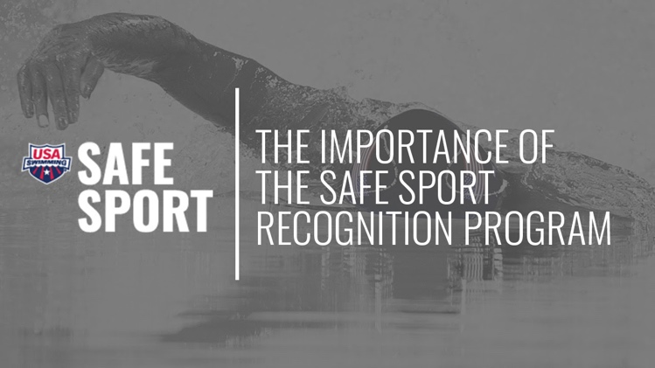
  Life Time Fitness Spotlight
  Hear from Pat Kerrigan, Aquatics Program Coordinator for Life Time Fitness, as she talks about her journey of helping all 28 of the Life Time Fitness swim teams become Safe Sport Recognized.

 |  |  | 

© 2025 USA Swimming
1 Olympic Plaza Colorado Springs, CO, 80909
Update Email Preferences

