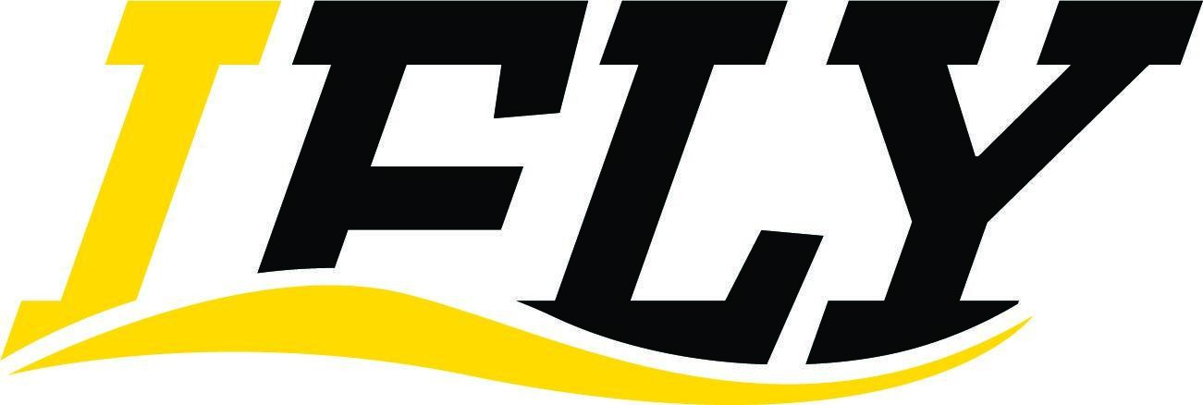 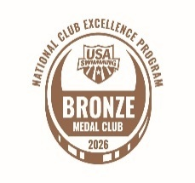2026 LCM Meet Schedule
Dates | Meet | Location | Appropriate for the following groups: | Set-Up (SCY/LCM/TF/P-F)
March 12-15, 2026 | 2026 Spring Sectionals | West Fargo, ND | Qualified Athletes Only | SCY, P/F
April 25, 2026 | 2026 LMST Spring Splash | Marion, IA | DEV, AG1, AG2  +*Select SR2-3 swimmers who need reimbursement | SCY, TF
May 8-10, 2026 | 2026 David Armbruster Open | Iowa City, IA CRWC | All Athletes | LCM, P/F
June 6-7, 2026 | 2026 ICE Splash Out Hunger | Iowa City Mercer Park | Dev ⇒ AG2  + Select SR2-3 swimmers who  need reimbursement | LCM, TF
June 11, 2026 | 2026 Mike Brotherton Intrasquad | Iowa City, IA CRWC | All Athletes | LCM,TF
June 19-21, 2026 | 2026 Waukee Open Summer Invite | Waukee, IA | All Groups | LCM, TF
June 26-28, 2026 | 2026 CW Eric Namesnik | Ann Arbor, MI | Qualified Athletes Only | LCM, P/F
July 9 - 12, 2026 | 2026 CZ Summer Sectionals | Westmont, IL | Qualified Athletes Only | LCM, P/F
July 9-12, 2026 | 2026 BLAST Summer Sizzler | Cedar Falls, IA | All Groups | LCM, P/F
July 18-19, 2026 | 2026 IASI Regional and 8&Under Championships | Dubuque, IA | Athletes not yet qualified for IASI Championship meets & all 8&Us | SCY, TF
July 23-26, 2026 | 2026 IASI LCM Championships | Iowa City, IA | Qualified Athletes Only | LCM, P/F
July 23 -26, 2026 | 2026 Futures Championships | Madison, WI | Qualified Athletes Only | LCM, P/F
July 29 – August 1, 2026 | 2026 Central Zone 14&U Championships | Minneapolis,MN | Qualified Athletes Only | LCM, P/F
July 30 - August 3, 2026 | 2026 Summer Junior Nationals | Irvine, CA | Qualified Athletes Only | LCM, P/F
August 6th - August 9th, 2026 | 2025 CZ 14&U Zone  Championships | Minneapolis, MN | Qualified Athletes Only  IASI Selection “AAA” times required | LCM, P/F
Out of state meets
National level Meets – If needed

