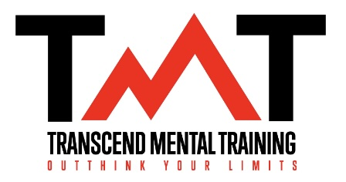

🏊‍♀️ Swimming Between the Ears 🏊‍♀️
How to Train Your Brain for Peak Performance

🧠 Your Brain Wants to Protect You—Not Perform
- Under pressure, the brain defaults to safety by triggering its threat response: tight muscles, slow reactions, fear. Slow decision making
- Mental training helps you shift from survival to performance mode.
  - You will still have nerves. Doubts will creep in and various other thoughts. Mental training teaches you have to show up and compete to the best of your ability despite these thoughts and feelings.
🗣 SELF-TALK: Train Your Inner Voice
- “I have to…” ➝ “I get to…”
- “I’m a bad swimmer…” ➝ “One race doesn’t define me.”
- Use the ABC Model to reframe:
- ABC Example – Faulty Pattern
- A(The event that induces a response or belief): Slow Time
- B(The belief of thought about the event): 'I’m a bad swimmer. I always choke. I’ve let everyone down.'
- C(Consequences of those beliefs): Feelings of doubt, shame, low motivation, negative spiral, another poor swim.
- ABC Example – Helpful Reframe
- A: Slow Time
- B: 'It’s one swim. I’ve trained hard. What can I learn from this?' (YES AND...)
- C: Feels grounded, focused on learning, confidence builds through action

🧘 MINDFULNESS & ACCEPTANCE: YES AND…
- Yes, I’m nervous… AND I’m ready.
- You can be nervous and still perform well. Nerves are good.
- Acceptance creates space to focus on What’s Important Now (W.I.N.)
- “I came to cross the river, not fight the alligators.”
- River = Your Goal is on the other side
- Alligators = Doubts, distractions, nerves, comparisons
- Focus on the process even when discomfort is present.

🌀 ROUTINES = ANCHORS
- Think Box = Mental prep
- Swim Box = Swim, trust your training
- Recovery Box = Recover, Reflect, Refocus, Re-energize
- Make sure you recognize the things you did well in addition to what needs to be improved

🖼 VISUALIZATION & IMAGERY
- Mental reps train the brain like physical reps train the body
- Picture the best, worst, and unexpected so you’re ready for all outcomes

🔥 PRESSURE = OPPORTUNITY
- Nerves = energy. Use it.
- You earned this moment. Excellence over perfection.
- Keep expectations low and standards high.

💪 CONFIDENCE IS A BEHAVIOR
- Confidence is not a feeling, it’s something you do
- Build it through small wins and hard work
- Trust your preparation—remind yourself what you’ve done to be here
- You do not need confidence to swim well. You need trust and trust is built on preparation

✅ FINAL REMINDERS
- Focus on being YOUR best, not THE best
- Embrace discomfort—it’s how you grow
- Train your brain like you train your body

