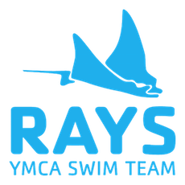
YMCA of Rock River Valley Stingrays
MAAPP 2.0 Acknowledgement

I acknowledge that I have received, read and understood the Minor Athlete Abuse Prevention Policy and/or that the Policy has been explained to me or my family. I further acknowledge and understand that agreeing to comply with the contents of this Policy is a condition of my membership with the YMCA of Rock River Valley Stingrays.

Name:

Signature:

Date:

