

ISI Admin Official
Webinar
Facilitator Notes

Introduction

About your role: Think of yourself as guide, discussion leader, facilitator, wise sage, meet referee as you pull together the asynchronous learning your participants have done in EdPuzzle. Put a face on officiating and give life and encouragement to continuing the process. Hopefully, with some pre-webinar suggestions, your participants will be eager to engage and ask questions to finish off this phase of their training. It will be important to get to know your folks during the introductions and to read their engagement on the screen.

About your audience: These folks have spent 1.5 hours watching 7 Edpuzzle videos that are very thorough.
- Admin is divided chronologically – videos divided by following a meet from entries to seeding, being a timing judge, taking event data and making results and one on general AO information.
- The other units detail how to be an official and training and certification details.

Net: The people in your webinar are not starting from scratch. Previous webinars have shown good knowledge of the material. Think of your audience as newer on-deck trainees or officials in an officials’ briefing.

About Zoom: A different environment in which to share and discuss information: it’s a tad sterile, somewhat disconnected, and harder for you to read body language and for folks to just jump in with a question. Your assistant/question monitor will help with some of this – you will adapt and get good at the medium. At the least, you should know how to switch from sharing your screen (and the PowerPoint) and “just” displaying participants. The “Brady Bunch” gallery during a discussion is another way to engage folks and keep them on topic. Explore using the annotate feature – it’s an informal way to have people mark your screen for important points. And the white board feature – if you just need to record ideas that people are throwing out, this is a good way to confirm with a visual.

About the PowerPoint: this is a visual guide, not intended to be a full clinic presentation, and certainly not created as your script to read. It’s an aid to keep you on track, and keep folks focused. Become familiar with its sequence and content and make it your own. When a slide is marked as transition, just use it as a road map or a spot for a short break. Subsequent slides in that section will help you through the actual material, and you don’t want to get ahead of yourself. You may have your own questions to ask the group and spark discussion, but some are provided here just in case!

About pacing your webinar: Create a timeline for how you will divide your session. Make your focus the timing adjustments, as that does not translate as easily to videos. Registration/On-Deck Training/Certification usually takes some time to field questions, so be sure to allow for that. Use the parking lot image to “park” questions that you will get to later.

Slide Notes



- Admin Official Webinar
  - This is a waiting room slide to use as you let people into the webinar
  - Engage folks to welcome, turn their video on and unmute (at least for the time being)
  - Ask them to change their name to include their club – name or acronym
  - Take attendance
  - Make small talk, start engaging
  - Try to start close to on time; latecomers can join in progress

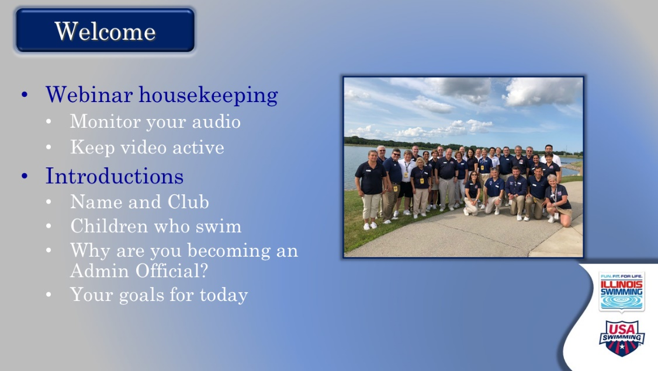

- Welcome
  - Official start
    - Offer a warm welcome and introduce yourself.
    - Thank them for their time and commitment
  - Offer basic meeting notes
    - Keep video active
    - Remain on mute when not talking
    - Use “raise hand” function (may need to direct to this)
    - They can jump in directly with questions
    - Will take at least one break
  - Introductions
    - Do introductions with these components. Start with yourself.
      - Who are they?
      - What club?
      - Children who swim
      - How have they gotten into officiating/swimming in general?
      - Goals for the day
    - Consider stopping your screen share for gallery view after you set this up

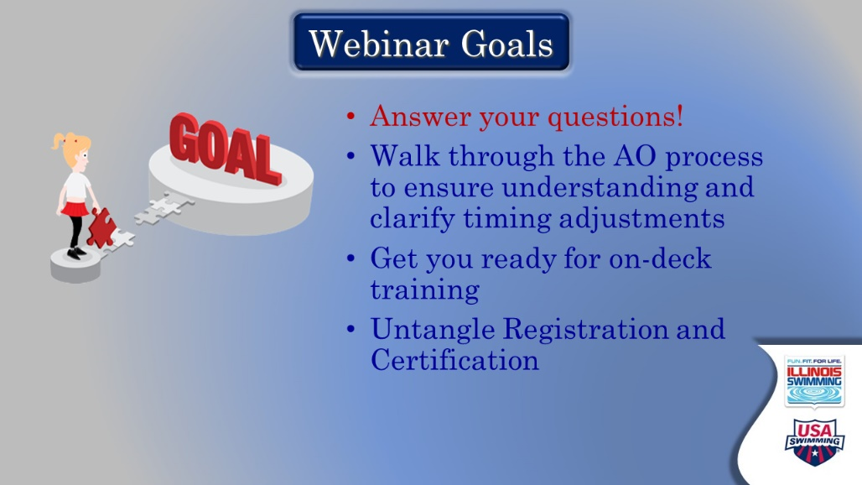

- Webinar Goals
  - You are setting the tone with this slide, with emphasis on answering questions and clarifying rules and issues sparked by their EdPuzzle learning and swim meet experiences
  - Display slide with a “here’s what we’re going to do today” and let participants read
  - Reiterate raising hand or jumping in with questions
  - Suggest a “parking lot” for a question that isn’t in the current flow, or will come up later

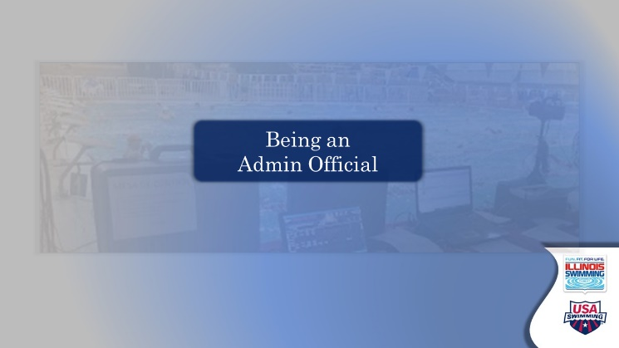

- Being an Admin Official – TRANSITION SLIDE
  - Set-up along the lines of: We’re going to start with some basics of being an official…

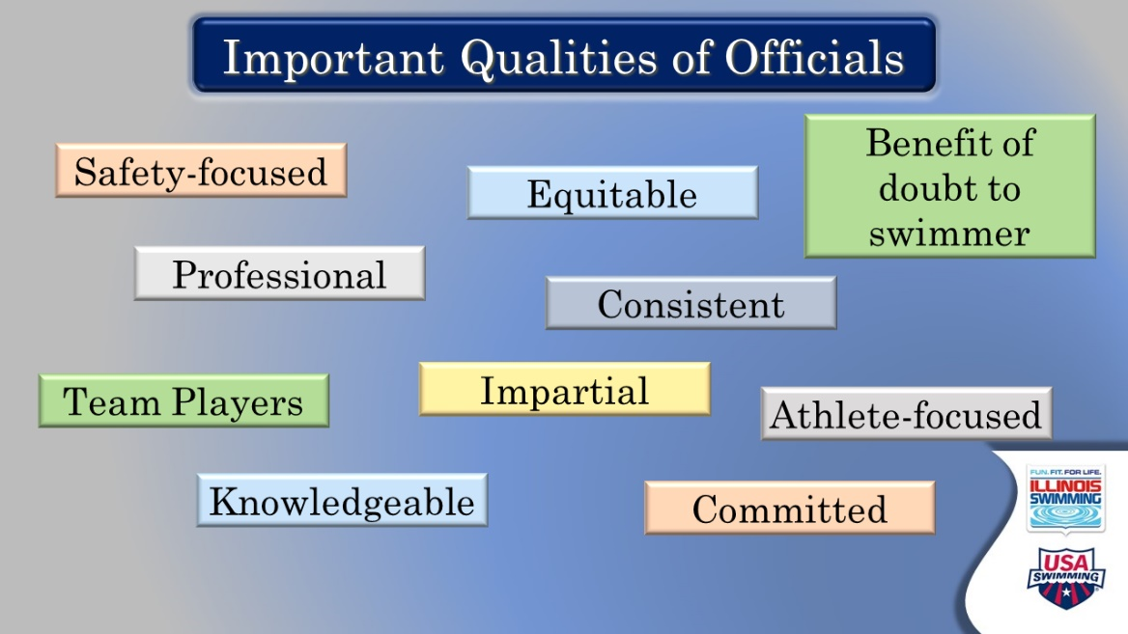

- Important Qualities of Officials
  - Ask: Thinking back to your videos and your observations of officials on deck, what qualities are most important for officials? If no one volunteers, start to call on people.
  - If comfortable with the ANNOTATE feature – ask everyone to put a mark near or on their top three
  - Ask if any qualities are missing, or shouldn’t be there
  - Summarize the top qualities and really emphasize their importance, maybe with a quick example or by asking participants to elaborate
  - Potential comments/questions:
    - Safety is our number one priority, physical and psychological (Hence SafeSport and Athlete Protection)
    - We look and act professional, and work as a team
      - We wear uniforms to identify ourselves, but also to blend in
    - What does benefit of the doubt mean in terms of administration?
      - You are going to make decisions on time and “give them the faster time” isn’t a criteria – your decisions affect not only the athletes you are making adjustments to but everyone in the event.
    - We don’t cheer on deck

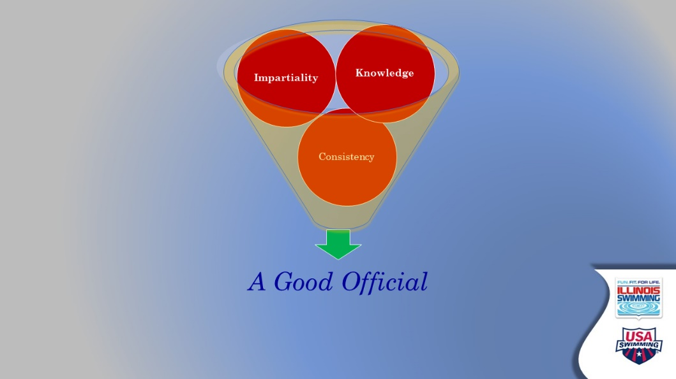

- Good Official Funnel
  - Use this visual to pull your discussion of important qualities together
  - Key qualities go into a funnel -- Impartiality, Knowledge, Consistency – to create a good official
  - Segue to next transition slide by reiterating our goal to create knowledgeable, impartial and consistent officials.



- AOs Power Meets
  - Smooth operations
    - A lot of the things that make a meet start on time (or late!) are admin functions.
    - The ability to keep up – post results, get awards out – that allow teams to plan days, parents to leave the building, etc., are admin functions.

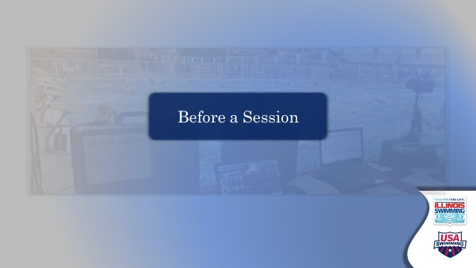

- Before a Session
  - Here’s where we’re going next- we are going in the same order as the videos, and starting with some basics

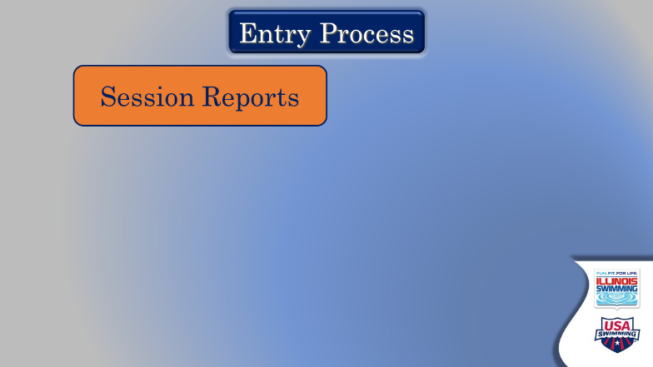

- Entry Process – 1st of 4 connected slides
  - Most of the next four slides stress the importance of knowing your meet packet and working with your meet referee to implement the contents of it, with some straight-out USA Swimming rules.
  - “Session reports”
    - Used to determine the timeline
    - Briefly discuss the four-hour rule. It is the referee’s call, but if you are the entry chair, you should always be watching the timeline during the process. Enter one team, check the timeline, enter another, then check…over and over.

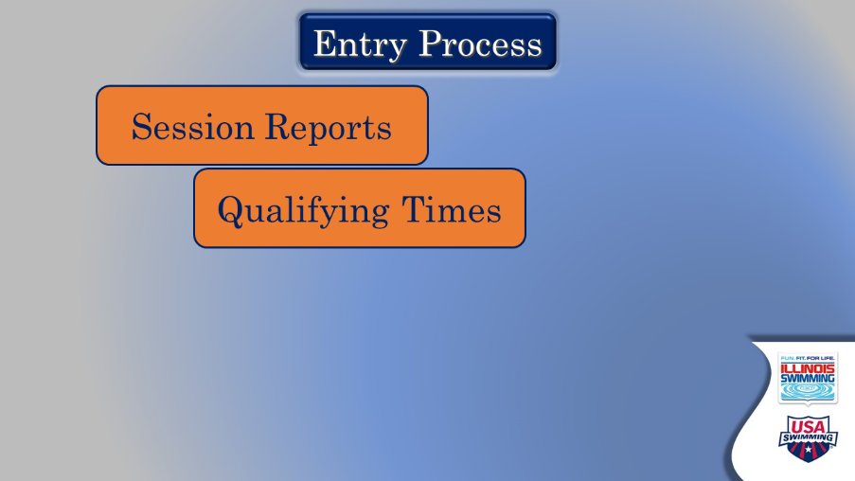

- Entry Process – 2nd of 4 connected slides
  - Qualifying times
    - Another issue for entries at some meets
      - There is an exception report for this.
      - Pop-up messages in the entry merger process of Meet Manager.

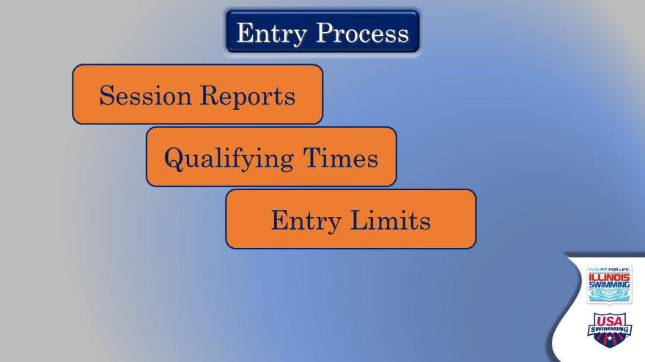

- Entry Process – 3rd of 4 connected slides
  - Entry limits
    - Another exception report
    - Total per session, total per meet, depending on the meet.

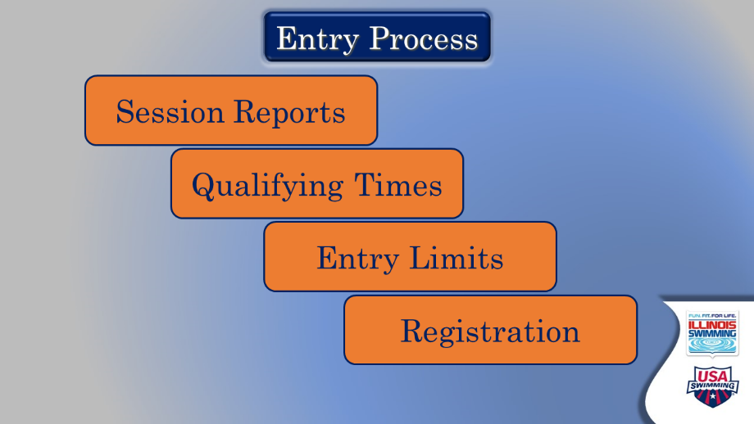

- Entry Process – 4th of 4 connected slides
  - Registration
    - Meet Recon process through Illinois Swimming
      - Sent to office the week ahead and all the athletes are checked for registration. They are given time to correct.
      - Importance of knowing the difference between sanctioned, approved and observed meets.

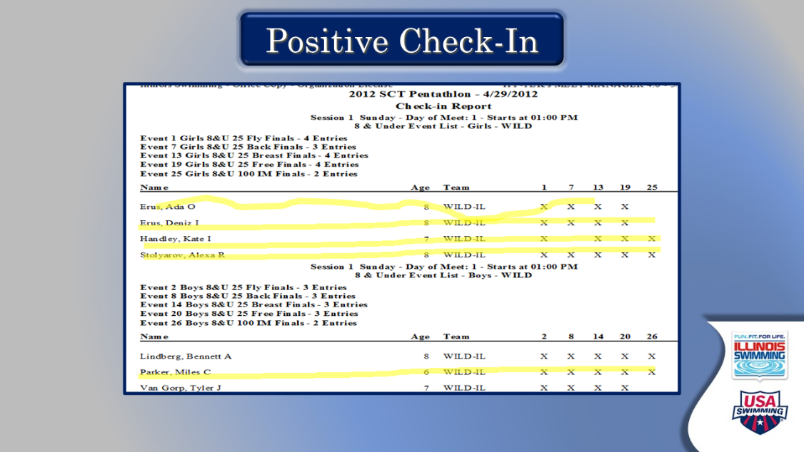

- Positive Check-in
  - Ask: what do you do when you are unsure what is highlighted?
  - Individual events? What happens if there are empty lanes?
  - Ask: Better to have an empty lane or to try to find room for an athlete?

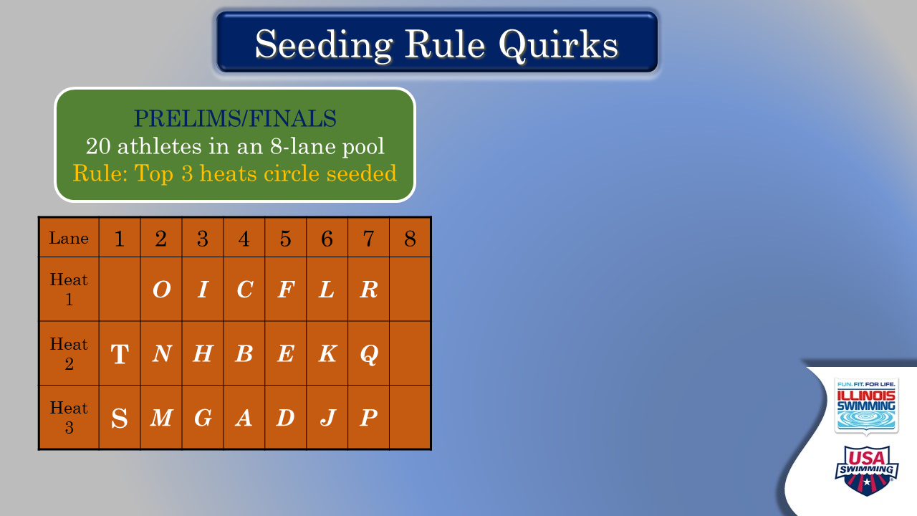

- Seeding Rule Quirks (1 of 2 slides)
  - Start with circle seeding
    - Ask: When do you see this?
    - Quirk – no athletes in lane 8
    - Quirk – Events over 400 only circle two heats

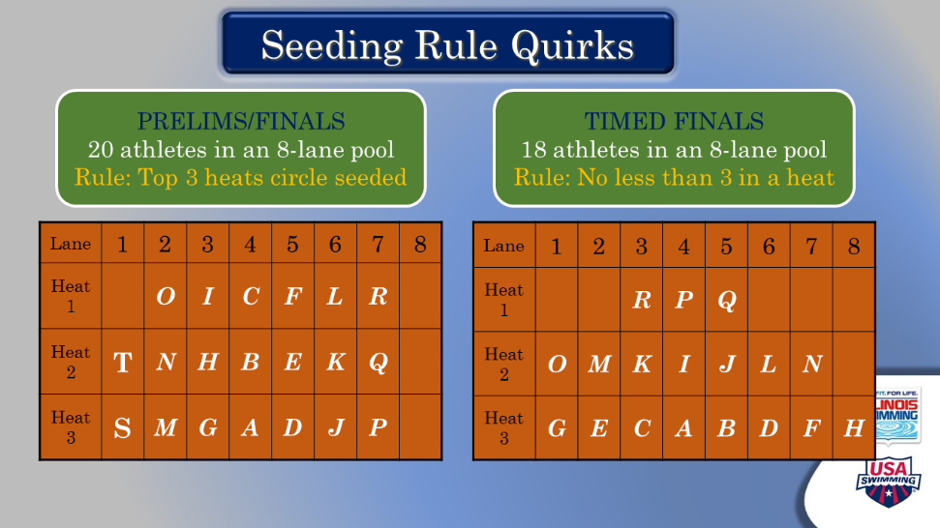

- Seeding Rule Quirks (2 of 2 slides)
  - Ask: when do you see this?
  - Quirk – minimum three swimmer in a heat
  - Quirk inside a quirk – exception to 3 in a heat is at finals, if you have 9 swimming in an 8 lane pool for instance.

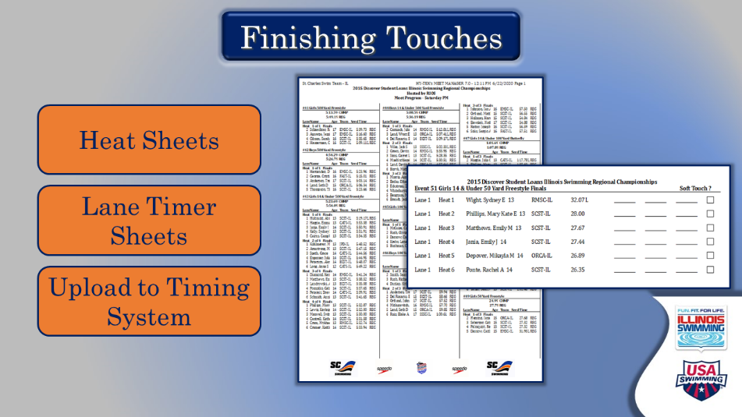

- Finishing Touches
  - These are the things required to get moving at the beginning.
    - Start the transition from entries to running a meet
    - Talk about starting on time, and the mad rush that the end of this time on deck is.
    - Important take away: remain calm, and have a mental checklist
    - Have they ever been to a meet that started late? How did they feel about it? What impact on the swimmers?

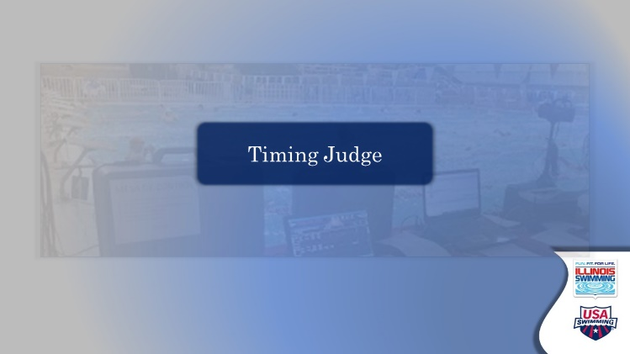

- Timing Judge – Transition Slide
  - Going into the most detailed part of the presentation – what is the time? Should you take a break?
  - Questions about previous information?
  - Understand general role of timing judge? To select the “correct” official time from the data.

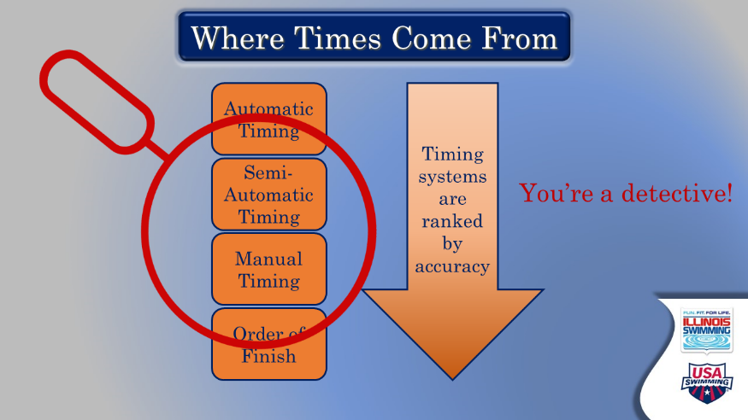

- Where Times Come From
    - Despite the basic nature of the slide there is a lot here:
      - Order of preference of the timing systems – auto, semi-auto then watches
      - Ask: What is the minimum number of watches and timers?
        - Three if primary
        - Always must have one watch despite existence of buttons
      - Why always one timer?
    - You’re a detective – we take data, determine its usefulness, compare things, contrast things, and make a determination.
    - It’s an art, not a science.

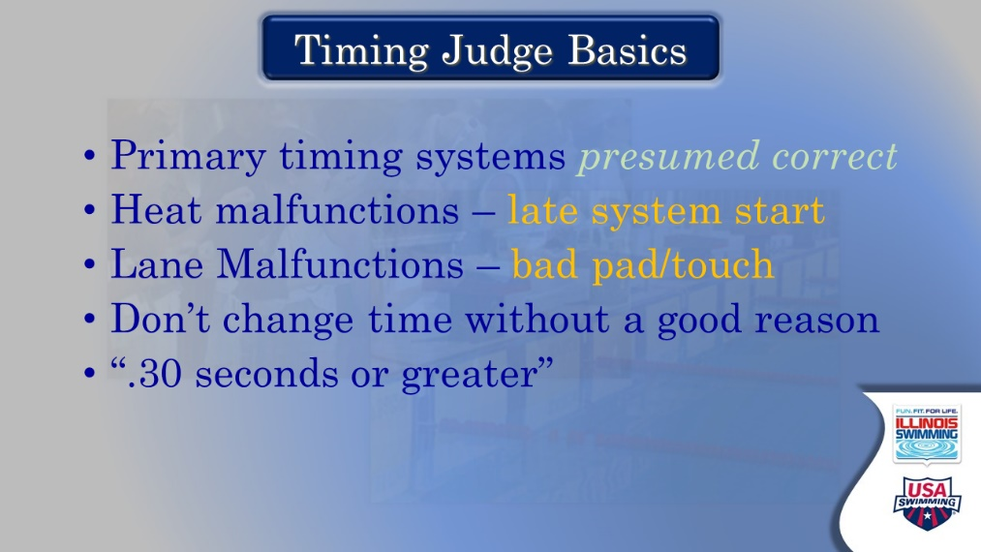

- Timing Judge Basics
    - These things are always true and form the basis of the decision making process
      - Primary system presumed correct unless evidence supports taking the time away
      - Ask: Which do you do first – heat or lane malfunctions?
        - Why? Heat applies to all lanes equally – done first then you check for lane (individual) problems. It makes it similar to the normal process.
        - Correcting a lane first would skew the heat calculation
        - Don’t use bad data in your heat calculation.

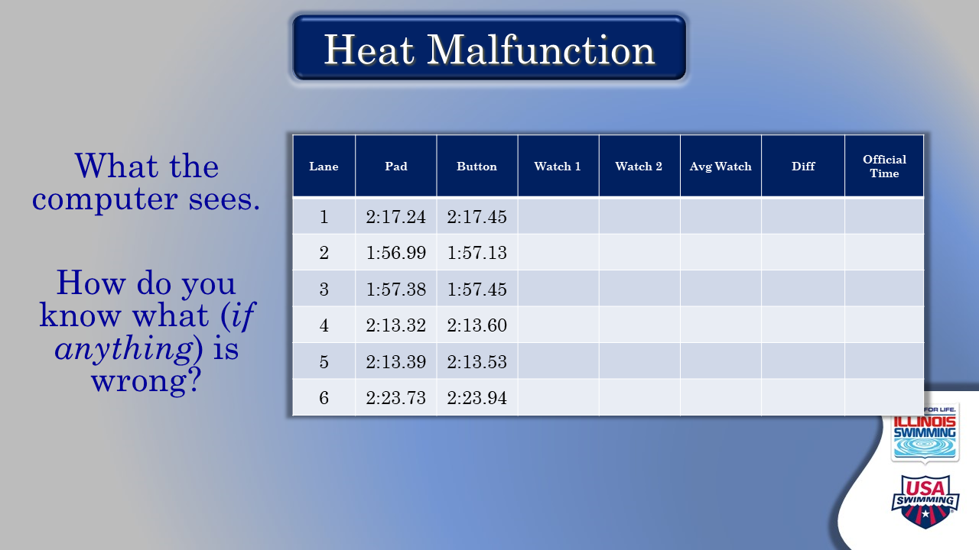

- Heat Malfunction (Slide 1 of 4)
  - Here they have the basic inputs they would see when doing a meet, before the timer sheets come in.
    - ASK: How do you know
      - Hard at this point, unless system operator has let you know. IT looks the SAME.

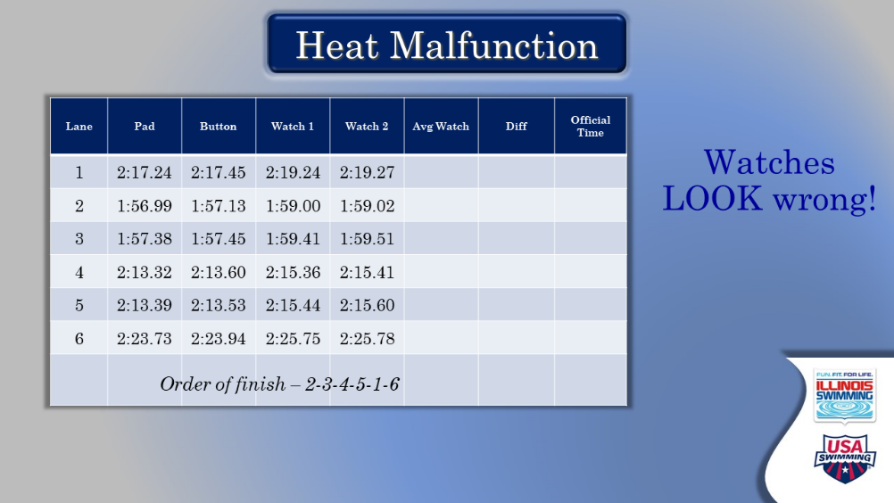

- Heat Malfunction (Slide 2 of 4)
    - You may not know until you see watches.
      - Should check every heat, even if not flagged in the computer. Especially when you are behind the events in the water.
      - May seem tedious, but only checking one lane per heat would at least give you the red-light warning to look closer.

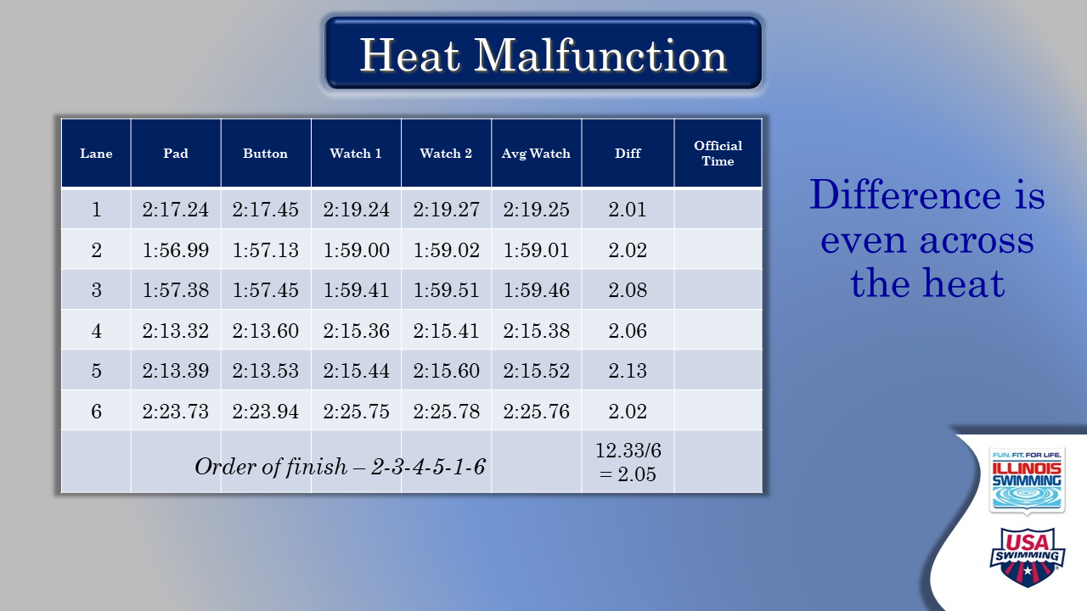

- Heat Malfunction (Slide 3 of 4)
  - This is where we start the calculation portion – after determining.
  - ASK: what would you do if one of the lanes was out of line with the rest of the lane’s differentials?
    - You can ignore – use the others as the calculation. In this example – what if one lane had average watches of 3.0? Or even 2.5?
  - ASK: do they understand the math?
    - Meet manager will do the calculation but you always have to know what MM is doing to be able to find the exceptions lie ignoring a lane.

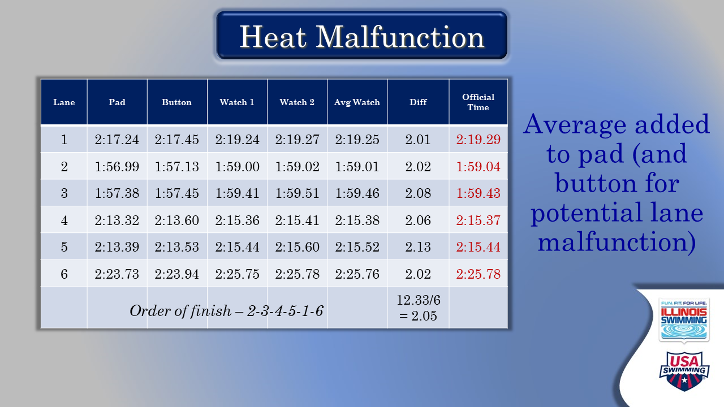

- Heat Malfunction (Slide 4 of 4)
  - This simply ties together the work of the previous slide into a final answer
  - Here is a good time to recap the steps and ask if there are questions on the calculation.

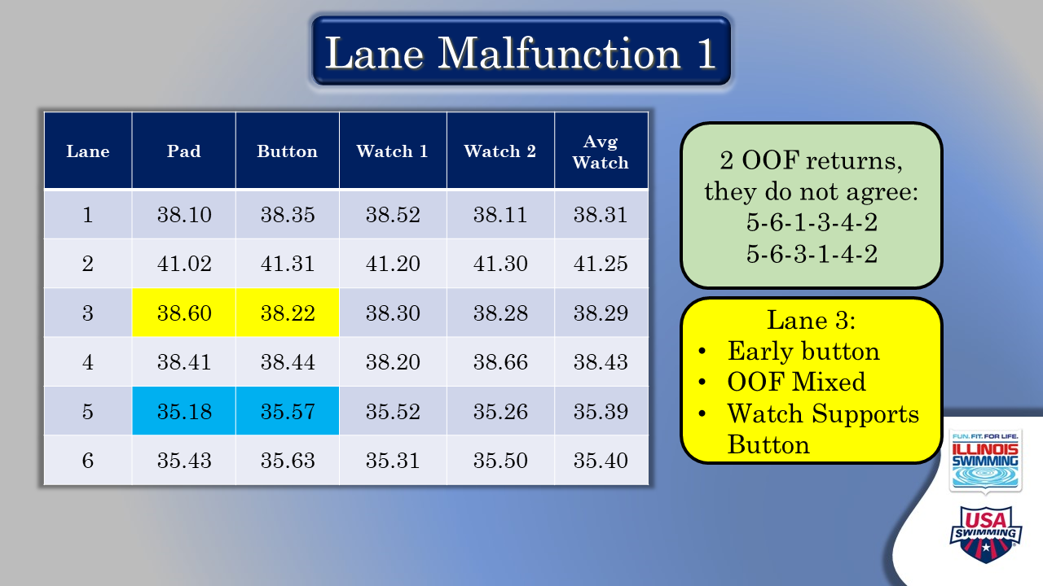

- Lane Malfunction 1 (Slide 1 of 2)
  - This is the material they saw in the videos, so we start with a recap.
    - Lane 3 first – this is, on its face, obvious, but the quirk is the difference in the OOF.
    - If they use the pad time, it puts lane 3 behind lane 4, which is inconsistent with BOTH OOFs.
    - ASK: what is the real value of OOF? How much do you rely on it? What is it best used for? (confirmations)

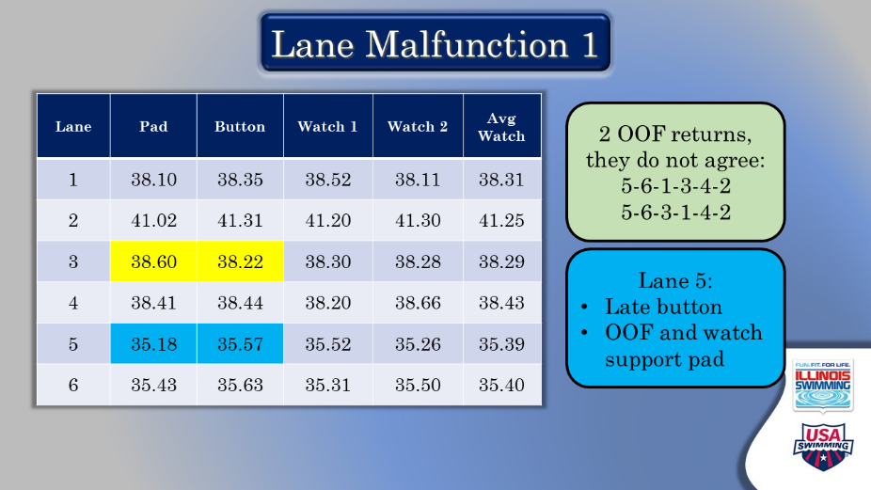

- Lane Malfunction 1 (Slide 2 of 2)
  - Lane 5 second – no real reason to think about them in this order – just how the example is set up.
    - Average watch and OOF support pad.
    - Have button and one watch late.
    - ASK: same timer? That would explain. Can they ask? YES.

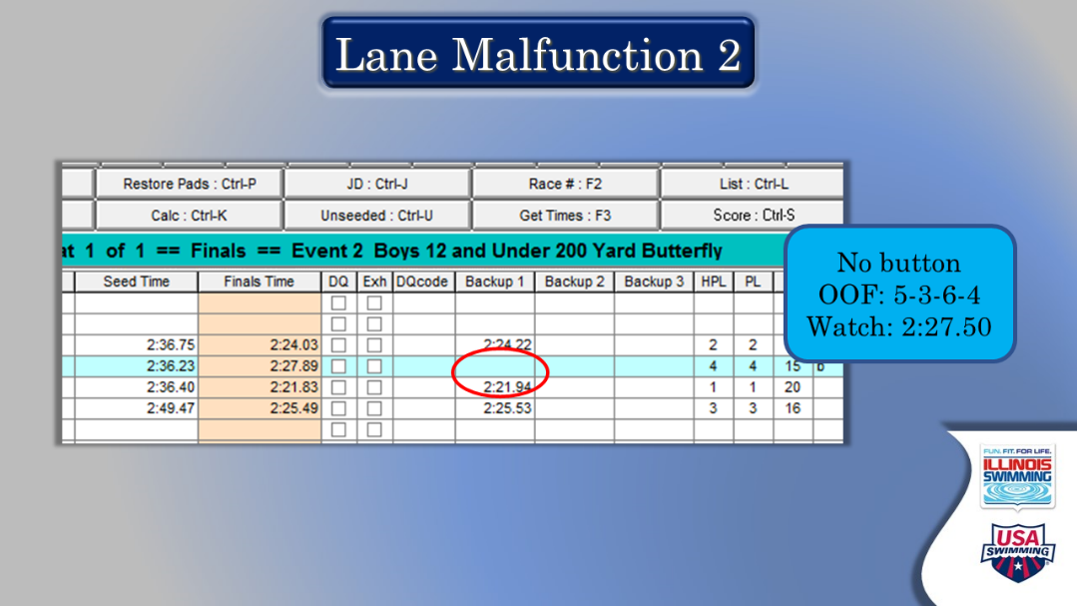

- Lane Malfunction 2
  - We are going to go through several Lane Malfunctions, highlighting some of the common things they will see.
  - Here – no button.
  - Watch is .39 faster – QUIRK. Generally, you get watch support for the pad and move on.
  - What do you do here? The OOF is of no consequence to your answer.
  - In truth – either is a supportable decision.
  - ASK: what can you consider?
    - Past history of the timer – consistently early watches? Erratic? Always right on it? All of these can be considered.
  - REITERATE: detective skills – look at more than what is right in front of you.

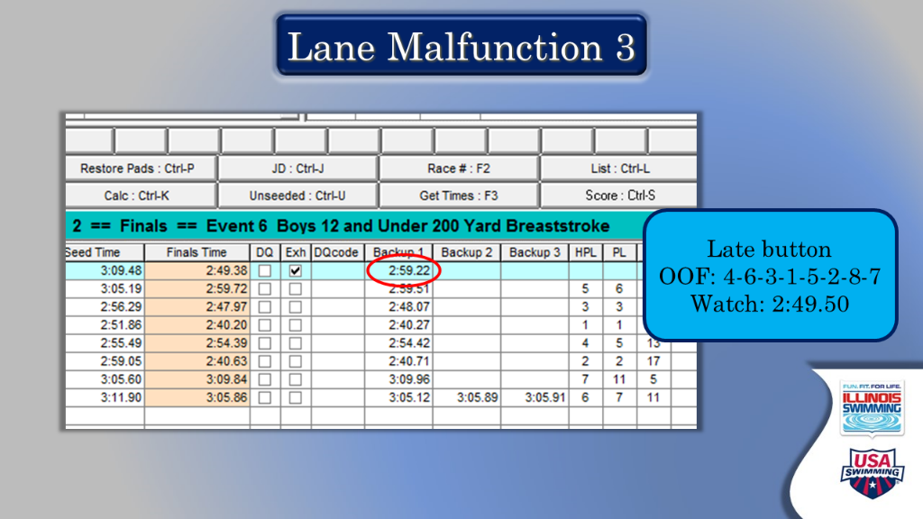

- Lane Malfunction 3
  - Late Button, watch supports pad.
  - NOTE- it is irrelevant and odd that the swimmer is marked as Exhibition – has nothing to do with the problem but can discuss what that means.

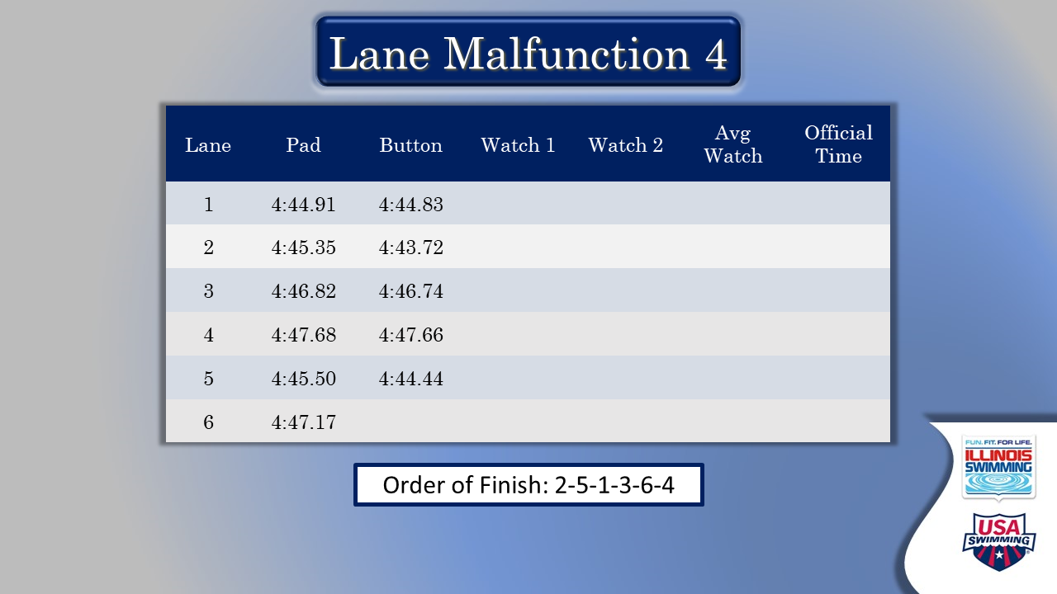

- Lane Malfunction 4 (Slide 1 of 3)
  - Tying some lane malfunctions together.
  - First slide does not have the highlighting
  - ASK: can you name the three problems?
    - Lane 2 – early button
    - Lane 5 - early button
    - Lane 6 – missing button

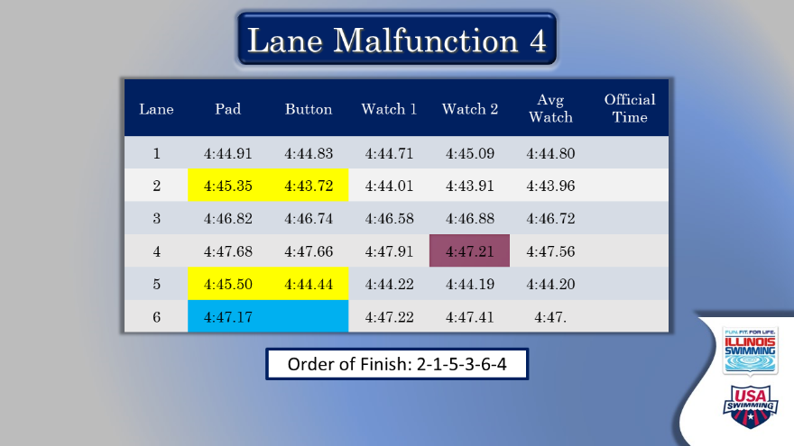

- Lane Malfunction 4 (Slide 1 of 3)
  - What do you do with Lane 2?
    - Early Button
    - Watch and OOF support button
  - What do you do with Lane 5?
    - Watches support button
    - OOF does not
    - I would go with button time, but you can ask questions about the OOF to the judge who took it. Or think about the quality of OOF you have seen before.
  - What do you do with Lane 6?
    - Watches and OOF support pad.
  - Why is there a watch time highlights in lane 4
    - Further discussion of the ides of aberrant information in your stream.

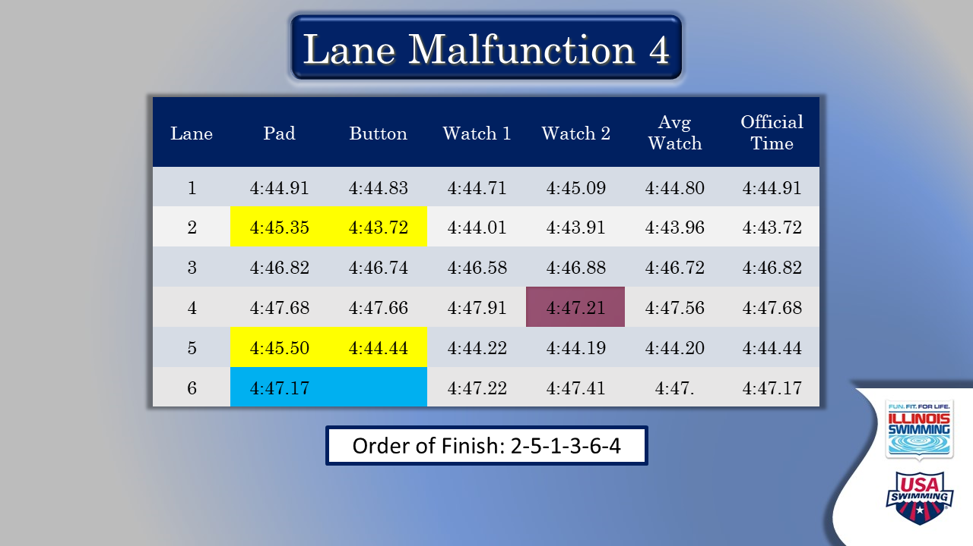

- Lane Malfunction 4 (Slide 3 of 3)
  - Answers – consistent with the information above.
  - Seek questions!



- No Traditional Data
  - “Admin nightmare”
  - First – how do you know?
    - Best way to know is that the referee reports a different number of “no shows” than are on the meet management software.
    - Otherwise – can get late complaint from coach that no result is available.
    - Best if you are checking counts – the longer this problem exists the less ways there are to fix it.
  - Second – fundamental rule: NO SWIMMER SHALL RESWIM BECAUSE OF FAILURE OF TIMING SYSTEM.
  - What can you look at?
    - Coach’s watch
    - Head timer?
    - OOF – time in the middle of the people around them. Ask the judge – close to one or another?
    - I once put a watch on a video replay.
    - Just think – where might information be available.



- Finishing Events and Scoring – Transition Slide
  - Excellent time for a break if needed!
  - Going to wrap up the inputs into results

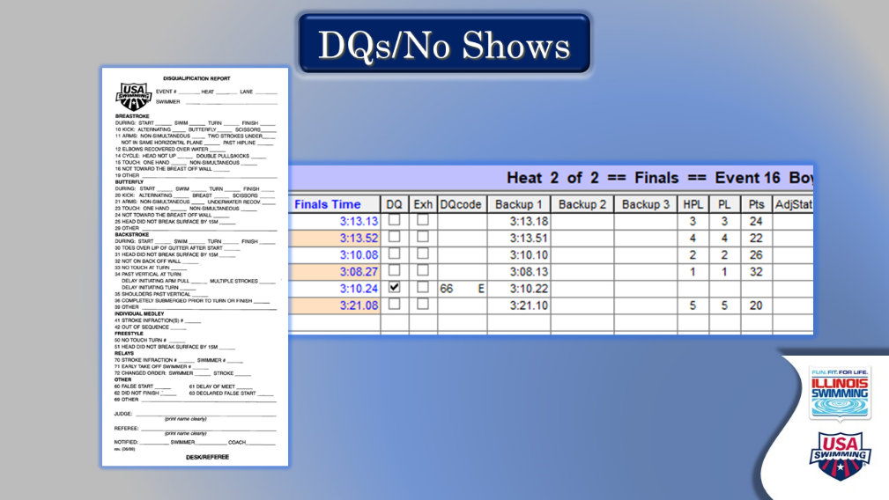

- DQs and No Shows
  - Get the slips and enter
    - Drop down menu (only allows one code)
    - Verify slip is signed, correct information.
    - Check name against heat and lane – send stuff back to the referee if it is not correct/consistent
  - No-Shows
    - Correct counting can allow you to avoid finding out late that you have a “no data” problem.
    - Is this a penalty meet?
      - This was in the videos
      - ASK: what are the penalties?
      - ASK: How do they know (look in the meet packet)

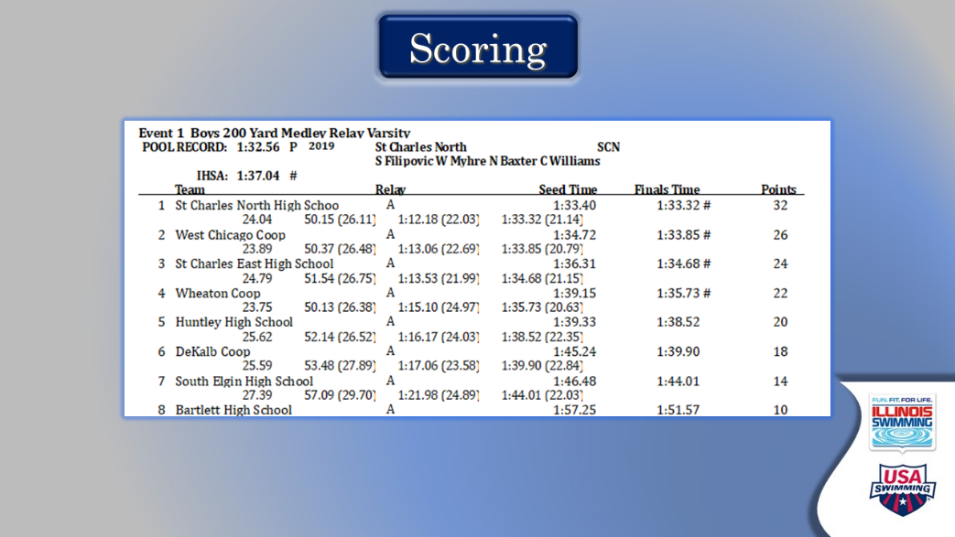

- Scoring
  - Once everything is in:
    - Do the results look right?
      - Did you certify a world record by mistake?
      - Do your DQs and No Shows look the way they should?
  - Awards?
  - Labels?
  - Know your meet packet

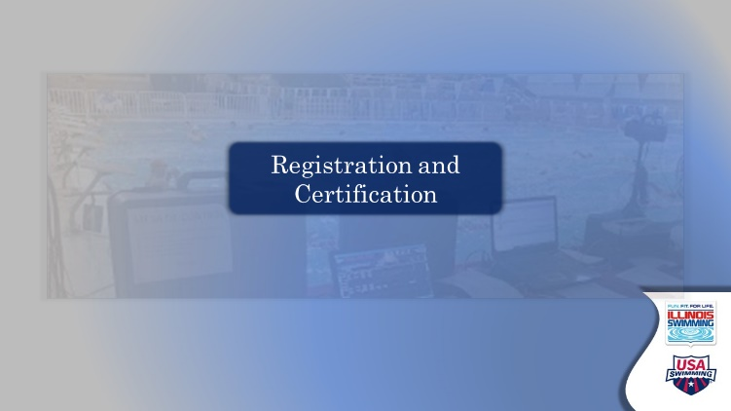

- Registration and Certification – transition slide
  - Unless there are any other questions regarding officiating, set up the final section to cover registration and certification information

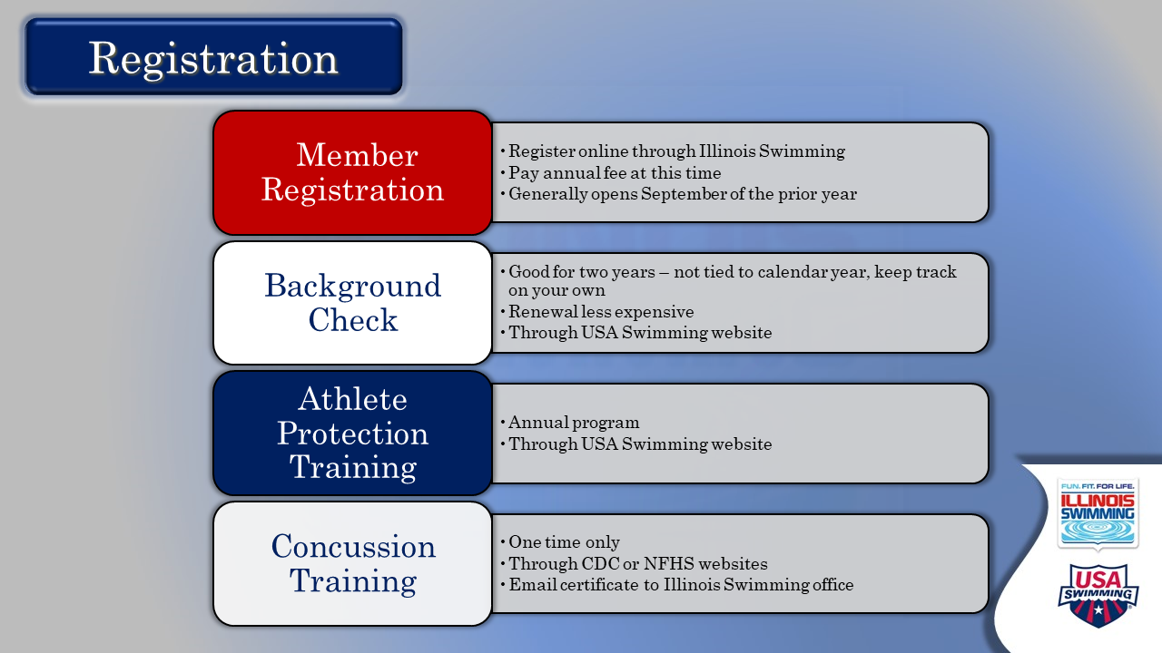

- Registration
  - There’s lots of info on this slide, and it has been covered in an EdPuzzle unit. Generally, there are questions and clarifications.
  - Best approach here – let audience read the components, then ask for questions
  - At some point, EMPHASIZE: Registration is handled by Illinois Swimming office and must be completed before beginning on-deck training.
  - Information for you to have at your fingertips, should questions come up. You DO NOT want to read/go through all of this:
    - WHY registration?
      - Athletes, coaches and officials – along with some other volunteers – must be registered members of USA Swimming to participate in the organization’s activities.
      - Helps promote safety
      - Provides liability insurance to clubs and venues for events, and supplemental insurance to members.
      - Most of the fee goes to USA Swimming. About 15% of it goes to Illinois Swimming to fund programming for athletes.
    - WHAT and HOW?
      - Step one: complete online non-athlete registration form on ilswim.org and submit annual dues. Once this is processed and accepted, they can move on
        - Credit card processing is $3. Annual dues are $81 for 2021 – and at this time, will take you through to December 2021. (This information is as of June 2020).
      - Step two: create a USA Swimming account at usaswimming.org, which is needed for background check and APT. This links to the Officials Tracking System (OTS), which they also will want access to going forward.
      - Step three: on the SafeSport page, apply for a background check (good for two years). This has to be done through usaswimming.org’s vendor, even if they already have a background check through another outlet.
        - Usually takes 4-10 days, unless you live in some counties in New York, or have lived internationally. That causes a little time lag.
      - Step four: also, from the SafeSport page, take the Athlete Protection Training course. (good annually)
        - Point out that updates and renewals are shorter and cheaper than the initial instance of these things.
      - Step five: complete a concussion training unit, either from the National Federation of High Schools or the CDC. Send certificate of completion to the Illinois Swimming office. This is done once in a career.
        - This can be done anytime but does not link to the account on its own.

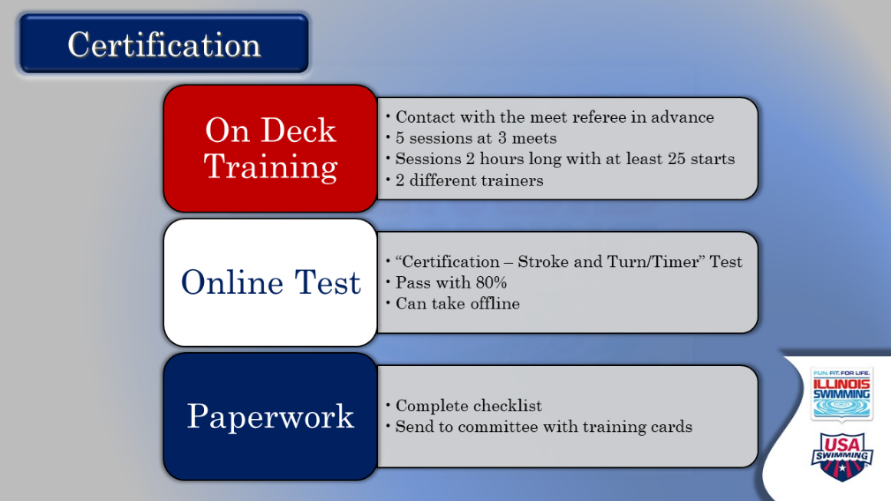

- Certification
  - There’s a lot on this slide as well. Start by letting them read it all – then ask for questions. (Detailed info provided below for your reference)
  - On deck training is the thing most new officials are most excited about or most nervous about or both. Therefore, it leads to the most questions. Make sure you start making people feel welcome on deck at this juncture.
    - Reinforce contacting the Meet Referee in advance to arrange training and review how to do that.
    - Review the uniform (white collared shirt, navy bottoms (not denim), predominantly white non-slip athletic shoes)
    - Remind them to print training cards to bring to sessions, along with cards from prior sessions
    - Share what to expect
    - Training requirements have been designed to give a variety of different experiences and time to see a lot of different things in the water.
  - Test info:
    - Available on USA Swimming website in Officials area – linked to USA Swimming account
    - Can take now, during on-deck training or after
    - Take the CERTIFICATION test, not RECERTIFICATION
    - Current rule book needed; download in .PDF from USA-S website.
    - Easier to download the whole test and complete, before going back to fill in answers.
  - Paperwork
    - Certification check list online
    - Complete and mail to Committee
  - EMPHASIZE that officials’ certification is handled by the ISI Officials Committee and is distinct from membership issues.
    - Once they are members, their initial officials’ card (which can be printed from OTS or accessed through Deck Pass) will show their position as T for trainee. When certified, it will change to C. Need to have this to get on deck.

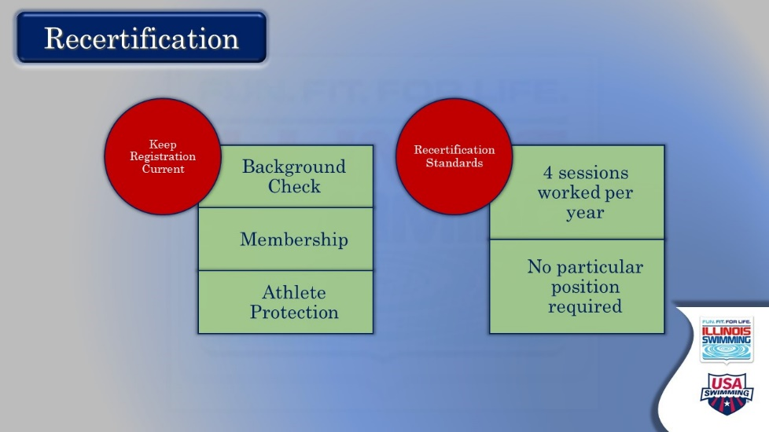

- Recertification
  - Topline the fact that we renew our membership and recertify every year as officials.
  - Let them read the two components. Entertain questions.

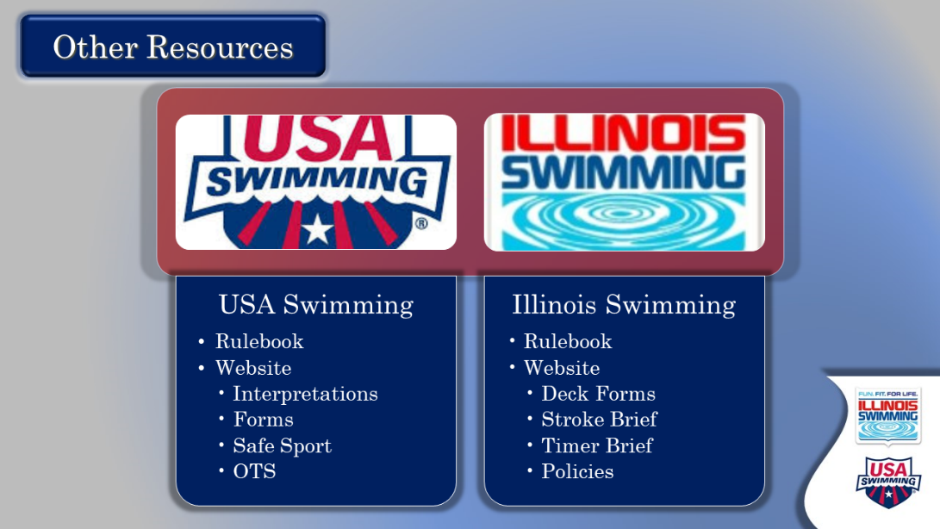

- Other Resources
  - The purpose of this slide is to remind them that they have lots of online help when they have a question or need more information.
  - After making that comment, let them read. Entertain any questions.
  - Comment that Officials Committee sends periodic newsletters with the most up-to-date information and reminders about all things officiating.



- Feedback – are you ready to go?
  - This is a genuine attempt to get some real-time feedback on the effectiveness of our training process and identify what might be missing, or what’s coming up on deck. NOTE: attendees also will be sent an email with a feedback instrument.
  - Ask each person for their assessment of how they feel about moving on deck and what they will need going forward.
  - Close by thanking them for their willingness to join the ranks of officials and taking the time to learn the process. Reassure them that it will take time to become comfortable, and that there will be a lot of support from officials at their club and at meets.

