

ISI Referee
Webinar
Facilitator Notes

Introduction

About your role: Think of yourself as guide, discussion leader, facilitator, wise sage, meet referee as you pull together the asynchronous learning your participants have done in EdPuzzle. Ideally, with some pre-webinar suggestions, your participants will be eager to engage and ask questions to finish off this phase of their training. It will be important to get to know your folks during the introductions and to read their engagement on the screen.

About your audience: These folks have spent about 1 hour watching two Edpuzzle videos that are very thorough:

- False Start Scenarios
- Start Process

Net: The people in your webinar are not starting from scratch. Previous webinars have shown good knowledge of the material. Think of your audience as new referee trainees almost ready to go on deck.

About Zoom: A different environment in which to share and discuss information: it’s a tad sterile, somewhat disconnected, and harder for you to read body language and for folks to just jump in with a question. Also, harder to demonstrate things, like whistles and hands. Your assistant/question monitor will help with some of this – you will adapt and get good at the medium. At the least, you should know how to switch from sharing your screen (and the PowerPoint) and “just” displaying participants. The “Brady Bunch” gallery during a discussion is another way to engage folks and keep them on topic. Explore using the annotate feature – it’s an informal way to have people mark your screen for important points. And the white board feature – if you just need to record ideas that people are throwing out, this is a good way to confirm with a visual.

The question could arise – why don’t we include appropriate video snippets of starts in this webinar? Comment that embedding recorded video in the Zoom video platform does not deliver quality results.

About the PowerPoint: this is a visual guide, not intended to be a full clinic presentation, and certainly not created as your script to read. It’s an aid to keep you on track, and keep folks focused. Become familiar with its sequence and content and make it your own. When a slide is marked as transition, just use it as a road map or a spot for a short break. Subsequent slides in that section will help you through the actual material, and you don’t want to get ahead of yourself. You may have your own questions to ask the group and spark discussion, but some are provided here just in case!

About pacing your webinar: Create a timeline for how you will divide your session. On-Deck Training/Certification usually takes some time to field questions, so be sure to allow for that. Use the parking lot image to “park” questions that you will get to later.

Slide Notes



- REFEREE TRAINING WEBINAR
  - This is a waiting room slide to use as you let people into the webinar
  - Engage folks to welcome, turn their video on and unmute (at least for the time being)
  - Ask them to change their name to include their club – name or acronym
  - Call attention to the emoji feature – you may ask for a thumbs up or a round of applause during the webinar
  - Take attendance
  - Make small talk, start engaging
  - Try to start close to on time; latecomers can join in progress

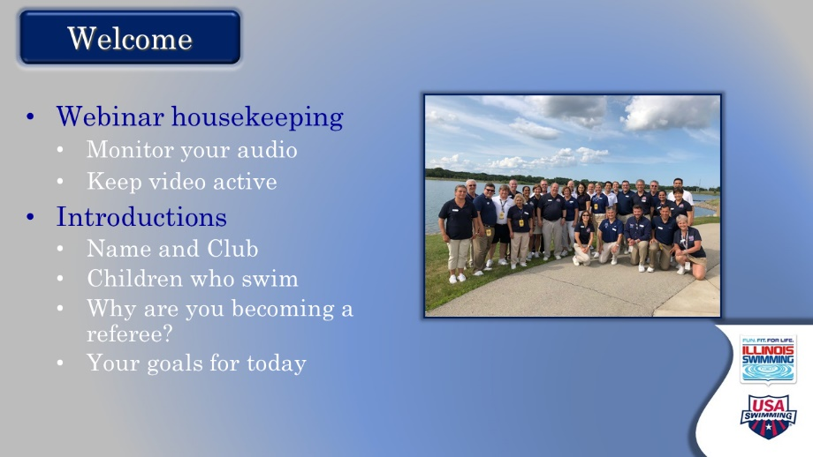

- WELCOME
  - Official start
    - Offer a warm welcome and introduce yourself.
    - Thank them for their time, commitment, and willingness to move up to referee
    - Comment that the referee’s role on deck is different than the others they have trained at – need to have a more thorough understanding of the rules and take a global view of the meet.
  - Offer basic meeting notes
    - Keep video active
    - Remain on mute when not talking
    - Use “raise hand” function (may need to direct to this)
    - They can jump in directly with questions
    - Will take at least one break
  - Introductions
    - Do introductions with these components. Start with yourself.
      - Who are they?
      - What club?
      - Children who swim
      - Why are they moving up to referee?
    - Consider stopping your screen share for gallery view after you set up this task (better interaction among participants)

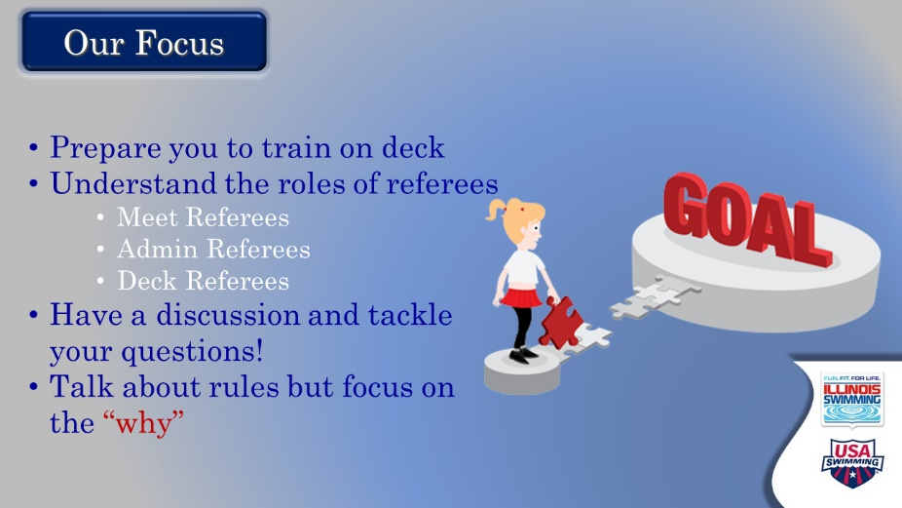

- OUR FOCUS
  - Set-up: Here’s a look at what we hope to accomplish today.
  - Then let them just read it
  - Emphasize the hope to have good discussions, to field outstanding questions, and to provide a good understanding of the who’s and why’s of being a referee
    - Nothing will replace actual on-deck training to develop referee skills
    - They will not “know” the rules when we are done. This like all other training elements is designed to help them and to be one of the building blocks of a good referee.
  - OUR FOCUS: Get them thinking about why we do things the way we do. On deck training will help them master the mechanics of the position, but a referee must understand why a meet works the way it does, why certain procedures are followed, etc.



- THE CORE PHILOSOPHY – TRANSITION SLIDE
  - Transition into the broadest part of the content, the basic rules a referee lives by.
  - It takes time to become a competent, then good referee.
    - Rather steep learning curve for referee, and at times intimidating
    - Always be learning, watching, listening – always want to grow
    - Give examples of things you learned recently, or of bigger learning moments in your career as referee.
  - IT IS FUN TO BE A REFEREE, DESPITE THIS LEARNING CURVE.



- SAFETY
  - We are going to come back to this a few times, and not a lot needs to be said other than what is on the slide but:
    - Referees are responsible for the physical, social, and emotional well-being of the athletes.
    - It’s why we will talk about Athlete Protection, SafeSport, and MAAPP (Minor Athlete Abuse Prevention Program) in this webinar.
  - Possible discussion point: to solicit ways that referees do this (briefing deck marshals, working with meet director on MAAPP implementation, checking equipment for cords, sharp spots, etc.)

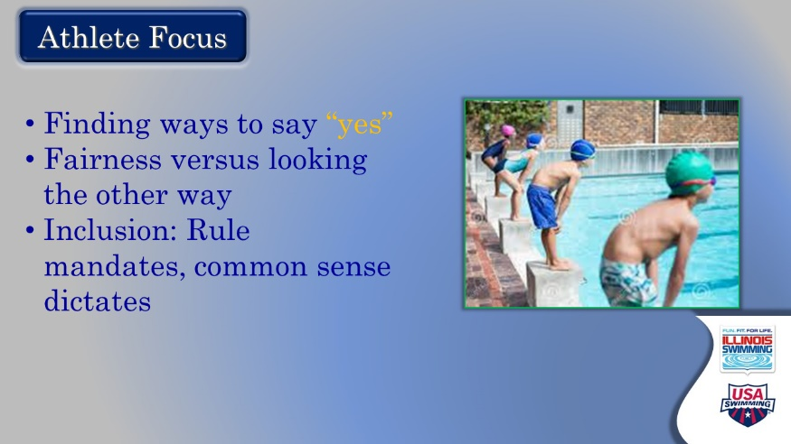

- ATHLETE FOCUS
  - Referees are the “keeper of the rules,” but that does not mean we are looking to say no to things. Like a stroke judge we should always be thinking of the benefit of the doubt for the swimmer.
  - Fairness is not doing what makes an athlete happy – you must think about the other swimmers in the heat, event, meet…
    - Possible discussion point: what are some things that a referee can do that set a precedent for the rest of the meet?
  - Inclusion of athletes is something we will discuss later – but it is something to stress that the referee must be aware of and work towards.

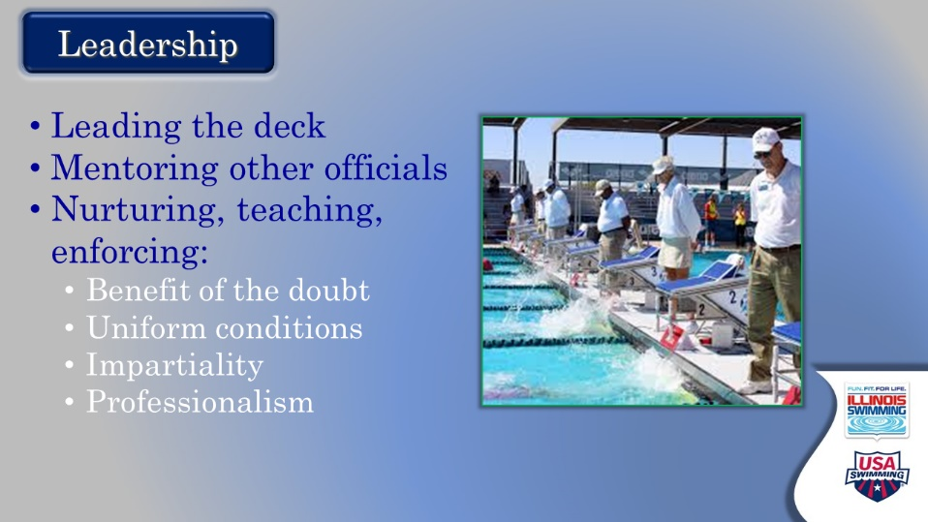

- LEADERSHIP
  - This is a larger facet of being a referee than in other positions.
  - Things to think about/discuss:
    - Dealing with coaches
    - Working with judges and other officials with training and upholding the philosophy
    - Creating and managing the environment for optimum athlete experience
    - Talk about what they have seen both good and bad in this regard
    - Remind them that they are to be mentors to younger officials now - by input and example, both active and passive
      - Give a shout out to new officials, celebrate accomplishments
      - Always be willing to share your experiences and mistakes
      - Be willing to communicate away from meets
      - Help newer officials and those from other clubs to meet other officials and incorporate them in the social scene

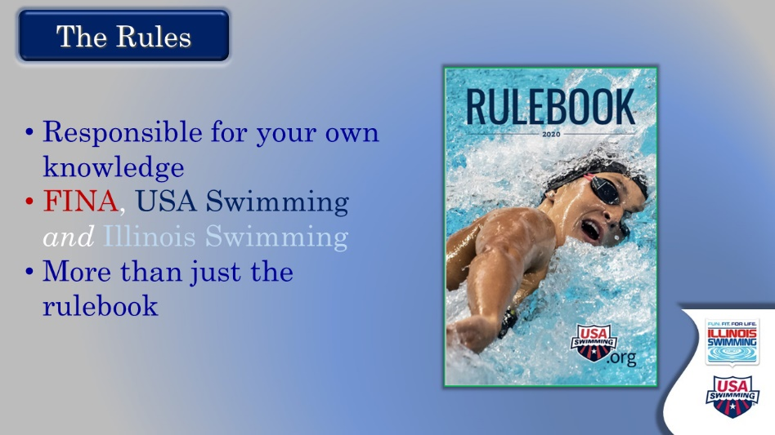

- THE RULES
  - There are lots of rules to know as a referee beyond the stroke rules.
    - Referees should take learning seriously
    - Administrative and stroke rules, but also: meet/session structure and set up, training rules, Code of Conduct, etc.
  - This can be daunting to a new referee.
    - Did you know all the rules when you started?
    - How did you learn? Can you share a story of your own growth or having been mentored?

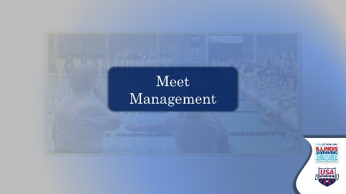

- MEET MANAGEMENT - TRANSITION SLIDE
  - These slides are going to cover things that happen to make sure a meet runs.
  - Some of these issues are “Meet Referee” jobs, but all referees should be aware of them and be willing to help.
  - We will outline these things in the next slide.

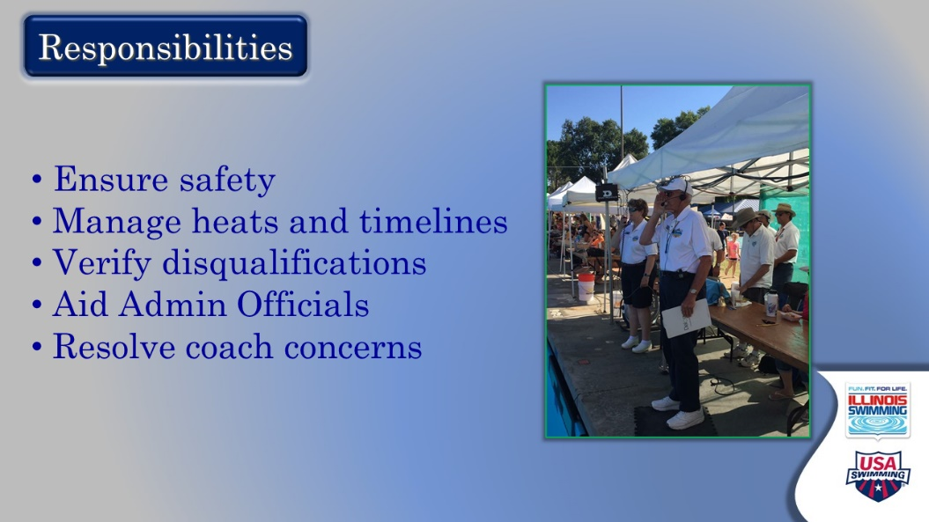

- RESPONSIBILITIES
  - First, a basic overview
    - These are the basic job titles of a referee and we will be going into each as we move along. We are starting to stress at this point that referees do more than blow the whistle.
  - Different types of referees do different things.
    - Meet referee – involved in all aspects of the competition, adherence to rules, adherence to meet packet
    - Deck referee – owns events – primary place for coaches to discuss issues, arbiter of calls
    - Admin referee – At larger meets, a referee with strong admin background who oversees the work at the table
  - Talk about how a good referee team works together, following chain of command and staying in their lanes

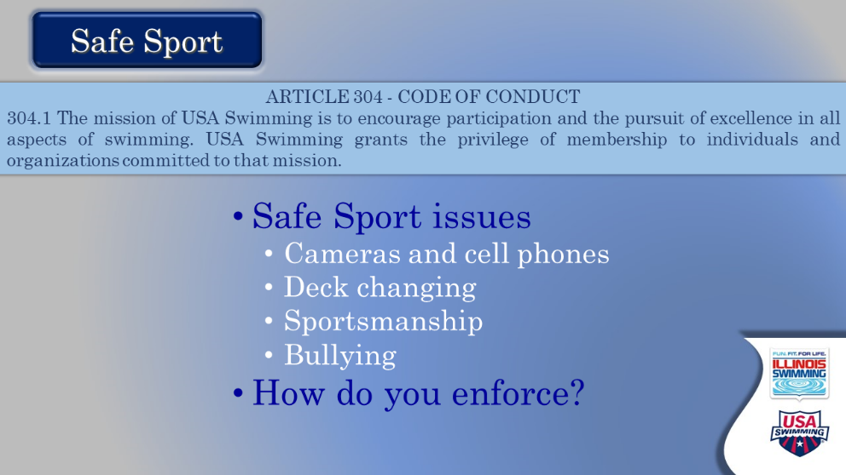

- SAFE SPORT ISSUES
  - The quote is from the introduction to the Code of Conduct and need not be read.
    - The examples are those common things contained in the code of conduct, but the posed question is the important thing: how does a referee enforce these things?
      - State a few basics – working with the meet director and other volunteers and stressing that a lot of this is working with coaches.
      - Is it appropriate for a referee to deal with an athlete directly on these issues? When?
      - What happens if there is a big issue, or you cannot resolve it well on deck? Do you HAVE to report things to Safe Sport?
        - Some yes – think about APT, and some no – bad language.
    - They are not just looking at athletes though, as a referee has a responsibility to oversee other officials and should be willing to discuss conduct of coaches when appropriate.

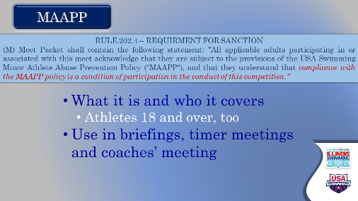

- MAAPP
  - First off – the acronym is for “MINOR ATHLETE ABUSE PREVENTION POLICY.”
  - It is not the Code of Conduct, directly, it is a system of policies put in place to further the aims of the Code of Conduct that need to be adhered for sanctioning.
    - The document is in their pre-webinar materials and they should be encouraged to read the document and learn to include them in their pre-meet meetings with officials, coaches, and timers.
    - 18-year-old athletes are now taking APT!
    - Here are some MAAPP concepts:
      - Communication between coach and athlete – always involves a parent
      - Interruptible contact with athletes
      - Designated locker rooms when possible for Under 18 athletes
      - Important to designate restrooms officials can use
    - Role of officials when they see a violation or concern
    - Refer to USA Swimming website for more information on MAAPP – become knowledgeable

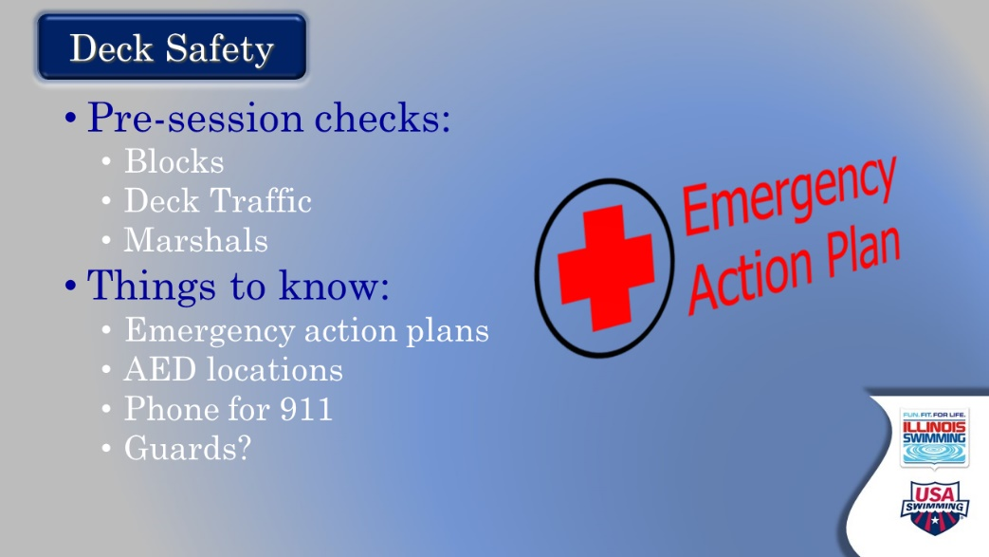

- DECK SAFETY
  - Before they were checking blocks, and wires as a starter. That is part of this.
  - Deck Safety at any facility requires thinking globally.
    - Deck traffic
    - Facility emergency action plans
      - Are their lifeguards? A medical marshal?
      - Where are the AEDs, or a phone?
      - Who handles bleeding incidents?
    - Remind them that all accidents on the deck require a Report of Occurrence
      - Can be submitted online through the USA Swimming website.
      - May also have to do paperwork for the facility.
      - Good time to work with the Meet Director!

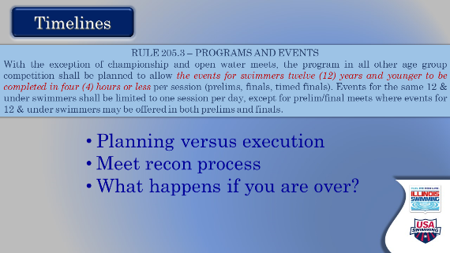

- TIMELINES
  - This is a pre-meet issue, so we start with it.
  - The four-hour rule is widely misunderstood so spend some time working through it, but at its simplest:
    - Session must be PLANNED to be completed in 4 hours.
      - What is the difference between planning and execution?
    - Meet recon
      - Meets go to ISI office a week ahead of time and the timelines are reviewed. You must submit plans to get under 4 hours if you have over entered the meet.
      - You can expect a reasonable scratch
      - You can limit entries in events allowed by the meet packet
  - Additional ISI Rules/Interpretations:
    - 203.3.1 – Timed final days limited to 10 hours; prelim/finals 11.5 hours total. 4 hours for planned time for 12 and under events.
    - Open events are not included just because 12 and unders are in them, unless 12 and unders must be scored separately per the meet packet.
    - Only the first heat of 800/1000/1500/1650 free count toward the 4 hours.
  - What happens if you are over?
    - If you planned for a 4-hour session and something prevented it, like a lightning break or a timing system failure, and you run over then document it and you will be OK.
    - If you submit a plan to get under 4 hours and don’t follow through and go over the host team is fined $500 for every part of a quarter-hour you are over.
  - Meet Referee should share expectations before the session
    - Note if you are gaining or losing time
    - It is not a race to finish early
    - It is not necessarily bad to be behind, but problem-solve issues if you can
    - Important to note big things (like we stopped for “X” reason) so the meet ref can put in the reports.
    - A 5-minute break can fix lots of problems

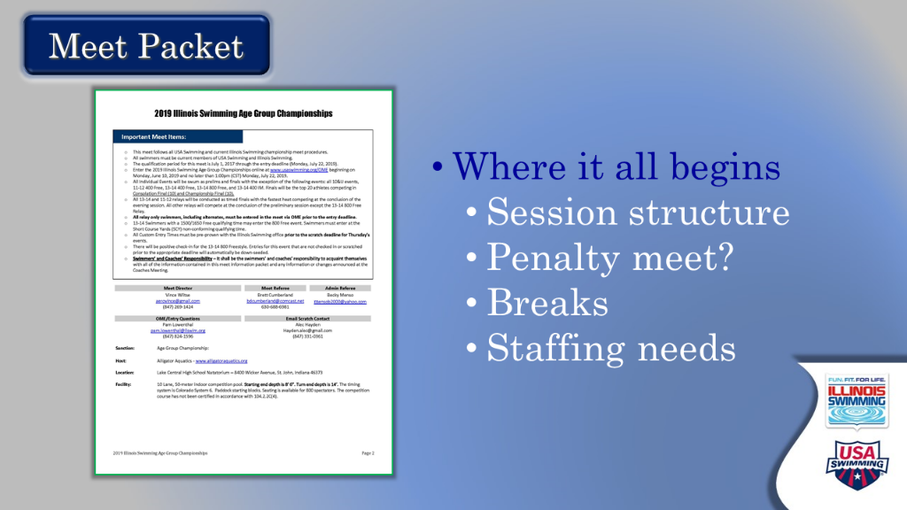

- MEET PACKETS
  - All referee should know the meet packet
    - What events?
    - Are you flying over? Doing chase starts?
    - Scheduled breaks help with the staffing of a deck.
    - What about penalty?
      - Cover penalty and enforcement a little bit here – if it is a penalty meet and there is a NS, what happens? Does it carry over? What is the difference between prelim/final and timed final events?

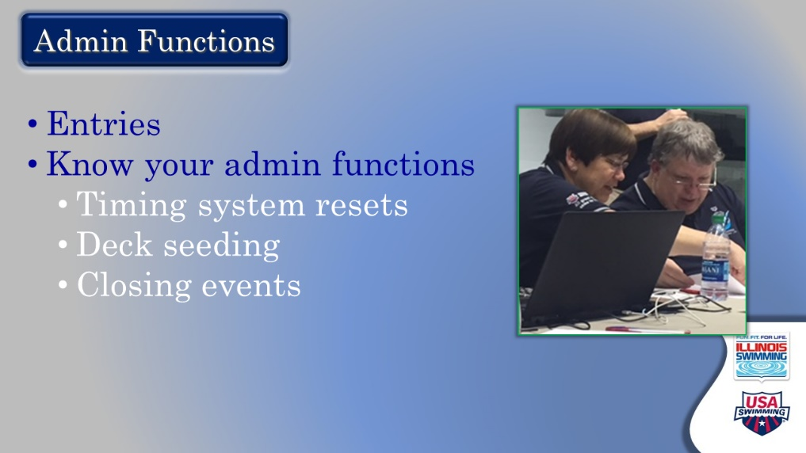

- ADMIN FUNCTIONS
  - There is a reason ISI requires DRs to have some training at AO!
    - Working as part of the team
      - You may not need to do the admin function, but you may need to explain it to a coach!
      - You need to know what AOs are doing.
        - Getting to know the timing operator, AO, and announcer
      - Learning their table practices:
        - DQ Slips, no shows, declared false starts, etc.
        - Closing events
        - Are we deck seeding and how will that happen?
        - Who will handle swimmers who missed their heats, or late additions to the heat sheet?
        - How will everyone be notified?

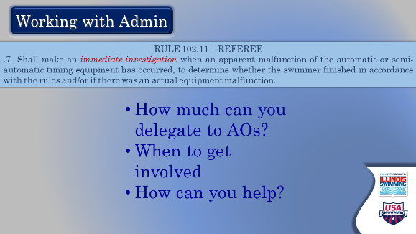

- WORKING WITH AOs
  - “Referees shall make an immediate investigation…”
  - Do you? Every time?
    - No.
  - You trust your AOs, but work with them if there are big issues.
  - Are you confident you could help?

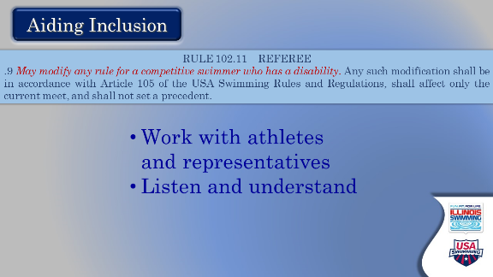

- AIDING INCLUSION
  - Rule 102 says you will modify – RULE 105 tells you how!
  - UPDATE YOUR VOCABULARY!
    - These athletes would much prefer being called para swimmers, adaptive athletes, or adaptive swimmers. They would like us to focus on what THEY can do!
  - Athletes and coaches are generally good about knowing what they need. Listen to them!
    - Para swimmers have different requests for accommodation; the referee should make every effort to accommodate them.
    - Have the expectation that swimmers will follow the rules to the extent they are able – being lenient otherwise is a disservice to the athlete.
    - Starters need to be aware of and proficient in the use of hand signals for swimmers with hearing impairments.
    - Some athletes need assistants to help them on the blocks, get out of the pool, signal when to start – this is allowed.
    - Be very aware of a heat with an adaptive swimmer and adjust
    - More time in or out of the water; probably not a heat you want to stand

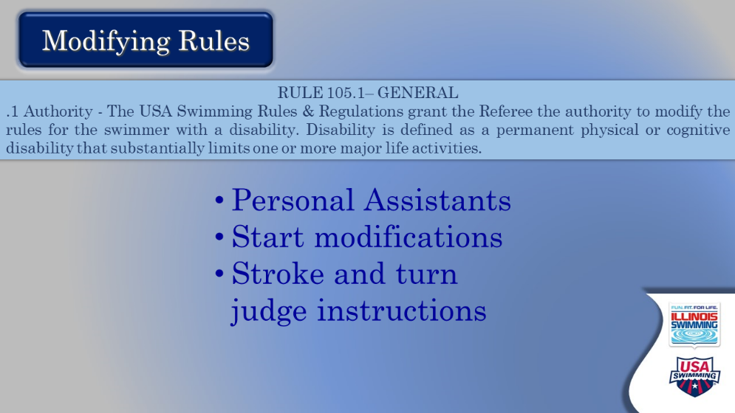

- MODIFYING RULES
  - What types of modifications are allowed?
  - Must be a permanent disability.
  - Personal assistants are allowed and NEED NOT BE USA SWIMMING MEMBERS

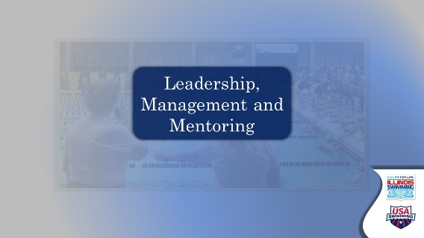

- TRANSITION SLIDE – LEADERSHIP, MANAGEMENT AND MENTORING.
  - This section is about running meetings, setting up decks and staffing, but should be done through the lens of mentorship of officials

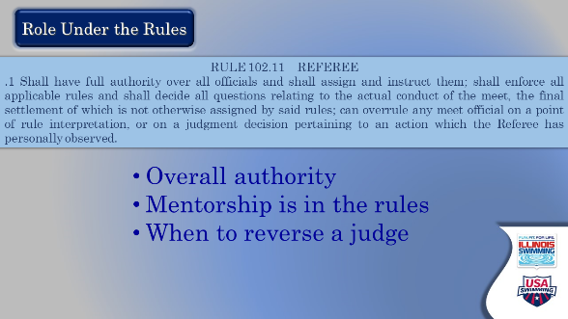

- ROLE UNDER THE RULES
  - You are now responsible for “assigning and instructing” all officials. That is a role a referee should take seriously.
  - When to overrule: on a point of interpretation (if the judge does not understand the rule) OR something you have seen yourself.
  - You are not supposed to question the observation itself – if a judge says they saw something help them to get to where they can explain how it violates a rule or does not.
  - Mentorship of judges can be difficult –
    - What if a judge is “over calling”?
    - What if they are not calling anything?

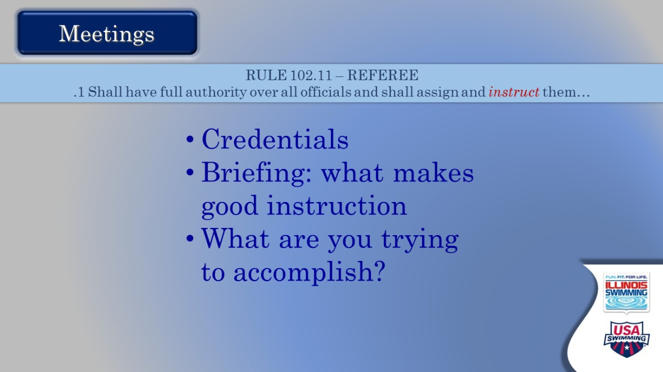

- MEETINGS
  - Basics of meetings are easy – we assign and instruct.
  - What does a good stroke briefing sound like?
    - Know you audience
    - It’s OK to read, but work towards learning the brief.
    - Include others as part of their learning.
    - Always talk to others as your equals. Admit when you are wrong if that the case.
  - What are you trying to accomplish?
    - Having judges understand the rules in a common way
    - Having judges feel they are part of the meet process.
    - What else?
  - How can you keep people engaged?

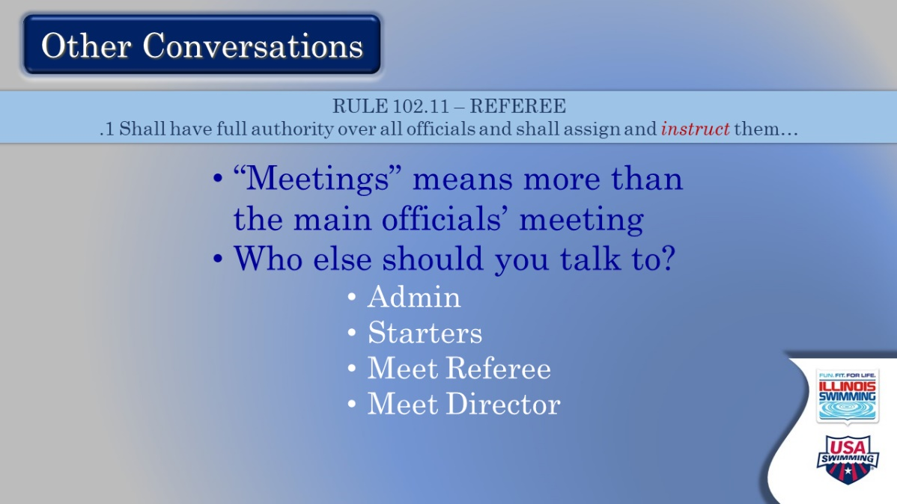

- OTHER CONVERSATIONS
  - This is really about who else you should talk to before a session to make sure it runs smoothly.
    - Starters and other refs –
      - Get on the same page for false starts, protocols about the starts, etc.
    - Questions for your meet referee:
      - What is the expectation for timing?
      - Whistle protocols
      - What do they want to be notified of?
    - Meet Directors
      - More an issue for meet referees. A good MR is always communicating with the Meet Director about timing and session issues, volunteers, marshals, etc.

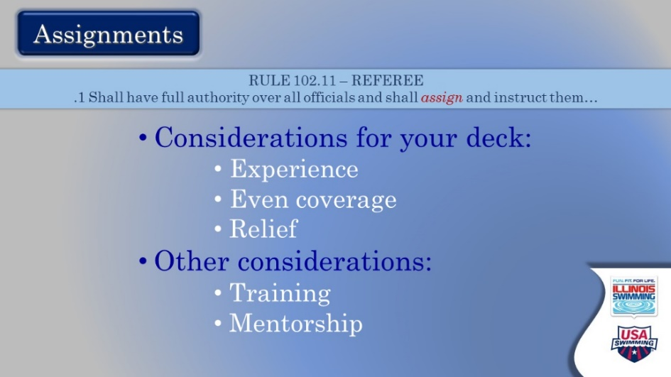

- ASSIGNMENTS
  - Every deck is different.
    - Physical constraints
    - Staffing issues
    - What are some good/bad things they have seen?
    - How important is relief (VERY IMPORTANT)?
  - Considerations other than numbers
    - Who are your best trainers?
    - What existing judges need mentorship?
      - Always be recruiting, always advocate advancement!

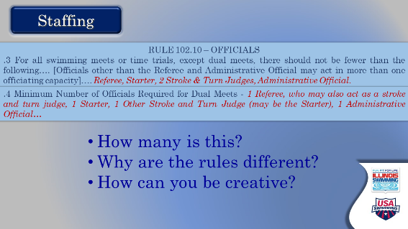

- STAFFING
  - Required for different meets
    - Multi team meet – 4 plus admin
    - Dual meet – 2 plus admin
  - Time trials are not like dual meets, they are like multi-team meets.
  - What have they seen that works or does not work?

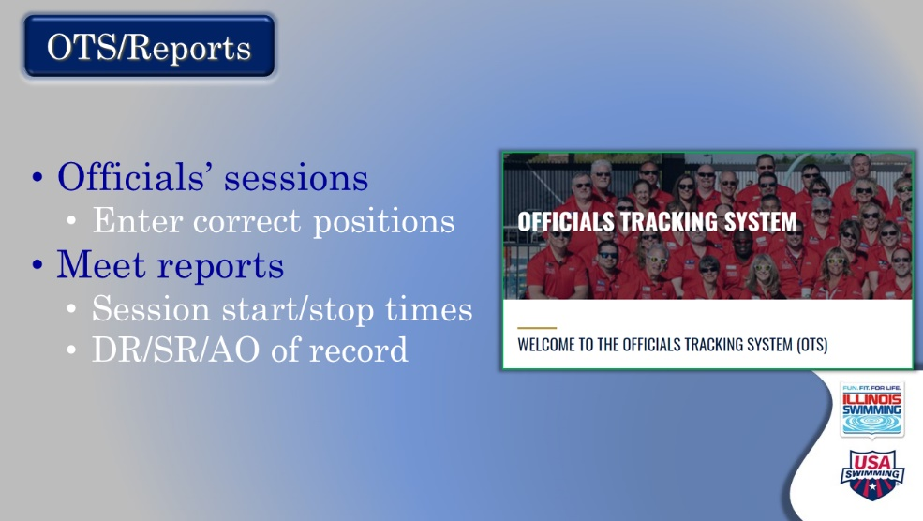

- OTS/REPORTS
  - Go over briefly the need to put sessions in appropriately (correct positions).
  - Meet report ensures the meet had enough officials and checking timelines. The format is available in a word doc on the ISI website.

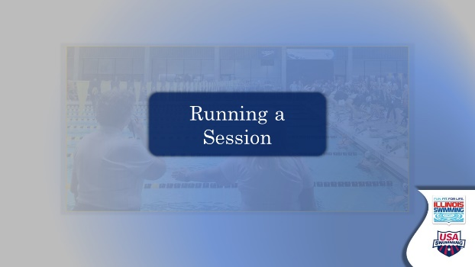

- RUNNING A SESSION - TRANSITION SLIDE
  - HERE IS A GOOD PLACE FOR A BREAK!
  - This section covers the mechanics of running a session.
    - Whistles and starts
    - False Starts
    - What does a referee watch?
    - DQs
    - Questioned calls
    - Protests

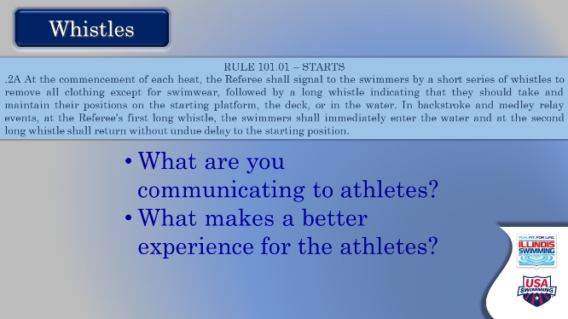

- WHISTLES
  - We treat this as communication between the referee and the athletes and the deck.
  - Short whistles
    - Shorts advise swimmers to prepare.
    - Should be distinctive, crisp, staccato. Most likely need to practice
    - More than three – three is Red Cross signal for emergency in the pool and will startle lifeguards!
    - Total length should be different from the long whistle.
  - Long whistles
    - Long whistle signals swimmers up on blocks or into water for backstroke
    - Blow with authority
    - Second long whistle for backstroke when last head pops up
  - ATHLETE EXPERIENCE
    - Consistency is key
    - What do you do if you get caught late with the short whistles? Do you immediately blow the long whistle?
    - It’s OK to work on physical features – short whistle at the flags and long whistle at last touch or something like that, but what you are striving for is consistency in the timing between.

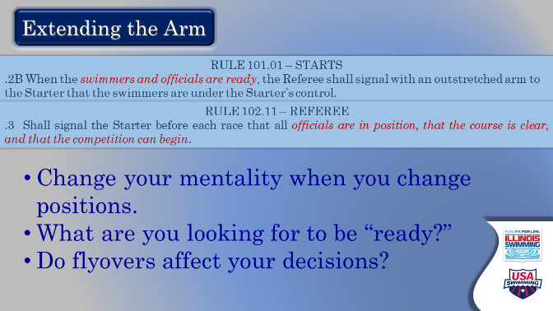

- EXTENDING THE ARM
  - Seems simple but stress it is not done when the swimmers are ready for “Take Your Mark.” The arm is unrelated to the start itself.
  - Letting starter know the pool is ready and that all the swimmers are on the block.
  - How do flyovers play into the thinking? How do they affect the timing of the whole thing?
  - Referees are not starters anymore – the time for “Take Your Mark” and the beep are on the starter.
  - The referee is letting the starter know the pool is ready for the next heat.
  - Be starter friendly!
    - Consistency
    - Early communication
    - Do not make them worry about things other than starts
    - Delivery of a good start is a team effort – your extended arm indicates the building, the pool and the staff are ready for the start
    - DO NOT nitpick starts during sets. Have any necessary discussions with your starter away from the box, unless unavoidable
    - You could toss out a compliment or two!

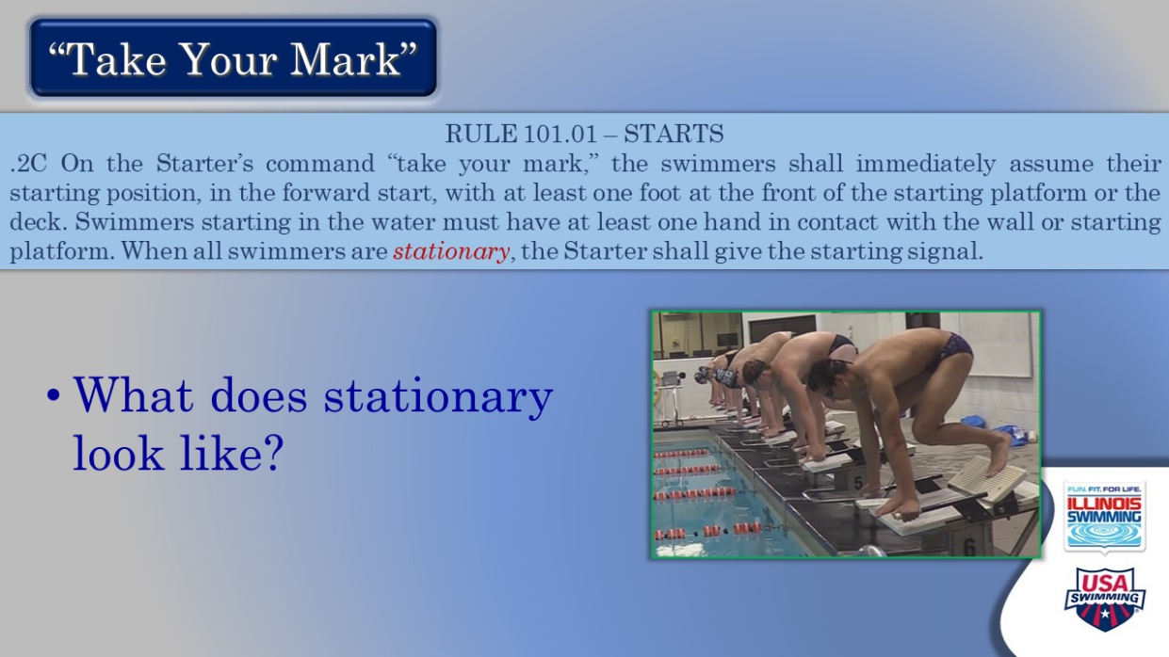

- TAKE YOUR MARK
  - Talk about the difference between stationery and stillness.
  - How do you define?

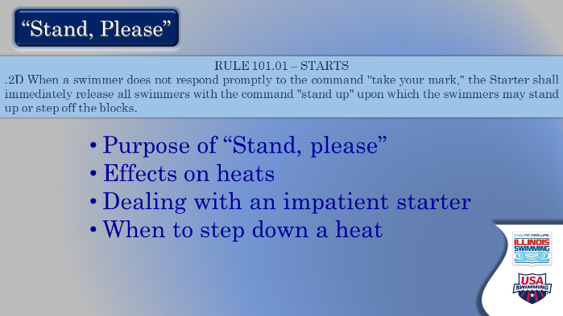

- “STAND, PLEASE.”
  - What is the purpose of “Stand, Please”?
    - To release the swimmers when one is late in responding, so that they are not set for an inordinate amount of time.
    - Allows the heat to reset fairly.
    - Does not “save” a false start in purpose, though it can in practice.
    - When should you step down a heat?

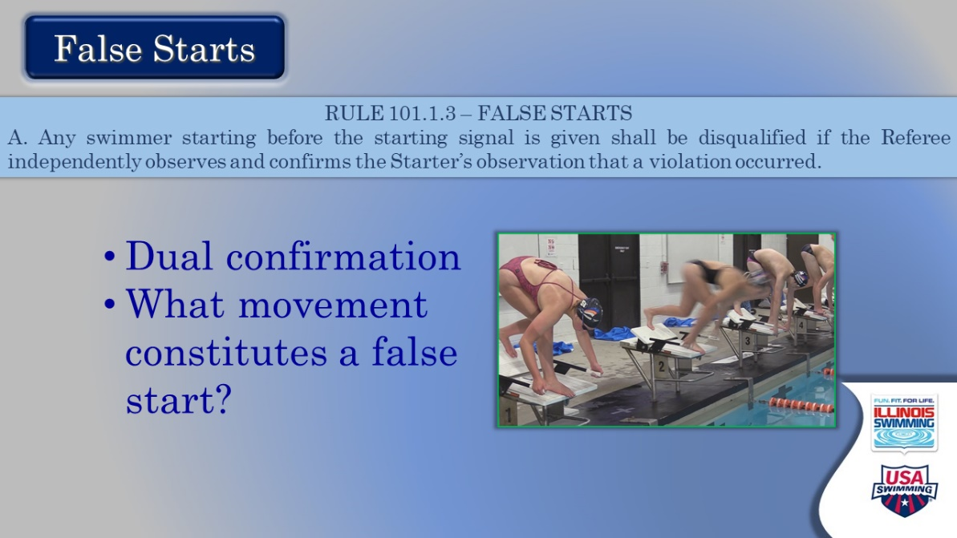

- FALSE STARTS
  - We used to spend a lot of time on this in clinics – but that has been supplanted by the videos they have seen.
  - This covers the rule of the false start, and as we have already discussed what constitutes “still,” here we should discuss what constitutes movement that is a false start.
  - What is movement that is not a false start?
  - Talk about the protocol and why we have the starter approach the referee
    - It guarantees independent observations
    - It enforces the two not discussing it beforehand.
  - NOTE that it is easy to get distracted as a referee with so many responsibilities.

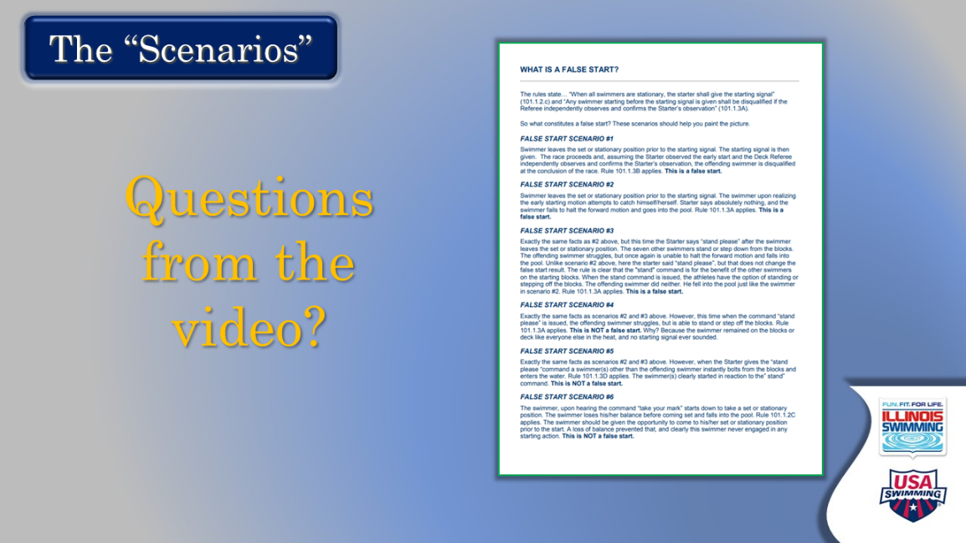

- THE SCENARIOS
  - They have already seen the video covering all of these.
  - What questions do they have from the video?

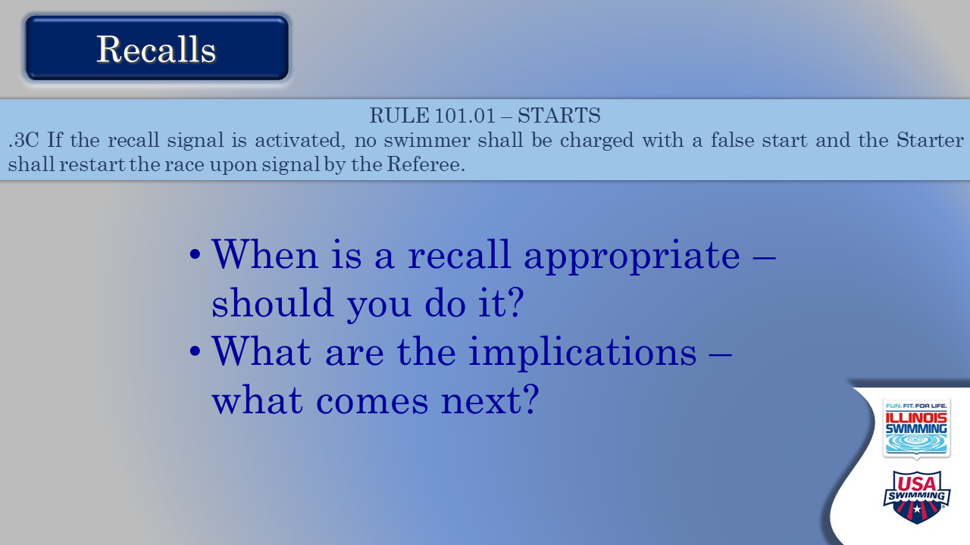

- RECALLS
  - When do you recall a heat?
    - A fundamentally unfair start.
    - Can they give an example?
  - What is the implication of a recall?
    - No false starts charged.
    - Heat re-swum.
    - Do you always do it right then? When do you wait a while to redo the heat?

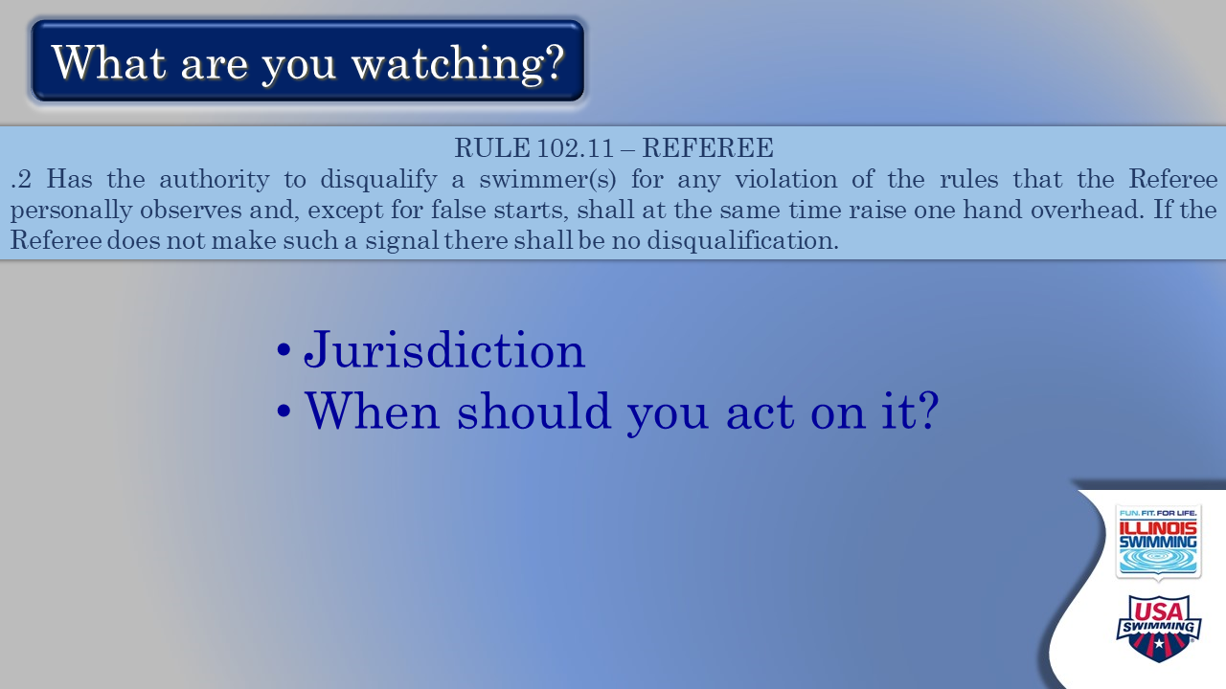

- WHAT ARE YOU WATCHING?
  - After the start they:
    - Walk away from the starter
    - Let the SR come to them if appropriate.
    - Assume their other responsibilities.
  - The referee has total jurisdiction.
  - What do you watch after the heat?
    - Clock start?
    - Hands up?
    - Infractions?
  - When should a referee make a call on their own?

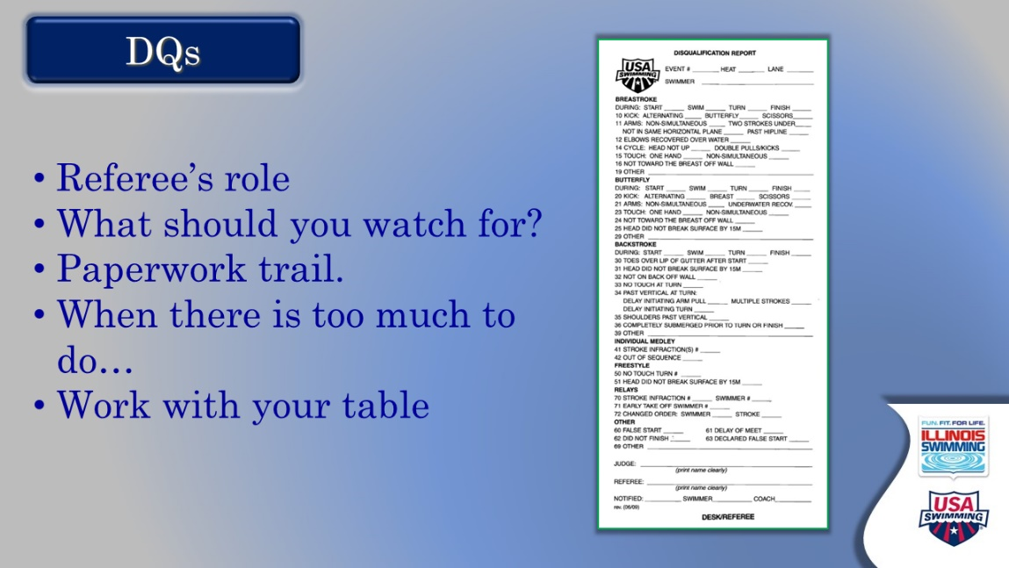

- DQs
  - What is the role of a referee in the process of the DQ?
    - Gatekeeper.
    - What if the slip is wrong?
      - Does not mean that the call is invalid – a DQ slip is not a legal document!
    - What happens when there are too many?
      - Can you get help from another referee?
      - Can you take a 5-minute break?
    - The DR should
      - Know that a DQ is coming by seeing a raised hand – eyes on the water
      - Mark your heat sheet to indicate this – start 1-3, or turn 7-8
      - When the DQ slip arrives – proofread (right call, right info) and note call on your heat sheet
      - Sign
      - Give to table

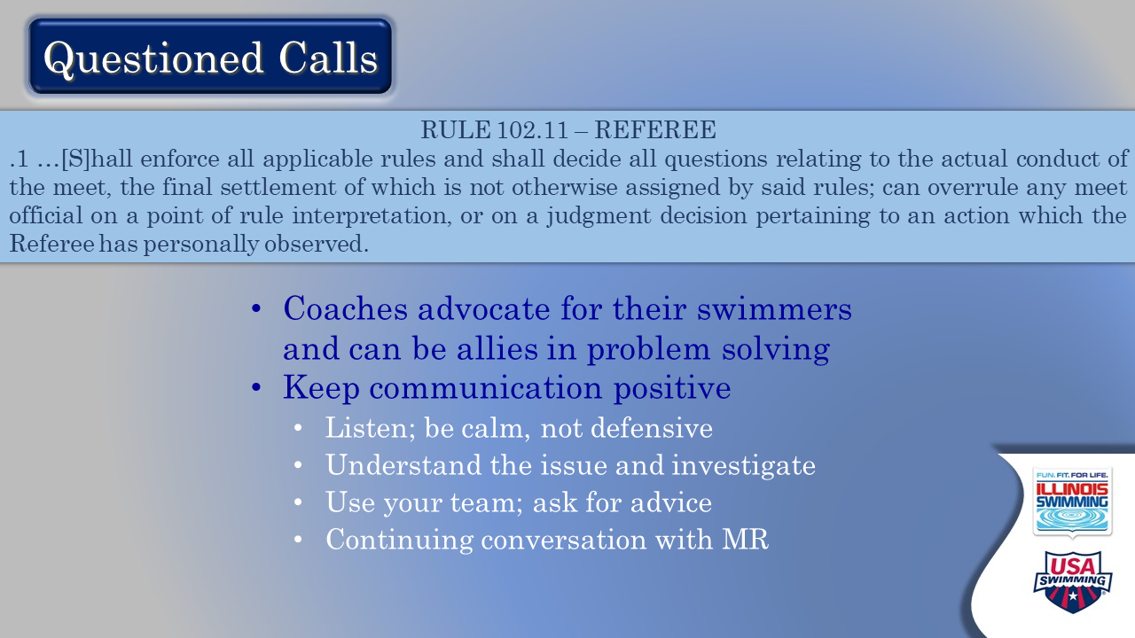

- QUESTIONED CALLS
  - Coaches can have questions ranging from “what was the call” to “how can that be.”
  - This concept is new to referees who have previously been shielded from this process as judges and starters. It is important to stress that it is not confrontational.
  - Coaches are advocates for athletes.
    - Layout the partnership between officials and coaches – as advocates for swimmers, as people who run meets and solve problems.
    - Encourage participants to get to know coaches “in good times” so the lines of communication will stay open.
    - We are all here for swimmers, we just look at things in a different way sometimes
    - Ref’s responsibility to all athletes in the event. Decisions affect all of them
    - Stay calm and helpful – watch your tone
    - Deferential, smarmy, or arrogant behavior has no place
  - Primary consideration – actively listen to the concern, do not make up your mind ahead of time, play back what you hear the coach saying
  - Second and equally important – stay calm
  - As a guide to resolving issues, highlight:
    - Understanding the issue
    - Getting all the facts (officials, timers, whomever)
    - Problem solve.
    - Using your team for advice and as a sounding board
    - Be decisive; firm but fair.

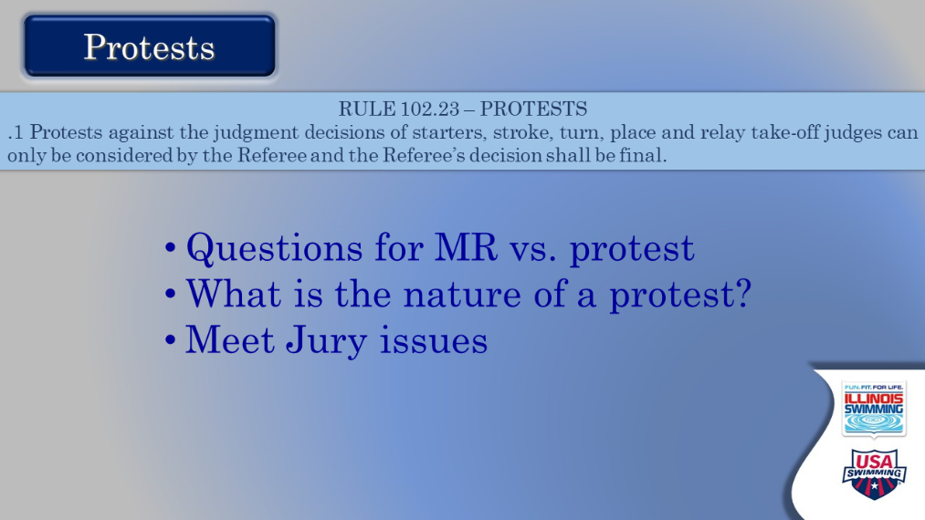

- PROTESTS
  - Protests and questioned calls are not the same thing.
  - A protest is a formal process involving a meet jury,
    - Juries cannot handle question of judges’ observations, only a meet referee can do that.
    - Juries deal mostly with things outside the judging process, such as meet packet issues (can the MR change the order of events?) etc.

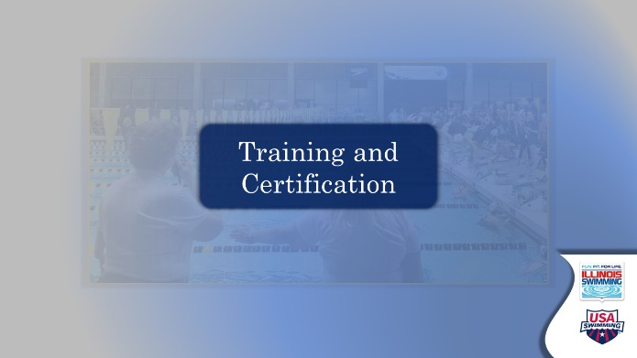

- TRAINING AND CERTIFICATION - TRANSITION SLIDE
  - TAKE QUESTIONS ABOUT THE MATERIALS WE ARE MOVING TOWARDS THE END!

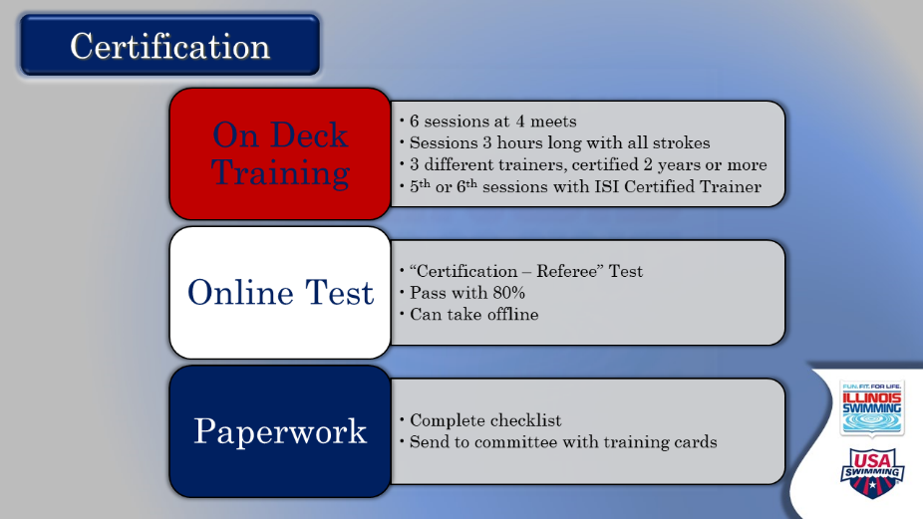

- CERTIFICATION
  - Comment: this slide reviews the three components of certification: on Deck training, online test, and the paperwork. Let’s break it down:
  - On Deck Training
    - Key for referees, who are always training and learning.
    - Regular on-deck sessions:
      - Six sessions across four different meets (varied experiences, hopefully different facilities, and challenges)
      - Three-hour minimum for sessions
      - At least three different trainers (Learn from different perspectives and experience levels)
        - 5th or 6th with certified trainer (N2 and in position for two or more years)
      - Contact the meet referee in advance to set up training; this is always appreciated and could ensure that you will be trained.
      - Be sure your training cards have comments. Ask for feedback, be happy with improvement across sessions.
  - Online Test
    - Emphasize to take the CERTIFICATION test for REFEREE; pass with 80%. Some people like to print the test, complete offline, and then enter answers.
    - Timing does not matter – pre/post on deck training; recommended to take before.
  - Paperwork
    - Complete checklist and include training cards (form on website)
    - Send to officials’ email – not the ISI office
    - Confirmation email when status is changed from trainee to certified
  - Note: if discussion devolves to personal cases, say that you will stay on after the session to answer, or questions can be sent to the officials email address.
  - ALL REFEREES are reviewed by the committee, so there is a longer lag in certification.

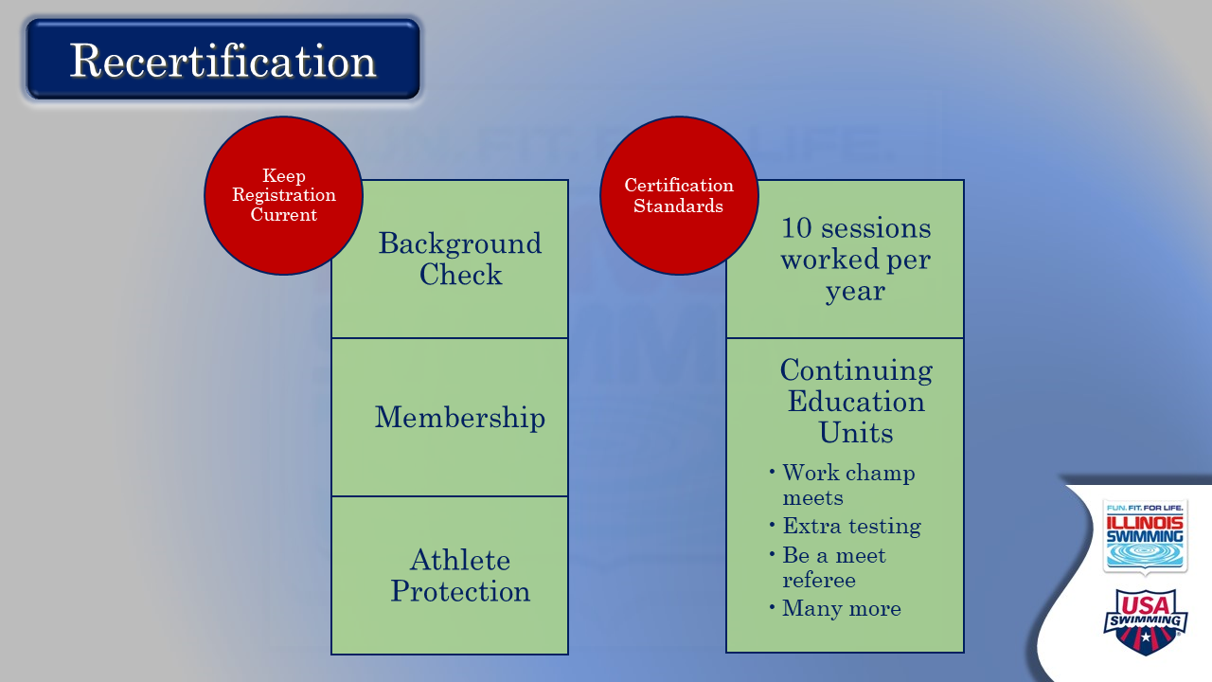

- RECERTIFICATION
  - Topline the fact that we renew our membership and recertify every calendar year as officials.
  - Let them read the two components. Entertain questions.
  - Note that background check and APT expirations are month-specific and need to be monitored.

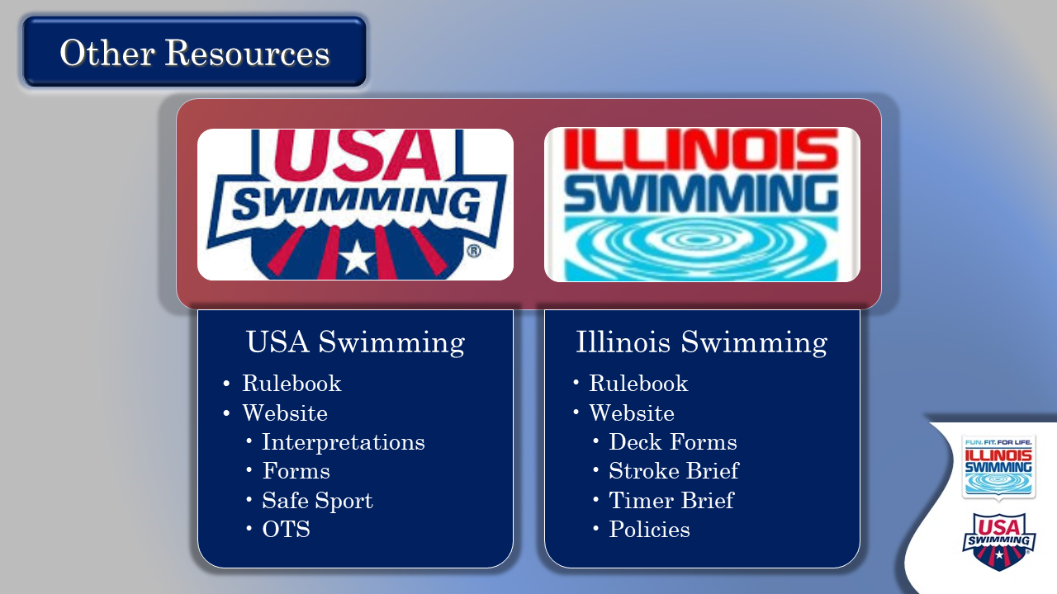

- OTHER RESOURCES
  - The purpose of this slide is to remind them that they have lots of online help when they have a question or need more information.
  - After making that comment, let them read. Entertain any questions.
  - Note that Officials Committee sends periodic newsletters with the most up-to-date information and reminders about all things officiating.



- FEEDBACK – ARE YOU READY TO GO?
  - This is a genuine attempt to get some real-time feedback on the effectiveness of our training process and identify what might be missing, or what’s coming up on deck. NOTE: attendees also will be sent an email with a feedback instrument.
  - Ask each person for their assessment of how they feel about picking up the whistle and what help they will need going forward.
  - Close by thanking them again for their willingness to move up in the ranks of officials and taking the time to learn the starting process. Reassure them that it will take time and repetition to become comfortable in their new role, and that there will be a lot of support from other officials at their club and in the LSC.

