

ISI Stroke and Turn Judge
Webinar Facilitator Notes

Introduction

About your role: Think of yourself as guide, discussion leader, facilitator, wise sage, meet referee as you pull together the asynchronous learning your participants have done in EdPuzzle. Put a face on officiating and give life and encouragement to continuing the process. Hopefully, with some pre-webinar suggestions, your participants will be eager to engage and ask questions to finish off this phase of their training. It will be important to get to know your folks during the introductions and to read their engagement on the screen.

About your audience: These folks have spent 1.5-2 hours watching 10 Edpuzzle videos that are very thorough.
- Each stroke unit presents an overview of the stroke rules, the USA Swimming training video, and a section on the rule for the stroke.
- The other units detail how to be a judge, how to handle a DQ, etc., and training and certification details.

Net: The people in your webinar are not starting from scratch. Previous webinars have shown good knowledge of the material. Think of your audience as newer on-deck trainees or officials in an officials’ briefing.

About Zoom: A different environment in which to share and discuss information: it’s a tad sterile, somewhat disconnected, and harder for you to read body language and for folks to just jump in with a question. Your assistant/question monitor will help with some of this – you will adapt and get good at the medium. At the least, you should know how to switch from sharing your screen (and the PowerPoint) and “just” displaying participants. The “Brady Bunch” gallery during a discussion is another way to engage folks and keep them on topic. Explore using the annotate feature – it’s an informal way to have people mark your screen for important points. And the white board feature – if you just need to record ideas that people are throwing out, this is a good way to confirm with a visual.

About the PowerPoint: this is a visual guide, not intended to be a full clinic presentation, and certainly not created as your script to read. It’s an aid to keep you on track, and keep folks focused. Become familiar with its sequence and content and make it your own. When a slide is marked as transition, just use it as a road map or a spot for a short break. Subsequent slides in that section will help you through the actual material, and you don’t want to get ahead of yourself. You may have your own questions to ask the group and spark discussion, but some are provided here just in case!

About pacing your webinar: Create a timeline for how you will divide your session. Registration/On-Deck Training/Certification usually takes some time to field questions, so be sure to allow for that. Use the parking lot image to “park” questions that you will get to later.

Slide Notes



- Stroke and Turn Webinar
  - This is a waiting room slide to use as you let people into the webinar
  - Engage folks to welcome, turn their video on and unmute (at least for the time being)
  - Ask them to change their name to include their club – name or acronym
  - Take attendance
  - Make small talk, start engaging
  - Try to start close to on time; latecomers can join in progress

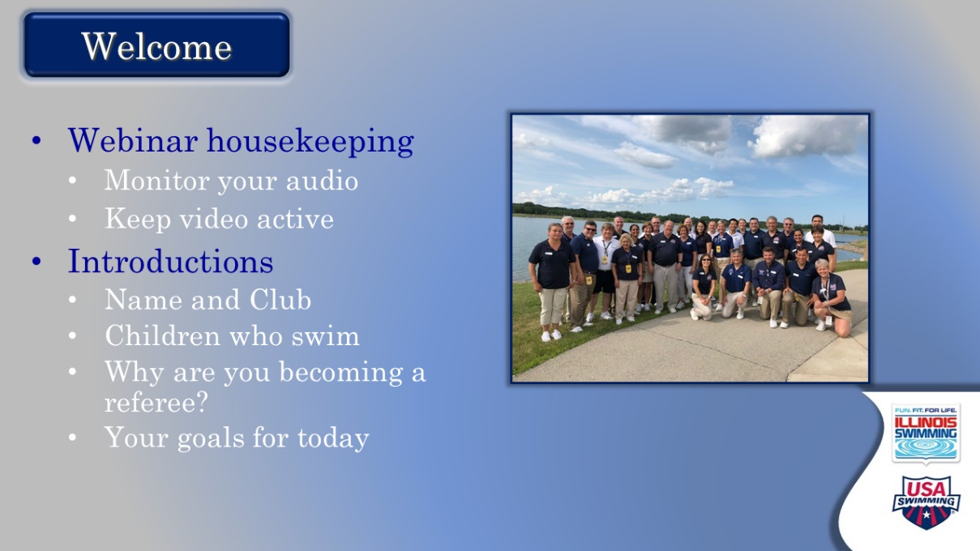

- Welcome
  - Official start
    - Offer a warm welcome and introduce yourself.
    - Thank them for their time and commitment
  - Offer basic meeting notes
    - Keep video active
    - Remain on mute when not talking
    - Use “raise hand” function (may need to direct to this)
    - They can jump in directly with questions
    - Will take at least one break
  - Introductions
    - Do introductions with these components. Start with yourself.
      - Who are they?
      - What club?
      - Children who swim
      - How have they gotten into officiating/swimming in general?
      - Goals for the day
    - Consider stopping your screen share for gallery view after you set this up

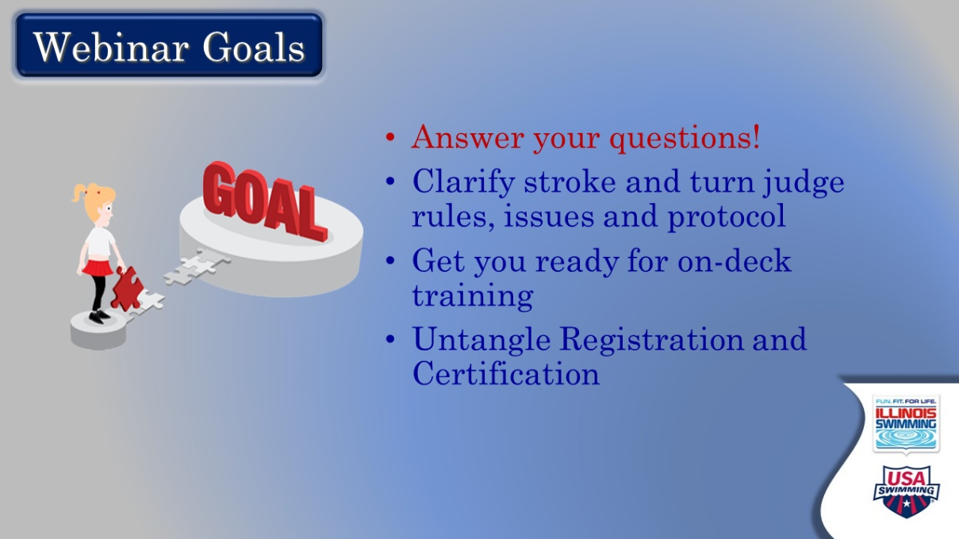

- Webinar Goals
  - You are setting the tone with this slide, with emphasis on answering questions and clarifying rules and issues sparked by their EdPuzzle learning and swim meet experiences
  - Display slide with a “here’s what we’re going to do today” and let participants read
  - Reiterate raising hand or jumping in with questions
  - Suggest a “parking lot” for a question that isn’t in the current flow, or will come up later

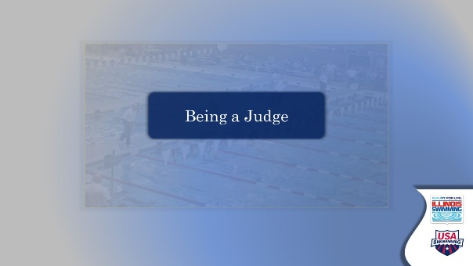

- Being a Judge – TRANSITION SLIDE
  - Set-up along the lines of: Let’s spend some time looking at the life of a stroke & turn judge

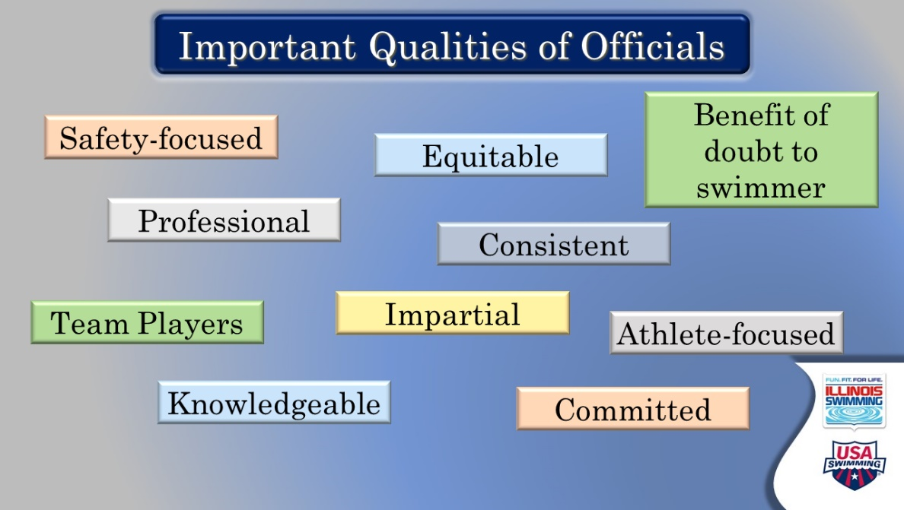

- Important Qualities of Officials
  - Ask: Thinking back to your videos and your observations of officials on deck, what qualities are most important for officials? If no one volunteers, start to call on people.
  - If comfortable with the ANNOTATE feature – ask everyone to put a mark near or on their top three
  - Ask if any qualities are missing, or shouldn’t be there
  - Summarize the top qualities and really emphasize their importance, maybe with a quick example or by asking participants to elaborate
  - Potential comments/questions:
    - Safety is our number one priority, physical and psychological (Hence SafeSport and Athlete Protection)
    - We look and act professional, and work as a team
      - We wear uniforms to identify ourselves, but also to blend in
    - We judge younger swimmers the same as Olympians
      - Swimmers’ achievements must be even across the sport – it is not a good idea to let things go and have an athlete qualify for a meet where they will then be disqualified.
      - Coaches work hard to teach fundamentals to athletes, and if we do not enforce the rules, we are hurting their ability to do so.
    - What does benefit of the doubt mean if we are talking about not “cutting athletes slack” when we judge?
      - Benefit of the doubt simply means you need to call what you see, but to be certain you saw it. It does not mean to turn a blind eye to things you are certain you see.
    - Officials need to be willing to judge athletes equally and impartially.
      - We don’t cheer on deck

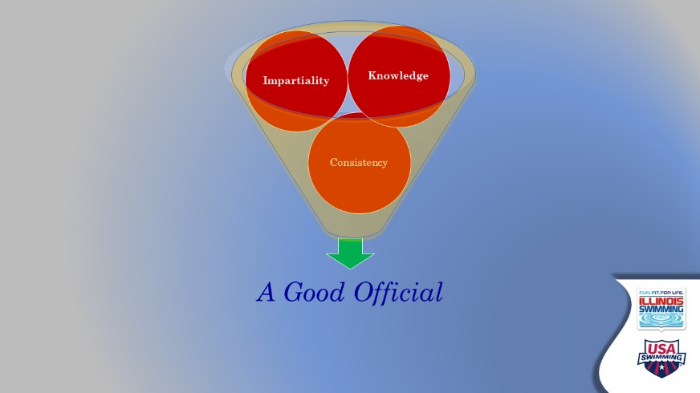

- Good Official Funnel
  - Use this visual to pull your discussion of important qualities together
  - Key qualities go into a funnel -- Impartiality, Knowledge, Consistency – to create a good official
  - Segue to next transition slide by reiterating our goal to create knowledgeable, impartial, and consistent officials

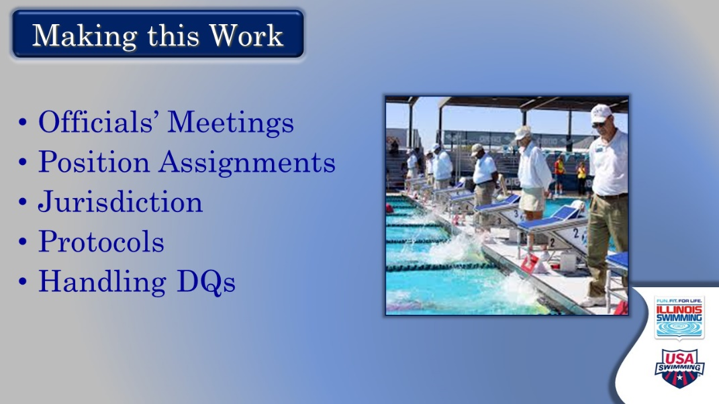

- Making this Work – Transition
  - Ask: So how do we get there? How does this work?
  - Here’s where we’re going next – let them read, stay silent

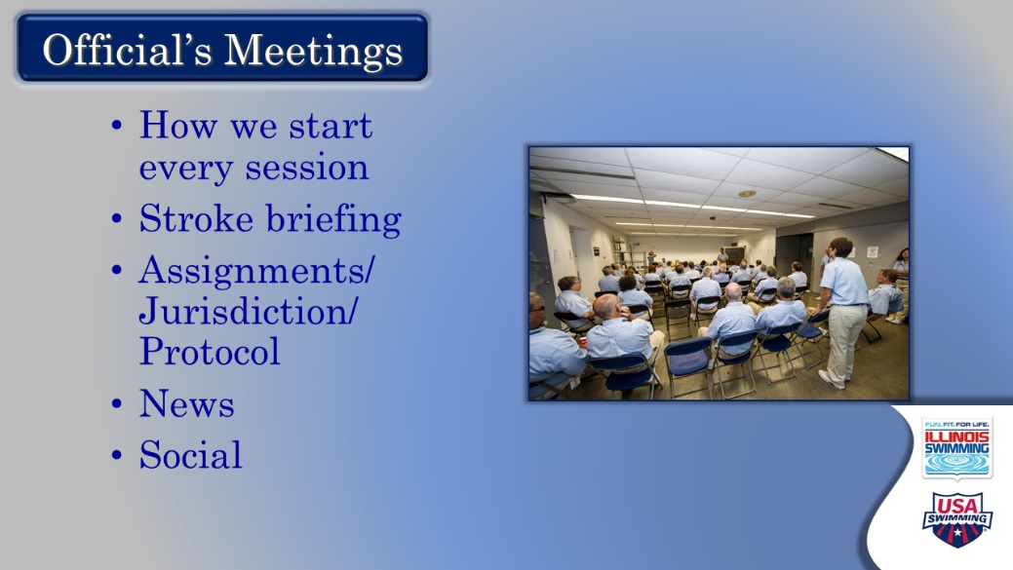

- Official’s Meetings
  - Set up the meeting as the key to establishing consistency and knowledge
  - Review when it takes place, and what gets covered
    - Main items listed on the screen and covered in following slides

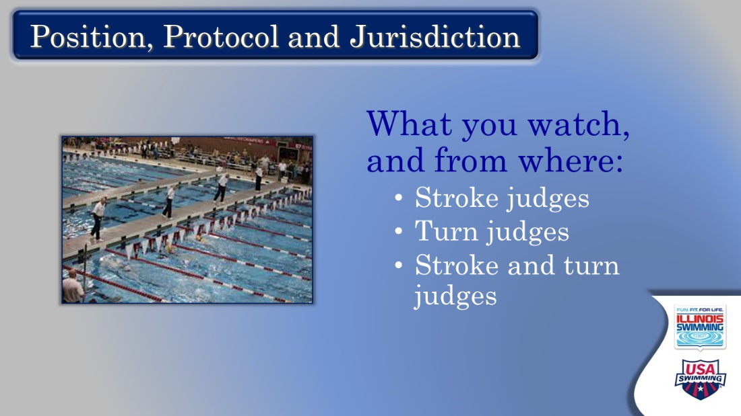

- Position, Protocol, Jurisdiction
  - What you watch and from where – one of the major components of the officials’ meeting
    - Important to understanding assignment
  - Ask: What observations questions or concerns do you have about this?
  - Answer questions, relate some experiences, stress important of protocols to be uniform and unremarkable, being in correct position and having the jurisdiction to make the call
  - Ask: why are protocols different at different meets?
    - Preferences of meet referee, available staff, physical layout of pool
  - Next slide is a pool map to help

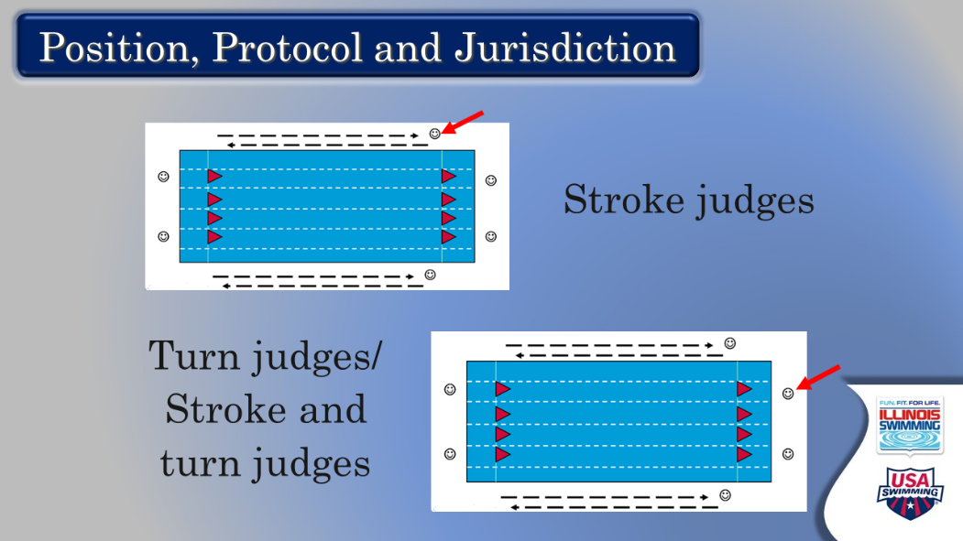

- Pool map
  - Shows stroke judge positions (note that we don’t often use these because of deck crowding). DON’T get into a length conversation about lead/lag at this point.
  - Adds turn judges
  - Talk about overlapping jurisdiction with turn judges and stroke judges, but the common occurrence of functioning as both the stroke and turn judge
  - Ask: Why is jurisdiction important? Why is it important to understand yours? Why are jurisdictions different at different meets?
  - Talk a little bit about assignments, and making sure you understand where you are going and how relief will occur

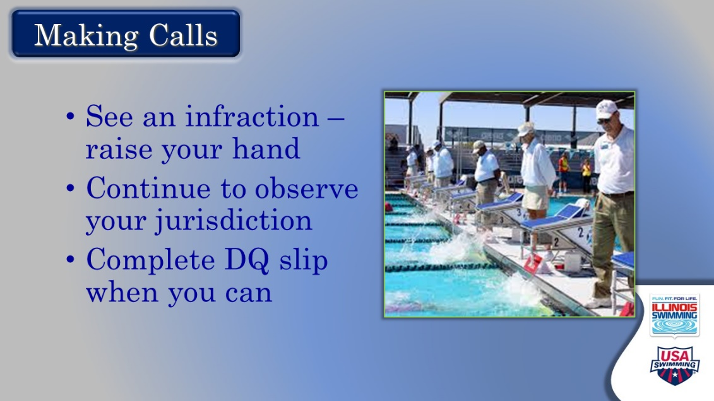

- Making Calls
  - Role of the judge to observe the swim and match it to the rules
  - Emphasize that we are trying to QUALIFY the swims
  - Talk about raising the hand with assurance when observing something that does not match the rules
    - Signal to deck referee
    - Perhaps also to chief judge
    - No DQ if hand is not raised
    - Call what you see – see what you call
  - Emphasize continuing to watch other swimmers in jurisdiction when you have a call; complete DQ slip when you can
  - Will be told in meeting how to process the DQ slip
  - Ask: How do you feel about doing this?
  - Remind: takes time to put it all together

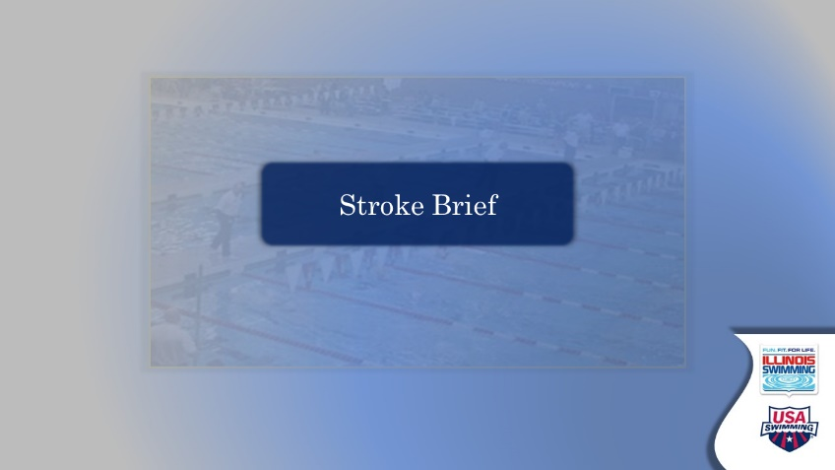

- Stroke Brief – Transition Slide
  - This MIGHT be a good place for a 4-5-minute break.
  - Acknowledge that they have spent time watching stroke videos and reading the rules for each stroke
  - Point out that each meeting has a stroke brief (for consistency and knowledge)
  - Set up the opportunity for putting rules together and asking questions
  - Comment that this form of stroke brief is sometimes used for variety at meetings
  - You might get asked why this webinar does not show video. Answer: hard to get good video quality when sending through the Zoom interface.

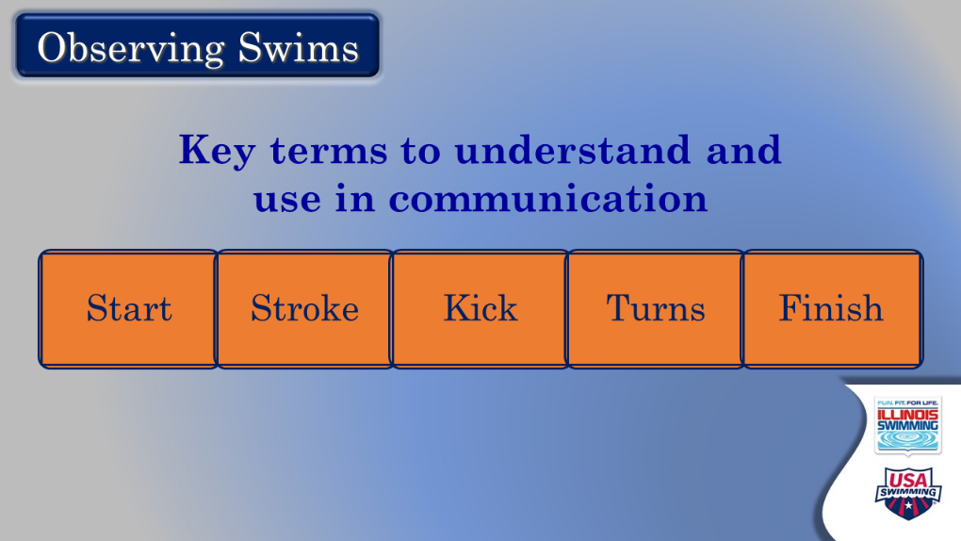

- Observing Swims
  - Joke: They’ve probably seen this so many times they could create it in their sleep! It’s a good thing!!
  - Ask: any questions of concerns about how the parts are defined? You might ask different people to give you a definition
    - Start – from entry into the water until head breaks water’s surface
    - Stroke – the pull by the arms, but also can refer to total body
    - Kick -- legs
    - Turns – from the beginning of the last full stroke, through the turning action, until heads up the other direction
    - Finish – from the beginning of the last full stroke until the touch at the end of the required distance
  - Note that we divide strokes into these parts for communication purposes, and what and how to observe
    - Have an example like: the butterflier who dives in and does an alternating kick because he forgot which stroke … and then corrects (at the start) has a different problem than the flyer who consistently does an alternating kick down the pool and back (during the swim)
  - Places on DQ slip to indicate
  - Ask: What’s the subtle difference between “observing” vs. “scrutinizing”
    - It may seem small, but it fits in to the “benefit of the doubt” philosophy. We do not DQ swimmers, they do something that makes us do so.

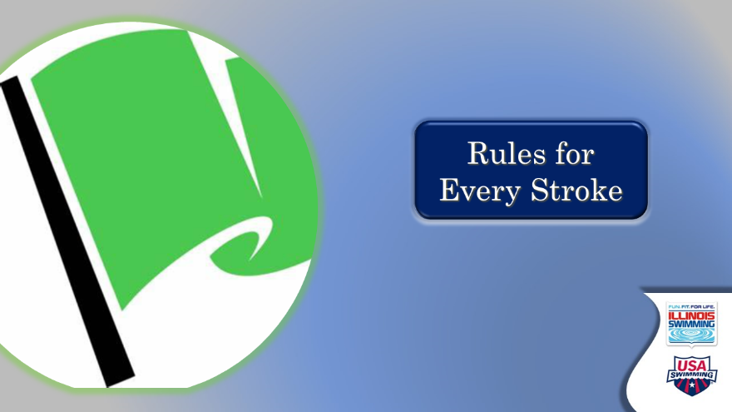

- Rules for every stroke
  - You might want to check these off as they come up, so you can see what else you need to introduce at the end
  - Ask: what rules apply to every stroke? If answers are not forthcoming, call on people.
    - Did not finish
    - Start and finish in same lane
    - No walking on the bottom
    - No pulling on lane lines
    - No interference with other swimmers
    - Touch the wall at each end
      - You could ask: when is it OK to swim back if you miss the wall and when isn’t it? Freestyle only.
    - Unsportsmanlike conduct
    - Delay of meet (referee’s jurisdiction)
    - False start (starter and referee jurisdiction)

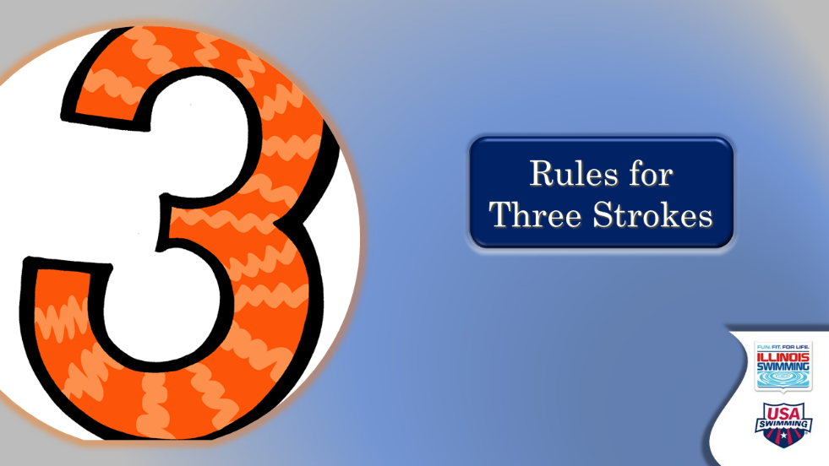

- Rules for three strokes
  - Ask: Some rules apply to three out of the four strokes. What are they?
    - 15-meter rule – fly, back, free
      - EMPHASIZE: video referred to lane line markers, but rule change now requires this to be judged by tape or tile marks on side of pool deck
    - Forward start – fly, back, free
    - Maintain body position – fly, back, breast

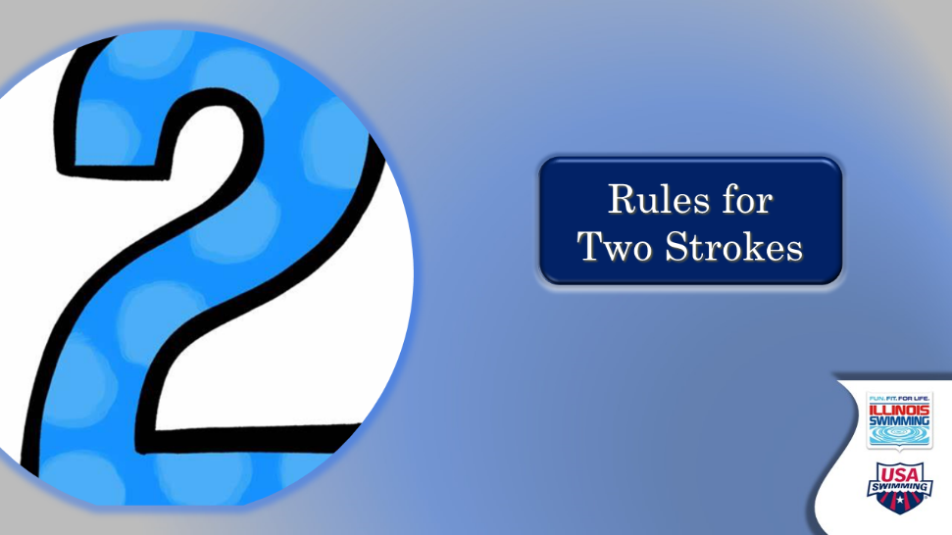

- Rules for two strokes
  - Ask: what rules cover two of the four strokes?
    - Two hand separated simultaneous touch – fly and breast
    - Touch with any part of body – free and back
    - Simultaneous arms and legs – fly and breast
    - Any kick, any stroke – free and back
    - Swum on the breast – fly and breast

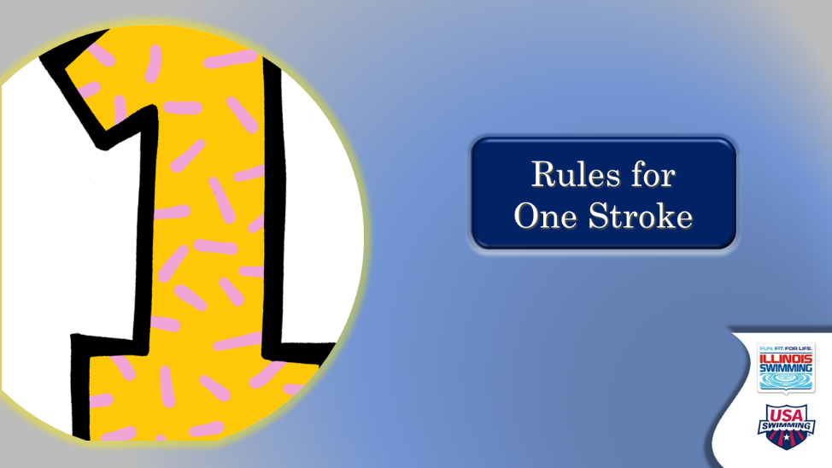

- Rules for one stroke
  - Backstroke – start with back to the course, swim on back
  - Backstroke – toes not over the gutter after the start
  - Backstroke – make change prescribed body position during the turn
  - Breaststroke – all movement of arms and legs symmetrical (and simultaneous)
  - Breaststroke – all movement of arms and legs in same horizontal plane
  - Breaststroke – underwater recovery of hands
  - Breaststroke – pullout rules
  - Breaststroke – cycle stroke
  - Breaststroke – no 15-meter rule
  - Butterfly – over water recovery of hands, unlimited kicks underwater –first pull brings to surface of water



- Any other stroke questions?
  - This slide is a catch all opportunity to see if anything was missed across the previous five slides
  - Questions that could come up or you could ask:
    - More detail about the backstroke turn
    - Definitions of the arm in butterfly
    - What is simultaneous in butterfly?
    - What does a separated two-hand touch mean?
    - Kick definitions – butterfly, alternating, breaststroke. scissor
    - What’s the horizontal plane
    - Undulation in breaststroke pullout vs. actual butterfly kick

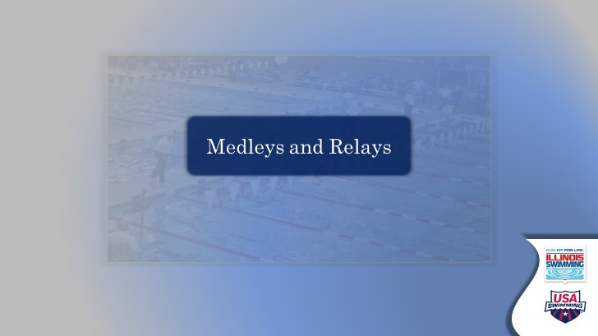

- Medleys and relays – transition slide
  - Serve this up as looking at rules when strokes are combined (medley) and when multiple athletes compete (relays)

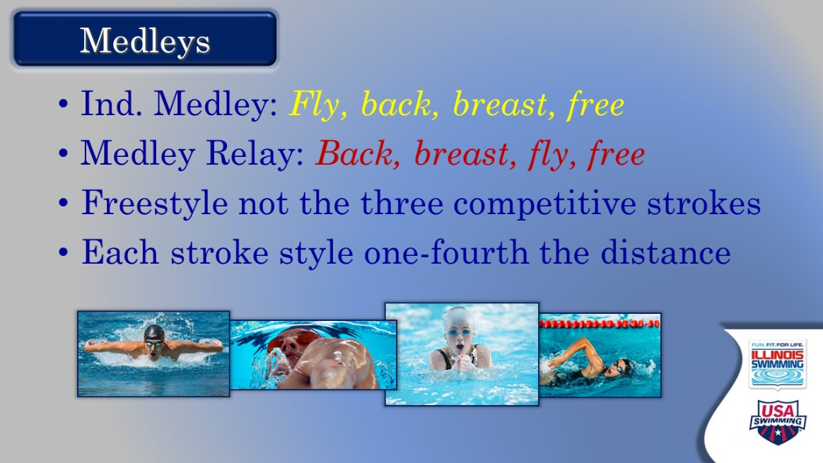

- Medleys
  - Note the order difference for the IM and medley relay
  - Ask: why might this be?
  - Freestyle is defined as NOT one of the other three competitive strokes
  - Each stroke is swum one-fourth the distance of the race
    - You might share a story about little ones being confused about this when they move from the 100 IM to the 200 IM for the first time!

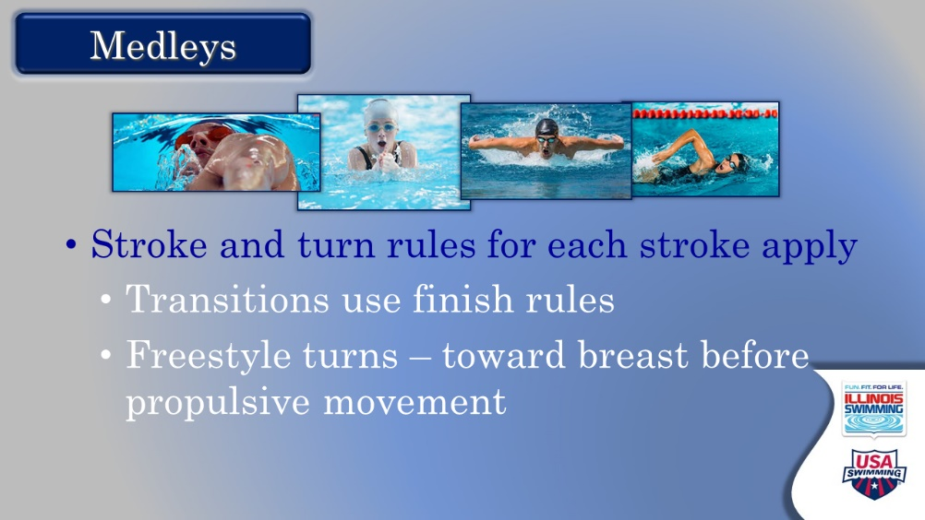

- Medleys
  - Ask: how do we judge the strokes in the relays?
  - Emphasize: turns are turns (so at the turn end the view rarely changes), transitions use the finish rules for each stroke
  - Ask: what’s the one stroke where a turn needs to be different? And then discuss the freestyle rule
    - No propulsion on your back after a turn
    - Ask: why can you do this in a freestyle event but not an IM?

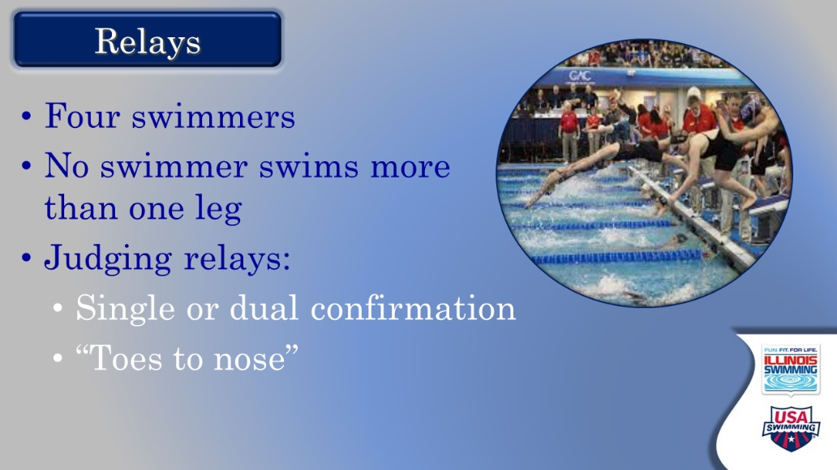

- Relays
  - Always made up of four different swimmers
  - Ask: what’s the rule say about relay take-offs?
  - Rule requires inbound swimmer to touch wall before outbound swimmer leaves
    - Discuss how we judge – from top down, benefit of doubt to swimmer
  - Ask: difference between single and dual confirmation, discuss protocol for dual confirmation and filling out relay card?

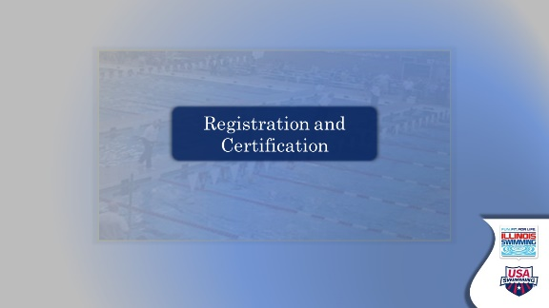

- Registration and Certification – transition slide
  - Unless there are any other questions regarding officiating, set up the final section to cover registration and certification information

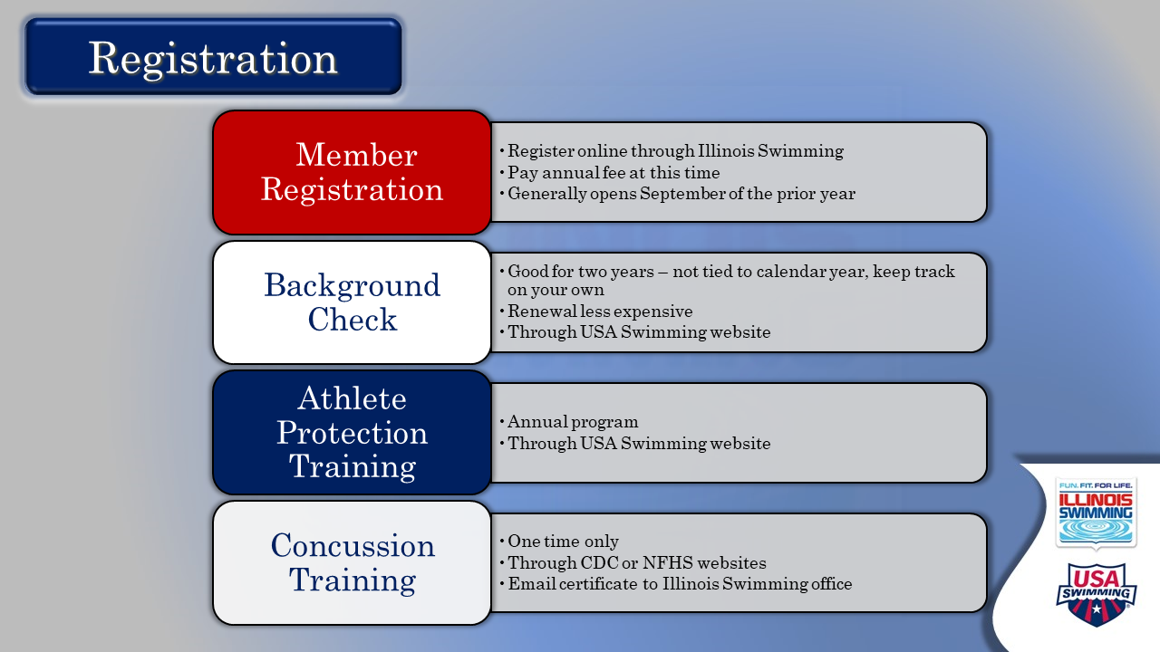

- Registration
  - There’s lots of info on this slide, and it has been covered in an EdPuzzle unit. Generally, there are questions and clarifications.
  - Best approach here – let audience read the components, then ask for questions
  - At some point, EMPHASIZE: Registration is handled by Illinois Swimming office and must be completed before beginning on-deck training.
  - Information for you to have at your fingertips, should questions come up. You DO NOT want to read/go through all of this:
    - WHY registration?
      - Athletes, coaches, and officials – along with some other volunteers – must be registered members of USA Swimming to participate in the organization’s activities.
      - Helps promote safety
      - Provides liability insurance to clubs and venues for events, and supplemental insurance to members.
      - Most of the fee goes to USA Swimming. About 15% of it goes to Illinois swimming to fund programming for athletes.
    - WHAT and HOW?
      - Step one: complete online non-athlete registration form on ilswim.org and submit annual dues. Once this is processed and accepted, they can move on
        - Credit card processing is $3. Annual dues are $81 effective June 1, 2020 – and at this time, will take you through to December 2021. (This information is as of June 2020).
      - Step two: create a USA Swimming account at usaswimming.org, which is needed for background check and APT. This links to the Officials Tracking System (OTS), which they also will want access to going forward.
      - Step three: on the SafeSport page, apply for a background check (good for two years). This has to be done through usaswimming.org’s vendor, even if they already have a background check through another outlet.
        - Usually takes 4-10 days, unless you live in some counties in New York, or have lived internationally. That causes a little time lag.
      - Step four: also, from the SafeSport page, take the Athlete Protection training course. (good annually)
        - Point out that updates and renewals are shorter and cheaper than the initial instance of these things.
      - Step five: complete a concussion training unit, either from the National Federation of High Schools or the CDC. Send certificate of completion to the Illinois Swimming office. This is done once in a career.
        - This can be done anytime but does not link to the account on its own.

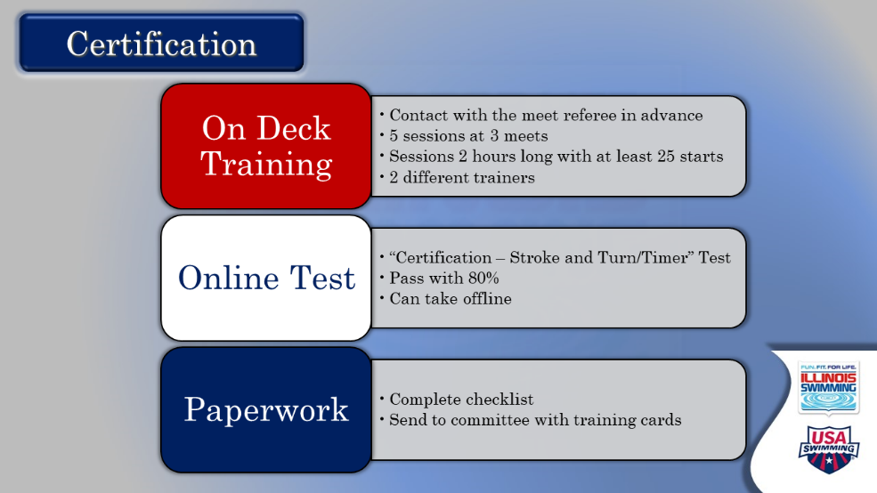

- Certification
  - There’s a lot on this slide as well. Start by letting them read it all – then ask for questions. (Detailed info provided below for your reference)
  - On deck training is the thing most new officials are most excited about or most nervous about or both. Therefore, it leads to the most questions. Make sure you start making people feel welcome on deck at this juncture.
    - Reinforce contacting the Meet Referee in advance to arrange training and review how to do that.
    - Review the uniform (white collared shirt, navy bottoms (not denim), predominantly white non-slip athletic shoes)
    - Remind them to print training cards to bring to sessions, along with cards from prior sessions
    - Share what to expect
    - Training requirements have been designed to give a variety of different experiences and time to see a lot of different things in the water.
  - Test info:
    - Available on USA Swimming website in Officials area – linked to USA Swimming account
    - Can take now, during on-deck training or after
    - Take the CERTIFICATION test, not RECERTIFICATION
    - Current rule book needed; download in .PDF from USA-S website.
    - Easier to download the whole test and complete, before going back to fill in answers.
  - Paperwork
    - Certification check list online
    - Complete and mail to Committee
  - EMPHASIZE that officials’ certification is handled by the ISI Officials Committee and is distinct from membership issues.
    - Once they are members, their initial officials’ card (which can be printed from OTS or accessed through Deck Pass) will show their position as T for trainee. When certified, it will change to C. Need to have this to get on deck.

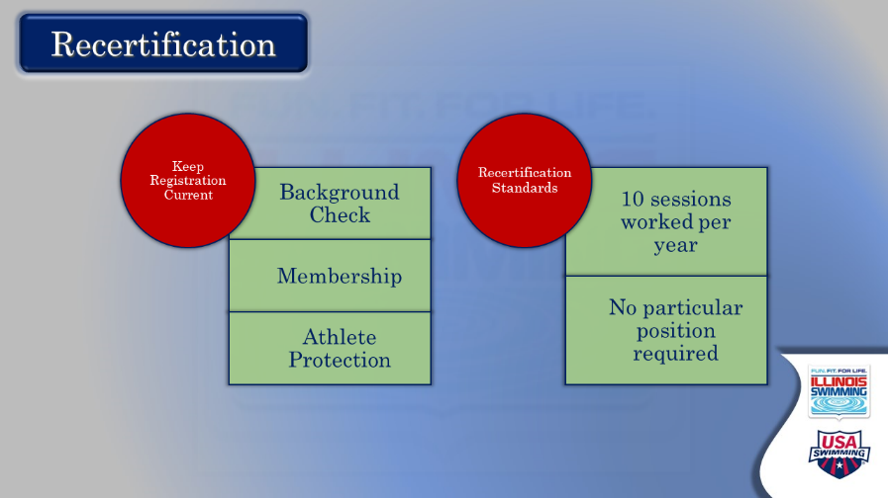

- Recertification
  - Topline the fact that we renew our membership and recertify every year as officials.
  - Let them read the two components. Entertain questions.

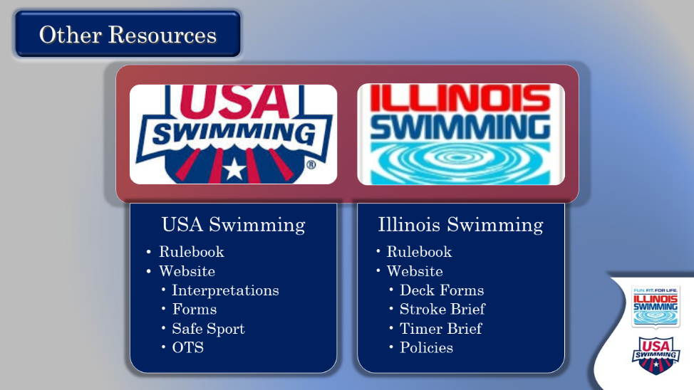

- Other Resources
  - The purpose of this slide is to remind them that they have lots of online help when they have a question or need more information.
  - After making that comment, let them read. Entertain any questions.
  - Comment that Officials Committee sends periodic newsletters with the most up-to-date information and reminders about all things officiating.

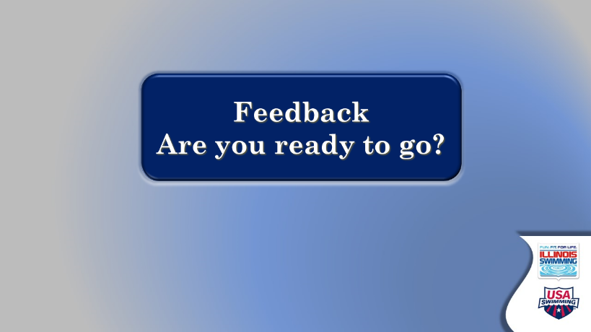

- Feedback – are you ready to go?
  - This is a genuine attempt to get some real-time feedback on the effectiveness of our training process and identify what might be missing, or what’s coming up on deck. NOTE: attendees also will be sent an email with a feedback instrument.
  - Ask each person for their assessment of how they feel about moving on deck and what they will need going forward.
  - Close by thanking them for their willingness to join the ranks of officials and taking the time to learn the process. Reassure them that it will take time to become comfortable, and that there will be a lot of support from officials at their club and at meets.

