

ISI Starter
Webinar
Facilitator Notes

Introduction

About your role: Think of yourself as guide, discussion leader, facilitator, wise sage, meet referee as you pull together the asynchronous learning your participants have done in EdPuzzle. Ideally, with some pre-webinar suggestions, your participants will be eager to engage and ask questions to finish off this phase of their training. It will be important to get to know your folks during the introductions and to read their engagement on the screen.

About your audience: These folks have spent 1-1.5 hours watching three Edpuzzle videos that are very thorough:
- Starter Basics
- False Start Scenarios
- Start Process

Net: The people in your webinar are not starting from scratch. Previous webinars have shown good knowledge of the material. Think of your audience as new starter trainees almost ready to go on deck.

About Zoom: A different environment in which to share and discuss information: it’s a tad sterile, somewhat disconnected, and harder for you to read body language and for folks to just jump in with a question. Also, harder to demonstrate things, like cord handling or deaf starts. Your assistant/question monitor will help with some of this – you will adapt and get good at the medium. At the least, you should know how to switch from sharing your screen (and the PowerPoint) and “just” displaying participants. The “Brady Bunch” gallery during a discussion is another way to engage folks and keep them on topic. Explore using the annotate feature – it’s an informal way to have people mark your screen for important points. And the white board feature – if you just need to record ideas that people are throwing out, this is a good way to confirm with a visual.

The question could arise – why don’t we include appropriate video snippets of starts in this webinar? Comment that embedding recorded video in the Zoom video platform does not deliver quality results.

About the PowerPoint: this is a visual guide, not intended to be a full clinic presentation, and certainly not created as your script to read. It’s an aid to keep you on track, and keep folks focused. Become familiar with its sequence and content and make it your own. When a slide is marked as transition, just use it as a road map or a spot for a short break. Subsequent slides in that section will help you through the actual material, and you don’t want to get ahead of yourself. You may have your own questions to ask the group and spark discussion, but some are provided here just in case!

About pacing your webinar: Create a timeline for how you will divide your session. On-Deck Training/Certification usually takes some time to field questions, so be sure to allow for that. Use the parking lot image to “park” questions that you will get to later.

Slide Notes


- Starter Training Webinar
  - This is a waiting room slide to use as you let people into the webinar
  - Engage folks to welcome, turn their video on and unmute (at least for the time being)
  - Ask them to change their name to include their club – name or acronym
  - Call attention to the emoji feature – you may ask for a thumbs up or a round of applause during the webinar
  - Take attendance
  - Make small talk, start engaging
  - Try to start close to on time; latecomers can join in progress

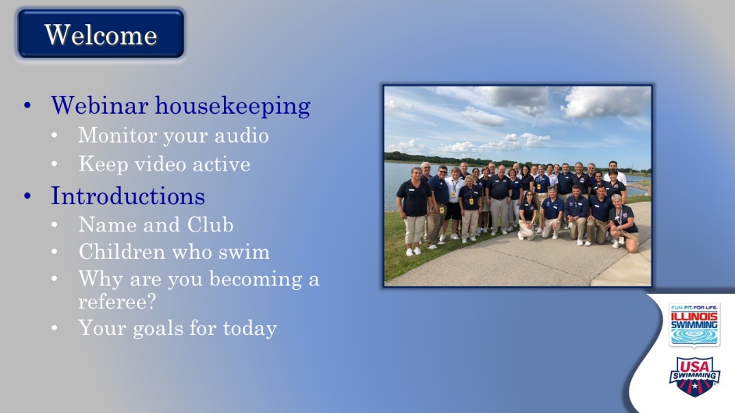

- Welcome
  - Official start
    - Offer a warm welcome and introduce yourself.
    - Thank them for their time, commitment, and willingness to move up to starter
    - Comment that the starter’s role is different from anything else on deck, and a whole new way of looking at a swim meet.
  - Offer basic meeting notes
    - Keep video active
    - Remain on mute when not talking
    - Use “raise hand” function (may need to direct to this)
    - They can jump in directly with questions
    - Will take at least one break
  - Introductions
    - Do introductions with these components. Start with yourself.
      - Who are they?
      - What club?
      - Children who swim
      - Why are they moving up to starter?
      - Goals for the day
    - Consider stopping your screen share for gallery view after you set up this task (better interaction among participants)

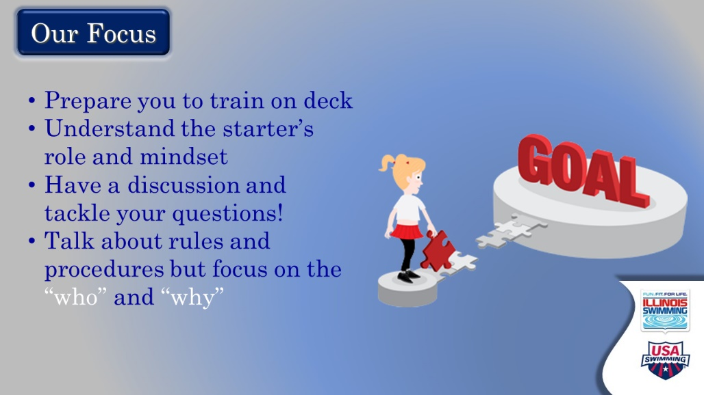

- Our Focus
  - Set-up: Here’s a look at what we hope to accomplish today.
  - Then let them just read it
  - Emphasize the hope to have good discussions, to field outstanding questions, and to provide a good understanding of the who’s and why’s of starting
    - Nothing will replace actual on-deck training to develop starting skills

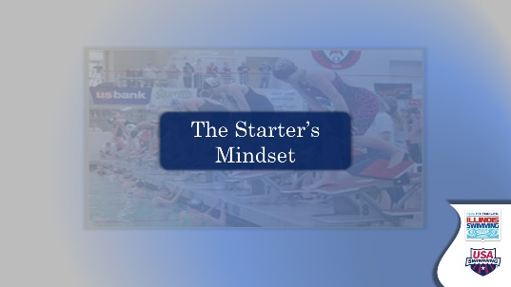

- The Starter’s Mindset – Transition Slide
  - Transition into content with something like – so let’s spend a few minutes getting into the head of the starter

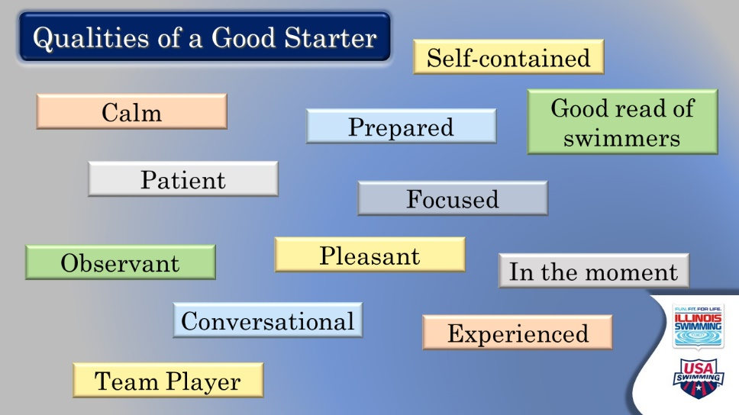

- Qualities of a Good Starter
  - Ask: Thinking back to your videos and your observations of starters on deck, what qualities are most important for the starter? If no one volunteers, start to call on people.
  - If comfortable with the ANNOTATE feature – ask everyone to put a mark near or on their top three choices
  - Ask if any qualities are missing, or shouldn’t be there
  - Summarize the top qualities and really emphasize their importance, maybe with a quick example or by asking participants to elaborate
    - You could punch out the teamwork aspect of working with the referee and safety first (cords, flyover starts, etc.)
    - The importance of being calm, focused, in the moment and self-contained, with discussion of not getting sucked into other activities on the deck
      - In a nutshell, this would be SWIMMER FOCUSED
      - Offer an example if you have one of the consequences of being distracted
    - We will hammer home being patient and reading the swimmers. Start that here

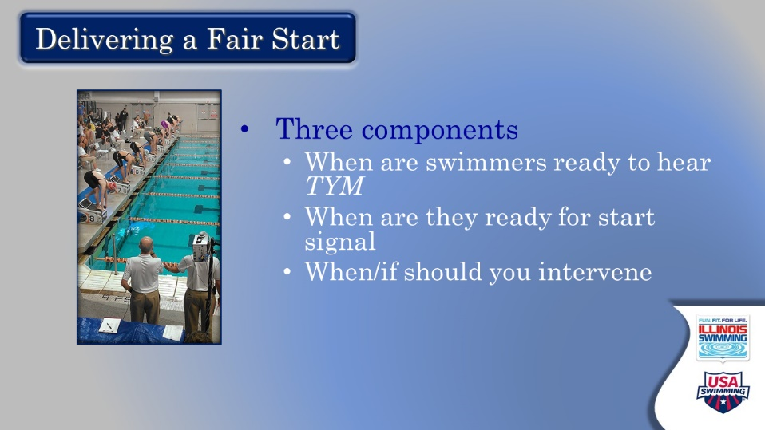

- Delivering a Fair Start
  - Pull the qualities from the last slide together and ask how they contribute to delivering a fair start
    - Qualities most important for knowing when swimmers are ready to hear “Take Your Mark”
    - Anything to add or subtract to know when they are ready for the start signal
    - What qualities would help you know when and if you should intervene in the start
      - For example, when to stand a heat. When to step it down. When to give the swimmers a little more time before sending the heat
  - Ask: Does this differ by age of swimmer, or experience level? In what ways?
  - Ask: Were there good examples of this in the videos you watched?

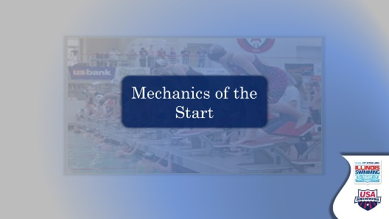

- Mechanics of the Start – transition slide
  - Make a transition with something like – let’s bring these qualities and goals into the actual mechanics of the start

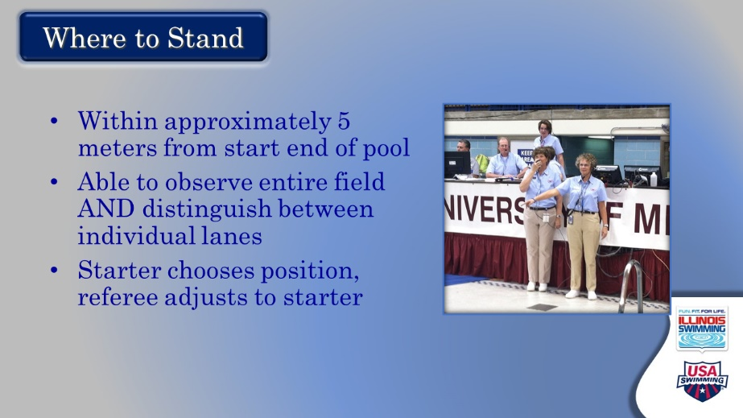

- Where to Stand
  - The mechanics of the start may have seemed easy during the videos with an emphasis on the details. Lead the discussion here.
  - Point out by rule that the starter shall stand within five meters from the start end of the pool. Where starters stand varies widely by preference and pool restrictions.
    - In on deck training, they should explore many different spots to find something comfortable for them
  - Starter gets to pick spot first – then the referee
    - Ask: why is this so? How does this get handled on deck?
    - Need to see the deck referee’s hand when getting the heat
  - Emphasize the goal in selecting the vantage point: able to see the entire field and identify individual lanes
    - Talk about peripheral vision and the need to expand it as they train
  - This is a good spot to ask for any other comments or questions on this

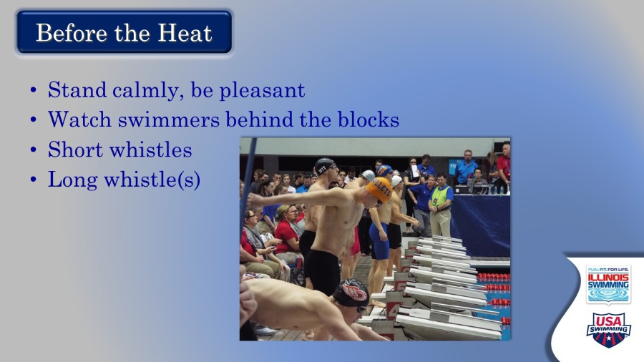

- Before the Heat
  - Interesting to get their perspective here first – so ask: what do starters do before the short and long referee whistles? And why?
  - Emphasize: focus on the next heat behind the blocks, looking calm and pleasant
  - Ask: why is this important?

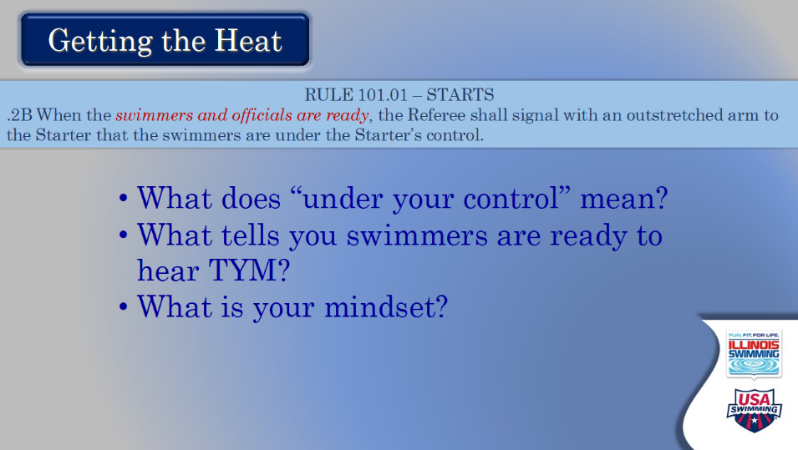

- Getting the Heat
  - Ask: what does it mean when the ref’s arm goes out? What are you thinking?
    - Heat is yours
    - Are the swimmers ready for TYM? How will you know this?
      - Emphasize that the arm DOES NOT mean the swimmers are necessarily ready; talk about different refs giving the heat at different moments in the start sequence
      - Note: You are going to talk a lot more about this on the next slide but setting up the discussion will be valuable.

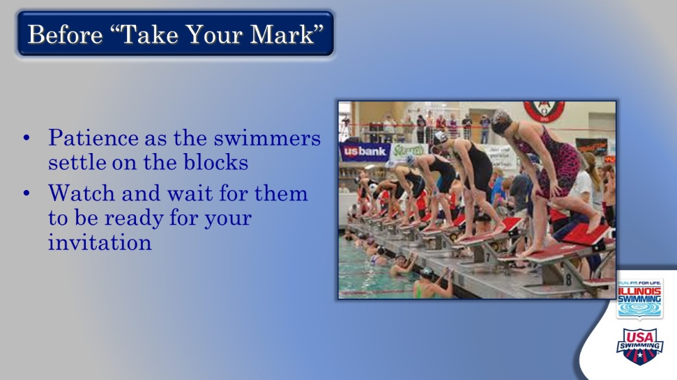

- Before TYM
  - Comment: when swimmers get up on the blocks, they need a few seconds to gather their thoughts and their bodies
    - Ask: when are they ready to hear from the starter? What are you going to look for?
  - Comment: a bit more patience with athletes before the invitation to TYM will lead to a better start
  - Comment that the swimmers in the slide look ready.

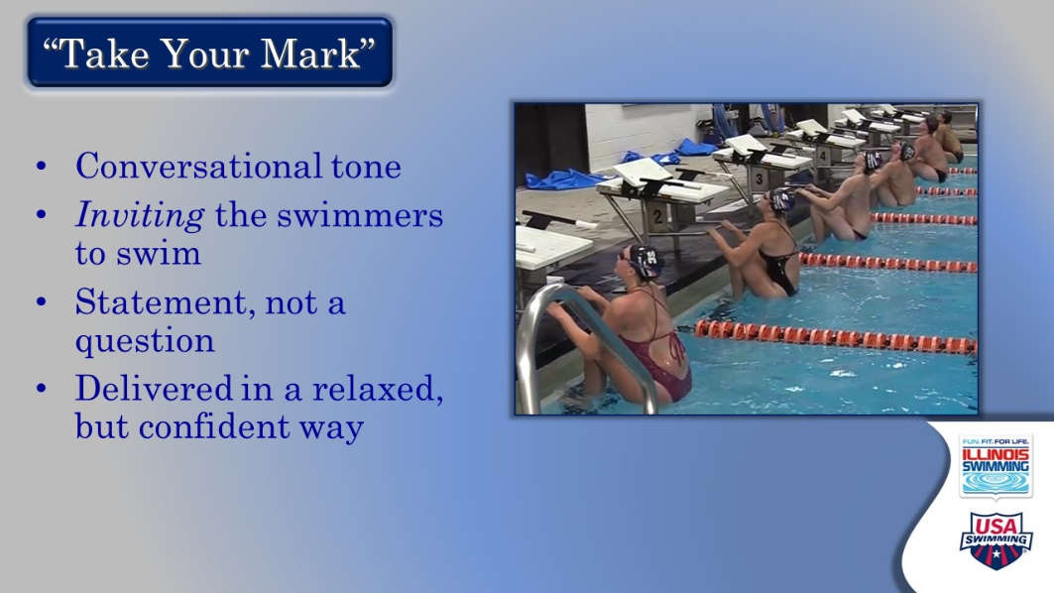

- Take Your Mark
  - Comment: this is an invitation done in a conversational voice, not a command or a question
  - Exercise: you might ask everyone to give you their best starter “Take Your Mark”
    - You’re not going to critique individually, but see if you notice a trend and comment (mostly monotone, too strong, too fast, mostly pleasant and a great place to begin, etc.)
    - Ask if it’s easy or hard to say, “Take Your Mark,” especially without an audience or a microphone
    - Ask: do they hear other starters in their heads? Is this a good thing or a bad thing?
      - You might comment on staying in your own bubble, especially when part of a multiple starter team
  - Discuss ways to stay calm and relaxed: hydration, smile, deep breath prior, practice, pre-race routine, having a conversation, etc.

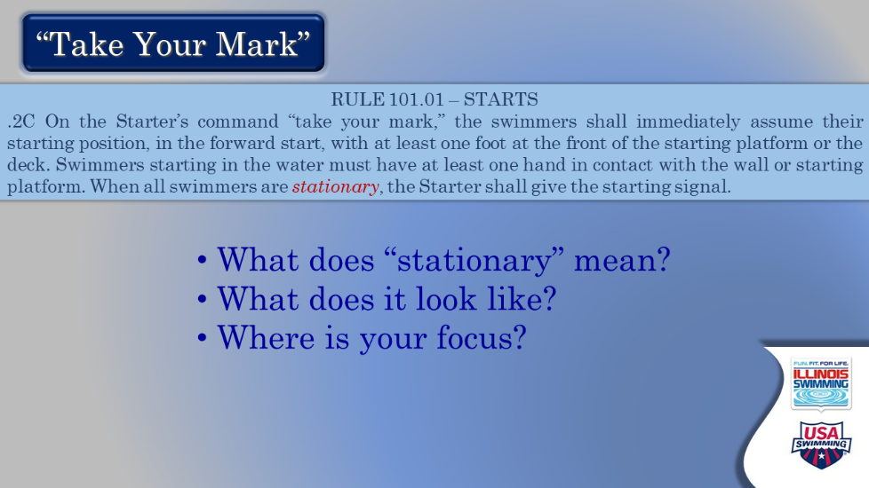

- Take Your Mark 2
  - Discuss what “stationary” means, using all analogies that work like the radio tower blowing in the wind or a Metra train stopped in the station
    - Ask: Why is this concept so important to the starter?
  - The rule box also details having one foot at the front of the block at this point – discuss
  - Key takeaway from this slide is WHERE the starter’s focus should be – avoid scanning the blocks, but rather focus between center lanes and let peripheral vision handle the outside lanes
  - Next slide offers a picture to help with establishing stationary



- What Does Stationary Look Like?
  - Comment: sometimes a picture is worth 1,000 words
  - (Draw the line) Establishing a virtual line with the swimmer relative to the block provides a reference point
  - (Draw the line) Because swimmers move in three dimensions, a line at the top of the body also helps
  - Make the comment: having this reference in your head helps when determining a false start; also, you are doing this for each swimmer on the blocks using your peripheral vision
  - Also emphasize – find something that works for you, so you can establish the set position for all athletes and be able to identify a false start

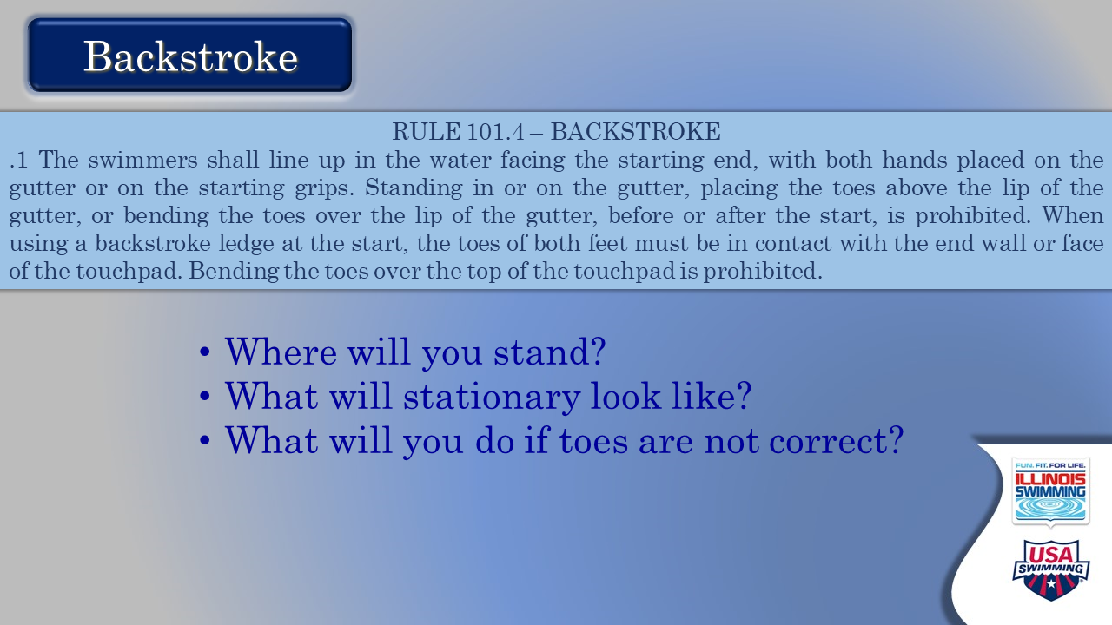

- Backstroke
  - Ask: What’s different about a backstroke start? After “just about everything,” allow attendees to probe the differences, and help elaborate on them
    - Do you stand in a different place? Why or why not? No right answer.
    - Foot position – more pieces than a forward start? Toes and the gutter? Toes and the backstroke ledge (only discuss if this comes up; ledges are not prevalent in our LSC yet)
      - What do you do when the toe position is not correct? Lane X, toes below the gutter. Lane Y, toes on the wall, please
    - Stationary – how different is this for a backstroke start? The balance of not having athletes “hang” vs. allowing them to be set/relaxed
    - Question: when and how do you intervene when something is not right?
      - “Stand, please” – swimmers expect the same words
      - Use “Relax, please” only when a longer interval before restarting

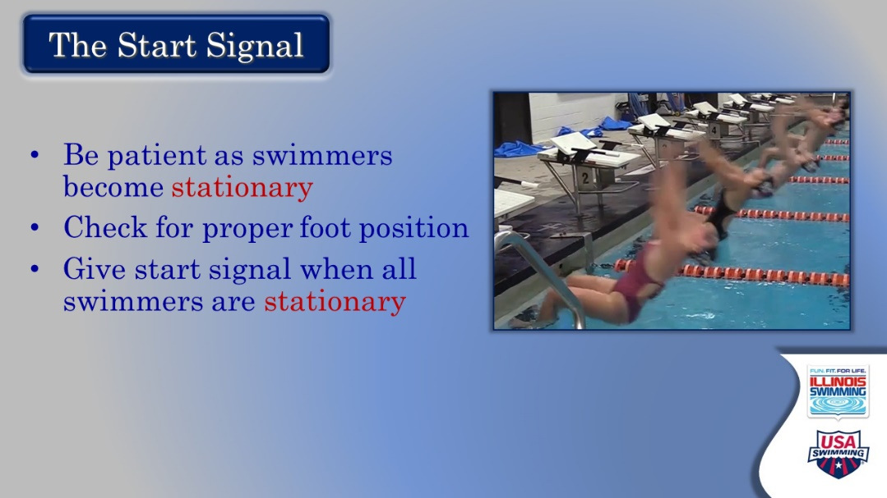

- Start Signal
  - This slide ideally will serve as a review of discussion on the previous slide
  - Stress the need for patience, for position to see feet
  - To give the signal when all swimmers are stationary

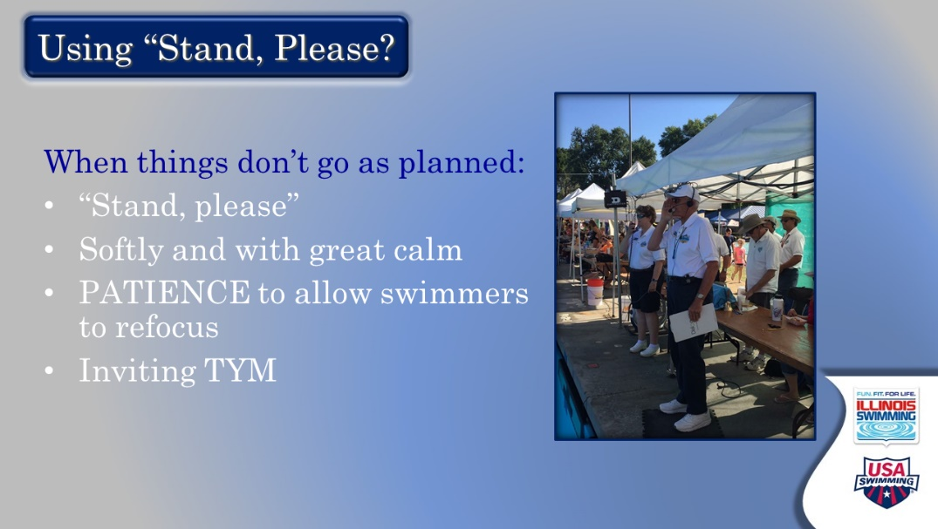

- Using “Stand Please”
  - Ask: when do you use this request? What are you seeing? How immediate is the request?
  - Note: tendency is to be rushed when asking for a Stand. Don’t be.
  - Emphasize: taking a deep breath and not rushing the TYM. Gives athletes a chance to reset, but also you. Your TYM should be relaxed and inviting

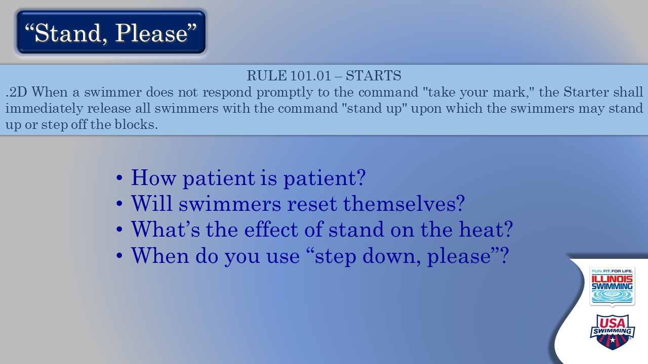

- “Stand Please”
  - Continue the discussion on the amount of patience required to let swimmers set/reset
    - Is this age group and experience dependent?
    - What effect does a stand have on the rest of the swimmers?
    - What happens to the other swimmers if you wait too long for someone to settle?
  - When is it appropriate to ask swimmers to “step down, please”?
    - When referee tells you
    - When swimmers seem stressed and need a complete reset

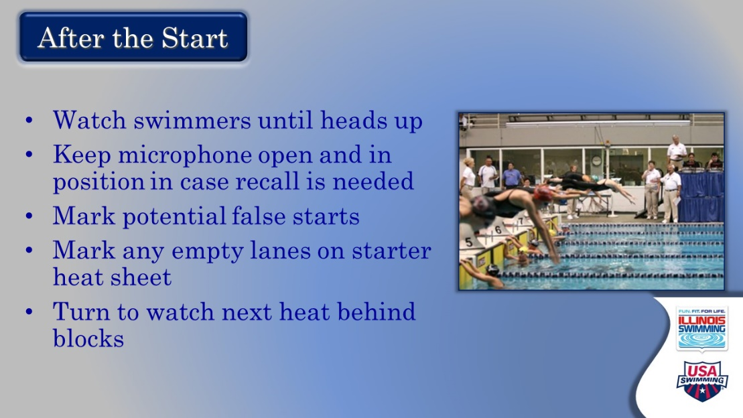

- After the start
  - Ask: You’ve given the start signal, now what are you going to do – and why?
    - Slide will give the key points – let them read first
    - Ask if there are questions on comments on the sequence after the start
  - Points of emphasis to cover:
    - Watching the heat go into the water with an open mic – looking for any problems that might necessitate a recall. Tell a story if you would like about this.
    - Finding a routine to put the mic somewhere and then indicate a false start and mark empty lanes – admin will be grateful to have another data point to resolve a potential problem
    - Turning emphasis to the next heat, and not watching the heat in the water. Be present to the next set of swimmers and watch for potential problems. Stay focused
      - You might comment or it might be asked – what to do with longer length races. Do you have to stand there the whole time?? Of course, it depends. Talk about this if it seems to be a concern.

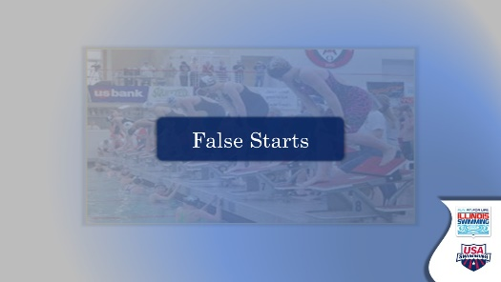

- False Starts – transition slide
  - This is a good place for a stretch break of 3-4 minutes. Reminder it’s not just for your participants but for you. Stand up, walk around, get a drink, etc.
  - As you pull the group back together, remind them that becoming a good starter takes lots of practice and repetition. Some things may not be clear until they are holding a microphone on their own.

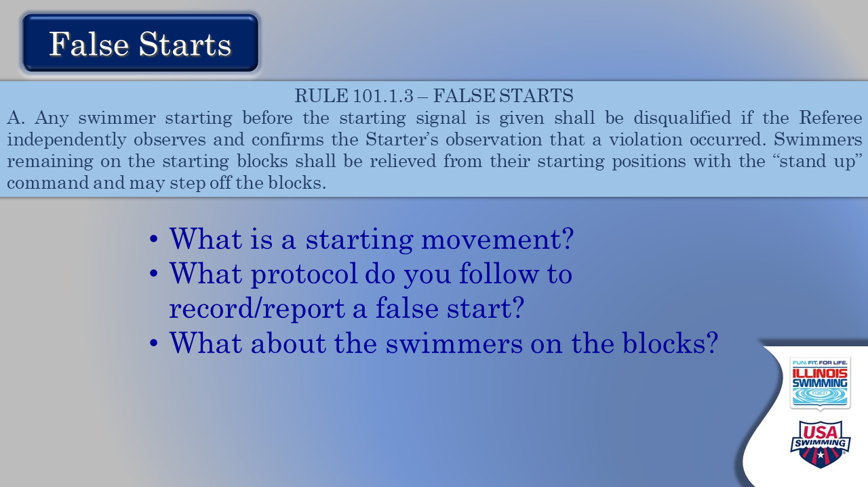

- False Starts
  - Note: by rule, a swimmer starting before the starting signal
    - Ask: so, what’s starting? What are you looking for?
    - Review: disqualifiable vs. non-disqualifiable movement
  - Ask: What protocol do you follow if you observe a false start?
    - Circle offending lane
    - Approach referee with “I have a potential false start”
    - If confirmed, referee will handle paperwork and notification
  - Ask: If this happens before the start signal, what about the swimmers on the block?
    - Referee might ask to step heat down
    - If this doesn’t happen, and you think it should – suggest to referee

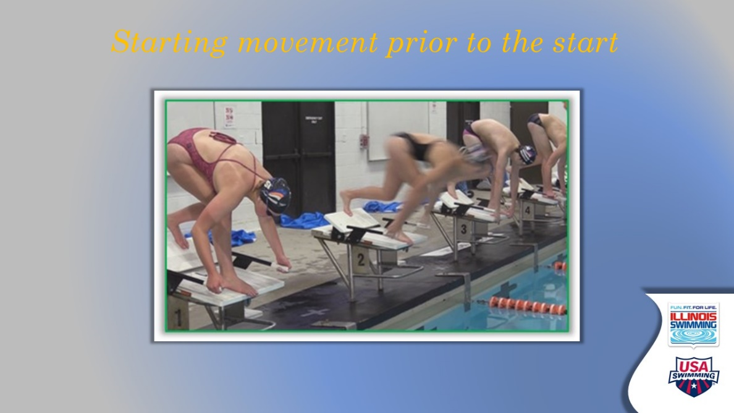

- Starting motion before the signal
  - Great picture of swimmer in Lane 2 moving while other swimmers remain set
  - You could introduce:
    - If you see this and can’t stop from giving the starting signal, what do you do? (review false start procedures)
    - If you see this and can stop from hitting the button, what do you do? (review us of stand, and possibly step down)

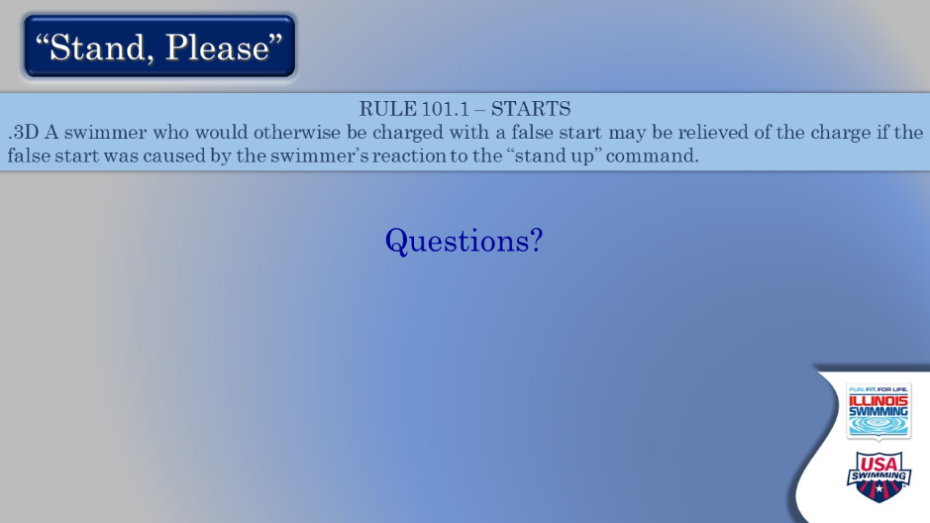

- Stand, Please
  - The emphasis of this slide is the reaction of the other swimmers to stand.
    - Confirm that ANOTHER swimmer who reacts to the stand command by moving or entering the water is NOT charged with a false start

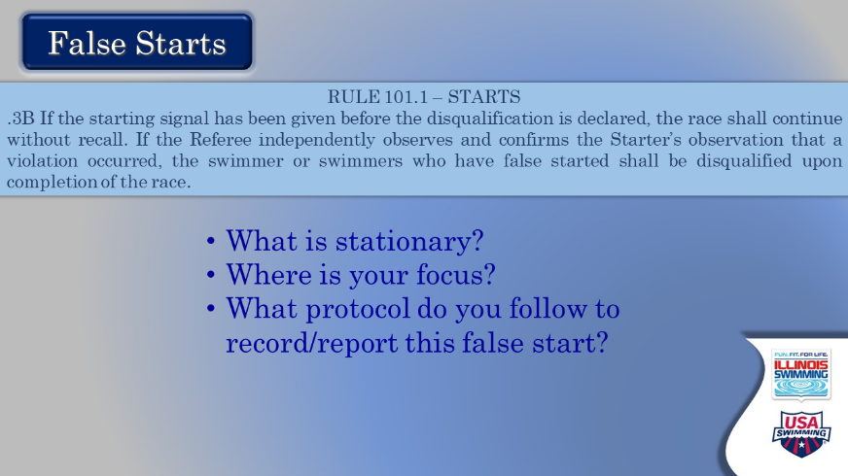

- False Starts
  - This slide offers the rule and key questions, again. Let participants read.
  - Ask: is there anything that we haven’t already talked about that we should here?
    - Proceed accordingly

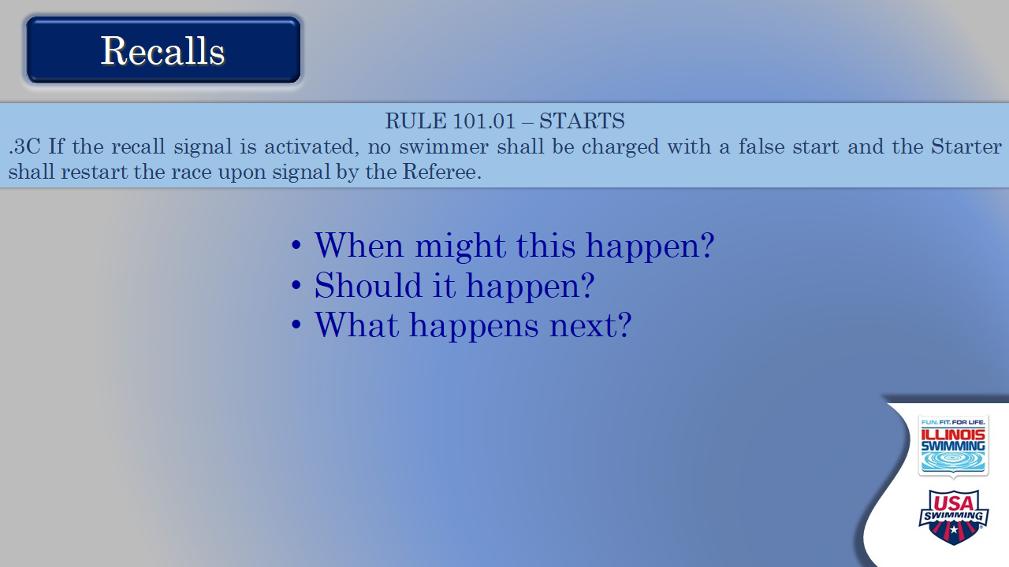

- Recalls
  - Comment: what’s a recall, how is it initiated and by whom?
    - Mic needs to be keyed, depress start button again
    - Starter independently, starter when referee asks
  - Why would you recall?
    - Inadvertent (Note that they should be prepared for this to happen to them, at least once in their career)
    - Is it a good thing to recall?
  - Once a recall has occurred, what happens next?
    - Procedure in the hands of the deck ref, perhaps the meet ref, with discussion at the table and with coaches
    - As a starter, stay calm and focused; keep contact with swimmers behind block. Be prepared to make any announcements, or walk behind the block to notify swimmers

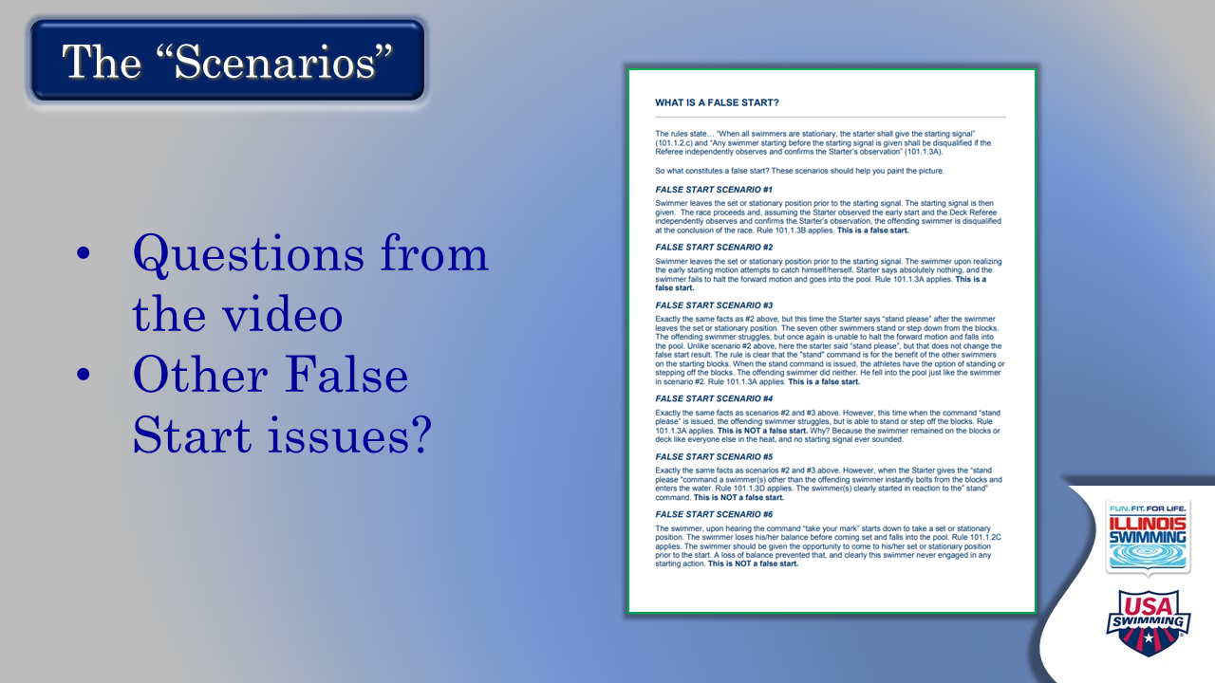

- The Scenarios
  - Participants have watched a dedicated video that shows the scenarios.
  - Reinforce that these are from the National Officials Committee in an attempt to make judgments about false start situations more consistent
  - Recommend that this video be viewed several times during training and even when “out in the wild”
  - Ask: Any questions from the scenarios? Any other false start issues we should be addressing?
  - Comment: like most aspects of starting, developing an eye for false starts will come with practice and repetition

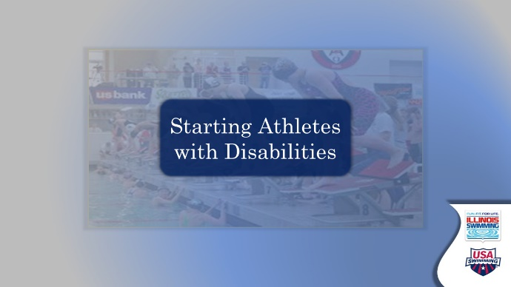

- Starting Athletes with Disabilities – transition slide
  - Maybe a spot for another mini break, maybe not
  - Introduce the concept of adapting starts for athletes with disabilities. Our LSC has a fair number of accomplished adaptive athletes and starts should be prepared to serve them well
    - These are not disabled athletes – rather athletes with disabilities. Or para swimmers, adaptive swimmers
    - Their focus is on what they have, not what they are missing. Ours should be too!

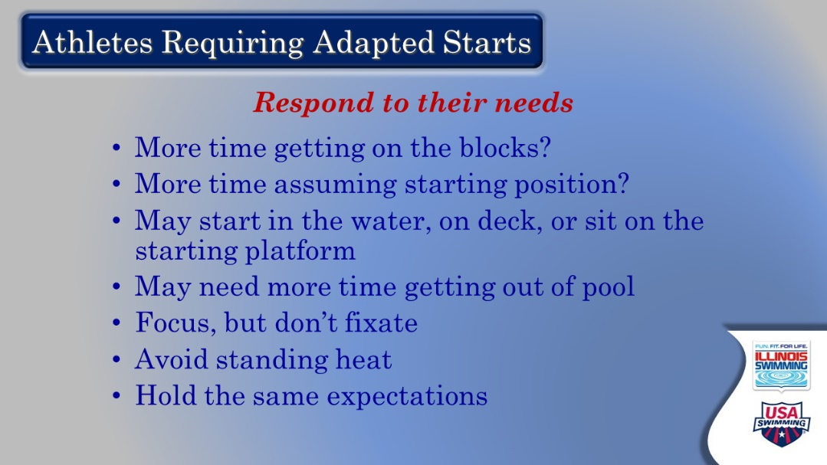

- Athletes Requiring Adaptive Starts
  - Key takeaway – as officials, we will respond to their needs
  - Let attendees read the list; ask if there are questions or comments
  - Note that meet referee should communicate any needs or requests to deck referees who will pass along to starters
    - Emphasize that patience is key; you want to get the start right without a stand.

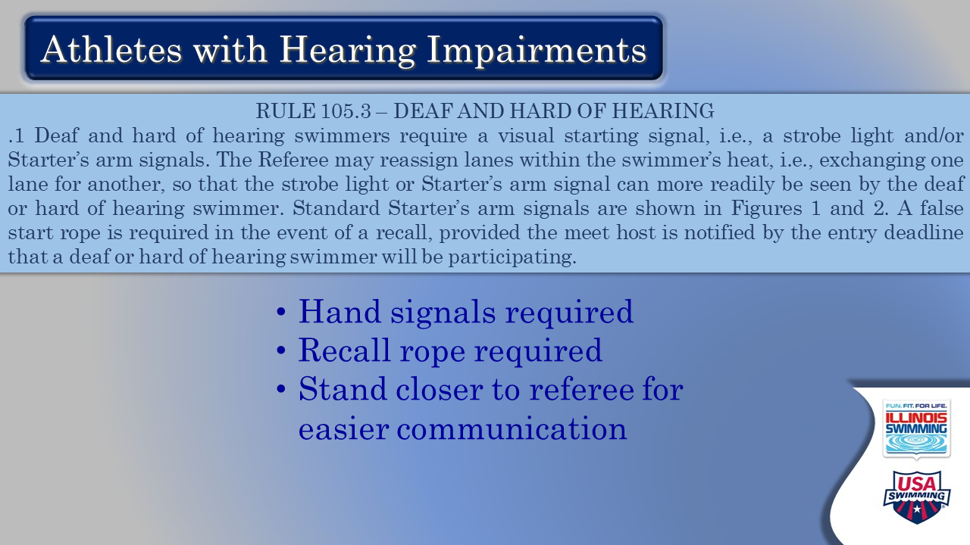

- Athletes with Hearing Impairments
  - Comment: not being able to hear the start commands and signals requires the most adaptation
  - By rule: hand signals required, recall rope required (meet director, facility); may require more conversation between DR and SR so stand closer

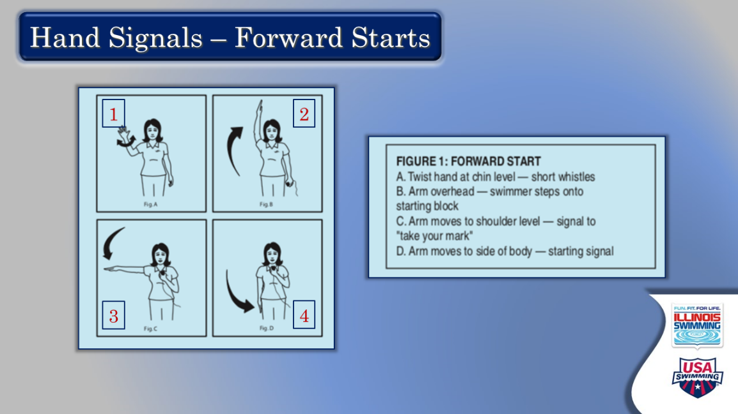

- Hand Signals – Forward Starts
  - Comment: Like anything else, these take time to become facile and comfortable
    - Should be included in fourth or fifth training session
    - Should be practiced at home
    - Should be practiced routinely on deck when you are a starter – so you are ready
    - Could involve putting mic in non-dominant hand – practice this
  - Review mechanics and answer any questions – comment on need for crispness and timeliness
    - Short whistles – hand wave in alert
    - Long whistle – raise hand overhead
    - At TYM – straight arm down to shoulder height
    - At signal – snap arm to side

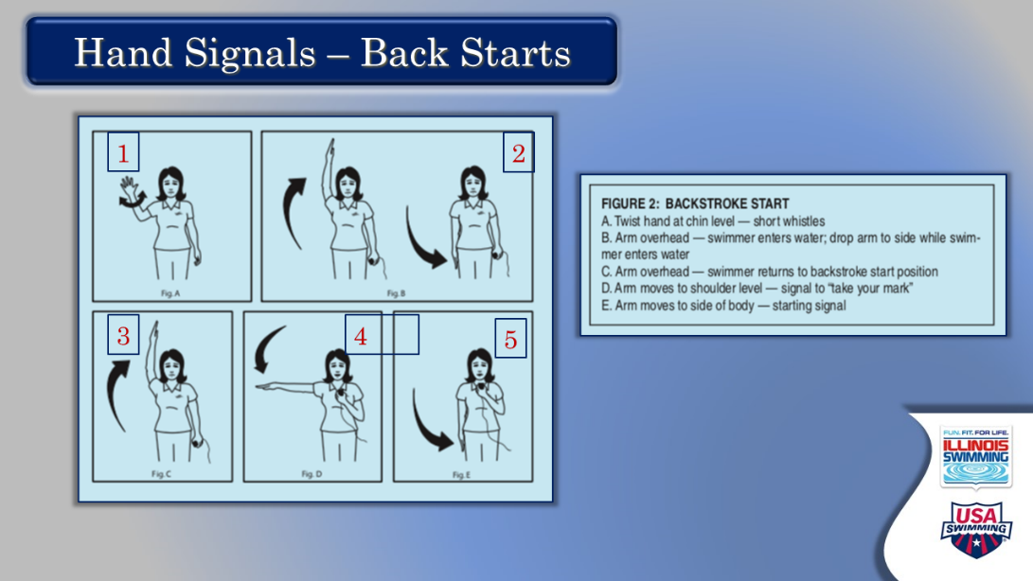

- Hand Signals – Back Starts
  - Ask: how does a backstroke start different from a forward start?
    - Two long whistles so sequence changes slightly
      - First long whistle – raise arm overhead, then take down
      - Second long whistle – raise arm overhead again and follow sequence already discussed
  - Remind: you are still responsible for the entire heat; don’t fixate
  - Ask: Any other questions or concerns about deaf starts?
  - Remind: All of this takes focus and a lot of practice.



- Other Things – transition
  - This little section wraps up some of the other tasks for the starter. It should go quickly

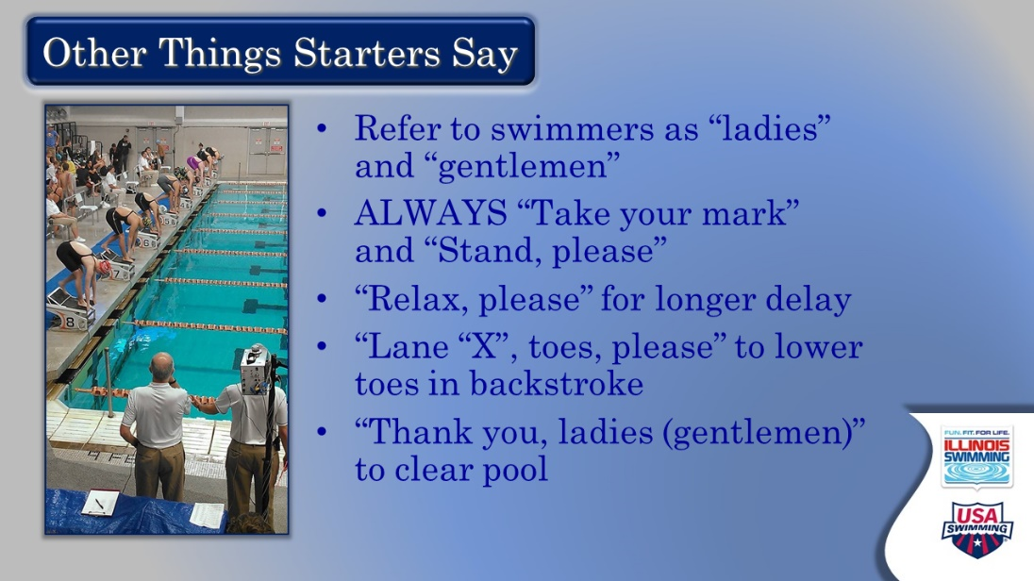

- Other Things Starters Say
  - At this point, all these things should have come up in discussion
  - Emphasize:
    - We use “ladies” and “gentlemen” as common parlance, so we only learn it once for all levels. You may hear starters say “swimmers” instead. This is okay as well.
    - Always use “please” with any request.
    - Don’t say a lot on your own – wait for your referee to ask.

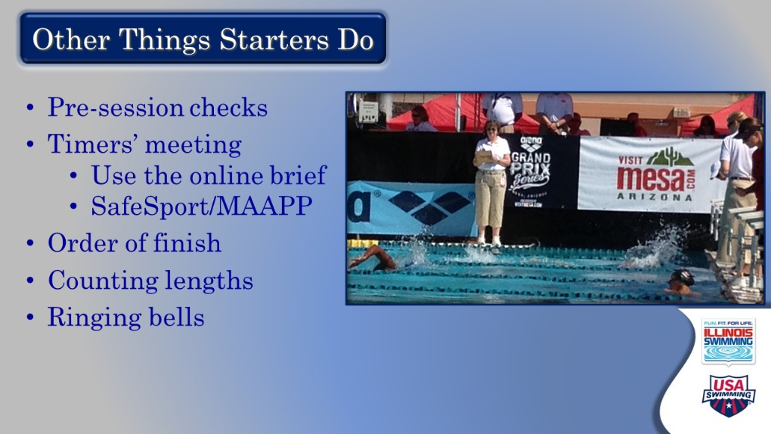

- Other Things Starters Do
  - Comment: EdPuzzle videos alluded to several other tasks given to the starters
  - Topline/Review:
    - Pre-session checks: start system position, mic volume, block check, speaker check (if present)
      - Stress importance of each starter checking the volume level for themselves and arriving at a common setting that will work
    - Timers’ meeting – refer to sample briefing; importance of knowing what will be asked of timers (number of watches, fly over starts? Number of buttons)
      - SafeSport and MAAPP – no phones or cameras behind blocks; what restrooms are available for timers
    - Order of finish – ask: who has done this before? Why is it being done?
      - Stress focus on the task – get first swimmer of a tight heat… and may be able to get last one or two. All the data is important.
    - Counting lengths – good practice for OOF; help determine if counters are correct, know when to ring bell

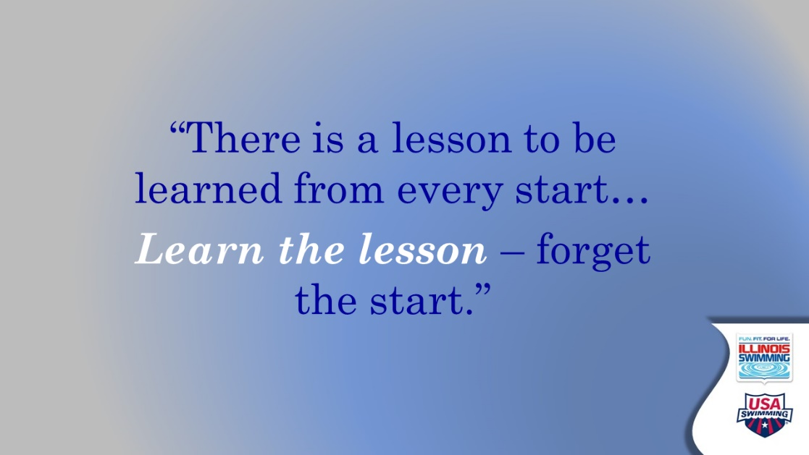

- Quote
  - This is a great mantra for a starter
    - Learn the lesson of each start, but forget the start
    - Mulligan in golf
    - Live in the moment – tell a story if you would like. [Dustin Johnson the golfer is such a champ because he can completely erase any previous shots or putts and solely focus on the shot at hand.]
  - Check for any lingering or outstanding questions on starting.



- Training and Certification – transition slide
  - Final stretch – review requirements for training, certification, and recertification

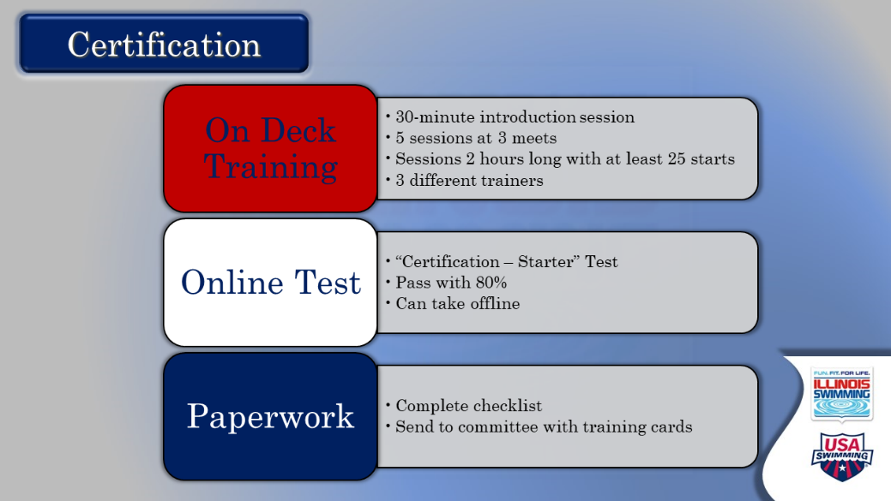

- Certification
  - Comment: this slide reviews the three components of certification: on Deck training, online test, and the paperwork. Let’s break it down:
  - On Deck Training
    - While important for all positions, this is the KEY COMPONENT for a starter. In fact, we are always training and learning.
    - New to the online training world: a 30-minute introduction session during a club’s practice. Arranged by the Officials Committee with a senior starter trainer conducting the session; get the kinks out before going live
    - Regular on-deck sessions:
      - Five sessions across three different meets (varied experiences, hopefully different facilities, and challenges)
      - Two-hour minimum for sessions
      - 25 starts (you’ve got to practice!)
      - At least three different trainers (Learn from different perspectives and experience levels)
        - Try all suggestions; take what works and make it your own
      - Contact the meet referee in advance to set up training; this is always appreciated and could ensure that you will be trained.
      - Be sure your training cards have comments. Ask for feedback, be happy with improvement across sessions.
  - Online Test
    - Emphasize to take the CERTIFICATION test for starter; pass with 80%. Some people like to print the test, complete offline, and then enter answers.
    - Timing does not matter – pre/post on deck training; recommended to take before.
  - Paperwork
    - Complete checklist and include training cards (form on website)
    - Send to officials’ email – not the ISI office
    - Confirmation email when status is changed from trainee to certified
  - Note: if discussion devolves to personal cases, say that you will stay on after the session to answer, or questions can be sent to the officials email address.

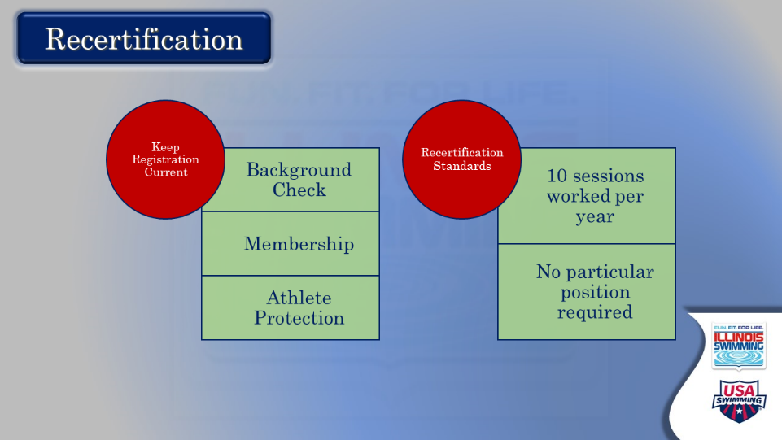

- Recertification
  - Topline the fact that we renew our membership and recertify every calendar year as officials.
  - Let them read the two components. Entertain questions.
  - Note that background check and APT expirations are month-specific and need to be monitored.

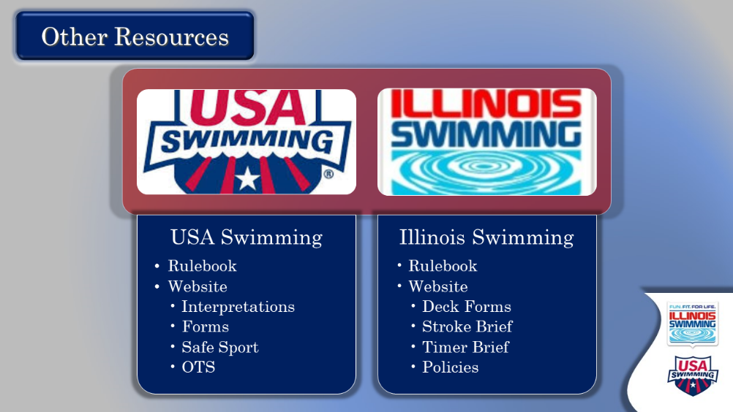

- Other Resources
  - The purpose of this slide is to remind them that they have lots of online help when they have a question or need more information.
  - After making that comment, let them read. Entertain any questions.
  - Note that Officials Committee sends periodic newsletters with the most up-to-date information and reminders about all things officiating.

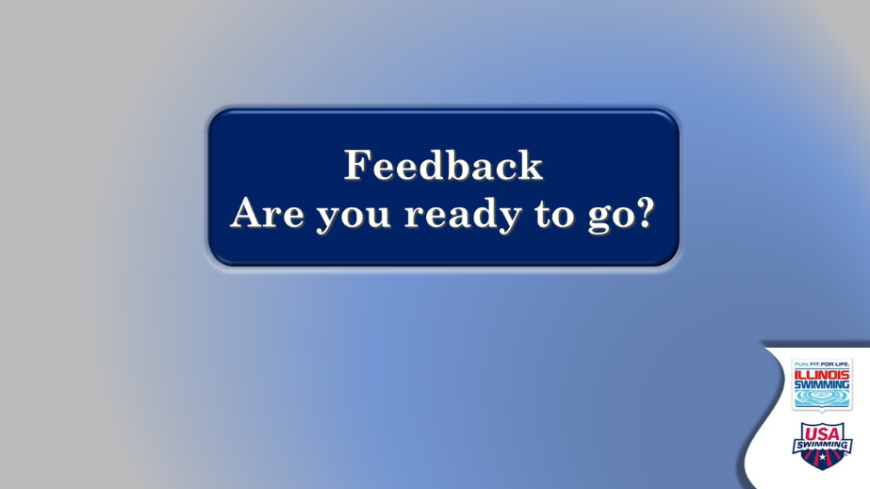

- Feedback – are you ready to go
  - This is a genuine attempt to get some real-time feedback on the effectiveness of our training process and identify what might be missing, or what’s coming up on deck. NOTE: attendees also will be sent an email with a feedback instrument.
  - Ask each person for their assessment of how they feel about picking up the microphone and what help they will need going forward.
  - Close by thanking them again for their willingness to move up in the ranks of officials and taking the time to learn the starting process. Reassure them that it will take time and repetition to become comfortable in their new role, and that there will be a lot of support from other officials at their club and in the LSC.

