WRITTEN ACKNOWLEDGEMENT OF POLICY

Sage YMCA Piranhas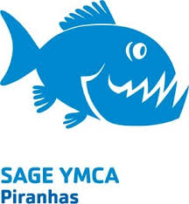

I acknowledge that I have received, read and understood the Minor Athlete Abuse Prevention Policy and/or that the Policy has been explained to me or my family. I further acknowledge and understand that agreeing to comply with the contents of this Policy is a condition of my membership with Sage YMCA Piranhas (USA Swimming member club).

Name: Athlete Name:
Signature: Signature:
Date:

