- Login to the website
- Click on the “My Account” section and click the “My Account” link (as shown below)
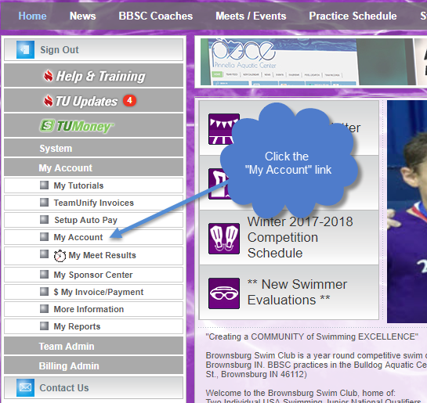
- Click on the “Members” tab
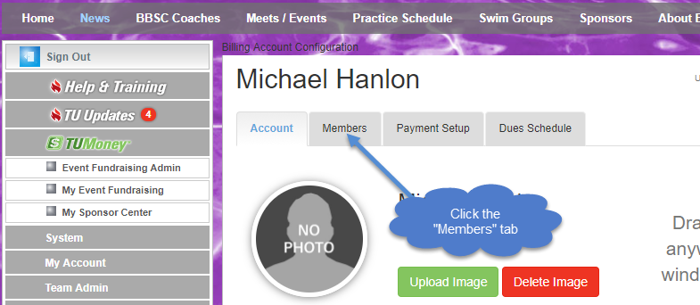

- Once there, if you have more than one swimmer, select the tab with the name of the swimmer you want to edit.
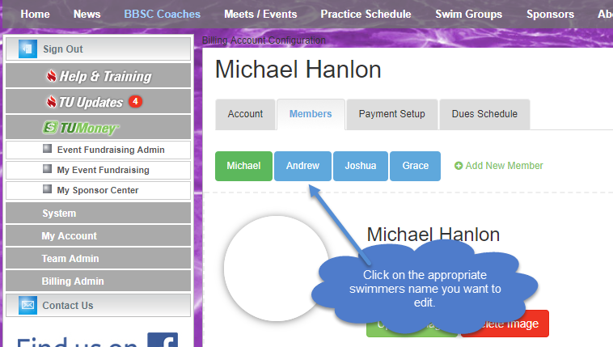

- Scroll down on the screen until you see the area on the left where you can select the “Shirt Size”.

NOTE: Even though we only need their Shirt Size, you can also enter their other information here, just in case they are receiving a Parka (We would like to use “Jacket Size” for Parka’s because sometimes people’s shirt sizes are smaller than their jacket sizes)
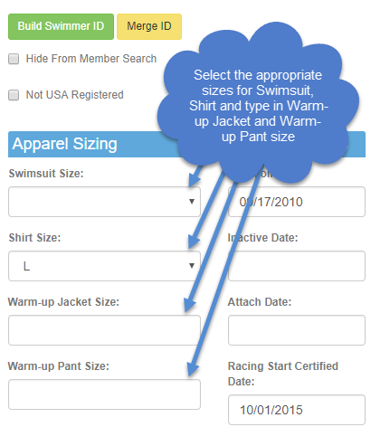

- You must scroll up to the top (or down to the bottom) of the screen and click on the “Save” button to save your changes.
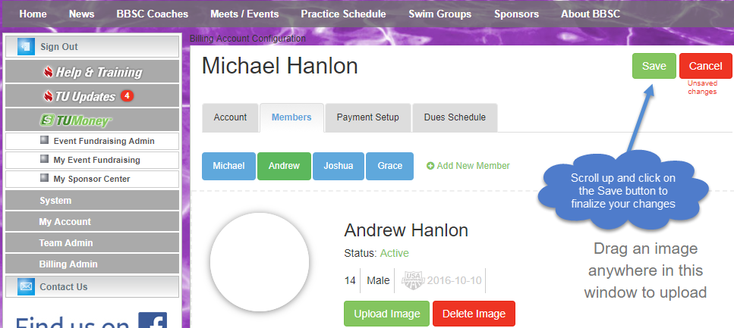

Once you have completed these steps, verify that the values that you entered are there. You have completed the necessary steps to update your swimmers’ information. If you have more than one swimmer to update, go back to step 4 and click on the other swimmer(s) and complete this for them as well.

