Registration and Sanction Information for Coaches

ANNUAL REGISTRATION
Opens: Sept. 1, 2022
Deadline: Dec. 1, 2022 or prior to the entry deadline for any sanctioned YMCA meet, whichever is earlier.
- Please complete your registrations as early as possible and update any expired certifications immediately upon renewal.
- Access Registration: regional website, national website, or if your team is a TeamUnify customer, go to YMCA Admin tab on left side of screen once you are logged in.
- For help with the process, go to http://university.teamunify.com/ymca-registration-portal/ymca-teamunify-team#
Team Registration (for all YMCA teams):
- The team registration fee is $50 per team per year.
- Team registration fees are paid online with a credit card at time of registration. This is the only payment option. Checks are not accepted. This is a secure payment system linked through the TeamUnify platform directly to the YMCA of the USA. After submitting payment, an email will be sent that will include the payment information and a link to print out the receipt. Credit cards accepted: Visa, Mastercard, Discover. American Express is not accepted.
- Please complete all team information as accurately as possible. This provides important data on the size, scope and structure of YMCA Swimming across the country.

Option 1: If you have a TeamUnify Site
Help Site: https://support.teamunify.com/en/articles/449
If you have bookmarked your YMCA portal or your home webpage address for your TeamUnify site please login to the system. If not, you can search for your team’s portal from the National YMCA Swimming and Diving Website. When you have found your address please click Sign In and login using your login email address and the password you created for your account in the previous lesson.
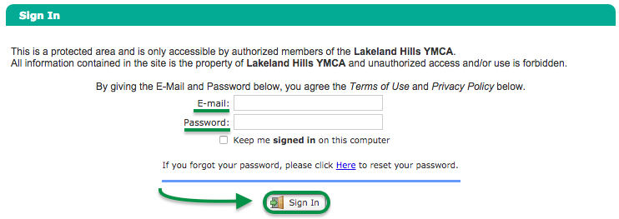

Team Access
In the side menu click YMCA Admin > My Team. Your team details will now load into view on the My Team tab. Note your Regional Rep’s name and number in blue at the top in case you have any questions.
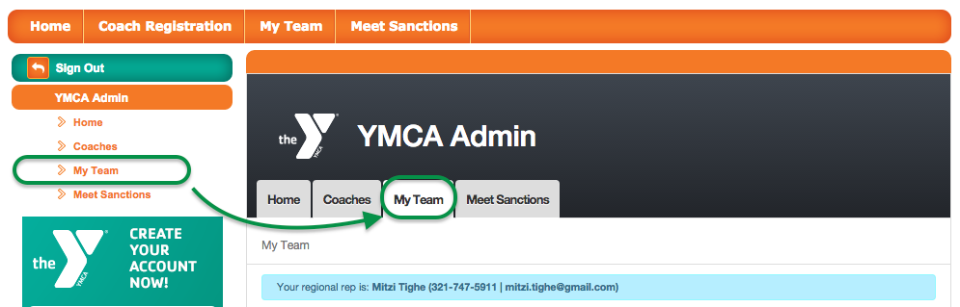

As a requirement for YMCA Team Registration, you will need to ensure that the information for your team is as complete and accurate as possible prior to submitting your team registration. This includes Team Profile, General Info and Staffing, Program Info, and Facility Info.
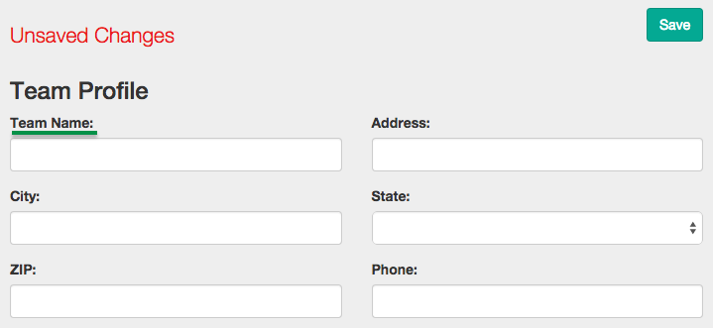

Team Details
Once you have updated your team information click Save. Your information will then be uploaded to the YMCA Database.
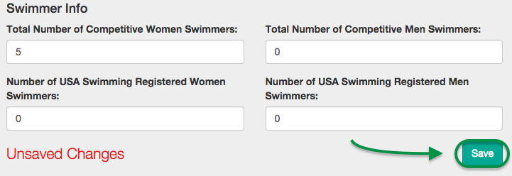

Submit Registration
To submit your Team registration, scroll back to the top of the page and click the Submit Team Registration button.
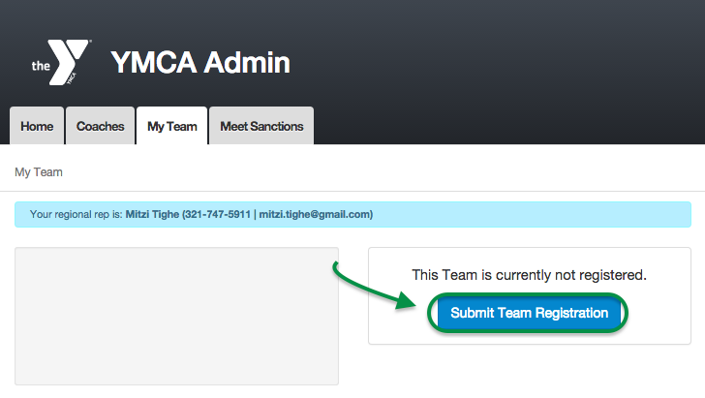

This will open a form to pay for your team registration via credit card.
- If you do not have a CC on file, simply fill in credit card and billing details (click Copy From Account Info to save time), then click Next.
- If you already have a CC on file, simply fill in the CVV of the card.
- If you want to use a different CC than the one you have on file, click Add/Select Card, then click Add New Card, fill in credit card and billing details (click Copy From Account Info to save time), and click Next.

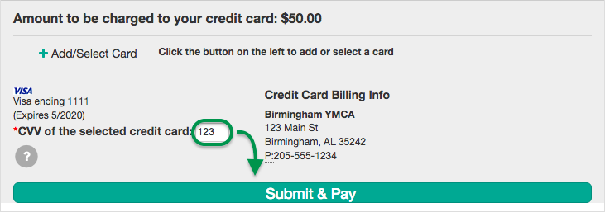
Click Submit & Pay, then OK to confirm.
That is it. You will now receive additional details via email, and you will see the status of your registration on this page. You can return to this page at any time in the future to review the status of your submission.
You are now done with the team registration submission process. It is now time to submit coach registrations or meet sanctions.

Option 2: If you do not have a TeamUnify Site
Help Site: https://support.teamunify.com/en/articles/457

Find Your YMCA
To find your YMCA, navigate to either the YMCA National site or your Regional site and click the Register Coaches & Teams Now button.
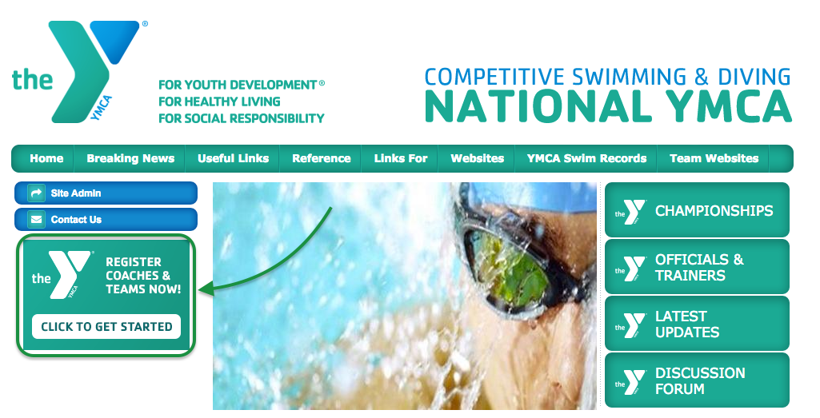
From the YMCA Search page, you will be presented with a few ways to find your YMCA — by Association # or by Team Name and State.
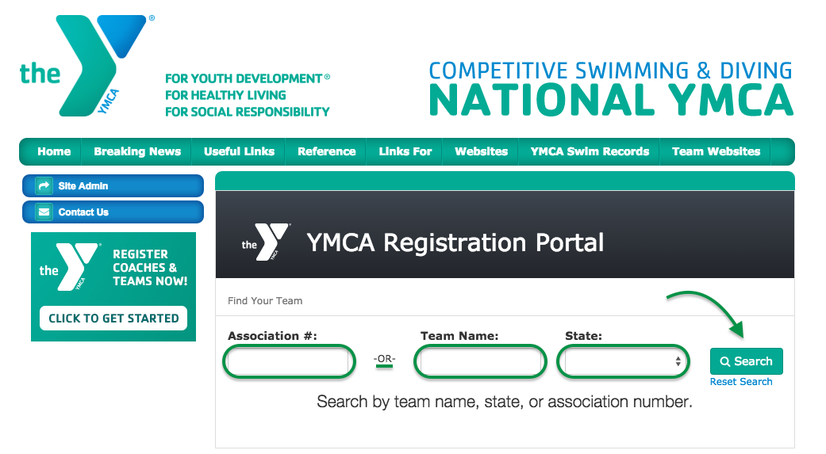

Access Your YMCA Admin Site
Click Search and you will be presented with a list of YMCAs to choose from. Find your YMCA and click Select or Reset Search if your YMCA does not appear.
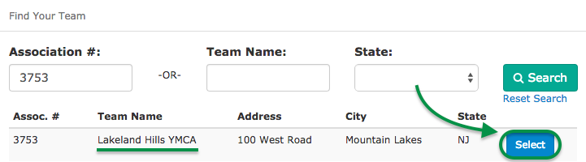

TeamUnify Customer Access
You will now be presented with some information about the registration process. Please note, as a TeamUnify customer, your team administrator will need to create an account on your team’s website if you have never logged in before. Please email or contact your Team Administrator to create a login if you do not have one.
Next, click the Continue to my team’s website button.

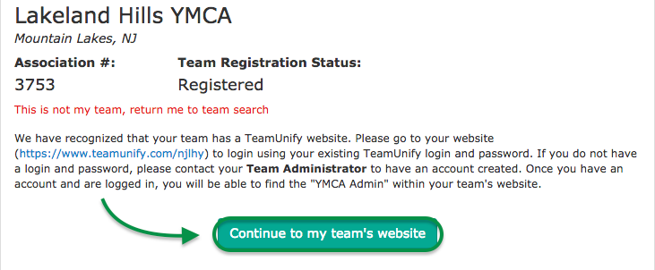

Non-TeamUnify Customer Access
You will now be presented with some information about the registration process.
If you have a login to your team’s registration portal please click Yes I have a login button. If you have a login but forgot your password also click the Yes I have a login and use the reset password functionality. If you have never created an account or logged in to the new YMCA Registration portal please click the No I do not have a login button.
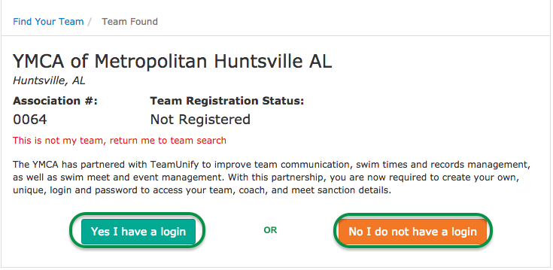

If you have a login please skip to the Account Login step of this Lesson. If you do not have a login please continue to the next step.
After logging in, you will be redirected to the YMCA Registration Portal homepage. From here you can choose to continue the process to register yourself or someone else as a coach, register your team, or to submit a meet sanction request.

Create Your YMCA Login
Enter your email address, first name and last name. Please enter the email address that you have used when registering in the past and click Continue; you can update it later if necessary.
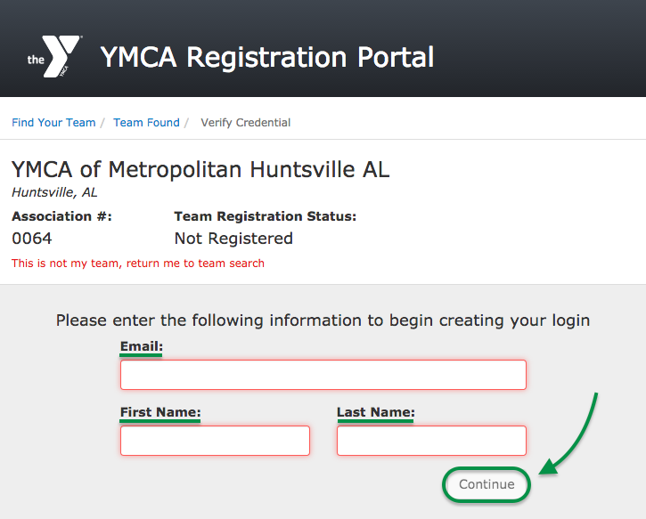

The YMCA Registration Portal will attempt to find your existing registration. If it finds that you have previously registered with the YMCA, you can simply click the Reset my password button. A password reset email will be sent to your email address with instructions on how to finish setting up your account. If you happen to remember your password you can click Wait, I remember my password and you will be redirected to your team’s portal.
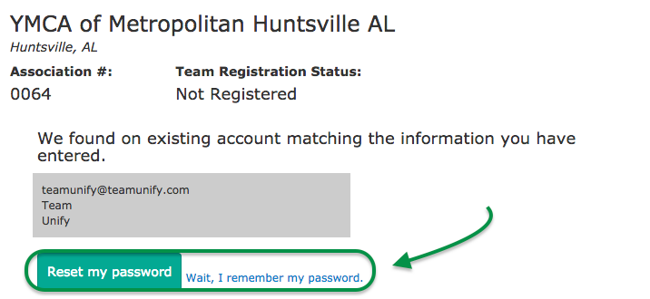

In the event that we are unable to find your existing registration, you will have the ability to create a new account by clicking Create my account.
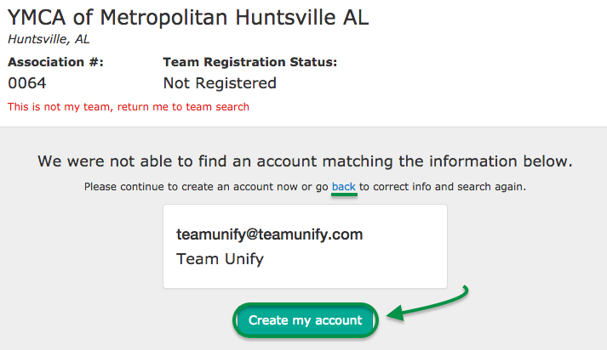

Please follow the instructions on the screen and enter the required information, then click Create Now. Once entered, further instructions will be sent to you via email to finish creating your account. It will take anywhere from 24-48 hours for you to receive this email.
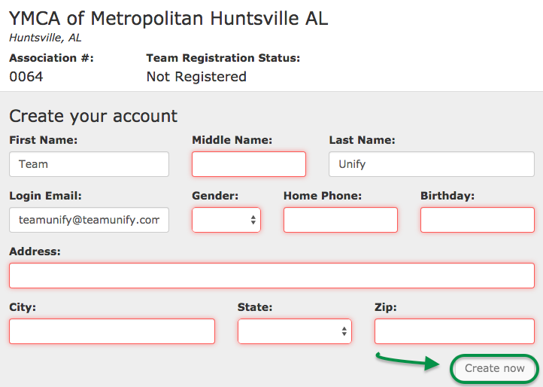

Once you have received this email please follow the instructions. You will find your instructions, your email login, a link to set your password and a link to your team’s homepage. It is a good idea to bookmark or save this web address for future use.
Click the long URL link to set your password.
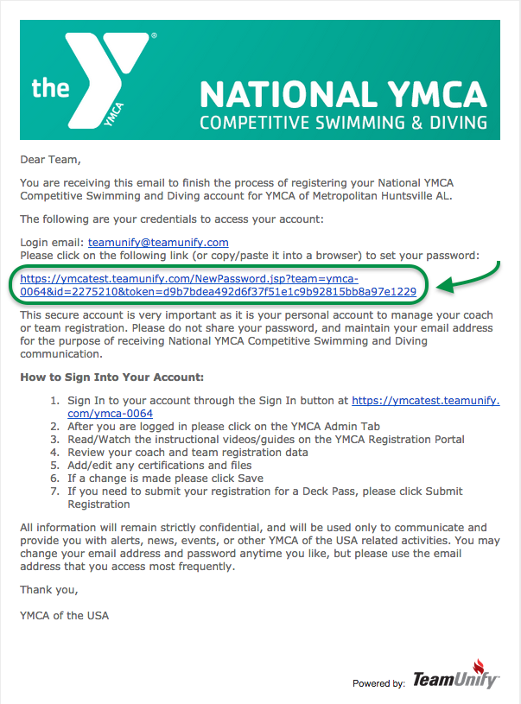
Type in your password you want to set for your account, type it again and click Change Password. The two fields must match.
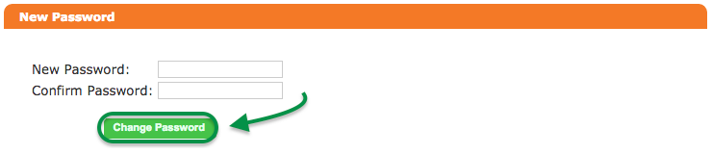

Account Login
Once on your website, login with the login email address and password you use to access your TeamUnify team website and click Sign In. If you do not remember your login, follow the reset password instructions. If you do not have a login or need help, please contact your team’s TeamUnify Website Administrator.
After logging in, you will be redirected to the YMCA Registration Portal homepage. From here you can choose to continue the process to register yourself or someone else as a coach, register your team, or submit a meet sanction request.

