
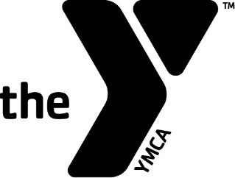

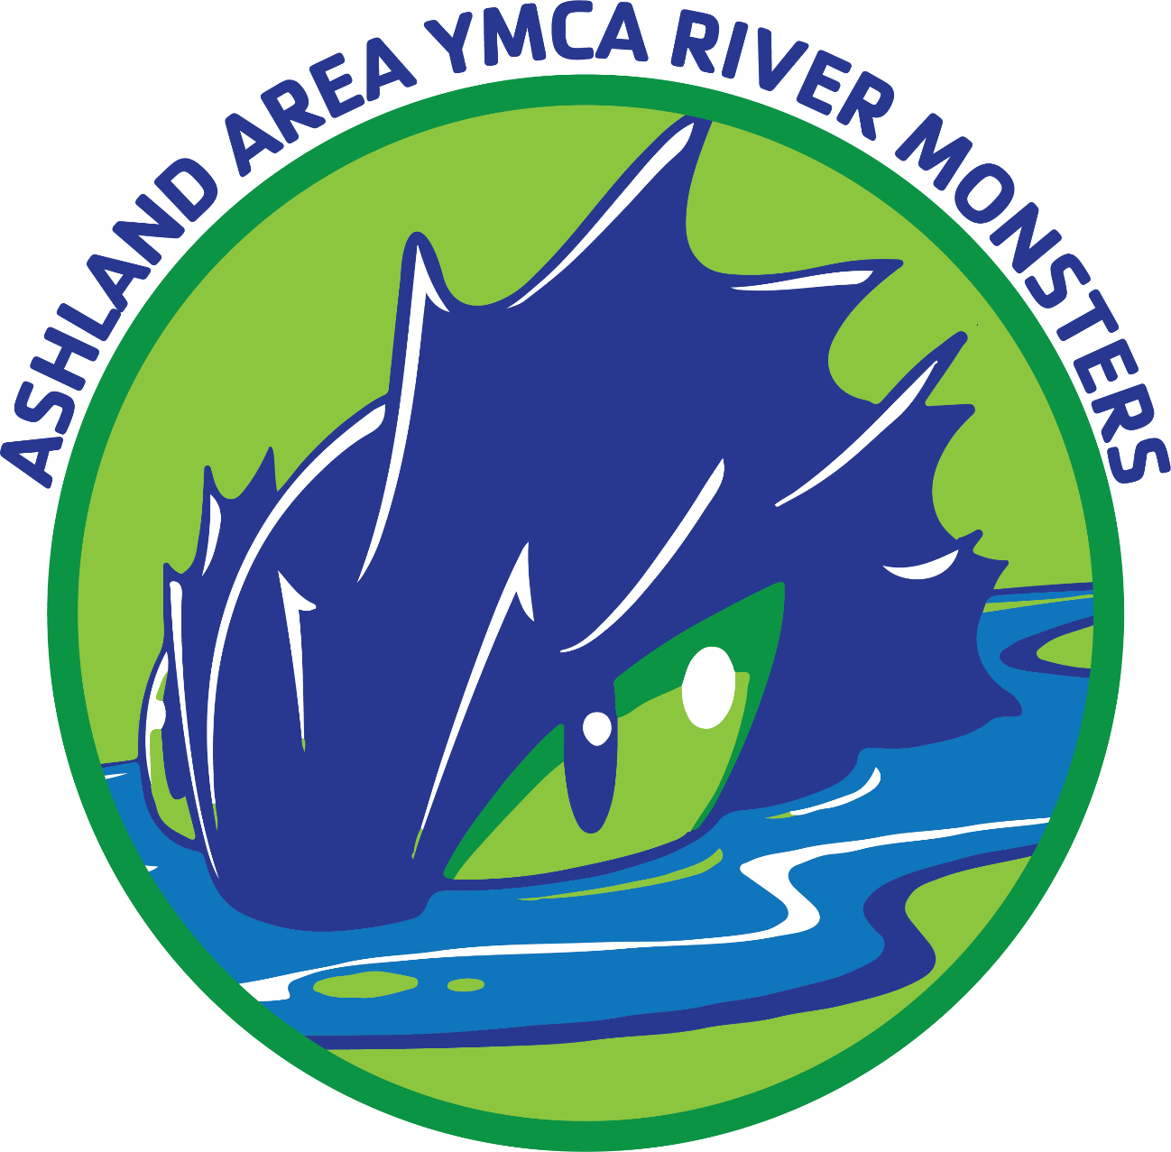

ASHLAND AREA YMCA RIVER MONSTERS SWIM TEAM
PARENT HANDBOOK AND SWIM TEAM GUIDE
Table of Contents

Table of Contents ……………………………………………………………………… 1
Purpose ………………………………………………………………………………….. 2
Eligibility ………………………………………………………………………………… 2
Team Fees ………………………………………………………………………………. 2
Group & Practice Times …………………………………………………………….. 3
The Program …………………………………………………………………………… 4
Rules ……………………………………………………………………………………… 4
Team Sponsored Home Meets ……………………………………………………. 5
Team Activities ………………………………………………………………………… 5
Swimming Seasons …………………………………………………………………… 6
League Participation and Swim Meets ………………………………………… 6
Club Facility ……………………………………………………………………………. 7
Parent Information ………………………………………………………………… 8 – 11

YMCA RIVERMONSTERS SWIM TEAM
PURPOSE
The purpose of the AAY Swim Team is consistent with that of the KYCSL (Kentucky “Y” Competitive Swim League), which states:
“To provide boys and girls (ages 5-18) an opportunity to participate in supervised competitive swimming, under conditions that will promote Christian fellowship, skillful aquatic ability, systematic physical exercise, education and sportsmanship of the highest caliber.”
The program will teach fundamentals and techniques of swimming, which will enable the swimmer to compete at all levels. Although we enjoy winning, we hope to keep the emphasis on participation, self-discipline, self-improvement and responsibilities as a team member.
ELIGIBILITY
In order to be eligible to swim with the team swimmers must:
- Be a member of the Ashland Area YMCA
- Complete on-line registration.
- Pay all swim team fees and keep current each month.
- Attend required number of practices as determined by the coaching staff (please call if illness, excessive homework and church, etc.)
- Be able to swim one lap of the pool of freestyle and backstroke
- Abide by all rules as established by the staff
Team Fees
- YMCA Membership - various options and pricing. All participants must be a YMCA member. Please see http://www.ashlandareaymca.org/membership.html for more details on pricing.
- Practice group fees (per swimmer) - Developmental group $55/month; Junior Group $55/Month; Intermediate group $60/month; Senior Group $65/month
- One time per-season League fee of $50 per swimmer, sent to KYCSL (This is entry fee for all YMCA meets).
- USA Card $99 as of 2023 per year (Must have to participate in USA & KYLSC sanctioned meets). All fees must be paid directly to US Swimming.
- In September, registration will be done on-line and all fees will be paid at that time, including any past due fees. Each month, fees must be paid through the on-line system at the beginning of each month.
- All team fees must be paid in full each month. Fees will be auto-deducted by the card you place on file upon registration. If fees are in arrears, team member may not participate in practice or attend meets. As of January 1, 2023 the state of Kentucky requires state tax of 6% to be collected on all fees. 6% KY tax will be collected on all fees.
- YMCA membership is non-refundable.
- Team fees are not pro-rated.
- There are no discounts except those allowed for multiple swimmers from same family.
Group & Practice Times
From developmental stages to Collegiate Level swimming, The Ashland Area YMCA River Monsters will teach and train kids in all levels of swimming! The AAY River Monsters swimming program offers a couple of different training groups for kids of all ages and skill levels. So if you like to swim and love the thrill of competition, then you are definitely a River Monster!!
Developmental Group
Meets Monday, Tuesday, Thursday: 6:30PM - 7:30PM
This group focuses on learning fundamentals of competitive swimming, learning all four competitive strokes (Butterfly, Backstroke, Breaststroke, Freestyle), building endurance, and will also begin to learn proper techniques for Starts, Turns, and Finishes.
Junior Group
Meets Monday, Tuesday, Thursday 6:30PM – 7:45PM, Wednesday 5:00PM – 6:30PM
This group continues to focus on improving stroke technique, improving level of endurance, building strength and advanced turn and start techniques, clock and interval work.
Intermediate Group
Meets Monday, Tuesday, Thursday, Friday: 4:00PM - 5:30PM, Wednesday Dryland 4:00PM – 5:00PM, Swim 5:00PM – 6:30PM
This group continues to focus on improving stroke technique, improving their level of endurance, building strength, learning race strategies, goal setting, and race preparation.
Senior Group
Meets Monday, Tuesday, Thursday, Friday: 4:30PM - 6:30PM, Wednesday Dryland 4:00PM – 5:00PM, Swim 5:00PM – 6:30PM, Saturday Morning 8:00AM – 9:00AM Dryland
Additional Practices during Summer Session.
This group continues to build their strength, endurance, goal setting, and race preparation at a higher level.

The Program
The AAY Swim Team is a program that emphasizes a place for every swimmer regardless of their level of accomplishment. The coaches are responsible for training the swimmers and determining the level of instruction. Grouping the swimmers according to ability allows the coach of that individual group to refine and develop those swimmers to perform effectively.
Warm-up and warm-down is very important and is an essential part of practice. They help prevent injuries, tightness, and stroke degradation, etc. Practice does not end here. One of the best times to stretch is after practice in the shower when hot water makes the muscles plyable.
Parents are welcome to attend practices. Please stay on the side of the pool and refrain from entering the area behind the blocks.
All actions of swimmers, coaches, and parents are representative of the Ashland Area YMCA. Everyone should keep this in mind.
Rules
Rules will be enforced to a greater degree as swimmer moves up through the groups.
- BE ON TIME. Enter the water when the practice is scheduled to start.
- Do no stop in the middle of the pool.
- No jumping off bottom.
- Flip every turn.

Team Sponsored Home Meets
The AAY Swim Team will host several home meets during the year. We have hosted meets in the past that was organized as well as fun. We want to continue the tradition and in order to do this we need a lot of parent workers to do various jobs. Please plan on working at least three meets this season and get involved in all the aspects of hosting a meet. This gives parents a chance to be a good role model and show “team work” to our children.
Away Swim Meets: When attending away meets parents are still required to help out when needed. The host team will usually let us know what they need. It’s always nice for all parents to put in their fair share so there’s not just a few doing all the work. TEAM WORK!
Team Activities
We will always try to schedule special activities throughout the swimming season. Your suggestions are always welcome.
Watch AAY Bulletin Board for information on Special Activities.

Swimming Seasons
There are two swim seasons, fall/winter and spring/summer. Fall/winter seasons practices and swim meets are conducted indoors and are called “short course” pools. Our winter home is at the YMCA and begins Sept. 1st of each year. Summer begins May 1st and is considered long course season. Most meets that we will be attending will be long course (50meter). We will continue to practice at the Y unless otherwise notified.
League Participation and Swim Meets
Participants who choose to compete with the YMCA River Monsters Swim Team must make a season long commitment. The swimmer must compete in at least two “Y” meets, (within the KYCSL), to be eligible for competition in the State Championships and three YMCA meets for “Y” Nationals. They must also be in “good standing” with the team, which means all league and entry fees have been paid. Remember “Team Work” is essential for a successful year.
Whether “Y” or USA (United States Swimming), there are basically two types of swim meets: the invitational and the duel or tri meets. For an invitational, the host club invites any teams it wishes. These meets can be quite large. They are generally two or three-day meets and are divided into sessions with various age groups swimming either in the morning or afternoon. Invitational meets often offer team trophies, individual and/or age group trophies and medals or ribbons in various divisions. The types of awards given are entirely up to the host team. There are three YMCA Invitational Meets per fall/winter swim season. The league fee of $40 per year per swimmer is your entry fee to the YMCA meets.
For USA Invitationals, swimmers are often grouped into three categories (A,-AAAA, B,BB) according to their ability to swim different strokes and distances relating to time standards set at the state and national levels. Many invitational meets are structured to accept all or some categories of A, B, C swimmers. There are some meets throughout the meet season that a swimmer must hold an “A” time to be entered. The USA Invitational has an entry fee per event that swimmers enter. There is a USA card that must be purchased each year per swimmer to participate in USA meets. Price may vary from season to season.
In the duel or tri meets, the host team invites only one or two teams. The schedule of events is much shorter, the entries limited (number of swimmers per event, number of events per swimmer) and the meet usually lasts only a few hours (Saturday morning or afternoon). These meets are usually YMCA meets.

CLUB FACILITY
The Ashland Area YMCA provides the swim team with a pool to use for practices and meets. Our staff, swimmers and parents have an obligation to use the facilities and equipment carefully and to respect the rights of others. Some points of importance are as follows:
1. Leave the pool deck and locker room tidy.
2. Never enter the water without the coach’s permission.
3. Be courteous to others using the facility (including good behavior in locker rooms).
4. Never run around or abuse any part of the facility during or after workouts.

PARENT INFORMATION
We define parent broadly to include all adults with primary responsibility for raising children, including biological parents, adoptive parents, guardians, stepparents, grandparents, or any other type of parenting relationship.

Practice Attendance and Behavior
The River Monsters are expected to attend as many practices as possible. All practices are mandatory! We recognize that there may be occasional conflicts (sickness, church, excessive homework, out of town); however, if a swimmer will be out of the water for a period of more than a few days, please notify the coaching staff. Parents, please keep in mind that we need your help in seeing that children are at practice and on time. The more one practices, the better the swimmer will progress. Any swimmer who is active in outside activities will be required to contact coaches and work out alternate practice schedules.
Bad weather/cancellations:
- We will have swim practices on all of our usual days unless notified otherwise.
- In case of bad weather, at least one of our coaches will always be there (unless the YMCA shuts down or severe weather prevents us from being there). Practice will not be cancelled. Parents must use their own judgment about attending practice in bad weather. If in question, please contact the “Y” before leaving for swim practice.
- If the pool is closed due to inclement weather (thunder/lightning), practice will be moved to dry land.
- If practice falls on a major holiday or on the day of a meet, we will not have practice.
Swimming is one of the most disciplined sports. Discipline is the responsibility of the swimmer and each must understand his/her role on the team. Swimmers are expected to be ready at their respective practice times. We must plan to make the most of our scheduled workouts by being on deck, on time.
Parents:
It is important to participate with your child on the swim team. The swimmer must be delivered to practice on time with constant encouragement and positive reinforcement. Once at practice, the coaches have sole responsibility for the swimmer’s training during practice. To discuss your child’s progress please contact the coach by telephone or after practice to set up a convenient time to meet. Although the swimming program has maintained an open-door policy for spectators, practices generally go smoother and swimmers’ attention kept better during practice if parents, siblings, etc. are not in the pool area. If a parent/family member stays in the pool area during practice, please sit on the blue tiled bench opposite the windows. Parents/family should not sit or stand behind the block area.
Cancellations: If a meet should ever be canceled due to severe weather every attempt will be made to contact each swimmer and the meet will be rescheduled if possible. If in question about a cancellation, please contact the front desk at the Y or one of the coaches.
Away Meets: Parents are responsible for arranging transportation and motel/hotel accommodations to away meets. We want to encourage parents to attend these meets, as we are responsible for providing timers, judges and officials.

Communication and Parents Group
We have a Parents Group that helps with various activities of the team. The Parents Group will help organize the set-up of the meets and organize parent workers to time, judge, and officiate the meets. At home meets we will offer concessions to visiting team/teams. All parents are expected to work at meets (please).

RESPONSIBILITIES
Responsibilities of Swimmers
To ensure a successful program, swimmers have the following responsibilities:
1. To be part of this team because your goals and ambitions are the same as those established by the coaching staff
2. To attend the designated number of practices as determined by the coaching staff
3. To follow the rules established by the coaches
4. To arrive 15 minutes prior to the start of practice or the meet warm-up and get ready immediately so you may begin on time (unless it is just impossible because of school).
5. To make sure handouts and announcements are delivered to your parents at home
6. BE PREPARED – bring all appropriate/required equipment or training aids to each practice.
7. To come to practice with a positive, appropriate attitude conducive to the Ashland Area YMCA Swim Team. No disruptive behavior! (Any disruptive behavior, swimmers will be asked to leave)
Responsibilities of Parents
To ensure a successful program, parents have the following responsibilities:
1. To take an interest in your child’s swimming and to support him/her emotionally by attending meets (Maybe you can’t attend all meets, but at least one parent should be present at most of them.)
2. To praise your child when he/she is successful (an improved skill, an award, etc.) and to comfort, not scold, them in their moments of disappointment. Make sure that your love for them is not dependent on how well they perform and that they know it.
3. To pay dues and fees on time
4. To provide transportation for the swimmer to and from practice and to and from meets. The swimmer should arrive about 15 minutes prior to the start of practice or warm-ups.
5. To participate in team functions
6. To check your email and the bulletin board for team correspondence.
7. To help staff the swim meets in these areas: TIMERS AND RUNNERS, CLERK OF COURSE AND AIDES, CONCESSIONS, SCORERS, RIBBON WRITERS, SET UP AND CLEAN UP, STARTER, AGE GROUP REPRESENTATIVE.
8. To stay away from gossip and rumors. If you don’t understand something concerning the coaching, ask the coach before or after practice (NEVER DURING) and as a last resort, call him/her at home. One of the most destructive things to a team is prolonging rumors rather than getting to the bottom of them.
9. To support the Ashland Area YMCA philosophy with thoughts, words and actions during practice, at meets and at home. Believe it or not, our kids do learn from watching and listening to us.
10. Not to be on deck during swim practice.
Responsibilities Shared by Swimmers and Parents
The swimmer and the parent share some responsibilities. They include the following:
1. To check the bulletin boards at the pool for special announcements, upcoming meet notices and entry information.
2. To contact coaches with your plans regarding meets and make sure you have signed up on bulletin board in pool area (if you plan on going or not). They cannot read minds.
A strong triangle emerges when each party (swimmer, parent and coach) does its part and collapses when one party neglects its responsibilities or tries to assume those of another party. The latter situation usually arises with the very best of intentions. To avoid this, it is important that each party know the responsibilities of the other two and then avoid assuming them.
One of the pitfalls that parents fall into is coaching their child. This situation usually arises after a parent has observed some coaching instruction or attended a meet. He or she notices a shortcoming in his/her swimmer and attempts to correct it. It is the responsibility of the COACH to critique the swimmer’s skills and not the parents.
As to the reason why the swimmer was not doing a skill better, there may be several. First of all, there are many, many skills to be learned in swimming, and they can’t all be taught at the same time. Furthermore, there is a progression of skills, some need to be mastered before others can be learned. Some skills cannot be learned in a week, two weeks, a month, or even six months. It may take two years to entirely develop a stroke because the swimmer may need to develop more strength to acquire the next building block. Skill development will be something a swimmer will be working on during his or her entire swimming career. Once a skill has been learned, it will have to be practiced correctly to be maintained. Furthermore, skill techniques are continually evolving and faster techniques are continually being developed.

