How to register for this season
Go to this address: https://www.gomotionapp.com/team/kycgb/page/home
Step 1: From the home screen, select the button labeled “Registration”.
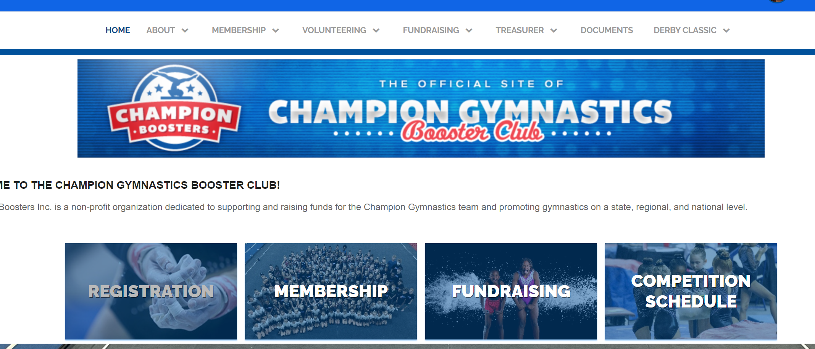

Step 2: All registrations look like below. Select “Add to Cart”.
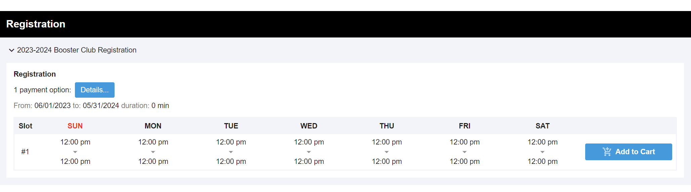
Step 3: Select "My Shopping Cart" in the bottom left screen or the upper right corner of the page. Click "Checkout Now".
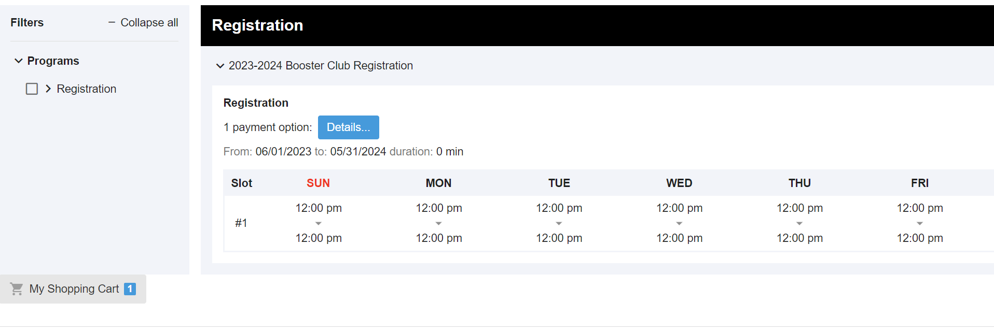
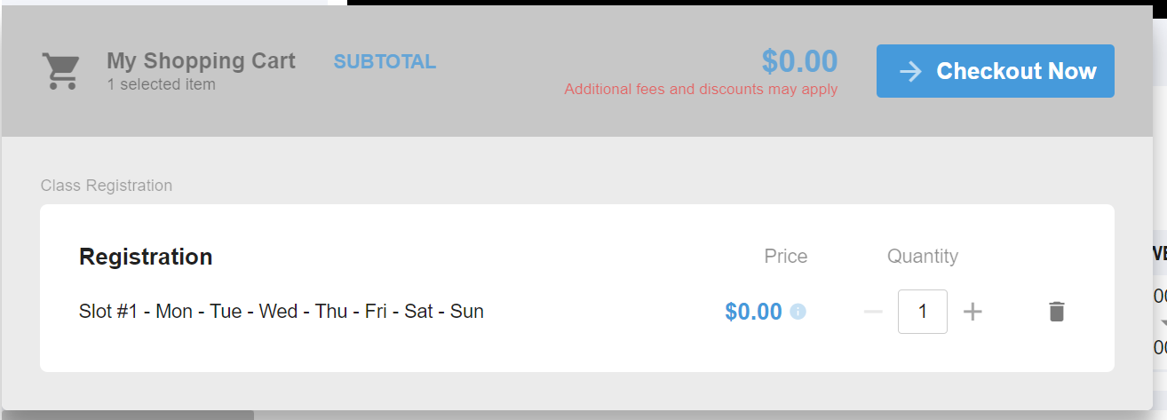

Step 4: From the drop down under Assign Member, choose "Add New Member". If you had an account from last year, and your gymnast is already listed, choose them from the drop down.
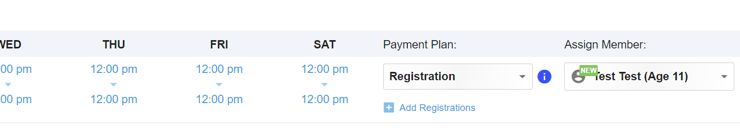
If you are setting up your account for the first time, or have a new gymnast to add to your account, select “Add New Member”. The following window pops up to add member information. This is GYMNAST information that needs to be listed. Only the required fields are necessary. Repeat steps for additional gymnasts.
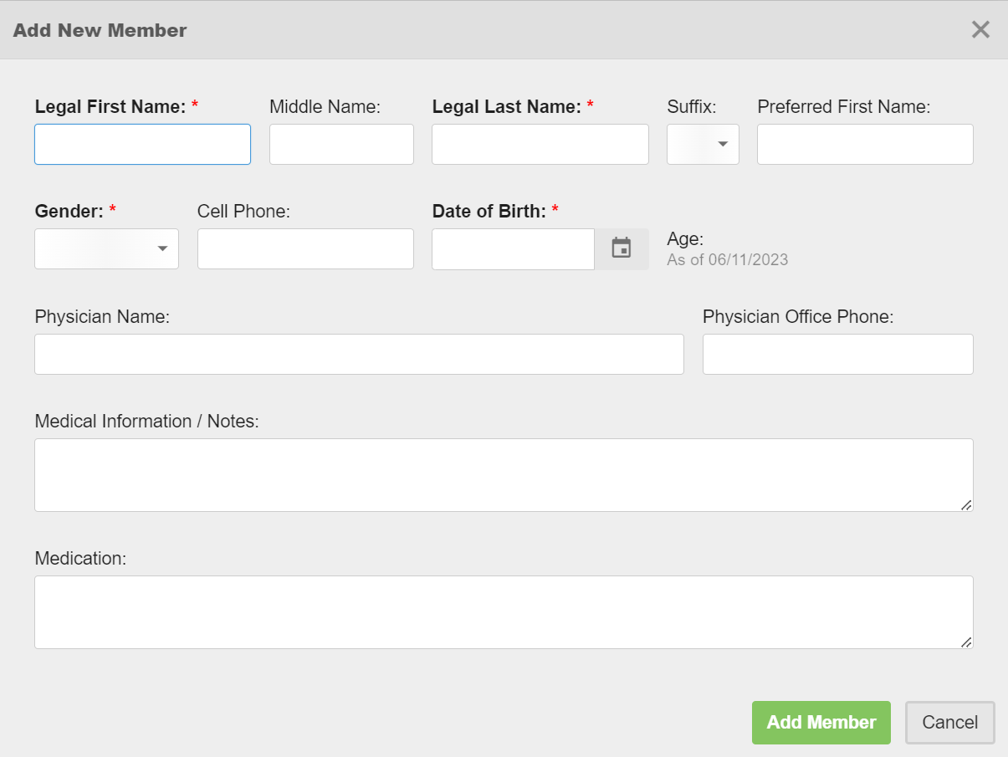
Step 5: Read and click the box for "I have read and agree" the membership agreements. This is acknowledgement of all Booster requirements.
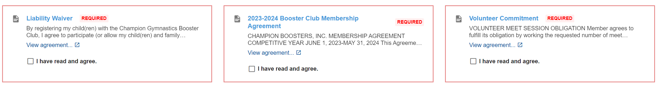
All three forms need to be reviewed and signed off on before you can move to the next page. These agreements are imperative to the booster club being able to operate and your gymnast being able to compete per your agreement with All About Kids.
Step 6: Confirm registrations on the summary page.
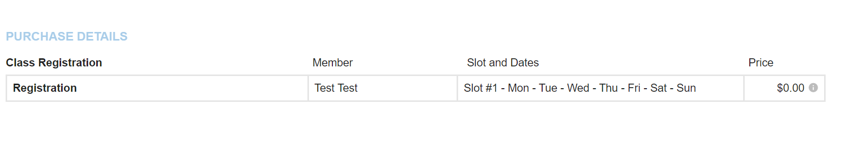
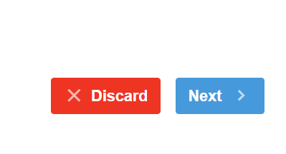
Step 7: The billing page is not setup to take payment due to being able to fundraise the registration fee, but you can indicate your method of payment. Once you complete registration, you can then go to your account and pay your balance in that area. Fundraising makes the registration fee different for all families. You must select “Pay Now” to complete registration.
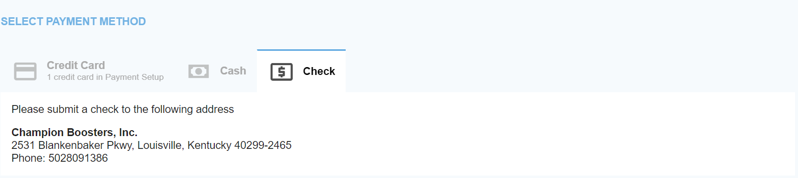
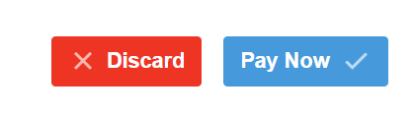
Step 8: If you are paying via cash or check, please drop payment of $450 less any fundraising in the black box next to the booster office. If paying electronically, please see instructions below.
Please allow processing time for the bookkeeper and/or treasurer to properly apply the payment to your account. Fundraising Report (as of 6/1/2023)
You are now a registered member of 2023-2024 Champion Boosters! We hope everyone has a fantastic season!
If paying electronically:
Step 1: Go to your account via the top right corner of the home page.
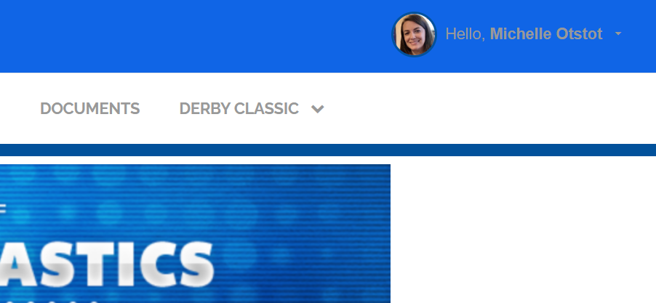

Step 2: Within My Account, go to the “Payment Setup” to setup your electronic form of payment.
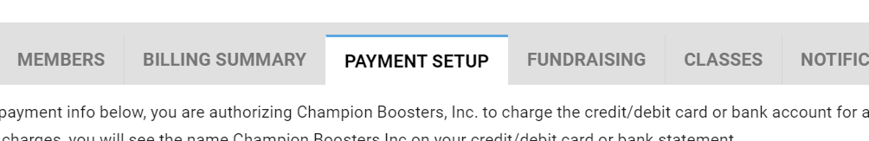

Step 3: Next go to the “Billing Summary” tab that sits next to the “Payment Setup” tab. Click the green button that says “Payment”. This is for on-demand payments and can be used anytime throughout the year.
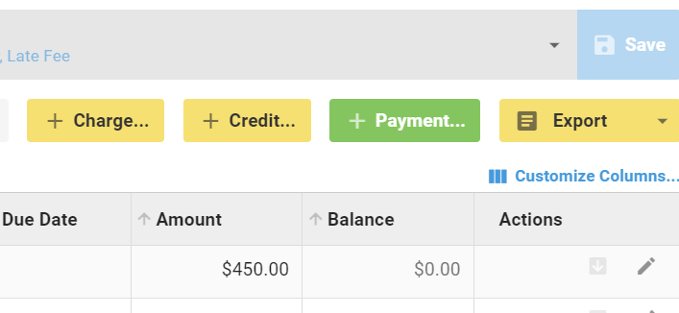
Step 4: Enter the amount owed and select payment method. Fundraising Report (as of 6/1/2023)
Please note there will be a processing fee for all electronic payments. We the booster club do not receive any of this money, it is a fee that must be collected and remitted to the card processor. To avoid this fee, cash and check are accepted.
The fees are $1.50 plus 3.25% of the amount being charged. For $450, this will increase the total to $466.13.
Step 5: The card information you filled out under payment setup should appear. Click the “Process Payment” button and you are finished!
