HELP US PAY OUR BILLS! IF YOU KNOW OF A BUSINESS THAT WOULD LIKE TO SPONSOR US, PLEASE REACH OUT TO THEM!
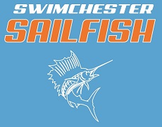
2025-2026 Team Sponsor Form
Sponsor Name _____________________________________________________
Sponsor Address ____________________________________________________
Sponsor Contact______________________________Phone #_________________
_____Title Sponsor $5,000
Primary logo space on website and live-streams, t-shirts worn at meets, separate company banner in pool area and naming rights to Sailfish-hosted meets.
_____Gold Corporate Sponsor $1,000
Logo on the website, team T-shirts (larger print than blue sponsors), team banner that will be hung in the pool area, logo in heat sheets and livestreams.
_____Silver Sponsor $500
Logo on the website, team T-shirts (larger than blue sponsors), team banner that will be hung in the pool area
_____Blue Sponsor $250
Logo on team T-shirts
_____Friend of the Team Sponsor $________ ($50 minimum)
Thank you for your support! Please email the company logo (.ai is preferred file format) to CoachKevinSWSF@gmail.com

Please send the form to (check payable to Swimchester Sailfish):
Swimchester Sailfish
15 Wheeler Avenue
Winchester, KY 40391

