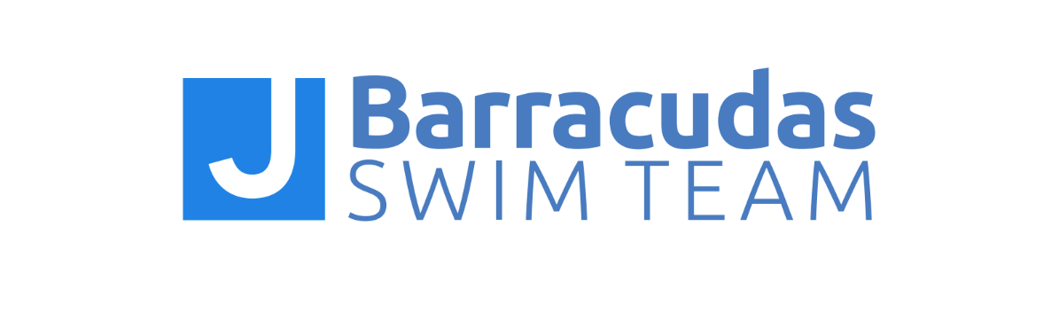

JBST Athlete Code of Conduct

All people participating in association with the JBarracudas Swim Team, including athletes, are responsible for upholding the team’s values at swim meets, practices, gatherings, and anytime they wear team gear. The purpose of a code of conduct for athletes is to establish a consistent expectation for athletes’ behavior.

For health and safety reasons, I agree to abide by the following rules:
- Swimmers under driving age will not be allowed to leave practice early without prior notification via email to the swimmer’s coach. Swimmers who drive themselves to practice must inform the coach before practice if they need to leave practice early.
- Swimmers may not wait outside the Lawrence Family JCC facility for their parents. Swimmers must wait on the pool deck or café area until their parents have arrived.

By signing this code of conduct, I also agree to the following statements:
- I will respect and show courtesy to my teammates and coaches at all times.
- I will demonstrate good sportsmanship before, during, and after all practices and meets and other swim team gatherings.
- I will set a good example of behavior and work ethic for my younger teammates.
- I will be respectful of my teammates’ feelings and personal space. Swimmers who exhibit sexist, racist, homophobic, or otherwise inappropriate behavior will be excused from the practice or meet immediately and will be faced with consequences as determined by the coaching staff.
- I will attend the required/expected minimum weekly number of practices for my group, all team meetings, and all swim meets, unless I am excused by my coach.
- I will be on time and ready to get in the water at the time my practice or swim meet is scheduled to start.
- I will bring all required equipment to every practice.
- I will abide by the team dress code and uniform policy at all practices and swim meets.
- At swim meets, I will report to my coach before and after every race. I will be behind the blocks prior to my race.
- I will not attend other swim team’s practices or other swimming instruction, including Masters’ Swimming practices, without the approval of my coach. Attendance at any other team’s practices or meets does not count toward the expected minimums for the JBarracudas Swim Team.

- I will not enter the water if I am ill with a contagious virus or have a severe open wound.
- If I am injured at practice or a swim meet, I will immediately report the injury to my coach.
- I will show respect for all facilities and other property (including locker rooms) used during practices, competitions, and team activities.
- I will refrain from foul language, violence, behavior deemed dishonest, offensive, or illegal.
- If I disagree with a coach, I will first discuss the problem with my coach. If the problem cannot be resolved, my parent or I will take the issue up with the head coach, who will help to resolve any issues.
- If I disagree with an official’s call, I will talk with my coach and not approach the official directly.
- I will obey all of USA Swimming’s rules and codes of conduct.
I understand that if I violate this code of conduct, I will be subject to disciplinary action determined by my coaches.

[Athlete and Parent Signatures are required to be kept on file with the Team.]

