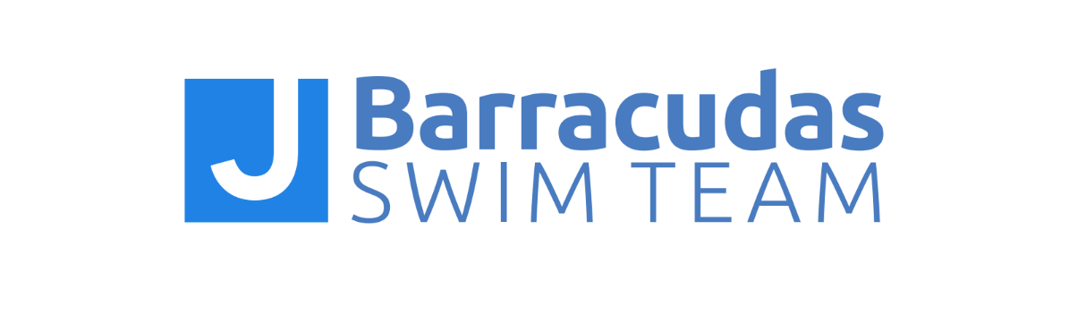

JBST GRIEVANCE PROCEDURE

The JBarracudas Swim Team Grievance Procedure provides swimmers, parents, coaches, and JBST leaders and employees a system to address and report grievances in a productive, systematic way. Following these procedures and policies allows the appropriate parties to properly investigate, intervene, and take disciplinary action when needed.

Where to Report:
For issues dealing with sexual misconduct, sexual harassment, and/or sexually explicit or inappropriate communication through social media:
- U.S. Center for Safe Sport: 833-5US-SAFE (833-587-7233)

For issues dealing with physical abuse, emotional abuse, criminal charges, and the use, sale, or distribution of illegal drugs:
- USA Swimming Safe Sport: safesport@usaswimming.org

For issues dealing with known or suspected child abuse:
- San Diego County Sheriff’s Department: (858) 285-6222
- San Diego Police Department: 858-484-3154
- California Child Abuse Hotline: (800) 344-6000

For issues dealing with peer-to-peer bullying, coach-athlete bullying, parent issues, violations of the JBarracudas Swim Team Codes of Conduct, and violations of the Minor Athlete Abuse Prevention Policy (MAAPP):
- Regarding swimmer conduct, contact the swimmer’s coach
If a parent or other swimmer feels another swimmer’s conduct is inappropriate or violates the JBarracudas Swim Team Athlete Code of Conduct or other policy, the parent/swimmer should discuss the concerns with the coach of the swimmer responsible for the violation. This complaint should be made in person or in writing. The coach will

ensure the Head Coach is notified, and the coaches will work as a team to assess behavior and address the violation.
- Regarding assistant coach conduct, contact the Head Coach
If a parent or other swimmer feels an assistant coach’s conduct is inappropriate or violates the JBarracudas Swim Team Coaches Code of Conduct or other Club policy or procedure, the parent/swimmer should discuss the concerns with the Head Coach. This complaint should be made in person or in writing.
- Regarding Head Coach conduct, contact the Aquatics Director,
If a parent or other swimmer feels the Head Coach’s conduct is inappropriate or violates the JBarracudas Swim Team Coaches Code of Conduct or other Club policy or procedure, the parent/swimmer should discuss the concerns with the Aquatics Director, Spencer Lynch. This complaint should be made in person or in writing.
- Regarding parent or official conduct, contact the Head Coach
If a parent or other swimmer feels a parent or official’s conduct is inappropriate or violates the JBarracudas Swim Team Parent Code of Conduct or other Club policy or procedure, the parent/swimmer should discuss the concerns with the Head Coach. This complaint should be made in person or in writing.
- Regarding (noncoach) LFJCC employee conduct, contact the Aquatics Director
If a parent or other swimmer feels any noncoach, LFJCC Employee’s conduct is inappropriate or violates a JBarracudas policy or procedure, the parent/swimmer should discuss the concerns with the LFJCC Aquatics Director. This complaint should be made in person or in writing.

When to Report
Unless the issue or violation deals with the immediate health and safety of swimmers, all matters should be discussed before or after a coaching session. In other words, coaches are not expected to deal with these issues during practice.

How Grievances Will Be Handled
The Head Coach has the authority to implement and enforce policies and procedures and to impose penalties for violations of the JBarracudas Swim Team Athlete, Parent, or Coach Codes of Conduct, any other Club policies, and any behavior they deem not conducive to the best interests of the Club or other swimmers. Consequences are at the sole discretion of the coaches and may include, but are not limited to, verbal warnings, dismissal from practice, contacting parents, temporary suspension, and expulsion. Involved parties will be informed of the processes

and range of potential consequences. The U.S. Center for Safe Sport, USA Swimming, and local law enforcement (if applicable) will be contacted within 24 hours if a coach, parent, or swimmer violates the Safe Sport Code for the U.S. Olympic and Paralympic Movements, the USA Swimming Code of Conduct, Athlete Protection Policy, or local laws.
- Information Gathering and Investigation: The appropriate individuals will contact the person who filed the grievance and the person against whom the grievance is filed to ask questions about what happened. Other witnesses may be contacted for more information. Summaries of information gathered will be recorded in writing.
- Assessment: The behavior of the person(s) against whom the grievance was brought will be assessed using club policies and facility rules, the USA Swimming Code of Conduct, USA Swimming Safe Sport policies, and applicable local and state laws.
- Action: Disciplinary action will be taken if appropriate. The consequences and disciplinary action will be decided based on the following general guidelines:
- Nature of the misconduct
- Severity of the misconduct
- Prior disciplinary actions
- Adverse effect of the misconduct
- Application of the Codes of Conduct and other Club policies

