ANNUAL AWARDS

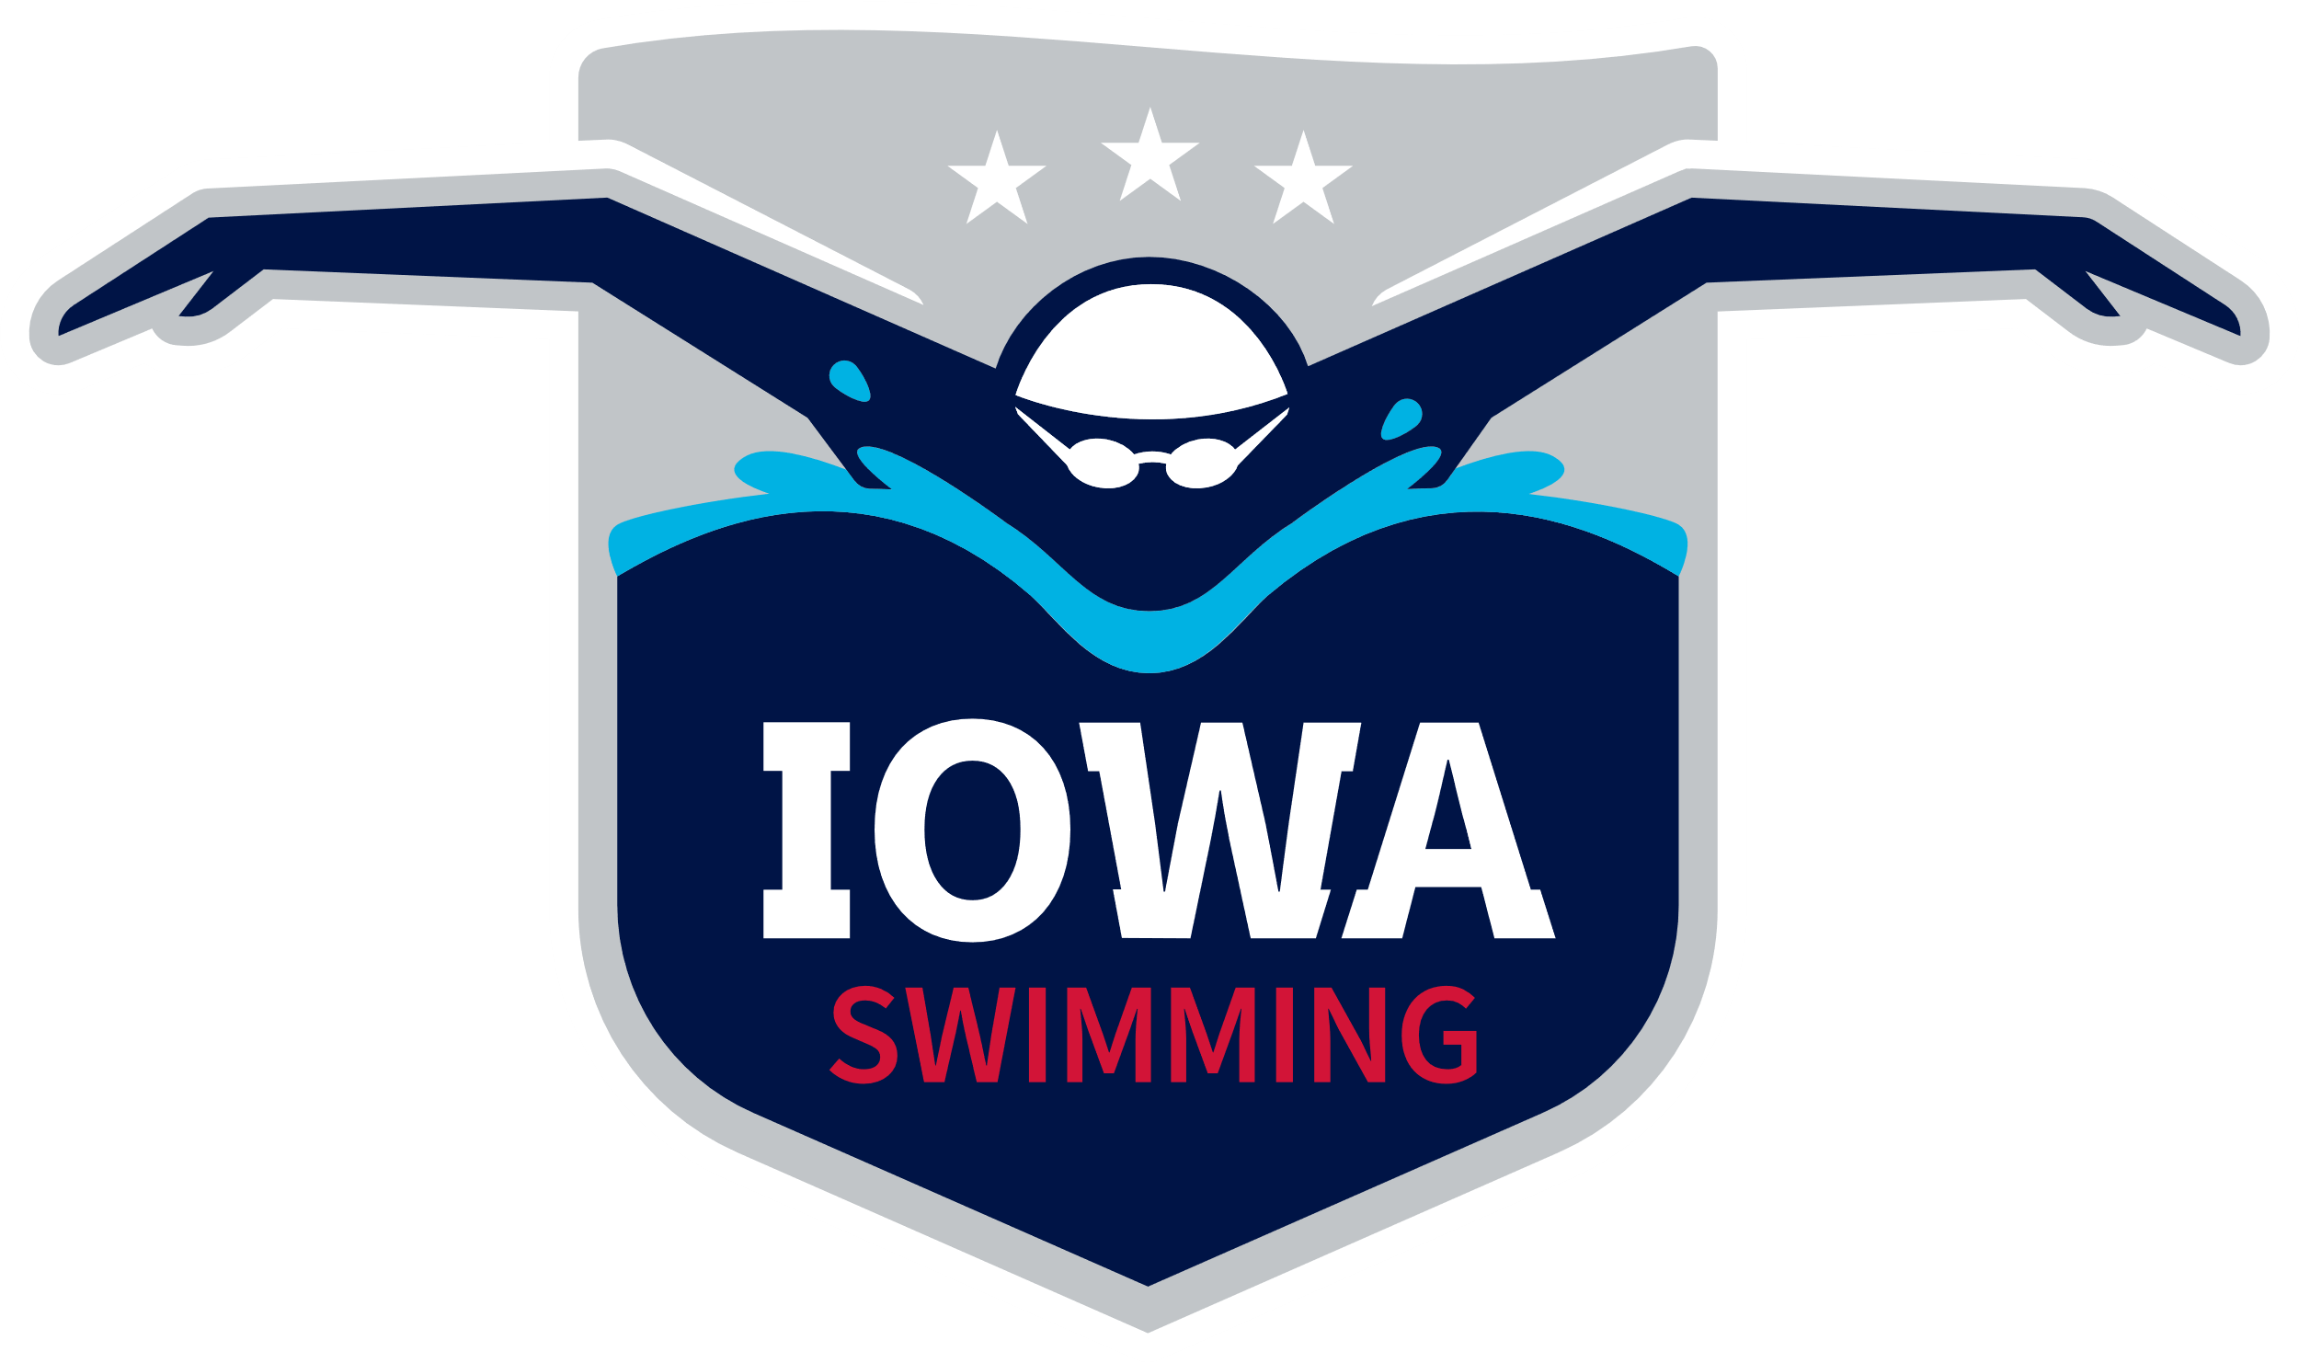

2023

New Iowa Swimming Records
2022 Long Course
Hudson Huberg IFLY 13-14 Boys 50 Freestyle LCM 23.93
Parker Macho IFLY 13-14 Boys 100 Butterfly LCM 57.95
Hannah Cousins PSC 15-16 Girls 400 Free Relay LCM 4:01.77
Izzy Heller PSC 15-16 Girls 400 Free Relay LCM 4:01.77
Cait Quinn PSC 15-16 Girls 400 Free Relay LCM 4:01.77
Mary Selden PSC 15-16 Girls 400 Free Relay LCM 4:01.77
Hannah Cousins PSC 15-16 Girls 200 Med Relay LCM 2:01.65
Izzy Heller PSC 15-16 Girls 200 Med Relay LCM 2:01.65
Hailee Messerly PSC 15-16 Girls 200 Med Relay LCM 2:01.65
Mary Selden PSC 15-16 Girls 200 Med Relay LCM 2:01.65
Hannah Cousins PSC 15-16 Girls 400 Med Relay LCM 4:27.37
Izzy Heller PSC 15-16 Girls 400 Med Relay LCM 4:27.37
Dawsyn Green PSC 15-16 Girls 400 Med Relay LCM 4:27.37
Mary Selden PSC 15-16 Girls 400 Med Relay LCM 4:27.37
Max Gerke IFLY 15-16 Boys 200 Free Relay LCM 1:37.85
Holden Carter IFLY 15-16 Boys 200 Free Relay LCM 1:37.85
Joe Polyak IFLY 15-16 Boys 200 Free Relay LCM 1:37.85
John Weigel IFLY 15-16 Boys 200 Free Relay LCM 1:37.85
Hayden Hakes IFLY 15-16 Boys 400 Med Relay LCM 3:56.27
Joe Polyak IFLY 15-16 Boys 400 Med Relay LCM 3:56.27
Holden Carter IFLY 15-16 Boys 400 Med Relay LCM 3:56.27
John Weigel IFLY 15-16 Boys 400 Med Relay LCM 3:56.27
Scarlet Martin IFLY 15-18 Girls 400 Free Relay LCM 3:54.64
Grace Hoeper IFLY 15-18 Girls 400 Free Relay LCM 3:54.64
Jade Roghair IFLY 15-18 Girls 400 Free Relay LCM 3:54.64
Heidi Stalkfleet IFLY 15-18 Girls 400 Free Relay LCM 3:54.64
Payden Rafferty DSMY 15-18 Girls 400 Med Relay LCM 4:21.03
Anja Peck DSMY 15-18 Girls 400 Med Relay LCM 4:21.03
Mallory Kell DSMY 15-18 Girls 400 Med Relay LCM 4:21.03
Taylor Judas DSMY 15-18 Girls 400 Med Relay LCM 4:21.03
Aiden Carstensen IFLY 15-18 Boys 200 Med Relay LCM 1:44.51
Jordan Christensen IFLY 15-18 Boys 200 Med Relay LCM 1:44.51
Holden Carter IFLY 15-18 Boys 200 Med Relay LCM 1:44.51
Kirk Brotherton IFLY 15-18 Boys 200 Med Relay LCM 1:44.51
Miriam Sheehan DASH 17-18 Girls 100 Freestyle LCM 55.95
Joe Hancock DSMY 17-18 Boys 800 Free Relay LCM 7:46.90
Asher Havenhill DSMY 17-18 Boys 800 Free Relay LCM 7:46.90
Tommy Hancock DSMY 17-18 Boys 800 Free Relay LCM 7:46.90
Lance Swanepoel DSMY 17-18 Boys 800 Free Relay LCM 7:46.90
Scarlet Martin IFLY Open Women 200 Free Relay LCM 1:47.84
Ella Hochstetler IFLY Open Women 200 Free Relay LCM 1:47.84
Jade Roghair IFLY Open Women 200 Free Relay LCM 1:47.84
Heidi Stalkfleet IFLY Open Women 200 Free Relay LCM 1:47.84

Long Course Records listed here were set between 9/1/2021-8/31/2022

New Iowa Swimming Records
2022-2023 Short Course
Parker Macho IFLY 13-14 Boys 100 Butterfly SCY 51.20
Jacob Pins DMSF 15-16 Boys 1650 Freestyle SCY 15:05.72
Hayden Hakes IFLY 15-16 Boys 200 Med Relay SCY 1:33.90
Winston Fan IFLY 15-16 Boys 200 Med Relay SCY 1:33.90
Parker Macho IFLY 15-16 Boys 200 Med Relay SCY 1:33.90
Hudson Huberg IFLY 15-16 Boys 200 Med Relay SCY 1:33.90
Hayden Hakes IFLY 15-16 Boys 400 Med Relay SCY 3:26.74
Winston Fan IFLY 15-16 Boys 400 Med Relay SCY 3:26.74
Parker Macho IFLY 15-16 Boys 400 Med Relay SCY 3:26.74
Hudson Huberg IFLY 15-16 Boys 400 Med Relay SCY 3:26.74
Jacob Pins DMSF 15-18 Boys 1650 Freestyle SCY 15:05.72
Miriam Sheehan DASH 17-18 Girls 100 Backstroke SCY 51.99
Miriam Sheehan DASH 17-18 Girls 100 Butterfly SCY 51.67
AJ Abram DSMY 17-18 Boys 200 Free Relay SCY 1:22.03
Asher Havenhill DSMY 17-18 Boys 200 Free Relay SCY 1:22.03
Nick Rounds DSMY 17-18 Boys 200 Free Relay SCY 1:22.03
Lance Swanepoel DSMY 17-18 Boys 200 Free Relay SCY 1:22.03
Owen Chiles IFLY 17-18 Boys 200 Med Relay SCY 1:30.45
Joe Polyak IFLY 17-18 Boys 200 Med Relay SCY 1:30.45
Holden Carter IFLY 17-18 Boys 200 Med Relay SCY 1:30.45
John Weigel IFLY 17-18 Boys 200 Med Relay SCY 1:30.45
Asher Havenhill DSMY 17-18 Boys 400 Med Relay SCY 3:18.54
Charlie Bishop DSMY 17-18 Boys 400 Med Relay SCY 3:18.54
Lance Swanepoel DSMY 17-18 Boys 400 Med Relay SCY 3:18.54
AJ Abram DSMY 17-18 Boys 400 Med Relay SCY 3:18.54
Aurora Roghair IFLY Open Women 500 Freestyle SCY 4:41.91
Miriam Sheehan DASH Open Women 100 Backstroke SCY 51.99
Miriam Sheehan DASH Open Women 100 Butterfly SCY 51.67
Jacob Pins DMSF Open Men 1650 Freestyle SCY 15:05.72
Short Course Records listed here were set between 4/1/2022-3/31/2023

Iowa Outstanding Swimmers of the Year
2022 Long Course

10 & Under Girls 10 & Under Boys
Maelyn Woltz BLST Sheldon Lamb DSMY
Ashlyn Burns DSMY Linrui An IFLY
Dana Assaad CIA Max Jeffryes CIA
Addie Deyoung ACAC Nathan Schlueter CIA
Aspen Fenton DSMY Joseph Saputra MACR

11-12 Girls 11-12 Boys
Caite Schaffel IFLY Ben Susil CIA
Katie Stone CIA Wesley Mooney DMSF
Tenley Michael PSC Misha Soloviov IFLY
Helena Mundisev IFLY Max Macho IFLY
Emery Baker DSMY Gus L’Heureux BLST

13-14 Girls 13-14 Boys
Charlotte Qualley DSMY Parker Macho IFLY
Hayden Bailey DSMY Hudson Huberg IFLY
Hannah Geng IFLY Winston Fan IFLY
Faith Frantum CIA Zack Heiar DASH
Riley Gojkovich DSMY Ryan Herink BLST

Iowa Outstanding Swimmers of the Year
2022-2023 Short Course

10 & Under Girls 10 & Under Boys
Aspen Fenton DSMY Sheldon Lamb DSMY
Evie Ward DASH Max Jeffryes CIA
Nelly Geneser IFLY Layten Norem ACAC
Dana Assaad CIA Joseph Saputra MACR
Kinzlee Smith IFLY Adrian Steven CIA

11-12 Girls 11-12 Boys
Caite Schaffel IFLY Misha Soloviov IFLY
Halle Sears UN Nathan Schlueter CIA
Lillian Andedo BETT Max Macho IFLY
Tenley Michael PSC Isaac Knapp MACR
Teresa Zhang LMST Clayton Treharne LMST

13-14 Girls 13-14 Boys
Hayden Bailey DSMY Parker Macho IFLY
Charlotte Qualley DSMY Wesley Mooney DMSF
Hannah Geng IFLY Leegan Sease CAST
Jaya Stacy BETT Winston Fan IFLY
Alexis Hergenreter DSMY Philip Berry-Stoelzle IFLY

2022-2023 Senior Athlete Award
Jacob Pins DMSF
Miriam Sheehan DASH
Olivia Swalley CIA

2023 Judy Hoffman Memorial Scholarship
Olivia Frantum CIA

2023 Iowa Swimming Scholarship
Blake Behrens LMST
Jacob DeLange DMSF
Keaton Weaver BETT

2023 Phillips 66 Service Award
Art Dinkin

USA Swimming Scholastic All Americans
2021-2022

4th Year
Heidi Stalkfleet IFLY

2nd Year
Cooper Callahan LMST
Jordan Christensen IFLY
Asher Havenhill DSMY
Carter Kirtz LMST
Fynlan Nadel CIA

1st Year
Joshua Chen ACAC
Owen Chiles UN
Samuel Davey DSMY
Josh Fisher ACAC
Faith Frantum CIA
Willa Hage CIA
Hayden Hakes IFLY
Nora Kemp CIA
Jozsef Polyak IFLY
Olivia Swalley CIA
Reed Wallace CIA
Reese Winer ACAC

