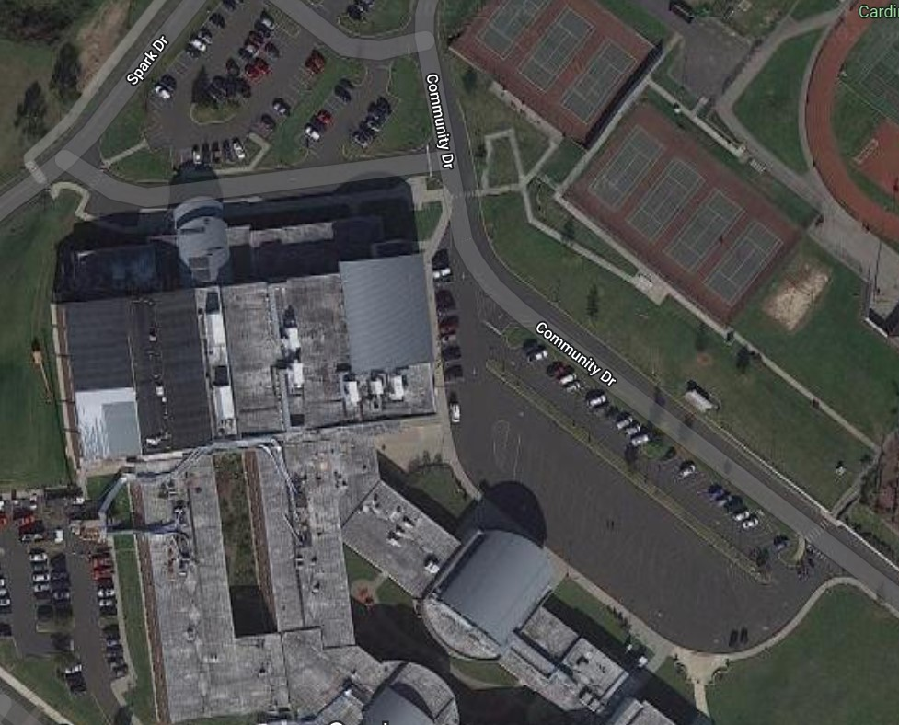
Event Parking
Bus Parking
Bus Drop Off
Pool
Pool Entrance

