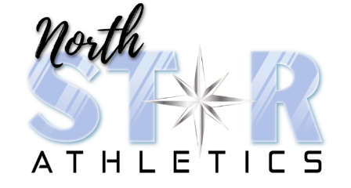

Snack bar permission slip

Athletes Name:

- Yes, my child can purchase snacks and/or drinks at clinics and charge it to my account.

Optional:

Weekly Max:
Daily Max:

- No, my child cannot purchase snacks and/or drinks on my account

- I will send my child with money in an envelope with their name and amount in it each day/week.

- My child is not allowed to purchase any snacks and/or drinks at North Star Athletics.

Allergies or restrictions:

